CEMP Guidelines for Monitoring and Assessment of loud, low and mid-frequency impulsive sound sources in the OSPAR Maritime Region
(OSPAR Agreement 2017-07)
Source: EIHA 17/9/1 Annex 15

1 Introduction
Anthropogenic sound is generated either as a by-product of human activities in the marine environment (for example shipping or construction), or is produced intentionally for the purposes of surveying the seabed or water column. The introduction of anthropogenic sound (also commonly known as noise) became widespread with the advent of motorised shipping, and now includes sources such as seismic surveys to inspect subsea oil and gas deposits, pile driving for inshore and offshore construction (see Figure 1), civilian and naval sonar activity, and the detonation of unexploded ordnance. Anthropogenic sound sources are categorised as impulsive or continuous.
The purpose of this indicator is to assess the amount and distribution of impulsive sound sources across the OSPAR region. Impulsive sound sources include percussive pile driving, seismic surveys, explosions, and some sonar sources. Such sources have been observed to cause temporary displacement of cetaceans (e.g. harbour porpoise, Thompson et al. 2013; beaked whales, Tyack et al. 2011), increased physiological stress in some fish species (e.g. European seabass; Debusschere et al., 2016), and developmental abnormalities in invertebrate larvae (e.g. scallop larvae; Aguilar de Soto et al., 2013). While effects on individual animals have been shown for a number of species, there is uncertainty over whether and how the effects of sound on individuals are translated to the population or ecosystem scales. In line with this threat OSPAR has adopted Recommendations to protect and conserve some of its listed threatened and/or declining species from anthropogenic underwater noise. These include the harbour porpoise, northern right whale, blue whale and bowhead whale.
The purpose of this document is to provide guidelines for a monitoring and assessment programme that allows efficient detection of spatial differences and temporal changes in the distribution of impulsive sound sources within the OSPAR Maritime Region, using the OSPAR Common Indicator for impulsive noise. OSPAR has adopted Indicator 11.1.1 of the EU Marine Strategy Framework Directive (MSFD) as the OSPAR Common Indicator. This is a pressure indicator based on the spatiotemporal distribution of low-frequency and mid-frequency impulsive sound sources. These guidelines consequently make extensive reference to the monitoring guidance for this Indicator issued by TG Noise (Dekeling et al., 2014), which were adopted by OSPAR (Agreement 2014-08).

2 Monitoring
2.1 Purpose
The purpose of monitoring impulsive sound sources is to quantify the pressure these sources exert on marine ecosystems, and the distribution of this pressure in space and time. This information will enable the varying contribution of anthropogenic impulsive sound to be considered in assessing the environmental status of the OSPAR maritime region, in combination with other indicators.
2.2 Quantitative Objectives
The programme enables the spatial and temporal distribution of anthropogenic impulsive sound activity (and trends in this activity) to be quantified. However, there is currently no quantitative spatial or temporal objective associated with this monitoring programme.
2.3 Monitoring Strategy
The monitoring strategy follows “Monitoring Guidance for Underwater Noise in European Seas” (Dekeling et al., 2014), adopted by OSPAR as guidance for noise monitoring in the OSPAR maritime region (OSPAR Agreement 2014-08).
2.4 Sampling Strategy
Contracting Parties maintain national impulsive noise registries, which collect data on impulsive noise activity meeting that criteria for inclusion (OSPAR, 2014) within their waters. These criteria include sound source level thresholds above which it is considered that anthropogenic sound may have harmful effects on marine fauna (see Agreement 2014-08 for specific threshold criteria).
The data recorded include:
- The type of activity (seismic survey; pile driving; explosion; sonar; acoustic deterrent device);
- Location of each activity (as a single point or polygon area);
- The days on which the activity occurred;
- Source properties – source level or proxy (essential minimum).
These basic data enable the computation of the Indicator, whose unit of measurement is Pulse Block Days (PBDs). PBDs record the number of days and their distribution within a calendar year that anthropogenic impulsive activity (meeting the criteria) occurred, within a defined spatial unit. For the Common Indicator, this spatial unit is the ICES statistical sub-rectangle.
As mentioned above, Contracting Parties may record, where available, more detailed information on the activity (e.g. further details on the sounds produced) and any source mitigation methods (e.g. the use of a bubble curtain) which were applied. These additional parameters are specified in the ICES Reporting Format (see below for further details; http://ices.dk/marine-data/Documents/NoiseRegistry/NoiseRegister.zip). Recording these additional data may enable further improvement of the assessment in the future.
Information on which Contracting Parties are undertaking monitoring, along with other information required for EU Marine Strategy Framework Directive monitoring reporting under article 11, are outlined in the CEMP Appendix for impulsive noise. The Appendix is an integral part of the CEMP and is updated annually.
2.5 Quality assurance/ Quality Control
Methods for the monitoring approach have been developed under guidance of working groups of OSPAR and the EU. Contracting Parties will have their own Quality Control Systems for their national impulsive noise registries. ICES also undertake comprehensive Quality Control checks when the national data is submitted to the OSPAR Impulsive Noise Register (INR), which they host on behalf of OSPAR, before it is accepted.
2.6 Data reporting, handling and management
Contracting Parties report data for a given year from national impulsive noise registries to the OSPAR Impulsive Noise Registry not later than the 1st of October of the following year. The reporting format and associated XML schema required by the INR are provided by ICES (http://ices.dk/marine-data/Documents/NoiseRegistry/NoiseRegister.zip). Figure 1 summarises the workflow for data reporting and production of Indicator outputs.
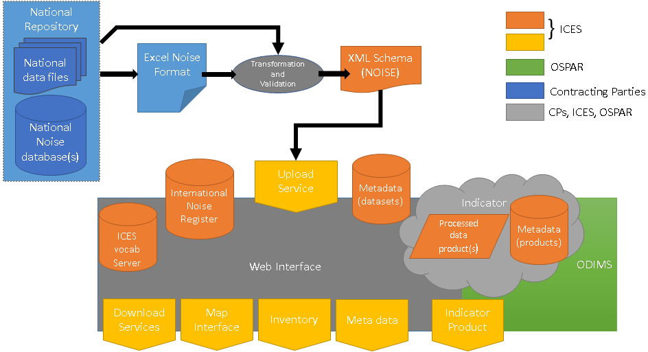
Figure 1 Data workflow for OSPAR Impulsive Noise Registry.

3 Assessment
3.1 Data acquisition
Data in the INR are accessed through the OSPAR Underwater Noise Data Portal, which is hosted by ICES (http://underwaternoise.ices.dk/map.aspx).
3.2 Preparation of data
The data reported by Contracting Parties to the INR do not have a standardised spatial unit: some activities are reported as occurring in polygons (of varying sizes), and others as point sources (specified by geospatial coordinates). To standardise these data spatially, all data are translated into ICES statistical sub-rectangles (see Figure 2), which are defined throughout the OSPAR maritime region. The methodology for converting polygons to sub-rectangles is to transfer all Pulse Block Days reported in the original polygon data into all ICES statistical sub-rectangles which overlap with that polygon, however marginal the overlap may be. This may lead to an overestimation of the reported area, as seen in Figure 2. One solution would be to report all activity as point sources, though this is currently not possible for all activity types.
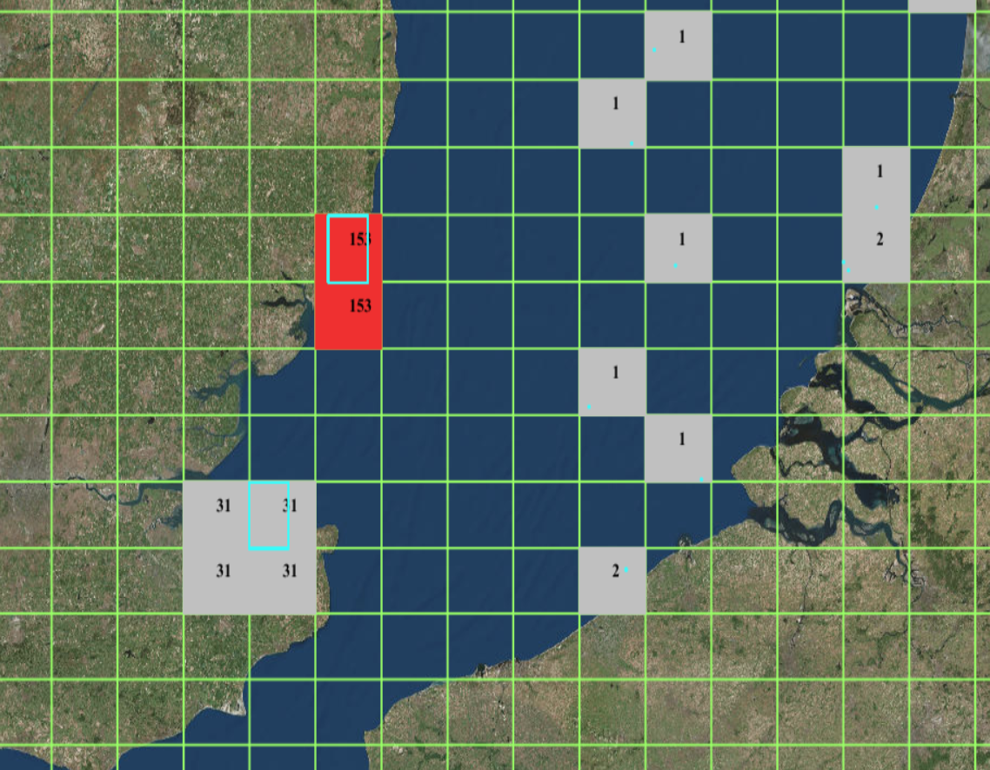
Figure 2 Conversion of point source and polygon data to ICES statistical sub-rectangles. ICES sub-rectangle grid plotted in green with number of pulse block days indicated within corresponding sub-rectangles; original polygon and point source data plotted in cyan.

3.3 Assessment criteria
The spatiotemporal assessment unit used in the assessment is termed Pulse Block Day. This is the number of days within a specified spatial unit in which anthropogenic impulsive sources occurred in a given calendar year. Only sound sources above a specified intensity level are included. These levels are detailed in the technical specification of the Impulsive Noise Indicator (OSPAR Agreement 2014-08). Note that the application of source mitigation measures may reduce source intensity such that an activity no longer qualifies for inclusion in the registry. The spatial component of the Pulse Block Day is the ICES statistical sub-rectangle, which is defined in a standard way throughout the OSPAR region, and provides detailed resolution at the regional sea scale.
3.4 Presentation of assessment results
The assessment describes the spatial and temporal distribution of anthropogenic impulsive sound sources in the OSPAR maritime region. The spatiotemporal unit of assessment used in the Intermediate Assessment 2017 is the Pulse Block Day (see above), which records the number of days of anthropogenic impulsive sound activity in a given ICES statistical sub-rectangle for a particular calendar year. The assessment results are presented as maps of Pulse Block Days for each calendar year of reporting. The indicator map for Intermediate Assessment 2017 is displayed in the OSPAR data page, and data currently recorded in the INR can be viewed and interpreted via the online ICES portal. At regional scale, these maps present a detailed and readily interpreted overview of anthropogenic impulsive sound activity for a given calendar year (Figure 3). The data can also be presented separately for each source type (e.g. seismic airgun; impact pile driver; explosion) to assess the contribution of the associated human activities (Figure 4). The periodicity of the indicator assessment is every three years.
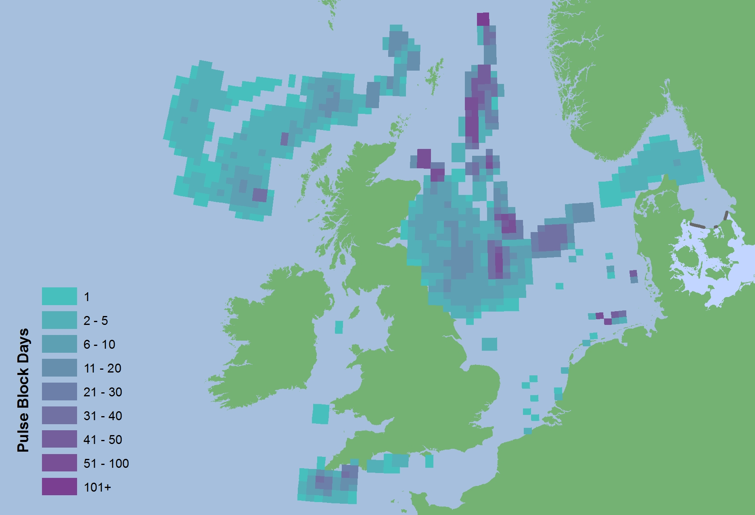
Figure 3. Total pulse block days reported for 2015.

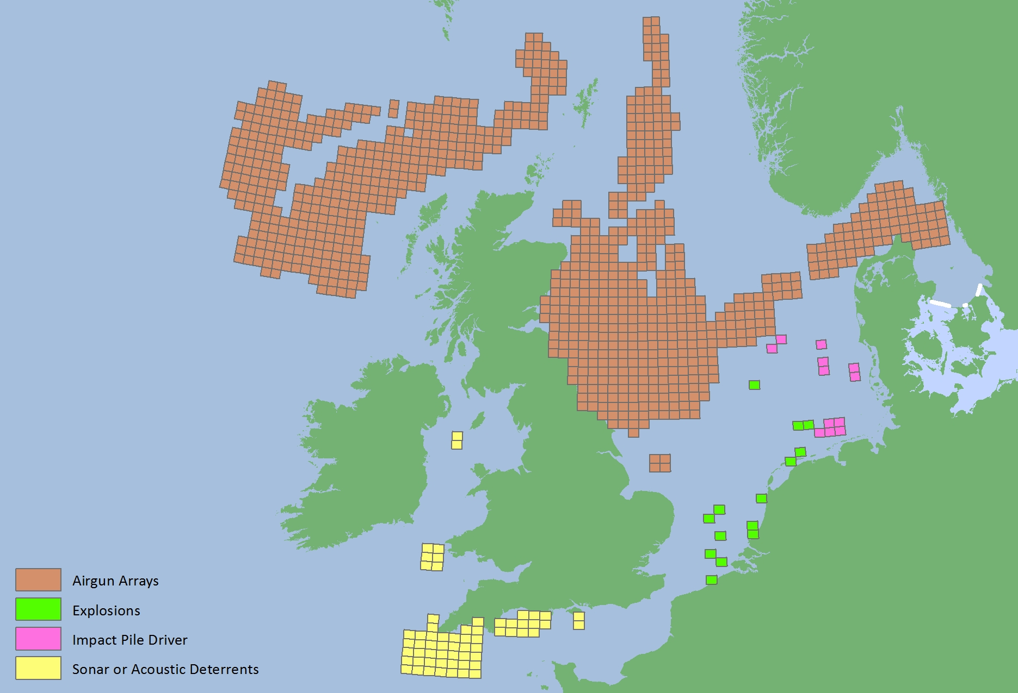
Figure 4. Activity type of pulse block days reported for 2015

4 Change Management
Requests for changes of the impulsive sound monitoring or assessment method should be raised at the Intersessional Correspondence Group on Underwater Noise (ICG-Noise). Such requests will be discussed within ICG-NOISE before any changes are proposed to the Environmental Impact of Human Activities (EIHA) Committee for agreement.

5 References
Aguilar de Soto, N., Delorme, N., Atkins, J., Howard, S., Williams, J. & Johnson, M. (2013) Anthropogenic noise causes body malformations and delays development in marine larvae. Scientific Reports, 3, 2831.
Debusschere, E., Hostens, K., Adriaens, D., Ampe, B., Botteldooren, D., De Boeck, G., De Muynck, A., Sinha, A.K., Vandendriessche, S., Van Hoorebeke, L., Vincx, M. & Degraer, S. (2016) Acoustic stress responses in juvenile sea bass Dicentrarchus labrax induced by offshore pile driving. Environmental pollution (Barking, Essex : 1987), 208, 747–57.
Thompson, P.M., Brookes, K.L., Graham, I.M., Barton, T.R., Needham, K., Bradbury, G. & Merchant, N.D. (2013) Short-term disturbance by a commercial two-dimensional seismic survey does not lead to long-term displacement of harbour porpoises. Proceedings. Biological sciences / The Royal Society, 280, 20132001.
Tyack, P.L., Zimmer, W.M.X., Moretti, D., Southall, B.L., Claridge, D.E., Durban, J.W., Clark, C.W., D’Amico, A., DiMarzio, N., Jarvis, S., McCarthy, E., Morrissey, R., Ward, J. & Boyd, I.L. (2011) Beaked Whales Respond to Simulated and Actual Navy Sonar. PLoS ONE, 6, e17009.

