Report of the workshop on natural capital accounting for the Northeast Atlantic, Wednesday 14th of December (online)

On the 14th of December a digital workshop on natural capital accounting for the Northeast Atlantic took place, with almost 50 participants from all across Europe. This document presents a report of that meeting.

- Welcome and introduction to the workshop

Rob van der Veeren (Rijkswaterstaat/Dutch Ministry of Infrastructure and Water management), who chaired this meeting, welcomed all participants and introduced the scope and purpose of this meeting: After having a workshop on natural capital accounting for the Dutch part of the North Sea on the 13th of December, the scope of today’s meeting is broadened to the Northeast Atlantic region. The title of the workshop is ‘Natural capital accounts in the North East Atlantic; recent developments and possible applications’. The meeting therefore started with a presentation by Maria Alarcon Blazquez who gave a presentation of the first version of the natural capital accounts she prepared for the Northeast Atlantic, followed by a presentation by Martha Stofmeel on the draft results of the second version. After this first content oriented half of the workshop, the second part of the meeting focussed on the possible ways that natural capital accounts could be used to support policy making by OSPAR, the organisation responsible to coordinate the environmental management of the Northeast Atlantic.

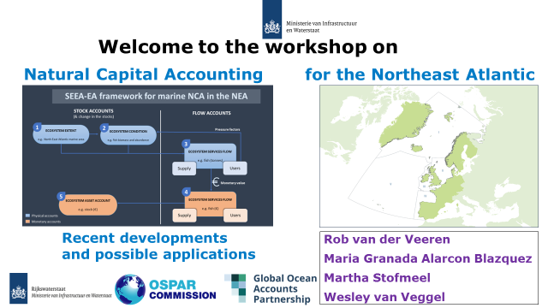

Although the focus of this meeting is on the Northeast Atlantic, the invitation for this workshop was not only sent to the members of the OSPAR Intersessional Correspondence Group on Economic and Social Analyses (ICG ESA), but to anyone else who might be interested, since today’s meeting is meant to be an opportunity to share lessons, experiences, and ideas on ‘how to (and how not to)’ apply and use NCA. The results of this meeting will be used to enrich and finalize the draft reports that were sent before the workshop.

- Natural capital accounts for the Northeast Atlantic

Maria Alarcon Blazquez (GOAP; Global Ocean Accounts Partnership) gave a presentation of the first version of the natural capital accounts for the Northeast Atlantic she prepared for OSPAR.

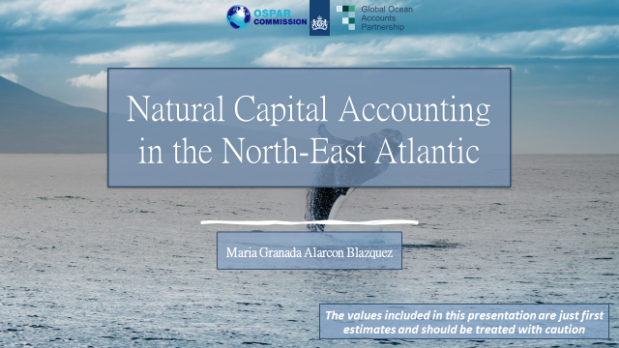

Maria started by presenting that OSPAR is the legislative mechanism by which 15 Governments and the European Union (EU) cooperate to protect the marine environment of the North-East Atlantic. After that she gave a short introduction of the SEEA - Ecosystem Accounting (SEEA-EA) framework that was adopted in March 2021. The main objective of the SEEA–EA framework is to create a set of accounts for important stocks of natural capital (ecosystem assets defined by their size and condition) and ecosystem service flow accounts. These flows are first recorded using quantitative physical metrics and then, if possible, expressed in monetary values. SEEA-EA therefore provides information in both maps and accounting tables. In the presentation Maria gave an overview of the first results she obtained for the various accounts. She concluded with the following lessons learned and final remarks:
- With respect to the ecosystem extent account, there are 2d maps available, but the sea is 3d, which caters for an additional challenge. In addition, there is a lack of time-series data, which makes it impossible to record changes.
- With respect to the condition account: There are lots of data available, but what to choose? Furthermore, most OSPAR condition indicators do not focus on water column nor are they compiled by ecosystem type (too weighted towards animal/species indicators)
- With respect to the ecosystem services: It would be recommendable to include more ecosystem services in the next version of the accounts, and to link the ecosystem services with the other accounts (ecosystem types, condition)
- And finally, with respect to the monetary accounts: Valuation is still very controversial, and the values obtained depend significantly on the method used.

The presentation by Maria gave a good impression of what natural capital accounts are and the regional scope, and, of course, the first results of the natural capital accounts for the Northeast Atlantic. In the second presentation, Martha Stofmeel built upon this and showed what she has done so far on the second version of natural capital accounts for the Northeast Atlantic and what she is still planning to add.
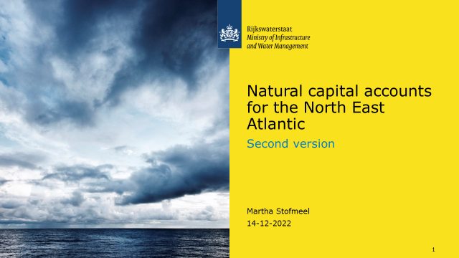

One of the things that Martha has done is updating the ecosystem extent account by using the EUSeaMap2021 with the EUNIS-2019 classification (instead of the EUNIS-2007 classification, what was done in the first version).
For the condition account, Martha will use data from four thematic assessments that are produced for the OSPAR Quality Status Report 2023 and have recently been agreed upon; underwater noise, marine litter, radioactive substances and offshore industry. For these indicators (for example ambient noise) maps were created. If possible, these maps will be overlaid with the map from the extent account to create the condition account. The reason why up until now the focus is mainly on pressures, not really condition indicators, is because the final versions of the thematic assessments on biodiversity related indicators are not agreed upon yet.
In order to analyse what ecosystem services might be relevant to analyse, the list of ecosystem services presented in the report ‘Impacts on ecosystem services due to changes in the state of the environment in the North-East Atlantic Ocean’ by Federico Cornacchia, which was produced as part of the preparations of the OSPAR Quality Status Assessment 2023, will be used as starting point since these ecosystem services were deemed to be important for OSPAR. However, since there are already so many different ecosystem service classifications, it is not very desirable to create another one. Therefore, the ecosystem services and abiotic flows included in the report by Cornacchia will be linked to the CICES classification of ecosystem services. Most of the ecosystem services will probably not be linked to specific ecosystem assets as OSPAR mostly reports for the five OSPAR regions and at the level of specific ecosystems. Ecosystem services for which data will be updated are Aquaculture, Fisheries, Carbon sequestration, and Outdoor recreation. Ecosystem services that will be added are Coastal protection, Water quality regulation, and Visual amenity services. In addition, next to an update of data for the abiotic services Mineral extraction, Wind energy, and Oil and gas extraction, Martha will add information on ‘Mediation of waste, toxics and other nuisances by non-living processes’.

In the discussion the following issues were raised:
- Availability of data may not be homogeneous. How did you deal with non-EU Member States, since they are not in the EUNIS maps? But this question also applies more general, since there are differences in data availability between OSPAR regions; there are some regions such as the North Sea that have detailed and rich data and other parts that are less data rich. One method is by leaving out missing data. That is why the ecosystem map covers ‘only’ 80%. And for the rest, just use available data as much as possible and add more when they become available. And obviously use commonly agreed upon data as much as possible.
- The comment was made that it was nice to see this interactive approach: Netherlands-OSPAR-Netherlands etc.
- Martha uses the CICES classification for ecosystem services. But SEEA-EA uses a list that deviates from CICES. If we would like to consistently apply the SEEA-EA methodology, should we than also use the SEAA-EA list, even though it deviates from the CICES list?
- With respect to fisheries data: ICES may have more spatially explicit information. And values of stocks are likely to vary significantly from one species to another.
- Benefits transfer is not a valuation approach in itself (was suggested in the presentation). The resource rent approach might be the least reliable approach. Especially for fisheries the results may be more questionable than for carbon sequestration. Benefits transfer using resource rent data might be the fastest/easiest approach. But how applicable are e.g. the so-called ‘efficient carbon prices’ that are used in the Netherlands for the rest of the OSPAR area? Maria has used the lower bound to produce conservative estimates.
- For habitat extent and deep-sea environment the data may be severely lacking, this is unfortunate, since deep sea mining is likely to become an increasingly important issue in the coming years. More in general, habitat maps are largely uncertain in the Northeast Atlantic. This applies especially to benthic habitats. Pelagic habitats may not be that important for the calculation of intermediate services beyond their contribution to fisheries. Nevertheless, data availability is an issue. Natural capital accounts can help to prioritize data collection.
- A representative of the OSPAR Secretariat mentions that the integrated bird population indictors, the habitat assessments, and the climate change assessment have been agreed to be published. So, those data can be used. The same applies to the OSPAR QSR assessment on ocean acidification. That could also be relevant for the condition account. This is a separate report from the OSPAR QSR climate change assessment report.
- Main use of natural capital accounts is to see whether marine use is harming the marine environment or not. Biodiversity monitoring is already taking place. What NCA adds, is that it integrates information on biodiversity with (socio) economic data. This means that the focus should be more on biodiversity related indicators.
- ICES has started a working group on linking condition indicators to ecosystem services.
- Whether or not we should build separate pressure accounts? There is not a pressure account included in the SEEA-EA framework yet. For Ocean Accounting, it is foreseen to include pressures (see section 13.5 of SEEA-EA). It will definitively a part of SEEA-Ocean (and possibly the next update of the SEEA-EA framework). Furthermore, GOAP (Global Ocean Accounts Partnership) is doing some work on including pressures now. Maybe, for the time being, it might already be enough if we would select indicators that link to pressures. For example, eutrophication and hazardous substances are important and there is already a lot of data on those (might have to think about how to aggregate indicators though). And swept area ratio or similar could be a good proxy for pressures by bottom trawling fisheries. However, if we would like to use NCA to provide the quantitative information that is used in the Drivers-Activities-Pressures-State-Impact Response (DAPSIR) framework, we need information on the pressures, and thus pressure accounts. At the same time, we need to be careful that we should not try to include everything in the natural capital accounts. Nevertheless, the natural capital accounts can play an important role to provide information for the central part of the DAPSIR framework.

- Potential policy use of natural capital accounts

The second part of the meeting focused on how we can use (these) natural capital accounts to support marine policy decision-making. Wesley van Veggel gave a presentation of his draft report dealing with exactly this issue.

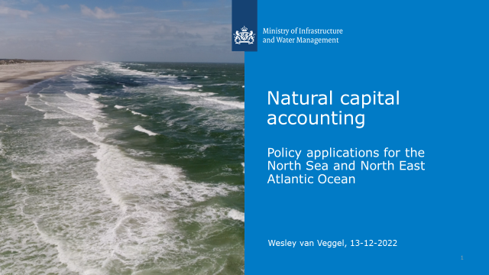

Wesley illustrated that there is a wide international interest in natural capital accounting: The SEEA-EA framework presented above was accepted as international accounting standard by the UN in March 2021. In July 2022 a proposal was made for a new EU Regulation that includes the mandatory provision of natural capital accounts by European member states. And OSPAR, the organisation responsible for coordination of environmental policies in the Northeast Atlantic has included as one of its strategic objectives in the most recent North-East Atlantic Environment Strategy that ‘By 2025 OSPAR will start accounting for ecosystem services and natural capital…’. In addition, there are many international projects on natural capital accounting, including MAIA, GOAP, MAREA, NCAVES, but also the current case study for the Dutch part of the North Sea discussed in yesterday’s meeting, and the current work on the second version of the natural capital accounts for the Northeast Atlantic discussed today. Currently the accounts are mainly supply driven, But how can we actually use this information? If you look at the literature, it appears that natural capital accounting is mainly used for issue identification and monitoring of the state of the marine environment; to establish insights on trade-offs and interactions between marine ecosystems and economy; to provide a communication tool for policy makers to establish the importance of the marine environment and blue economy; to support multidisciplinary communication and cooperation between various stakeholders within (and outside) the government; to combine with other methods such as scenario analysis to provide integrated insight in cost and benefits for environmental decisions; and to serve as data input for other statistical methods that include economic-environmental evaluation. With respect to the possible applications of NCA for OSPAR, natural capital accounts could be used to provide synergies with the DAPSIR framework, add quantitative economic perspective, and track changes over time. In addition, since many countries that are contracting party to OSPAR are also European Member States, many countries will have to implement the European Marine Strategy Framework Directive. Natural capital accounting can support the implementation of the European Marine Strategy Framework Directive by monitoring (changes in) the state of the marine environment (part 1 of the MSFD), focus monitoring to those indicators that are most important to convey the relevant messages and support the realisation of the program of measures (part 2 of the MSFD) and to contribute to cost benefit analyses and evaluate policy responses as part of the program of measures (part 3 of the MSFD). In addition, the Netherlands want to measure welfare beyond GDP (‘Wellbeing Economy’); Natural capital data could serve as data input for the North Sea, even though it does not include social capital and ”future generations”.

Some points raised during the discussion:
- Next to the possible applications mentioned in the presentation by Wesley, natural capital accounts could play an important role in supporting Maritime Spatial Planning, and cost benefit analyses to support biodiversity objectives. In the Irish MPA law, ecosystem services are explicitly mentioned as reason to protect Marine Protected Areas. For this quantitative information is very relevant. For example, robust and reliable information on carbon sequestration would be very valuable.
- With respect to the usefulness of NCA to contribute to the OSPAR objectives: A practical approach would be to apply NCA to regional scale ecosystem management, such as nature based solutions at a smaller scale; not necessarily the entire OSPAR region, but maybe a smaller scale analysis would be useful. For example, quantitative information could be useful to determine where to implement nature based solutions, based on trade-offs between potential economic and ecological consequences. Another possible topic might be offshore renewables. Work on evaluating the cumulative impacts of offshore wind on birds will start soon and also here illustration of the trade-offs might be an interesting application of natural capital accounts at a smaller scale.
- There are some challenges with respect to the potential use of natural capital accounting. An important one is that people are often very eager to have high quality data that we do not yet have. In addition, the spatial resolution of available data is often a challenge (we would like to say something about the condition of a particular ecosystem, but if monitoring data apply to the entire OSPAR area, this is not possible). Another issue is the timeliness; it does take a bit of time before data are processed by statistical offices, therefore published data often refer to a situation 2 years ago, whereas people would like to have more recent data. Another issue is that most applications of natural capital accounts up until now look back, but how can we use them for scenario analyses and cost benefit analyses?
- Having said that, accounting something is more than no accounting at all. Especially given the fact that we are confronted with a triple planetary crisis: Biodiversity loss, pollution, and climate change. Natural capital accounting can support monitoring and decision making in those areas by providing relevant and robust information in a consistent way.
- How to take into account ecological connectivity? We are talking about a dynamic ocean…. For example, the number of porpoises is increasing along the Dutch coast, but decreasing along the UK coast... Therefore, in order to take mobility into account, it is very important to use compatible approaches for the different countries. Biodiversity accounts may offer a solution since they are developed to take better into account (mobile) species and dynamics between ecosystems. (see the MAIA report and the report on the natural capital accounts for the Dutch part of the North Sea, where also a biodiversity account will be published)
- At the moment the SEEA-EA framework is looking at fisheries landings not at stocks. This is a difficult issue. What one could do is to look at changes in stocks. In the ideal situation, one could make a distinction between the causes in changes in stocks: Is it due to less use of the service? Less quality of the services? Or less supply of the service?
- An important lesson from both the UK and The Netherlands is that, in order to get policy makers involved, it is important to have policy makers involved right from the start and talk easily understandable language.
- It may be more important to prepare more complete accounts. Repeating available information is easy, but not very useful. It is therefore important to show how natural capital accounts can help to support various policies and thus be useful for different people. Tie in desire to work on policy application to support ecosystem-based management. Therefore, it is important for the people working on the natural capital accounts for the OSPAR region (and the OSPAR ICG ESA) to have close relations with the various thematic groups when preparing the next NCA; not only present the results at the end, but really close collaboration, so that it will become shared ownership. However, this would require far more significant capacity than currently available (students who work on this for a 6 months internship assignment). Maybe the SELINA project (follow up of the MAIA project) could be an option, or a separate Horizon 2020 project?

Closing words and next steps

Maria, Martha, Wesley and Rob thanked all the participants for their active contributions to the workshop. It has been very interesting and informative. The main objectives of today’s meeting was to share information on natural capital accounting for the North Sea, and to discuss the potential way ahead. The results of this workshop will be used by Martha and Wesley to finalize their reports, which are due early 2023. The participants of the workshop will be informed when the reports are published and where they can be downloaded.

The presentations by Maria, Martha and Wesley are sent as separate attachments.

