Last updated April 2021

North Sea Manual on Maritime Pollution Offences

Table of Contents

Revisions 4
Part I: Introduction and Background 5
Chapter 1: Introduction 5
Section 1.1: Purpose of this Manual 5
Section 1.2: Development of this Manual 6
Chapter 2: Oil Pollution and its Significance 7
Section 2.1: Oil spills 7
Causes 7
Consequences of oil spills at sea 7
Section 2.2: Behaviour of spilled oil 8
Section 2.3: Operational strategies 10
Part II: The Legal and Organisational Framework 11
Chapter 3: International Law 11
Section 3.1: Equipment and discharge regulations in MARPOL 11
Introduction 11
Regulations dealing with equipment 12
Discharge regulations in Annex I 12
MARPOL ANNEX V – Regulations for the Prevention of Pollution by Garbage from Ships 22
MARPOL ANNEX VI - Prevention of Air Pollution from Ships 33
Introduction 33
General 33
Survey, certification and means of control 33
International Air Pollution Prevention Certificate 33
International Energy Efficiency Certificate 34
Requirements for control of emissions from ships 35
Ozone-depleting substances: 35
Nitrogen oxides (NO_{x}) 36
Sulphur oxides (SO_{x}) and particulate matter 37
Carriage ban 38
Volatile Organic Compounds 38
Shipboard incineration 38
Regulations on energy efficiency for ships 39
Section 3.2: Instruments for cooperation in the field of prosecuting illegal maritime pollution 41
Introduction 41
MARPOL 41
UNCLOS 42
Instruments relating to Port State Control 45
European Conventions on international legal assistance in criminal matters 47
ANNEX 1 to Chapter 3 52
Chapter 4: National Law 56
Section 4.1: Belgium 56
Introductory note 56
Section 4.2: Denmark 58
Section 4.3: France 61
Offences 61
Ships and areas 62
Those liable and the penalties 62
Significant features of the enforcement and prosecution processes 66
Section 4.4: Germany 67
Offences 67
Ships and areas 68
Those liable and the penalties 69
Significant features of the enforcement and prosecution processes 70
Section 4.5: Ireland 70
Offences 70
Ships and areas 71
Those liable and the penalties 71
Section 4.6: The Netherlands 72
Offences 72
Introductory note 72
Offences 72
Ships and areas 72
Significant features of the enforcement and prosecution processes 73
Liability and Penalties 73
Section 4.7: Norway 74
Legislation 74
Jurisdiction 74
Offences 74
Significant features of the enforcement 75
Surrender agreement between the EU and Norway and Iceland 75
Section 4.8: Sweden 76
Offences 76
Ships and areas 76
Those liable and the penalties 76
Significant features of the enforcement and prosecution processes 77
Need for Swedish legal assistance? 77
Section 4.9: The United Kingdom 77
Offences 78
Ships and areas 78
Those liable and the penalties 79
Significant features of the enforcement and prosecution processes 79
Chapter 5: Gathering and Presenting Evidence 81
The nature of the offence and the evidence needed 81
Absolute offences and other offences 81
Other issues to be covered in the chapter 81
Annex A to Chapter 5 84
Request for Initial Information and Summary Report 84
Part III: Means of Securing Evidence 88
Chapter 6: Visual Observation 88
Section 6.1: Introduction 88
Section 6.2: Appearance of oil spills 88
Section 6.3: Observations as evidence of violations of MARPOL 91
Discharges from cargo tanks of oil tankers 91
Section 6.4: Assessment of oil quantity 92
Section 6.5: Reporting visual observation 93
Chapter 7: Remote Sensing 101
Section 7.1: Features and operational capabilities 101
Data presentation and management console 104
Data documentation and transmission 104
Calibration 105
Section 7.2: Brief description of sensors 105
General 105
Photographic camera systems 106
Video Cameras 107
Side-looking airborne radar (SLAR) 107
Infrared/ultraviolet (IR/UV) scanner 108
Synthetic-aperture radar (SAR) 110
Section 7.3: Satellite surveillance 110
Section 7.4: Documenting remote-sensing results 111
Chapter 8: Modelling the Behaviour of Spilt Oil 112
Section 8.1: Introduction 112
Section 8.2: Backtracking 113
Chapter 9: Sampling and Analysis 114
Chapter 10: Vessel Identification 118
Section 10.1: Automatic Identification Systems 118
Section 10.2: Use in surveillance 118
Section 10.3: Recording of identification 118

Revisions
Year | Section | Changes
2021 | 3.18 – 3.24 | Revised MARPOL Annex II
2021 | Table II, p18 | Washings containing Marpol Annex II Category “Y” substances
2021 | 3.26 – 3/44 | New MARPOL Annex V Chapter
2023 |  | New MARPOL Annex VI Chapter

Part I: Introduction and Background
The purpose of this manual is to support the detection of maritime pollution offences, the collection of evidence about such offences and the imposition of penalties on those responsible for them, thereby helping to deter further offences and improving the marine environment. As background, this section also sets out the effects of marine oil pollution.
This manual was jointly developed by the North Sea Network of Investigators and Prosecutors (NSN), a body associated with the OSPAR Commission, and the Agreement for cooperation in dealing with pollution of the North Sea by oil and other harmful substances, 1983 (Bonn Agreement). This manual is a living document and will continuously be updated and further developed by NSN and the Bonn Agreement in order to take into account legal, political and technical developments in the field of maritime oil pollution offences.

Chapter 1: Introduction
This chapter sets out the aims of this manual and the way in which it has been developed

Section 1.1: Purpose of this Manual
1.1 It is more than forty years since the international community first adopted international rules and standards to protect the marine environment against pollution from ships. This was achieved by the 1973 International Convention on the Prevention of Pollution from Ships, which was completed and adjusted to ensure entry into force by the 1978 Protocol to it - the two instruments together being known as MARPOL. Since then the international rules and standards set out in MARPOL have been extended, improved and strengthened on many occasions.
1.2 But the best of legislation will have no impact on the real world unless it is implemented and enforced. There is still much room for improvement in the implementation and enforcement of MARPOL. This manual is intended to assist in this process in the North Sea Area – the waters covered by the Bonn Agreement. It is also hoped that the experience described in the Manual will be helpful to other States.
1.3 The Manual is addressed, in the first place, to the national enforcement agencies concerned with implementing international rules and standards against oil pollution from ships, and the national legislation applying them. To achieve their purpose, this legislation must be effectively enforced. It is therefore essential that ships which contravene the legislation by illegally discharging materials are detected, prosecuted and convicted. Shipping is an international business and the North Sea Area covers some of the busiest shipping routes in the world. A pollution incident may affect more than one country. For example, a vessel may discharge an illegal quantity of oil in the exclusive economic zone (or equivalent area of jurisdiction) of one State whilst en-route between ports in two other countries. Cooperation between neighbouring States is therefore essential, and effective cooperation requires a common understanding of what is involved. This manual therefore aims to set out a common understanding of the impacts of oil pollution, how evidence of maritime pollution offences can be gathered, and the reliability of the methods used.
1.4 The Manual is also addressed to those involved in the processes of bringing offenders to justice - prosecutors, defence lawyers and magistrates and judges. For them, it is intended to provide an internationally agreed statement of the significance of maritime pollution offences and of good practice in assembling, presenting and evaluating evidence on such offences. Since violations of the regulations on maritime pollution offences can cause serious environmental damage, and lead to heavy costs for combating the oil spills and clearing up the damage, it is essential that appropriate action is taken against the violators. This Manual is intended to support such action.

Section 1.2: Development of this Manual
1.5 At the third International Conference on the Protection of the North Sea in the Hague in 1990, the Ministers and EC Commissioner decided that common actions should be taken at national and international level in order to improve the effectiveness of prosecution for violations of the international rules and standards established by MARPOL, and the associated collection of evidence.
1.6 As a first step, Ministers invited the Contracting Parties to the Bonn Agreement to produce a Manual explaining the systems of airborne surveillance and other methods used for identifying offenders and for obtaining evidence. The Manual "Oil Pollution At Sea - Securing Evidence on Discharges from Ships" was published in 1993 by the Bonn Agreement and was disseminated worldwide through the International Maritime Organization. The Manual was addressed to authorities in charge of detecting violations, police officers, prosecutors, defence lawyers and courts in order to explain how evidence can be gathered and to indicate the reliability of the methods used. It was intended to facilitate the common understanding of the methods used for those who are not familiar with the technicalities.
1.7 Taking into account the progress made in the establishment of exclusive economic zones (EEZ), the Ministers at the Fourth International Conference for the Protection of the North Sea in Esbjerg 1993 agreed as a second step to develop common procedures with the aim of facilitating, in a harmonised way, the rendering of assistance and the admissibility of different forms of evidence and co-operation between the North Sea States. To achieve this facilitation, the Contracting Parties to the Bonn Agreement agreed to develop guidelines for personnel engaged in securing or gathering evidence as a complement to the original Manual. These guidelines were published in 1999 as the Manual "Oil Pollution at Sea - Part 2: Effective Prosecution of Offenders - Guidelines on International Co-operation".
1.8 In 2002, the Fifth North Sea Conference, held in Bergen, Norway, returned to the issue. Although the progress that had been made was recognised, the Ministers recognised that further action was needed, both internationally and nationally, in order to prevent pollution from shipping activities in the North Sea. Accordingly, they agreed to take initiatives to create a network of investigators and prosecutors to improve understanding and cooperation in the different stages of the enforcement process, and urged all North Sea States to ensure that the investigators, prosecutors and others involved in the enforcement process in their systems are aware of each other's requirements.
1.9 With Sweden as host, the North Sea Network of Investigators and Prosecutors (the North Sea Network) was established in 2002, supported by the OSPAR Secretariat. Their annual meetings have served to improve mutual understanding and cooperation. The Contracting Parties to the Bonn Agreement and the North Sea Network have collaborated to integrate, revise and update the two parts of the Manual "Oil Pollution at Sea" into this Manual.

Chapter 2: Oil Pollution and its Significance
This chapter provides general information on oil spills, their behaviour and effects, including an explanation of the weathering process. It also outlines the operational strategy for dealing with oil pollution at sea and on the coasts.

Section 2.1: Oil spills

Causes
2.1 The North Sea contains some of the busiest shipping routes in the world: nearly 600,000 ship movements a year take place into, and out of, the 50 main ports around the North Sea. On average, more than 400 ships a day pass through the Straits of Dover and, at the same time, 600 ships cross those straits, including 200 ferries.
2.2 This shipping activity is rapidly increasing: container traffic increased by 120% in the 1990s, and is still increasing. Bulk carriage of oil and chemicals is likewise expected to continue increasing, particularly from the expected development of oil traffic from the Siberian pipeline terminal at Murmansk which will result in substantial traffic to Rotterdam and through the western part of the North Sea Area to the rest of the world.
2.3 All this activity gives rise to spills of oil. Some of these spills are the result of maritime accidents: collisions or shipwrecks which lead to the spilling of the oil on board the vessels involved, either fuel oil (bunkers) or lubricating oil for the ship itself or oil cargoes. Many of these maritime accidents result in acute pollution – the “black tides” (marées noires) as they are called in French. These acute incidents can result in massive oil spills: in 1993, the wreck of the Braer resulted in the release of 86 300 tonnes of oil.
2.4 At the same time, discharges of oil and oily wastes as part of the operations of the vessels often result in chronic oil pollution. Aerial observations in the North Sea Area detect oil spills resulting from such discharges in over 130 cases a year. And these are only the cases that are detected.
2.5 The offshore oil and gas industry also produces oil spills from offshore installations. In 2013, 15 spills of more than 1 tonne of oil were reported as well as 469 spills below 1 tonne resulting in a total of 135 tonnes of oil spilled. In addition, large quantities of oil are discharged in produced water (the water produced from oil and gas wells alongside the oil and gas). This is usually at low concentrations (in most cases below 30 parts per million, and rarely above 40 parts per million). Nevertheless, in 2013, 3 951 tonnes were discharged in this way.

Consequences of oil spills at sea
2.6 Oil spilled at sea threatens the environment. Resources at risk include ecologically important areas, fisheries, areas of outstanding natural beauty, industrial installations and areas used for recreation and tourism. An oil spill can present an immediate hazard by causing damage and death to birds and marine mammals and by exerting a toxic stress on subsurface organisms. Oil dissolved in the water is quickly dispersed to concentrations below the acute toxicity level but it can be taken up by organisms and affect their physiology, behaviour, reproductive potential and survival. Oil may also be transferred to the sediment, where it might persist for many years and impact on organisms on and in the sea bed (benthos).
2.7 Once oil arrives in inshore waters and starts to come ashore, its potential to cause damage is much wider. Should oil be spilt or drift into an estuary it can pose particular problems due to the shallow waters, high levels of sediment in the water (which can absorb the oil) and the presence of vulnerable mud flats and salt marshes. In archipelago and wetland areas the spill, as a rule, leads to very high costs for combating the clean-up measures.
2.8 Oil on tidal flats leading to the death of a large number of benthic organisms and to habitat deterioration can result in both short and long term damage. The reduction in the quantity of food (benthic organisms) and changes in the food composition may have effects on the size of the population of fish, shellfish, birds and seals. For each group of organisms there are different danger periods: the spring season for breeding birds and fish larvae, summer for benthic organisms and seals and winter for migratory or wintering birds.
2.9 Oil pollution – particularly chronic oil pollution – is a significant cause of death among seabirds. The measures that have been taken to reduce it have been successful in the North Sea – the proportion of dead guillemots polluted by oil has dropped by 50% since surveys started in the 1970s. Nevertheless, in the areas of the North Sea near the major shipping routes, the proportions of deaths of guillemots where oil pollution is a cause, or a contributory cause, is still over 10%.

Section 2.2: Behaviour of spilled oil
Development and behaviour of oil slicks
2.10 The behaviour of spilt oil is illustrated in figure 2.1.
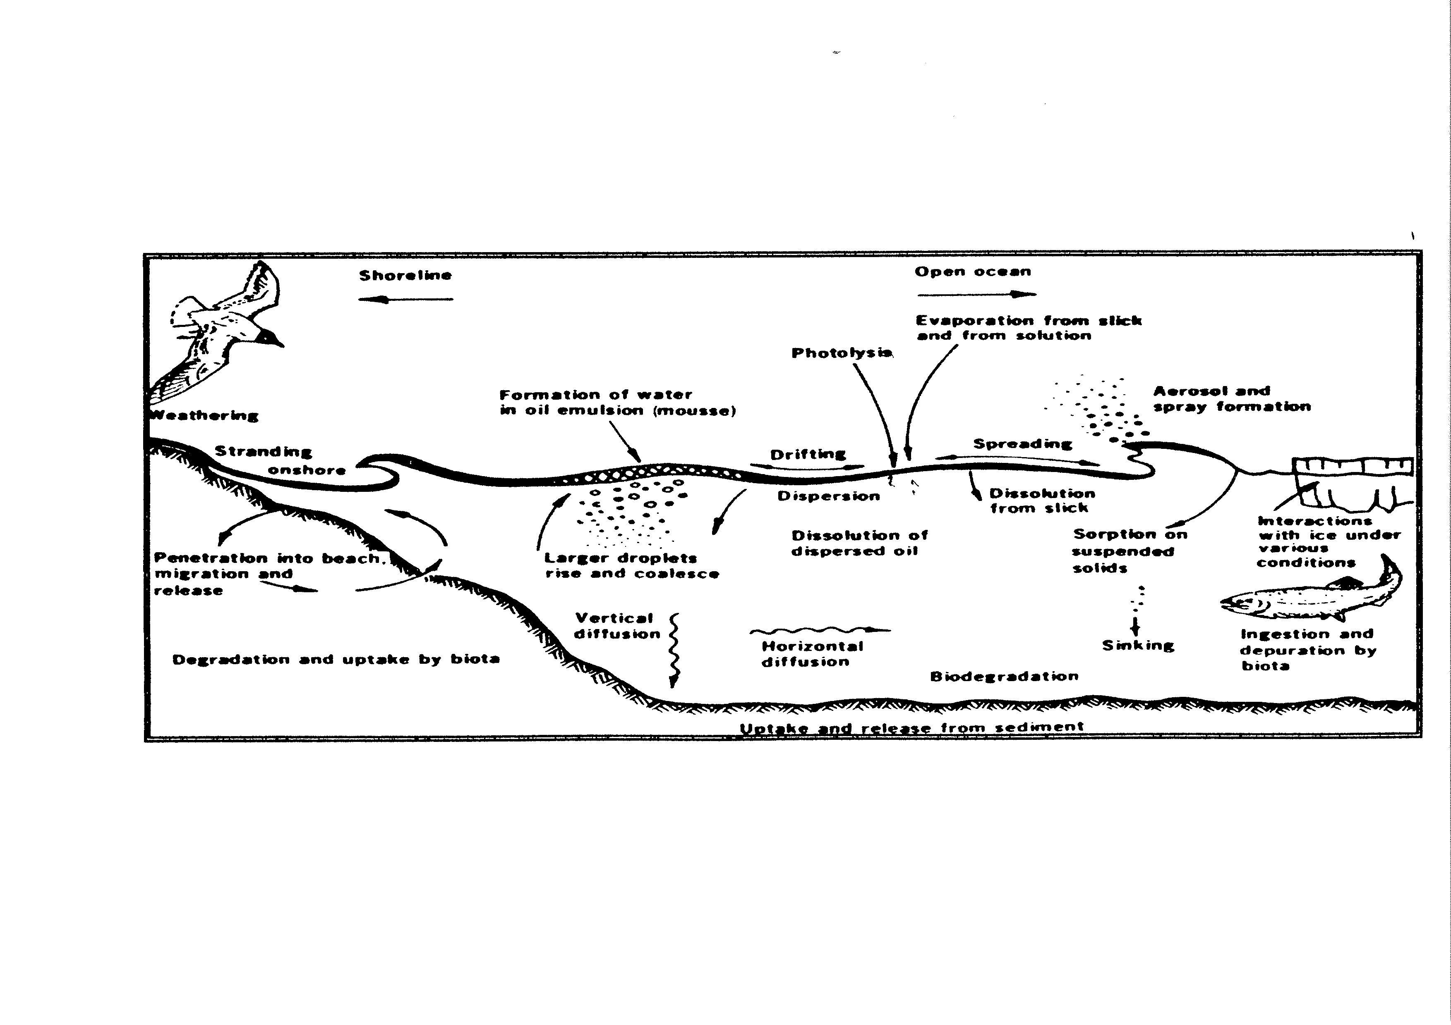
Figure 2.1: Processes taking place after an oil spill
2.11 Oil spilt on the sea surface will immediately spread. The oil will, due to its physical and chemical properties as well as external conditions, spread in an unpredictable way, resulting in an inhomogeneous spill (slick) consisting of thick patches and lumps interspersed with a thin oil film. The shape of the spill is largely determined by wind, waves and current.
2.12 The oil slick will then drift. The way an oil slick drifts at sea is determined by the following environmental factors:
a. sea current speed and direction (including tides);
b. wind speed and direction;
c. wave pattern.
The current moves the spill with the water. In the absence of wind the oil normally moves at the same speed and in the same direction as the current. However, the movement of the oil is also affected by the wind, at a speed estimated as a few percent of the wind speed.
2.13 Waves are less important as they do not induce any considerable net movement of the oil spill. They are more important for the spreading and weathering processes.
2.14 Oil spilt into the sea will be affected by a number of weathering processes. As the oil spreads, the evaporation rate increases but the speed and extent of evaporation will vary considerably depending upon its composition. Light oils, like gasoline or light fuel oil, evaporate very quickly (50% within a few hours) while heavy oils evaporate more slowly. Evaporation is also affected by wind speed and temperature, the higher the wind speed and temperature the faster the evaporation.
2.15 The process of vertical dispersion and re-dispersion plays an important part in the dissolution of oil into the sea. In rough weather a significant proportion of the oil on the surface of the sea will be dispersed into the water column, mostly due to the breaking of waves. The dispersed oil droplets will tend to resurface or be re-dispersed due to buoyancy forces: large droplets will quickly resurface, whereas smaller droplets can be transported by the water current far away from the point of spillage and remain dispersed for weeks. When the oil attaches to or forms particles with a density exceeding that of water it may sink to the bottom of the sea in a process called sedimentation.
2.16 A further important weathering process is the emulsification of the slick, for example, the incorporation of water into the oil, thus changing the properties of the oil and the amount present on the sea surface. The water content of these emulsions, which are often known as chocolate mousse, can reach a level of up to 80-90%. Wind conditions and the viscosity of the oil are the most important factors governing the formation of emulsions which can result in an oil spill volume double that of the spilt volume five days after the spillage.
2.17 The sun’s rays change the properties of oil on the sea surface by means of photo-oxidation. This increases the spreading and stabilises the formation of emulsion.
Biodegradation
2.18 Oil spills are also subject to biodegradation, an extremely slow process but one which is important in the long run. However not all components of the oil can be degraded by micro-organisms.
2.19 An illustration of the time span and relative importance of the various processes described above is shown in figure 2.2.

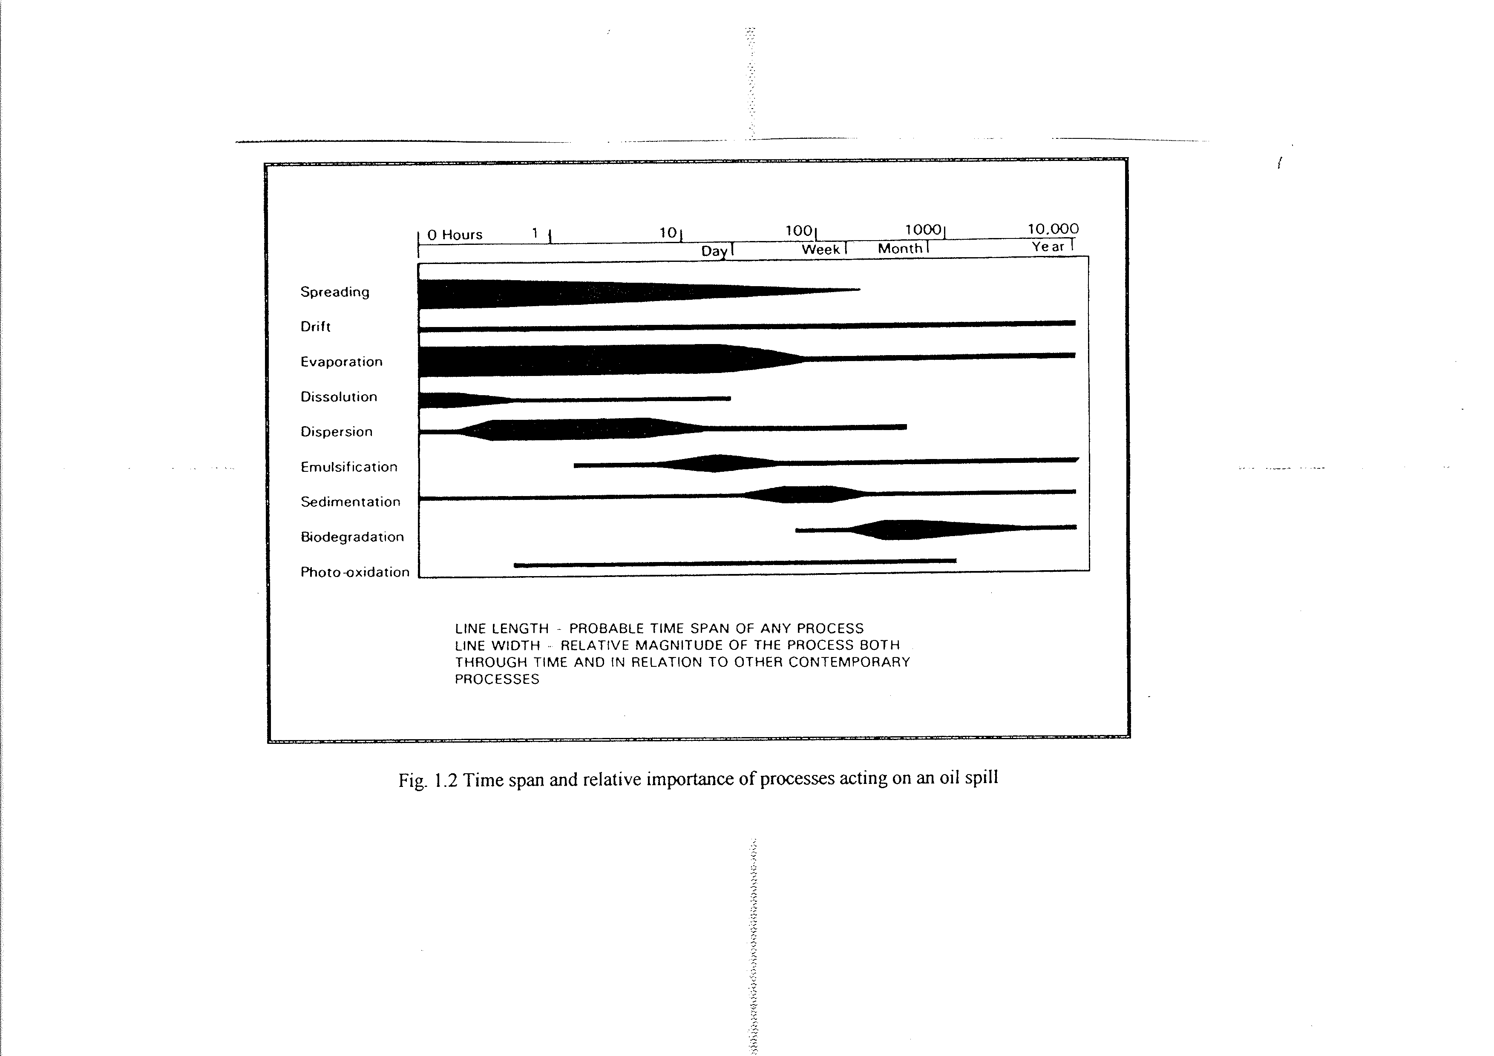
Figure 2.2: Time span and relative importance of processes acting on an oil spill

Section 2.3: Operational strategies
2.20 The operational strategy to deal with oil pollution at sea has two components:
a. a surveillance strategy to detect and identify spillages, document the discharge and identify the polluter;
b. a contingency plan to deal with the spilt oil: this covers determination of responsibilities, lines of command, lines of communication, location and content of stocks of equipment and available combating options. The main issues to be specified in the contingency plan are specified in the International Convention on Oil Pollution Preparedness and Response (OPRC).
2.21 The response action to minimize damage to the environment and reduce costs as much as possible is beyond the scope of this Manual.
2.22 As part of the surveillance strategy, evidence is gathered either to establish the basis for civil liability or to start legal proceedings against a violator of the MARPOL rules described in Chapter 3. This may involve a number of techniques such as:
a. inspection of the suspected pollution source;
b. visual observation of the spill;
c. remote sensing (aerial surveillance and satellite images);
d. spreading and drift models (back-tracking);
e. sampling and analysis.
Part II: The Legal and Organisational Framework
This part sets out the international rules and standards and the way in which they have been incorporated into the national laws of the States in the North Sea Area.

Chapter 3: International Law
This Chapter sets out the framework within which regional and national arrangements must work. This Chapter is subdivided in two main parts. The first part deals with the equipment and discharge regulations in MARPOL. The second part gives an overview of the legal instruments for cooperation in the field of prosecuting illegal maritime pollution.

Section 3.1: Equipment and discharge regulations in MARPOL

Introduction
3.1 The international regulations relating to the construction and operation of ships are contained in conventions established under the auspices of the International Maritime Organization (IMO), a specialised agency within the United Nations system. IMO is also in charge of the follow-up to such Conventions, assisting in their implementation by Member States and developing guidelines, recommendations etc.
3.2 The principal regulations relating to the construction of ships are contained in the Convention on the Safety of Life at Sea (SOLAS 74). This is not primarily concerned with pollution prevention.
3.3 The "International Convention for the Prevention of Pollution from Ships, 1973, as amended by the Protocol of 1978 thereto" (MARPOL) is aimed at minimising and eliminating pollution from ships. It covers two main subjects:
a. the special construction and equipment rules for the prevention of accidental pollution;
b. the circumstances in which discharges in the sea are authorised.
3.4 Each Contracting Party to MARPOL is obliged to incorporate the regulations in its national legislation, including provisions for prosecution of any discharge above legal limits. The regulations are different depending on whether the sea area has been declared a "Special Area" or not.
3.5 Specific sources of pollution are dealt with in the Annexes:
 |  | (date of entry into force)
Annex I - | oil | 2 October 1983
Annex II - | noxious liquid substances carried in bulk | 2 October 1983
Annex III - | harmful substances carried in packaged form | 1 July 1992
Annex IV - | sewage | 27 September 2003
Annex V - | garbage produced by ships | 31 December 1988
Annex VI - | air pollution from ships | 19 May 2005
3.6 Although the enforcement provisions described in section 3.2 apply for breaches of regulations of all annexes to MARPOL, only the relevant regulations in Annex I for the prevention of pollution by oil are described below. The summary of status of conventions on the IMO website (see section 3.2) shows that, as regards Annex I/II of MARPOL, the MARPOL Contracting Parties represented some 97 % of the total world ship tonnage at the end of 2003.

Regulations dealing with equipment
3.7 Although these regulations are mainly outside the scope of this document it is important to highlight the fact that ships built and equipped in accordance with the Convention are able to comply with the discharge regulations dealt with hereafter. For instance, as regards oil, there are two important Regulations in Annex I to the Convention which detail the required equipment.
3.8 Regulation 15 describes the equipment with which oil tankers shall be provided including:
a. oil discharge monitoring and control systems fitted with a recording device to provide a continuous record of the discharge in litres per nautical mile and the total quantity discharged, or the oil content and rate of discharge. The system shall be such as to ensure that any discharge of an oily mixture is automatically stopped when the permitted discharge rate is exceeded;
b. adequate means for cleaning cargo tanks and transferring dirty ballast residues and tank washings from the cargo tanks to slop tanks; and
c. arrangements for slop tanks with a capacity sufficient to retain the slop generated by tank washings, oil residues and dirty ballast residues.
3.9 Regulation 16 contains similar regulations for the equipment dealing with oil or oily mixtures on board ships which is not carried as cargo but as fuel. These ships must be fitted with oily water separating equipment which will ensure that any oily mixture discharged into the sea after passing through the system has an oil content below the limit indicated in the tables below (I, II and III).
3.10 Compliance with the Regulations will avoid discharges above legal limits. It follows that any discharge above legal limits will be the result either of an equipment failure (and as such "clear grounds" for thorough inspection in the next port of call) or a deliberate act. Any discharge or failure of the "oil discharge monitoring and control system" should be entered in the "Oil Record Book", which has to be carried on board ship.

Discharge regulations in Annex I
3.11 For the purpose of Annex I, ”Oil” is generally defined as petroleum in any form including crude oil, fuel oil, sludge, oil refuse and refined products (other than petrochemicals subject to provisions of Annex II); a more detailed list of oils can be found in Appendix I of Annex I.
3.12 The oil discharge regulations in the Convention apply differently depending on whether or not the sea area has been designated a “special area” (see Regulation 11 in Annex 1 below). These regulations do however not apply:
a. if the discharge is for the purpose of securing the safety of the ship, or saving life at sea, or
b. if the discharge is the result of accidental damage to the ship or its equipment – except if the damage and discharge is caused by negligence, intent or reckless behaviour.
3.13 “Special areas” for oil are:
1. The Mediterranean Sea area
2. the Baltic Sea area
3. the Black Sea area
4. the Red Sea area
5. the Gulfs area
6. the Gulf of Aden area
7. the Antarctic area
8. the North-West European Waters (incl. the North Sea and its approaches, the Irish Sea and its approaches, the Celtic Sea, the English Channel and its approaches and part of the North-East Atlantic immediately to the west of Ireland)
9. the Oman area of the Arabian Sea;
10. Southern South African waters.
3.14 Special area status is in force for all these areas.
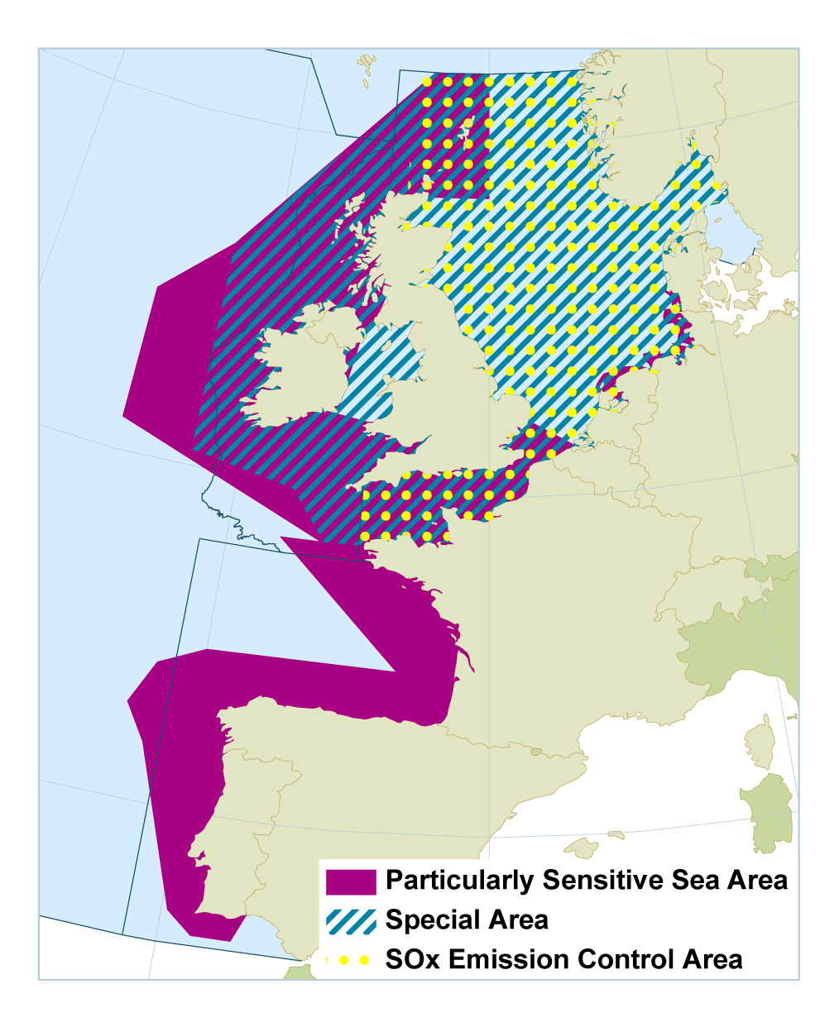
Fig. 3.1: Particularly Sensitive Sea Areas, Special Areas under MARPOL and SOx Emission Control Areas in the North-East Atlantic OSPAR Maritime Area Source: OSPAR 2009, JAMP Assessment on shipping, Publication no. 440, ISBN 978-1-906840-80-8

3.15 Table I, II and III below describe the discharge regulations in Annex I of MARPOL (as summarized from MARPOL consolidated edition 2011). Oil residues (sludge) which cannot be discharged into the sea in compliance with the regulations summarized in Tables I, II and III, have to be retained on board or discharged to reception facilities. MARPOL imposes on Parties a duty to establish reception facilities in their ports so that ships can discharge the residues that they are not allowed to discharge in the sea. It is however to be noted that, in some areas of the world, such facilities are not available and ships may then have difficulty in discharging their residues on land.

TABLE I
OIL TANKERS OF ALL SIZES
Oil discharge from cargo tank areas, including pump-room
Within special areas  (Regulation 34) | DISCHARGES PROHIBITED  Except clean or segregated ballast
Outside special areas  Regulation 34) | DISCHARGES PROHIBITED  Except clean or segregated ballast,  or  except when:  - tanker is more than 50 nautical miles from the nearest land, and  - tanker is proceeding en route, and  - instantaneous rate of oil discharge does not exceed 30 litres per NM, and  - total quantity of oil discharged does not exceed:  - 1/15 000 for tankers delivered on or before 31/12/1979;  - 1/30 000 for tankers delivered after 31/12/1979;  - of the total quantity of the particular cargo of which the residue formed a part, and  5. tanker has in operation an oil discharge monitoring and control system and slop tank arrangement as per Regulations 29 and 31

TABLE II
OIL TANKERS OF ALL SIZES and OTHER SHIPS ≥ 400 GRT
Oil discharge from machinery spaces
Within special areas  (Regulation 15B) | OIL DISCHARGES PROHIBITED, except when:  1. ship is proceeding en route, and  2. the oily mixture is processed through oil filtering equipment meeting the requirements of Regulation 14.7, provided with alarm arrangements and an automatic 15 parts-per-million stopping device, and  3. oil in the effluent without dilution does not exceed 15 part per million, and  4. bilge water does not originate from cargo pump-room bilges on oil tankers  5. the oily mixture, in the case of oil tankers, is not mixed with cargo oil residues.  Note: In respect of the Antarctic area, any discharge into the sea of oil or oily mixtures from any ship shall be prohibited.
Outside special areas  (Regulation 15A) | OIL DISCHARGES PROHIBITED, except when:  1. the ship is proceeding en route, and  2. the oily mixture is processed through oil filtering equipment meeting the requirements of Regulation 14, and  3. oil in the effluent without dilution does not exceed 15 parts per million, and  4. bilge water does not originate from cargo pump-room bilges on oil tankers; and  5. the oily mixture, in the case of oil tankers, is not mixed with cargo oil residues.  Note: Any ship of 10,000 GRT and above shall be fitted with oil filtering equipment meeting the requirements of regulation 14.7 (alarm arrangements and automatic stopping device).
TABLE III
SHIPS < 400 GRT OTHER THAN OIL TANKERS
oil discharges from machinery spaces
All areas except the Antarctic area  (Regulation 15 C) | OIL DISCHARGES PROHIBITED except when:  - the ship is proceeding en route, and  - the ship has in operation equipment of a design approved by the Administration that ensures that the oil content of the effluent without dilution does not exceed 15 parts per million  - bilge water does not originate from cargo pump-room bilges on oil tankers, and  - the oily mixture in the case of oil tankers is not mixed with cargo oil residues.  except when oil in effluent without dilution does not exceed 15 parts per million (this condition however does not apply for the Antarctic area).
Antarctic area  (Regulation 15 C) | OIL (MIXTURE) DISCHARGES PROHIBITED

General notes (Regulation 15 D):
1. No discharge into the sea shall contain chemicals or other substances in quantities or concentrations which are hazardous to the marine environment or chemicals or other substances introduced for the purpose of circumventing the conditions of discharges specified in Regulation 15;
2. The oil residues which cannot be discharged into the sea in compliance with Regulation 15 shall be retained on board for subsequent discharge to reception facilities.

Discharge regulations in Annex II

3.16 Regulations for the control of pollution by Noxious Liquid Substances in bulk are set out in Annex II to the Marpol Convention. ”Noxious Liquid Substances” are generally defined as any substances indicated in the Pollution Category column (c) of chapter 17 or 18 of the International Bulk chemical code (IBC code) or provisionally assessed under the provisions of regulation 6.3 as falling into category X, Y or Z. Provisional categorization of liquid substances are listed in the MEPC.2/Circular which will be updated yearly. Noxious Liquid substances are, in respect to marine resources or human health, divided into 4 categories, as follows:

Category X : major hazard
Category Y : hazard
Category Z : minor hazard
Category OS : no hazard
3.17 Noxious Liquid Substances are generally shipped by chemical tankers, combined chemical and oil tankers or product tankers. It should generally be noted that for ships carrying Noxious Liquid Substances a Certificate of fitness should be issued and the shipped cargoes should be mentioned on the ship’s NLS list of products attached to the Certificate of Fitness.
3.18 The discharge regulations of Noxious Liquid Substances depends on the type of category of the substance and whether the substance is solidifying, high-viscose or persistent floater.

3.19 Solidifying substance means a Noxious Liquid Substances which:
- In case of a substance with a melting point of less than 15°C at a temperature of less than 5° above its melting point at the time of unloading;
- In case of a substance with a melting point of equal to or greater than 15°C at a temperature of less than 10° above its melting point at the time of unloading;
3.20 High-viscosity substance means a Noxious Liquid Substances in category X or Y with a viscosity equal to or greater than 50 mPa.s at the unloading temperature.

3.21 Persistent floater means a slick forming substance with the following properties:
- Density: ≤ sea water (1025 kg/m3 at 20°C);
- Vapour pressure: ≤ 0.3 kPa;
- Solubility: ≤ 0.1% (for liquids) ≤ 10% (for solids); and
- Kinematic viscosity: > 10 cSt at 20°C."

3.22 Information regarding melting point, viscosity can be obtained from:
- column (o) of chapter 17 of the IBC code (16.2.6 / 16.2.9)
- Shipping document as required by Regulation 16.2.2. IBC code

3.23 Information regarding unloading temperature can be obtained from:
- Ullage report undersigned by Surveyor
- Dedicated document reflecting unloading temperature
- Electronic or digital information from ship
3.24 Information regarding persistent floaters can be obtained from :
- column (o) of chapter 17 of the IBC code (16.2.7)
- Shipping document as required by Regulation 16.2.2. IBC code
Notes:
- When column (o) in the table of chapter 17 IBC code refers to 16.2.6, the cargo’s viscosity at 20°C shall be specified on a shipping document. And if the cargo’s viscosity exceeds 50 mPa.s at 20°C, the temperature at which the cargo has a viscosity of 50 mPa.s shall be specified in the shipping document;
- When column (o) in the table of chapter 17 IBC code refers to 16.2.9, the cargo’s melting point shall be indicated in the shipping document
- When column (o) in the table of chapter 17 IBC code refers to 16.2.7, the substance can be considered as persistent floater.
- When other medium than water is used for tank washing, the medium shall be equal as it was cargo.

3.25 Tables I, II, III and VI below describe the discharge regulations in Annex II of MARPOL (as summarized from MARPOL consolidated edition 2011). The discharge of Noxious Liquid Substances shall be prohibited. Washings containing residues of Noxious Liquid Substances which cannot be discharged into the sea in compliance with the regulations summarized in Tables I, II, III and VI have to be retained on board or discharged to reception facilities.
Note: In the Antarctic area any discharge of Noxious Liquid Substances or mixtures containing such substances is prohibited.

TABLE I
Washings containing Marpol Annex II Category “X” substances
All areas except the Antarctic area | Stripping requirements according to P&A Manual:  - New ships after 1-1-2007: max 75 litres per tank  - IBC ships until 1-1-2007: max 150 litres per tank
All areas except the Antarctic area | DISCHARGE OF WASHINGS INTO THE SEA IS PROHIBITED  Mandatory pre wash in port with discharge to port reception facility  Until concentration NLS is below 0.1% of weight
All areas except the Antarctic area | Any water subsequently introduced into the tank may be discharged into the sea, under the following conditions:  - The ship is proceeding en route at a speed of at least 7 knots;  - The discharge is made below waterline through underwater discharge outlet(s);  - The discharge is made at a distance of not less than 12 nautical miles from nearest land;  - The discharge is made in a water depth of not less than 25 m (chart depth).
All areas except the Antarctic area | Solidifying or high-viscous “X” substances:  Mandatory pre wash as above.
Antarctic area | Discharge PROHIBITED

TABLE II
Washings containing Marpol Annex II Category “Y” substances
All areas except the Antarctic area | Stripping requirements according to P&A Manual:  1. New ships after 1-1-2007: max 75 litres per tank  2. IBC ships until 1-1-2007: max 150 litres per tank
All areas except the Antarctic area | DISCHARGE OF WASHINGS INTO THE SEA IS PROHIBITED, unless:  - The ship is proceeding en route at a speed of at least 7 knots;  - The discharge is made below waterline through underwater discharge outlet(s);  - The discharge is made at a distance of not less than 12 nautical miles from nearest land;  - The discharge is made in a water depth of not less than 25 m (chart depth).
All areas except the Antarctic area | Solidifying or high-viscose “Y” substances:  Mandatory pre wash similar as “X”  Any water subsequently introduced into the tank may be discharged into the sea, under the conditions mentioned above.
All areas except the Antarctic area | Persistent floaters “Y” substances  Persistent floaters with a viscosity equal to or greater than 50 mPa.s at 20ºC and/or  a melting point equal to or greater than 0ºC,  shall be treated as solidifying or high-viscosity substances for the purposes of the prewash.  Applicable for the following areas:  - North West European waters ( include the North Sea and its approaches, the Irish Sea and its approaches, the Celtic Sea, the English Channel and its approaches and part of the North East Atlantic immediately to the west of Ireland);  - Baltic Sea area;  - Western European waters (area that covers the United Kingdom, Ireland, Belgium, France, Spain and Portugal, from the Shetland Islands in the North to Cape S. Vicente in the South, and the English Channel and its approaches);  - Norwegian Sea
Antarctic area | Discharge PROHIBITED

TABLE III
Washings containing Marpol Annex II Category “Z” substances
All areas except the Antarctic area | Stripping requirements according to P&A Manual:  1. New ships after 1-1-2007: max 75 litres per tank  2. IBC ships until 1-1-2007: max 150 litres per tank
All areas except the Antarctic area | DISCHARGE OF WASHINGS INTO THE SEA IS PROHIBITED, unless:  - The ship is proceeding en route at a speed of at least 7 knots;  - The discharge is made below waterline through underwater discharge outlet(s)¹⁾ ;  - The discharge is made at a distance of not less than 12 nautical miles from nearest land;  - The discharge is made in a water depth of not less than 25 m (chart depth)  Note ¹⁾ Not mandatory for ships constructed before 1-1-2007
Antarctic area | Discharge PROHIBITED

TABLE VI
Washings containing Marpol Annex II Category “OS” substances
All areas except the Antarctic area | NO DISCHARGE RESTRICTIONS
Antarctic area | Discharge PROHIBITED

MARPOL ANNEX V – Regulations for the Prevention of Pollution by Garbage from Ships
Introduction
3.26 Garbage dumped or discarded into the oceans and coastal waters is an environmental, economic, health and aesthetic problem. This is a global problem.
The term ‘marine debris’ is used widely to describe garbage or waste, that finds its way into the oceans. Marine debris includes any persistent, manufactured or processed solid material that is no longer needed and disposed or discarded into the marine or coastal environment. Plastic is the main component of marine debris and is the biggest risk because of its persistence in the marine environment for hundreds of years. Ocean currents and winds can move garbage long distances causing it to accumulate in remote sea areas and beaches.
It is estimated that:
• 80% of marine debris is from land-based sources
• 20% is from marine-based sources like:
• Fishing industry activities: fishing lines and nets, fishing pots, bait box strapping bands, accidently
lost or deliberately discarded by commercial fishing vessels
• Ships, vessels and marine structures: garbage waste that is accidently or illegally discarded at sea.
General prohibition
3.27 On 1 January 2013, after a major revision of Annex V was done, a new revised MARPOL Annex V entered into force. The revised Marpol Annex V gives a general prohibition on all garbage discharges into the sea, except under limited exceptions. What this means is that no garbage or waste should be discarded at sea unless the Annex V regulations states the type that it can be discharged.
The discharge regulations of Marpol Annex V apply to ships and vessels of every size, including fishing, recreational vessels and fixed or floating platforms.
Definition Garbage
3.28 For the purpose of Annex V, ”Garbage” is generally defined as all kinds of food wastes, domestic wastes and operational wastes, all plastics, cargo residues, cooking oil, fishing gear, and animal carcasses generated during the normal operation of the ship and liable to be disposed of continuously or periodically except those substances which are defined or listed in other Annexes to the present Convention. Garbage does not include fresh fish and parts thereof generated as a result of fishing activities undertaken during the voyage, or as a result of aquaculture activities which involve the transport of fish including shellfish for placement in the aquaculture facility and the transport of harvested fish including shellfish from such facilities to shore for processing.
Categorization Garbage
3.29 Garbage is to be grouped into categories (for the purposes of the Garbage Record Book) as follows:
A Plastics
B Food wastes
C Domestic Wastes
D Cooking Oil
E Incinerator ashes
F Operational wastes
G Animal Carcasses
H Fishing Gear
I E-waste
J Cargo residues (non-HME)
K Cargo residues (HME)
All categories of Garbage mentioned are separately defined in regulation 1 Marpol Annex V.
The criteria for of the classification of Solid Bulk Cargoes as harmful to the Environment (HME), are set out in Appendix I to Annex V.
Discharge regulations
General prohibition on discharge of garbage into the sea (Regulation 3)
3.30 The discharge of all garbage into the sea is prohibited, except as provided otherwise in regulation 4, 5, 6 and 7 of Marpol Annex V and section 5.2 of part II-A of the Polar Code (Regulation 3, paragraph 1).
Except as provided in regulation 7 (Exemptions) of Annex V, any discharge into the sea of all Plastics, including but not limited to synthetic ropes, synthetic fishing nets, plastic garbage bags and incinerator ashes from plastic products and Cooking Oil is prohibited (Regulation 3, paragraph 2 and 3).
Note: The Polar Code, International Code for Ships Operating in Polar Waters, has been developed to supplementing existing IMO instruments in order to provide a more comprehensive set of provisions to address the increased interests and traffic in the polar regions. The Polar Code covers for example, a full range of environmental pollution protection matters relevant to ships operation in waters surrounding the two poles.
General exemption
3.31 The garbage discharge regulations in Marpol Annex V apply differently depending on whether or not the sea area has been designated a “special area” (see Regulation 1 paragraph 14 in Annex V). These regulations do however not apply (regulation 7 in annex V) in the following situations:
- The discharge of garbage from a ship necessary for the purpose of securing the safety of a ship and those on board or saving life at sea; or
- The accidental loss of garbage resulting from damage to a ship or its equipment, provided that all reasonable precautions have been taken before and after the occurrence of the damage, to prevent or minimize the accidental loss; or
- The accidental loss of fishing gear from a ship provided that all reasonable precautions have been taken to prevent such loss; or
- The discharge of fishing gear from a ship for the protection of the marine environment or for the safety of that ship or its crew.
Special areas
3.32 Special areas are seas which have particular pollution problems because of heavy marine traffic or low water exchange due to the geography of the area.
“Special areas” within Marpol Annex V are:
- the Mediterranean Sea area;
- the Baltic Sea area
- the Black Sea area;
- the Red Sea area;
- the Gulfs area;
- the North Sea area;
- the Antarctic area;
- the Wider Caribbean Region
Special area status is in force for all these areas, however for the Baltic area not into effect.
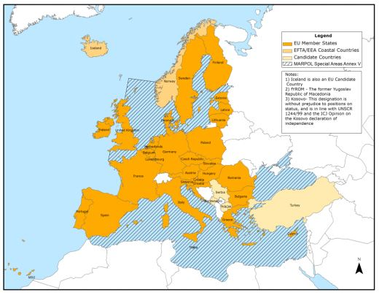Source: EMSA

Discharges of Garbage within Special area’s (Regulation 6):
Table I
Discharge of Garbage within special area’s
Provisions Regulation 6 Annex V
Garbage Category | Discharge requirements
Food wastes  (Cat B) | - As far as practicable from the nearest land, but not less than 12 nautical miles from the nearest land or the nearest ice shelf;  - Food wastes shall be comminuted or ground and shall be capable of passing through a screen with openings no greater than 25 mm;  - Food wastes shall not be contaminated by any other garbage type.
Non HME Cargo Residues  (Cat J) | Cargo residues that cannot be recovered using commonly available methods for unloading, where all the following conditions are satisfied:  - Cargo residues contained in hold washing water do not include any substances classified as harmful to the marine environment according to the criteria set out in appendix I to Marpol Annex V;  - Solid bulk cargoes as defined in regulation VI/1-1.2 of the International Convention for the Safety of Life at Sea (SOLAS), 1974, as amended, other than grain, shall be classified in accordance with appendix I to Marpol Annex V, and declared by the shipper as to whether or not they are harmful to the marine environment. Declaration as mentioned in chapter 4.2.3 IMSBC code shall be used  - Cleaning agents or additives contained in hold washing water do not include any substances classified as harmful to the marine environment taking into account guidelines developed by the Organization;  - Both the port of departure and the next port of destination are within the special area and the ship will not transit outside the special area between those ports;  - No adequate reception facilities are available at those ports taking into account guidelines developed by the Organization; and  - Where the above mentioned conditions have been fulfilled, discharge of cargo hold washing water containing residues shall be made as far as practicable from the nearest land or the nearest ice shelf and not less than 12 nautical miles from the nearest land or the nearest ice shelf.
Cleaning agents or Additives | Contained in deck and external surfaces wash water only if these substances are not harmful to the marine environment, taking into account guidelines developed by the Organization.
Other Garbage categories | PROHIBITED
Other areas than Special Areas:
3.33 Discharges of Garbage outside Special area’s (Regulation 4):
Table II
Discharge of Garbage outside special area’s
Provisions Regulation 4 Annex V
Garbage Category | Discharge requirements
Food wastes  (Cat B) | 3 nautical miles from the nearest land for food wastes which have been passed through a comminuter or grinder. Such comminuted or ground food wastes shall be capable of passing through a screen with openings no greater than 25 mm  12 nautical miles from the nearest land for food wastes that have not been treated as mentioned above.
Animal Carasses  (Cat G) | Discharge shall occur as far from the nearest land as possible, taking into account the guidelines developed by the Organization.
Non HME Cargo Residues  (Cat J) | 12 nautical miles from the nearest land for cargo residues that cannot be recovered using commonly available methods for unloading.  - These cargo residues shall not contain any substances classified as harmful to the marine environment, in accordance with the criteria set out in appendix I to Marpol Annex V;  - Solid bulk cargoes as defined in regulation VI/1-1.2 of the International Convention for the Safety of Life at Sea (SOLAS), 1974 , as amended, other than grain, shall be classified in accordance with appendix I to Marpol annex V, and declared by the shipper as to whether or not they are harmful to the marine environment. Declaration as mentioned in chapter 4.2.3 IMSBC code shall be used.
Cleaning agents or Additives | Cleaning agents or additives contained in cargo hold, deck and external surfaces wash water may be discharged into the sea, but these substances must not be harmful to the marine environment, taking into account guidelines developed by the Organization
Other Garbage categories | PROHIBITED
Arctic waters
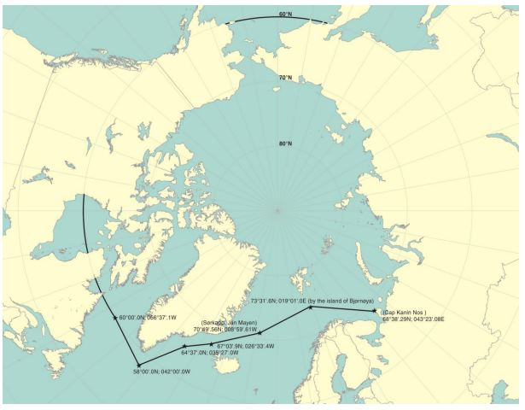Source: IMO
3.34 Discharges of Garbage within Arctic waters (section 5.2 of part II-A of the Polar Code)
Arctic waters: The North Pole area
Table III
Special Polar Code requirements for the Discharge of Garbage into Arctic waters
Provisions part II-A Polar Code
Garbage Category | Discharge requirements
Food wastes  (Cat B) | - As far as practicable form areas of ice concentration exceeding 1/10, but in any case not less than 12 miles from nearest land, nearest ice shelf of nearest fast ice;  - Food wastes shall be comminuted or ground and shall be capable of passing through a screen with openings no greater than 25 mm;  - Food wastes shall not be contaminated by any other garbage;  - Food waste shall not be discharged onto the ice
Non HME Cargo Residues  (Cat J) | Cargo residues that cannot be recovered using commonly available methods for unloading, where all the following conditions are satisfied:  - Cargo residues, cleaning agents or additives contained in hold washing water do not include any substances classified as harmful to the marine environment according to the criteria set out in appendix I to Marpol Annex V;  - Both the port of departure and the next port of destination are within Arctic waters the special area and the ship will not transit outside Arctic waters between those ports;  - No adequate reception facilities are available at those ports taking into account guidelines developed by the Organization;  - The discharge of cargo hold washing water containing residues shall be made as far as practicable form areas of ice concentration exceeding 1/10, but in any case not less than 12 miles from nearest land, nearest ice shelf of nearest fast ice.
Other Garbage categories | PROHIBITED
Antarctic area
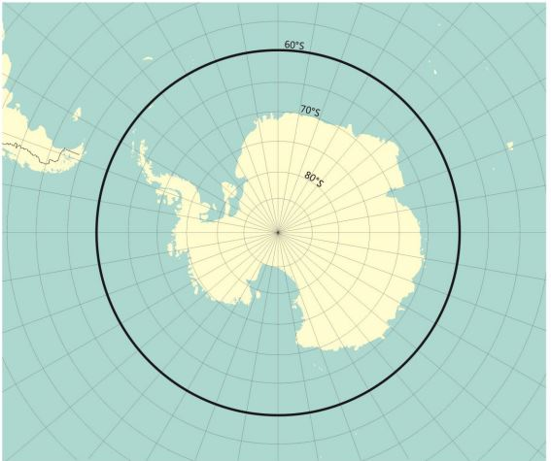Source: IMO
3.35 Discharges of Garbage within the Antarctic area (section 5.2 of part II-A of the Polar Code)
Antarctic area: The South Pole area
Table IV
Special Polar Code requirements for the Discharge of Garbage into Antarctic area
Provisions part II-A Polar Code
Garbage Category | Discharge requirements
Food wastes  (Cat B) | - As far as practicable form areas of ice concentration exceeding 1/10, but in any case not less than 12 miles from nearest land, nearest ice shelf of nearest fast ice;  - Food wastes shall be comminuted or ground and shall be capable of passing through a screen with openings no greater than 25 mm;  - Food wastes shall not be contaminated by any other garbage;  - Food waste shall not be discharged onto the ice;  - Discharge of introduced avian products, including poultry and poultry parts, only when it has been treated to be made sterile.
Non HME Cargo Residues  (Cat J) | See Table I: Discharge of Garbage within Special Area
Cleaning agents or Additives | See Table I: Discharge of Garbage within Special Area
Other Garbage categories | PROHIBITED
Fixed or floating platforms
3.36 Special requirements for the discharge of garbage from fixed or floating platforms (Regulation 5)
Fixed or floating platforms means fixed or floating structures located at sea which are engaged in the exploration, exploitation or associated offshore processing of sea-bed mineral resources.
Table V
Special requirements for the Discharge of Garbage from fixed of floating platforms
Provisions Regulation 5 Annex V
Garbage Category | Discharge requirements
Food wastes  (Cat B) | - from fixed or floating platforms located more than 12 nautical miles from the nearest land and from all other ships when alongside or within 500 m of such platforms;  - only when the wastes have been passed through a comminuter or grinder. Such comminuted or ground food wastes shall be capable of passing through a screen with openings no greater than 25 mm.
Other Garbage categories | PROHIBITED from platforms and ships when alongside or within 500 m of such platforms.
Mixed Garbage
3.37 When garbage is mixed with or contaminated by other substances prohibited from discharge or having different discharge requirements, the more stringent requirements shall apply.
Documents required under Marpol Annex V
Marpol Annex V is requiring certain documentation to be maintained by ships and/of fixed or floating platforms
Garbage Management Plan
3.38 A Garbage Management Plan shall be carried under the following conditions, to be followed by the crew:
- Every ship of 100 gross tonnage and above;
- Every ship which is certified to carry 15 or more persons;
- 3Fixed or floating platforms.
This plan shall provide written procedures for minimizing, collecting, storing, processing and disposing of garbage, including the use of the equipment on board.
The Garbage Management Plan should for example provide information on:
- Receptacles for different garbage categories, capacity and storage location
- Availability of an incinerator and capacity;
- Means for compacting and grinding of garbage.
It shall also designate the person or persons in charge of carrying out the plan.
Such a plan shall be based on the guidelines developed by the Organization and written in the working language of the crew.
Placards
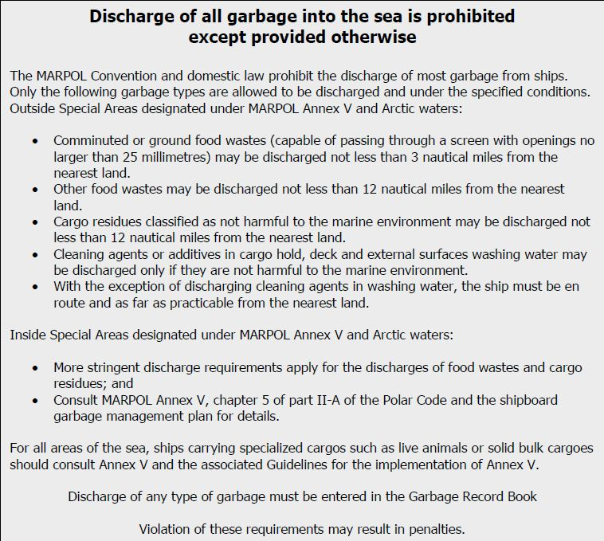
3.39 Placards shall be displayed, notifying the crew and passengers of the discharge requirements of regulations 3, 4, 5 and 6 of Annex V and section 5.2 of part II-A of the Polar Code , as applicable on:
- Every ship of 12 m or more in length overall;
- Fixed or floating platforms
The placards should also be placed in prominent places where crew will be working and living, and in areas where bins are placed for collection of garbage. These places include galley spaces, mess room(s), wardroom, bridge, main deck and other areas of the ship, as appropriate.
The placards shall be written in the working language of the ship's crew and, for ships engaged in voyages to ports or offshore terminals under the jurisdiction of other Parties to the Convention, shall also be in English, French or Spanish.
Garbage Record Book
3.40 Provided with a Garbage Record Book shall be:
- Every ship of 400 gross tonnage and above;
- Every ship which is certified to carry15 or more persons engaged in voyages to ports or offshore terminals under the jurisdiction of another Party to the Convention;
- Every fixed or floating platform.
The Garbage Record Book, whether as a part of the ship's official log-book or otherwise, shall be in the form specified in the appendix II to Annex V.
The following should be recorded in the Garbage Record Book:
- Each discharge into the sea or to a reception facility, or a completed incineration;
- For discharge into the sea, date and time, position of the ship (latitude and longitude), category of the garbage and the estimated amount (in cubic metres) discharged;
- For discharge of cargo residues the discharge start and stop positions shall be recorded in addition to the foregoing;
- Each completed incineration shall include date and time and position of the ship (latitude and longitude) at the start and stop of incineration, categories of garbage incinerated, and the estimated amount incinerated for each category in cubic metres;
- for each discharge to a port reception facility or another ship shall include date and time of discharge, port or facility or name of ship, categories of garbage discharged, and the estimated amount discharged for each category in cubic metres;
- In the event of any discharge or accidental loss referred to in regulation 7 of Annex V, an entry shall be made in the Garbage Record Book of the date and time of occurrence, port or position of the ship at time of occurrence (latitude, longitude and water depth if known), the reason for the discharge or loss, details of the items discharged or lost, categories of garbage discharged or lost, estimated amount for each category in cubic metres, reasonable precautions taken to prevent or minimize such discharge or accidental loss and general remarks. For ships of less than 400 gross tonnage, an entry shall be made in the ship's official log-book;
The Garbage Record Book shall be kept on board the ship or the fixed or floating platform, and be preserved for a period of at least two years from the date of the last entry made in it;
The Administration may waive the requirements for Garbage Record Books for:
- Any ship engaged on voyages of one (1) hour or less in duration which is certified to carry 15 or more persons; or
- Fixed or floating platforms.
The accidental loss or discharge of fishing gear, which poses a significant threat to the marine environment or navigation shall be reported to the Flag State, and, where the loss or discharge occurs within waters subject to the jurisdiction of a coastal State, also to that Coastal State.
Form of Garbage Record Book
3.41 The form of the Garbage record Book is set out in Appendix II to Annex V.
The Garbage Record Book has been divided in Part I and Part II.
Part I shall be used for each discharge into the sea or to a reception facility, or a completed incineration of the Garbage Categories A to I; and
Part II shall be used for each discharge cargo residues of Solid Bulk Cargoes into the sea or to a reception facility of the Garbage Categories J and K.
Reception facilities
3.42 Each Party undertakes to ensure the provision of adequate facilities at ports and terminals for the reception of garbage without causing undue delay to ships, and according to the needs of the ships using them.
Waste notification
3.43 The operator, agent or master of ships which are bound for the European Union shall, in accordance with Article 6 of the Directive (EU) 2019/883 of the European Parliament and of the Council of 17 April 2019 on port reception facilities for the delivery of waste from ships, amending Directive 2010/65/EU and repealing Directive 2000/59/EC, shall fill up complete truly and accurately the form set out in Annex 2 to this Directive “advance waste notification” and notify all the information contained therein to the authority or body designated for this purpose by the Member State in which that port is located.
The notification shall be;
- At least 24 hours prior to arrival, if the port of call is known;
- As soon as the port of call is known, if this information is available less than 24 hours prior to arrival; or
- At the latest upon departure from the previous port, if the duration of the voyage is less than 24 hours;
- Reported electronically;
- Available on board, preferably in electronic form, at least until the next port of call and shall be made available upon request to the relevant Member States’ authorities
Delivery of waste from ships
3.44 The master of a ship calling at a Union port shall, before leaving that port, deliver all its waste carried on board to a port reception facility in accordance with the relevant discharge norms laid down in the MARPOL Convention.
A Member State shall require the ship to deliver, before departure, all its waste if:
- It cannot be established, based on the available information, including information electronically available in that part of the information, monitoring and enforcement system referred to in Article 13 Directive (EU) 2019/883 or in GISIS (IMO), that adequate port reception facilities are available in the next port of call; or
- The next port of call is unknown
Upon delivery, the port reception facility operator or the authority of the port where the waste was delivered shall truly and accurately complete the form set out in Annex 3 of the Directive (EU) 2019/883 “waste delivery receipt” and issue and provide, without undue delay, the waste delivery receipt to the master of the ship.
The information from the waste delivery receipt shall be available on board for at least two years, where relevant with the appropriate Garbage Record Book or the Garbage Management Plan, and shall be made available upon request to the Member States’ authorities.

MARPOL ANNEX VI - Prevention of Air Pollution from Ships

Introduction
3.45 Air pollution poses a threat to the health of people, to the environment and to the climate. In 2014 ocean going vessels were responsible for 13% and 14% of the global anthropogenic emissions of respective SO₂ and NO_{x}. Ensuring satisfactory air quality and limiting acid rain were amongst the reasons for adding Annex VI to MARPOL in 1997. Annex VI came into force on 19 May 2005 with the aim of reducing various types of air pollution from ships and has been amended several times. Following MARPOL Annex VI regulations came into force on different types of air pollution:
- Regulation 12 on the prohibition on the deliberate emission of certain Ozone depleting substances;
- Regulation 13 on the reduction of emissions of Nitrogen oxides (NO_{x});
- Regulation 14 on Sulphur oxides (SO_{x});
- Regulation 15 on Volatile organic compounds (VOCs)
To combat CO₂ emissions from international shipping, technical and operational energy efficiency measures were adopted and entered into force on 1 January 2013. Requirements for ships of 5,000 gross tonnage and above to collect data on their fuel oil consumption entered into force on 1 March 2018.
This chapter has been written to include the amendments made to the revised Annex VI, which entered into force on 1 November 2022. It provides an overview of the requirements for ships and companies. Requirements only applicable to the Administration are excluded, as are regulations concerning investigation, which is dealt with in another part of the manual. For instance, regulations 10 and 11 include provisions on port state controls and for the detection of violations and enforcement and are therefore not covered in this part of the manual.

General
3.46 MARPOL Annex VI applies to all ships, unless expressly provided otherwise, as stated in regulation 1.
Definitions for the purpose of Annex VI are found in regulation 2.
Exceptions and exemptions are found in regulation 3. The regulations of Annex VI do not apply to any emission necessary for the purpose of securing the safety of a ship or saving life at sea or any emission resulting from damage to a ship or its equipment. This is provided that all reasonable precautions have been taken to prevent the emission, and that the owner or master has not acted recklessly or with intent to cause damage and with knowledge that damage would probably result. Exemptions can also be made by a Party for a ship to test ship emission reduction and control technologies and engine design programmes.
Furthermore, there are also exemption possibilities for emissions from seabed mineral activities and unmanned non-self-propelled barges.
Regulation 4 stipulates that the Administration may allow any fitting, material, appliance or apparatus to be fitted in a ship or other procedures, alternative fuel oils, or compliance methods, if these are at least as effective in terms of emissions reductions as those required by this Annex.

Survey, certification and means of control

International Air Pollution Prevention Certificate
3.47 In accordance with Regulation 5, all ships of 400 gross tonnage and above and every fixed and floating drilling rig or other platform shall be subject to a variety of surveys:
- An initial survey before the ship is put into service.
- A renewal survey at intervals specified by the Administration, but not exceeding five years.
- An intermediate survey within three months before or after the second anniversary date or within three months before or after the third anniversary date of the certificate which shall take the place of one of the annual surveys specified in point 4.
- An annual survey within three months before or after each anniversary date of the certificate, including a general inspection of the equipment, systems, fittings, arrangements, and other materials.
- An additional survey, either general or partial, according to the circumstances, shall be made whenever any important repairs or renewals are made.
Maritime administrations can establish appropriate measures to ensure that ships of less than 400 gross tonnage also comply with the provisions of chapter III of MARPOL Annex VI.
It follows from regulation 6 that ships that have been subjected to initial or renewal surveys in accordance with regulation 5 are granted an International Air Pollution Prevention (IAPP) Certificate.
In accordance with regulation 9, an IAPP Certificate is issued for a period specified by the Administration, which cannot exceed five years.

International Energy Efficiency Certificate
3.48 Regulation 5 also states that all ships of 400 gross tonnage and above shall be subject to the following surveys:
- An initial survey carried out before the new ship is put into service and before the International Energy Efficiency Certificate is issued.
- A general or partial survey, according to the circumstances, carried out after a major conversion of a new ship to which this regulation applies.
- If the major conversion of a new or existing ship is so extensive that the ship is regarded by the Administration as a newly constructed ship, the Administration may determine the necessity of an initial survey on the Attained Energy Efficiency Design Index (attained EEDI).
- For existing ships, the verification of the requirement to have a Ship Energy Efficiency Management Plan (SEEMP) on board according to regulation 26 of this Annex shall take place at the first intermediate or renewal survey identified in paragraph 1 of this regulation, whichever is the first, on or after 1 January 2013
Ships to which chapter 4 of this Annex applies shall also be subject to the surveys specified below, taking into account the guidelines adopted by the Organization:
- An initial survey carried out before a new ship is put in service and before the International Energy Efficiency Certificate is issued. The survey shall verify that the ship’s attained EEDI is in accordance with the requirements in chapter 4 of this Annex, and that the SEEMP required by regulation 26 of this Annex is on board;
- A general or partial survey, according to the circumstances, carried out after a major conversion of a new ship to which this regulation applies. The survey shall ensure that the attained EEDI is recalculated as necessary and meets the requirement of regulation 24 of this Annex, with the reduction factor applicable to the ship type and size of the converted ship in the phase corresponding to the date of contract or keel laying or delivery determined for the original ship in accordance with regulation 2.2.18 of this Annex;
- In cases where the major conversion of a new or existing ship is so extensive that the ship is regarded by the Administration as a newly constructed ship, the Administration shall determine the necessity of an initial survey on attained EEDI. Such a survey, if determined necessary, shall ensure that the attained EEDI is calculated and meets the requirement of regulation 24 of this Annex, with the reduction factor applicable corresponding to the ship type and size of the converted ship at the date of the contract of the conversion, or in the absence of a contract, the commencement date of the conversion. The survey shall also verify that the SEEMP required by regulation 26 of this Annex is on board and, for a ship to which regulation 27 applies, has been revised appropriately to reflect a major conversion in those cases where the major conversion affects data collection methodology and/or reporting processes;
- For existing ships, the verification of the requirement to have a SEEMP on board according to regulation 26 of this Annex shall take place at the first intermediate or renewal survey identified in paragraph 1 of this regulation, whichever is the first, on or after 1 January 2013;
- The Administration shall ensure that for each ship to which regulation 27 applies, the SEEMP complies with regulation 26.2 of this Annex. This shall be done prior to collecting data under regulation 27 of this Annex in order to ensure the methodology and processes are in place prior to the beginning of the ship’s first reporting period. Confirmation of compliance shall be provided to and retained on board the ship;
- The Administration shall ensure that, for each ship to which regulation 28 applies, the SEEMP complies with regulation 26.3.1 of this Annex. This shall be done prior to 1 January 2023. Confirmation of compliance shall be provided to, and retained on board, the ship;
- The verification that the ship's attained EEXI is in accordance with the requirements in regulations 23 and 25 of this Annex shall take place at the first annual, intermediate or renewal survey identified in paragraph 1 of this regulation or the initial survey identified in paragraphs 4.1 and 4.3 of this regulation, whichever is the first, on or after 1 January 2023; and
- Notwithstanding paragraph 4.7 of this regulation, a general or partial survey, according to the circumstances, carried out after a major conversion of a ship to which regulation 23 of this Annex applies. The survey shall ensure that the attained EEXI is recalculated as necessary and meets the requirement of regulation 25 of this Annex.
Other surveys might also be required by the Administration in accordance with regulation 5.
Regulation 6 states that ships shall be granted an International Energy Efficiency Certificate (IEEC) after a survey in accordance with the provisions referred to above.
The IEEC is normally valid throughout the life of the ship, unless it ceases to be valid under circumstances described in regulation 9.

Requirements for control of emissions from ships

Ozone-depleting substances:
3.49 Regulation 12 contains provisions on ozone-depleting substances (ODS), which are chemicals that degrade the ozone layer in the upper atmosphere.
Any deliberate emissions of ozone-depleting substances are prohibited. Deliberate emissions include emissions occurring while maintaining, servicing, repairing, or disposing of systems or equipment. This regulation does not apply to permanently sealed equipment where there are no refrigerant charging connections or potentially removable components containing ozonedepleting substances.
Installations that contain ozone-depleting substances, other than hydrochlorofluorocarbons, are prohibited on ships constructed on or after 19 May 2005, or in the case of the ships constructed before 19 May 2005 which have a contractual date of the equipment to the ship on or after the May 2005 or, in the absence of a contractual delivery date, the actual delivery of the equipment to the ship on or after 19 May 2005.
Installations that contain hydrochlorofluorocarbons are prohibited on ships constructed on or after 1 January 2020, or in the case of ships constructed before 1 January 2020 which have a contractual delivery date of the equipment to the ship on or after 1 January 2020, or, in the absence of a contractual delivery date, the actual delivery of the equipment to the ship on or after 1 January 2020.
Any ship of 400 gross tonnage and above or platforms and drilling rigs engaged in voyages to ports or offshore terminals under the jurisdiction of other Parties shall maintain a list of equipment containing ozone-depleting substances. They shall also maintain an ozone-depleting substances record book if they have rechargeable systems that contain ozone-depleting substances.

Nitrogen oxides (NO_{x})
3.50 Nitrogen oxides (NO_{x}) are a collective term which includes NO, NO₂ and other oxides of nitrogen. The provisions on NO_{x} are found in regulation 13.
The regulation of NO_{x} applies to each marine diesel engine with a power output of more than 130 kW installed on a ship and each marine diesel engine with a power output of more than 130 kW that undergoes a major conversion on or after 1 January 2000, except when demonstrated to the satisfaction of the Administration that such engine is an identical replacement to the engine that it is replacing and is otherwise not covered under paragraph 1.1.1 of MARPOL Annex VI.
It does not apply to devices used solely for emergencies or marine diesel engines installed on ships solely engaged on voyages within waters subject to the sovereignty or jurisdiction of the State the flag of which the ship is entitled to fly, provided that such engine is subject to an alternative NO_{x} control measure established by the Administration. Notwithstanding the provisions of paragraph 1.1 of this regulation, the Administration may provide an exclusion from the application of this regulation for any marine diesel engine that is installed on a ship constructed, or for any marine diesel engine that undergoes a major conversion, before 19 May 2005, provided that the ship on which the engine is installed is solely engaged in voyages to ports or offshore terminals within the State the flag of which the ship is entitled to fly.
There are three different tiers of NO_{x}, see the table below for NO_{x} emission limits:
Tier | Ship construction date on or after | Total weighted cycle emission limit (g/kWh)  n = engine’s rated speed (rpm)
Tier | Ship construction date on or after | n < 130 | n = 130 - 1999 | n ≥ 2000
I | 1 January 2000 | 17.0 | 45·n(-0.2)  e.g., 720 rpm – 12.1 | 9.8
II | 1 January 2011 | 14.4 | 44·n(-0.23)  e.g., 720 rpm – 9.7 | 7.7
III | 1 January 2016 | 3.4 | 9·n(-0.2)  e.g., 720 rpm – 2.4 | 2.0

The tier and on/off status of marine diesel engines installed on board a ship to which paragraph 5.1 of this regulation applies which are certified to both Tier II and Tier III or which are certified to Tier II only shall be recorded in such logbook or electronic record book¹⁵ as prescribed by the Administration at entry into and exit from a NOx Tier III emission control area, or when the on/off status changes within such an area, together with the date, time and position of the ship. 15 Refer to the Guidelines for the use of electronic record books under MARPOL (resolution MEPC.312(74))The NOx regulation encourages the use of technologies and practices that minimize NOx emissions, such as improved engine design, optimized combustion processes, and the use of after-treatment systems like selective catalytic reduction (SCR) or exhaust gas recirculation (EGR) systems.
The Tier III requirements apply within four emission control areas, as shown in the map below: in North America, in the United States Caribbean Sea Emission Control Area, in the Baltic Sea and in the North Sea.
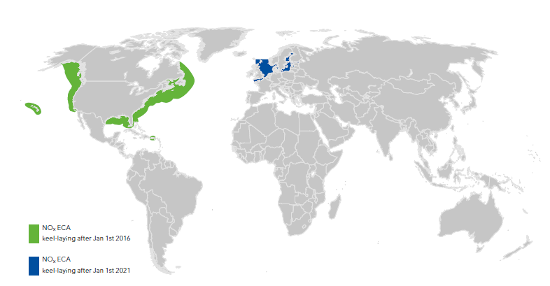
Source: DNV

Sulphur oxides (SO_{x}) and particulate matter
3.51 Sulphur oxide is formed when sulphur-containing fuels such as oil or coal are burned. Requirements concerning the sulphur content of fuel are found in regulation 14.
The sulphur content of fuel oil used or carried for use on board a ship shall not exceed 0.50% m/m.
There are four emission control areas for sulphur, highlighted in the map below. In the emission control areas, the content of fuel oil used on board the ship shall not exceed 0.10% m/m.
Those ships using separate fuel oils to comply with paragraph 4 of this regulation and entering or leaving an emission control area set forth in paragraph 3 of this regulation shall carry a written procedure showing how the fuel oil changeover is to be done, allowing sufficient time for the fuel oil service system to be fully flushed of all fuel oils exceeding the applicable sulphur content specified in paragraph 4 of this regulation prior to entry into an emission control area. The volume of low sulphur fuel oils in each tank as well as the date, time and position of the ship when any fuel oil changeover operation is completed prior to the entry into an emission control area or commenced after exit from such an area shall be recorded in such logbook or electronic record book²⁰ as prescribed by the Administration.
Ships may also use an exhaust gas cleaning system (EGCS) to achieve similar emission levels as with low-sulphur fuels. Utilizing alternative fuels is also an option to achieve compliance with the sulphur regulations. Some commonly used alternative fuels are: Liquefied Natural Gas, Liquefied Petroleum Gas, Methanol, Green Ammonia or Biofuels.
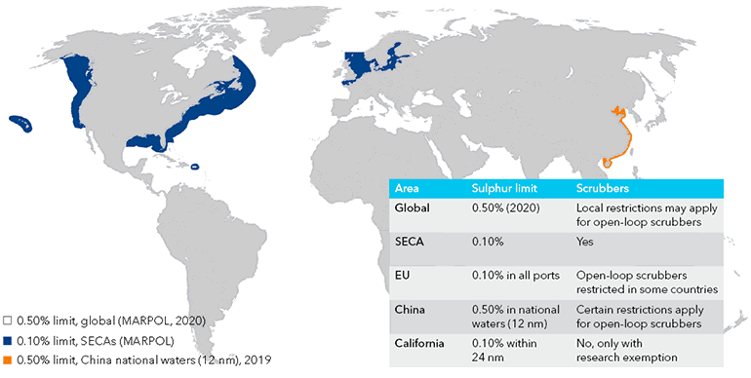
Source: DNV

Carriage ban
The IMO implemented a carriage ban on non-compliant fuel on March 1, 2020. This ban prohibits ships without exhaust gas cleaning systems (EGCS), from carrying fuel oil with a sulfur content exceeding 0.50% m/m on board. This means that even if a ship is not operating in an emission control area (ECA), it is not allowed to carry fuel oil with a higher sulfur content in its bunker tanks.

Volatile Organic Compounds
3.52 Volatile Organic Compounds (VOCs) are organic chemicals that easily evaporate into the air at room temperature. They have high vapour pressure and low water solubility. VOCs are generated during combustion and handling of oil products.
The rules on VOCs are found in regulation 15, and any regulations on the emissions of VOCs by tankers must be regulated in accordance with this regulation. It applies only to tankers and some gas carriers.
A tanker to which the regulation applies shall be provided with a vapour emission collection system approved by the Administration considering the safety standards for such systems developed by the Organization, and shall use this system during the loading of relevant cargoes.
A tanker carrying crude oil shall have on board and implement a VOC management plan approved by the Administration.

Shipboard incineration
3.53 In accordance with regulation 16, shipboard incineration is only allowed in a shipboard incinerator.
Shipboard incineration of the following substances is prohibited:
- residues of cargoes subject to Annex I, II or III or related contaminated packing materials;
- polychlorinated biphenyls (PCBs);
- garbage, as defined by Annex V, containing more than traces of heavy metals;
- refined petroleum products containing halogen compounds;
- sewage sludge and sludge oil neither of which is generated on board the ship; and
- exhaust gas cleaning system residues.
Shipboard incineration of polyvinyl chlorides (PVCs) is prohibited, except in shipboard incinerators for which IMO Type Approval Certificates.
Shipboard incineration of sewage sludge and sludge oil generated during normal operation of a ship may also take place in the main or auxiliary power plant or boilers, but in those cases, shall not take place inside ports, harbours or estuaries.

Regulation 18 states that for each ship subject to regulations 5 and 6 of this Annex, details of the fuel oil combustion purposes delivered to and used on board shall be recorded by means of a bunker delivery note that shall contain at least the information specified in appendix V to this Annex. The bunker delivery note shall be kept on board the ship in such a place as to be readily available for inspection at all reasonable times. It shall be retained for a period of three years after the fuel oil has been delivered on board. The bunker delivery note shall be accompanied by a representative sample of the fuel oil delivered.

Regulations on energy efficiency for ships
3.54 According to regulation 19, chapter VI applies to all ships of 400 gross tonnage and above.
The goal of the chapter, as stated in regulation 20, is to reduce the carbon intensity of international shipping, working towards the levels of ambition set out in the Initial IMO Strategy on reduction of GHG emissions from ships.
Ships that operate solely within waters subject to the sovereignty or jurisdiction of the State the flag of which the ship is entitled to fly are exempt, as are ships not propelled by mechanical means, and platforms including FPSOs and FSUs and drilling rigs.
Ships which have non-conventional propulsion are exempt from regulations 22, 23, 24 and 25. This does not apply to cruise passenger ships having non-conventional propulsion and LNG carriers having conventional or non-conventional propulsion, delivered on or after 1 September 2019. Cruise passenger ships having non-conventional propulsion and LNG carriers having conventional or non-conventional propulsion are exempt from regulations 23 and 25. Category A ships as defined in the Polar Code are exempt from regulations 22, 23, 24, 25 and 28.
The Administration can decide to waive the requirements of regulations 22 and 24 for ships of 400 gross tonnage and above, unless the building contract is placed on or after 1 January 2017, or if there is no building contract keel of which is laid or which is at a similar stage of construction on or after 1 July 2017, or the delivery of which is on or after 1 July 2019, or in cases of a major conversion of a new or existing ship.
Regulation 21 stipulates the functional requirements for the ships for which the different regulations apply. The technical carbon intensity requirements are found in regulations 22, 23, 24 and 25 and the operational carbon intensity requirements in regulations 26, 27 and 28.
The attained EEDI shall according to regulation 22 be calculated for:
- each new ship;
- each new ship which has undergone a major conversion; and
- each new or existing ship which has undergone a major conversion that is so extensive that the ship is regarded by the Administration as a newly constructed.
The requirements for the EEDI are found in regulation 24.
The EEDI is calculated with the following formula:
Attained EEDI ≤ Required EEDI =(1−x/100) ∙ Reference line value.
X is specified in table 1 in regulation 24.
For existing ships, the Attained Energy Efficiency Existing Ship Index (EEXI) shall, in accordance with regulation 23 be calculated for:
- each ship; and
- each ship which has undergone a major conversion.
The requirements for the EEXI are found in regulation 25.
The EEXI is calculated with the following formula:
Attained EEXI ≤ Required EEXI =(1−y/100) • EEDI reference line value.
Y is the reduction value found in table 3 in regulation 25.
Each ship shall, in accordance with regulation 26, keep on board a ship specific SEEMP. This may form part of the ship's Safety Management System (SMS).
In the case of a ship of 5,000 gross tonnage and above, the SEEMP shall include a description of the methodology that will be used to collect the data. Regulation 26.3 also stipulates what shall be included in the SEEMP for some ships of 5,000 gross tonnage and above.
Ships of 5,000 gross tonnage and above shall collect ship fuel oil consumption in accordance with regulation 27. In accordance with regulation 28, the operational carbon intensity shall be calculated each year for a selection of these ships.

Section 3.2: Instruments for cooperation in the field of prosecuting illegal maritime pollution

Introduction
3.45 There are two fundamental instruments available to the international community for taking action against the perpetrators of illegal acts of marine pollution:
a. the MARPOL Convention relates to the prevention of pollution from ships, and to the protection of the marine environment from violations of discharge regulations which are stipulated in this Convention - such discharges being the result of either an equipment failure or a deliberate act (see §§ 3.28 – 3.37);
b. the 1982 UNCLOS Convention is a more universal instrument which relates to matters governing the Law of the Sea including the protection of marine environments from the activity of shipping (see §§ 3.38 – 3.62).
3.46 Both conventions lay down the extent of enforcement powers of the Coastal State, Port State and Flag State respectively. In order to meet the aims of these two Conventions, they must be implemented in national law through appropriate legislation.
3.47 Offences against both mentioned maritime conventions usually have an international character involving transboundary, administrative and judicial cooperation between competent authorities. The Paris Memorandum of Understanding on Port State Control and the European Port State Directive ensure an effective, coordinated and uniform system of inspection or Port State control by maritime authorities in most European ports (see §§ 3.63 – 3.72). Procedures for international co-operation between judicial authorities are laid down in a number of European criminal law Conventions (see §§ 3.73 – 3.86):
a. European Convention on Extradition
b. European Convention on Mutual Assistance in Criminal Matters
c. European Convention on the Transfer of Proceedings in Criminal Matters.
3.48 Finally, the possibilities of quick and direct international Police co-operation (INTERPOL, Schengen Agreement) is briefly discussed (see §§ 3.87 – 3.93), and information is added on recent European legislative initiatives on ship-source pollution and on sanctions for pollution offences (see §§ 3.94 – 3.95).

MARPOL
3.48 The general provision in Art. 6 of MARPOL contains the obligation of Parties acting as Flag State, Port State or Coastal State, to co-operate in the detection of violations and the enforcement of the provisions of the Convention, using all appropriate and practicable measures of detection and environmental monitoring, adequate procedures for reporting and accumulation of evidence.
3.49 Contrary to UNCLOS, MARPOL does not provide that a Port State can take proceedings when a violation takes place on the high seas or in areas under the jurisdiction of another State. So in principle, MARPOL does not deviate from the exclusive jurisdiction of the Flag State. However, a Port State may inspect a ship that enters a port or offshore terminal under its jurisdiction, which in some circumstances may lead to the detention of that ship. A Coastal State can institute proceedings under its own laws in respect of any violation that occurred within its area of jurisdiction.

Enforcement by Flag State (Art. 4 of MARPOL)
3.50 The Convention provides that any violation of the Discharge Regulations or other MARPOL requirements shall be an offence under the law of the Flag State wherever the violation occurs. If the Flag State is informed of such a violation and is satisfied that sufficient evidence is available to commence proceedings, it shall cause such proceedings to be taken as soon as possible, in accordance with its law. The Flag State shall promptly inform the Party which has reported the alleged violation, as well as the IMO, of the action taken. A Flag State may request a Port State control inspection.

Port State control (Art. 5 & 6 of MARPOL)
3.51 MARPOL provides that a ship may, in any port or offshore terminal of a Port State which is party to the Convention, be subject to inspection by Port State control officers for the purpose of verifying whether the ship has discharged any harmful substances in violation of the provisions of the regulations. However, the officers appointed or authorised by that Port State are bound by special rules on inspection of ships.
3.52 A Port State may also inspect a ship when it enters the ports or offshore terminals under its jurisdiction, if a request for an investigation is received from any Party together with sufficient evidence that the ship has discharged harmful substances into the sea. The report of the investigation is then passed on to the requesting Party and the Flag State for appropriate action.
3.53 In some circumstances, MARPOL provides that a Port State has the right to detain a ship: in cases where a ship does not carry a valid certificate on board, or when the condition of the ship or its equipment does not correspond substantially with the particulars of that certificate, the Port State carrying out the inspection shall take the appropriate steps to ensure that the ship shall not sail until it can proceed to sea without presenting an unreasonable threat of harm to the marine environment.
3.54 With respect to the ship of non-Parties, a Port State shall apply the MARPOL requirements as may be necessary to ensure that no more favourable treatment is given to such ships.
3.55 All of this is current practice between European countries participating in the Memorandum of Understanding (MOU) on Port State Control.

Enforcement by Coastal State (Art. 4 of MARPOL)
3.56 Any violation within the jurisdiction of a Coastal State party to the Convention shall be an offence under the law of that Coastal State - whether the ship flies the flag of a Party or not - and sanctions shall be imposed under that law. A Coastal State may request a Port State control inspection.
3.57 Whenever a violation occurs within the jurisdiction of a Coastal State, that State shall either take proceedings under its own laws or report the offence to the Flag State - which shall take proceedings as described above. In such circumstances most countries choose to take proceedings under their own laws, informing the Flag State that they have done so.

UNCLOS
3.58 The 1982 United Nations Convention on the Law of the Sea (UNCLOS) entered into force on 16 November 1994. Most North Sea States and the EC are Parties to this convention.
3.59 UNCLOS inter alia provides jurisdiction to the Coastal States in the EEZ in addition to the sovereign rights of the territorial sea (Art. 211, § 5 and Art. 220). This is very important, since all Bonn Agreement Contracting Parties have established or are in the process of establishing an EEZ or an equivalent marine area.
3.60 UNCLOS further provides a powerful legal basis for international cooperation in exercising Flag State, Port State and Coastal State powers of enforcement in the territorial seas and EEZs or equivalent marine areas, such as the UK Pollution Zone, aiming, inter alia, at facilitating the enforcement and prosecution of MARPOL offenders. The general UNCLOS provisions relevant to this international cooperation are discussed below.
3.61 It is important to note that these UNCLOS provisions break through the traditional supremacy of the jurisdiction of the Flag State in respect of discharge violations in areas outside the jurisdiction of a Coastal State: when a ship is voluntarily within a port, the Port State is granted extensive judicial powers in respect of a discharge violation committed by that ship outside its internal waters, territorial sea or EEZ. The provisions of UNCLOS concerning this universal Port State jurisdiction represent a key factor in the successful prosecution of MARPOL Offenders.
3.62 With respect to the prosecution of a MARPOL offence committed in the territorial sea or EEZ of a Coastal State, UNCLOS provides the possibility for that Coastal State to:
a. request a Port State to investigate a ship and report back to the Coastal State, for administrative or judicial proceedings;
b. request a Port State to undertake judicial proceedings (Art. 218).
3.63 Furthermore, UNCLOS provides the possibility for a Coastal State to carry out an inspection on board and to detain or pursue a foreign ship at sea in respect of a serious discharge violation in its territorial sea or EEZ (under specific conditions) (Art. 220 + 111).
3.64 Breaking through the classic system of exclusive jurisdiction of the Flag State at sea made it necessary to establish certain guarantees to protect foreign ships. Such guarantees are provided with regard to the procedure of and conditions for inspecting ships (Art. 220 and 226), the suspension and restrictions on instituting proceedings (Art. 228), the notification to the Flag State (Art. 231), and liability of States arising from enforcement measures (Art. 232).

Enforcement by Flag States (Art. 217 of UNCLOS)
3.65 If a vessel commits a violation of MARPOL, the Flag State shall provide for immediate investigation and where appropriate institute proceedings in respect of the alleged violation, irrespective of where the violation occurred or where the pollution caused by such violation has occurred or has been spotted. Flag States conducting an investigation of the violation may request the assistance of any other State whose co-operation could be useful in clarifying the circumstances of the case.
3.66 At the request of any State, the Flag State shall investigate any violation alleged to have been committed by vessels flying their flag. If there is sufficient evidence available, Flag States shall without delay institute proceedings in accordance with their laws, and shall promptly inform the requesting State and the IMO of the action taken and its outcome.

Enforcement by Port States (Art. 218 and 219 of UNCLOS)
3.67 When a vessel is voluntarily within a port or at an off-shore terminal of a State, that Port State may undertake investigations and, where the evidence so warrants, institute proceedings in respect of any discharge from the vessel outside the internal waters, territorial sea or EEZ of that State in violation of MARPOL.
3.68 In cases where the discharge violation occurs in the internal waters, territorial sea or EEZ of another State however, the Port State may only institute proceedings upon request of that Coastal State, the Flag State, or another State damaged or threatened by the discharge violation. The Port State shall, as far as practicable, comply with these requests. It shall likewise, as far as practicable, comply with requests from the Flag State for investigation of a violation, irrespective of where the violation occurred. The records of the investigation carried out by a Port State shall be transmitted upon request to the Flag State, the Coastal State or a third State involved.
3.69 A Port State may also institute proceedings when the violation, committed in the internal waters, territorial sea or EEZ of another State, has caused or is likely to cause pollution in its own internal waters, territorial sea or EEZ.
3.70 Any proceedings instituted by the Port State on the basis of an investigation may be suspended at the request of the Coastal State (when the violation has occurred within its area of jurisdiction). The evidence and records of the case, together with any bond or other financial security, shall in that event be transmitted to the Coastal State. Also the Flag State can suspend proceedings instituted by the Port State.
3.71 In cases where a vessel within one of its ports or off-shore terminals is in violation of applicable international rules and standards relating to seaworthiness and thereby threatens damage to the marine environment, Art. 219 of UNCLOS provides that the Port State, upon request or on its own initiative, has the authority to take administrative measures to prevent the ship from sailing.
3.72 Port States enforcement can be vital for the cooperation between North Sea States as to illegal discharges committed by foreign ships in each other’s territorial seas or EEZs. A number of North Sea States have made pollution of another North Sea State’s waters an offence under their own domestic law. This greatly simplifies the exercise of Port State jurisdiction.

Enforcement by Coastal States (Art. 211 §5, 220, 226 and 218 of UNCLOS)
3.73 For the purpose of enforcement, Coastal States may in respect of their EEZ adopt laws and regulations for the prevention, reduction and control of pollution from vessels conforming to and giving effect to MARPOL.
3.74 When a vessel is voluntarily within a port or at an off-shore terminal of a Coastal State, that State may institute proceedings in respect of any violation of its laws and regulations adopted in accordance with MARPOL and UNCLOS, when the violation has occurred within its territorial sea or EEZ.
3.75 If there are clear grounds for believing that a vessel navigating in the territorial sea of a Coastal State, has, during its passage therein, violated laws and regulations of that State adopted in accordance with MARPOL, that Coastal State may undertake a physical inspection of the vessel “on the spot”, relating to the violation and may, where the evidence so warrants, institute proceedings, including detention of the vessel, in accordance with its laws.
3.76 Coastal States may also enforce discharge regulations in their EEZ in accordance with Art. 220 of UNCLOS which provides that a Coastal State may request information from a ship navigating in the EEZ or the territorial sea and suspected of a violation in the EEZ. In case of a serious pollution, the Coastal State may undertake a thorough inspection of such a ship “on the spot” (following specific procedures; Art. 226), or even institute proceedings, including detention of the vessel. The extent of these actions that can be undertaken by a Coastal State at sea depends on the available evidence, the gravity of the violation and the magnitude of (possible) damage to the marine environment. Some governments are in the process of establishing objective criteria to define such situations.
3.77 In case of illegal pollution within the area of jurisdiction of a Coastal State, Art. 218 of UNCLOS provides for coordination and cooperation between the Coastal State and Port State.

Right of hot pursuit (Art. 111 of UNCLOS)
3.78 Art. 111 regulates the right of hot pursuit, which under certain conditions allows a Coastal State to pursue a foreign ship in the event of a violation of its laws and regulations committed within the waters under its jurisdiction, including the EEZ. It provides that the right ceases as soon as the ship pursued enters the territorial sea of its own State or of a third State. The text of the Convention does not preclude the possibility of cooperation between States on this matter; in other words, it seems evident that this restriction can be lifted in bi- or multilateral agreements.

Measures to facilitate proceedings (Art. 223 of UNCLOS)
3.79 Art. 223 of UNCLOS provides the obligation for States instituting proceedings to take measures to facilitate the hearing of witnesses and the admission of evidence submitted by authorities of another State, and to facilitate the attendance at such proceedings of official representatives of, for example, the Flag State and any State affected by pollution arising out of any violation.

Notification to the Flag State and other States concerned (Art. 231 of UNCLOS)
3.80 States must promptly notify the Flag State and any other State concerned of any measures taken against foreign vessels, and shall submit to the Flag State all official reports concerning such measures. However, with respect to violations committed in the territorial sea, the foregoing obligations of the Coastal State apply only to such measures as are taken in legal proceedings.

Suspension and restrictions on institution of proceedings (Art. 228 of UNCLOS)
3.81 Proceedings initiated by a State to impose penalties in respect of any violation of MARPOL by a foreign vessel beyond its territorial sea, shall be suspended upon the taking of proceedings by the Flag State within six months of the date on which proceedings were first instituted. When the Flag State has requested a suspension, it shall in due course make available to the State previously instituting proceedings a full dossier of the case and the records of the proceedings. Only when proceedings instituted by the Flag State have been brought to conclusion, will the suspended proceedings be terminated.
3.82 The proceedings that were first instituted shall not be suspended however if they relate to a case of major damage to the Coastal State or if the Flag State in question has repeatedly disregarded its obligation to enforce MARPOL effectively.

Instruments relating to Port State Control

The Paris Memorandum of Understanding on Port State Control
3.83 The Maritime Authorities, consisting of 27 participating Maritime Administrations which cover the waters of European Coastal States and the North American basin from North America to Europe, cooperate in the Paris Memorandum of Understanding on Port State Control (further called MOU) on 26 January 1982. This Memorandum took effect on 1 July 1982. Some of the countries have acceded afterwards.
3.84 The MOU provides that these Maritime Authorities will maintain an effective system of Port State control with a view to ensuring that, without discrimination as to flag, foreign ships visiting the ports under their jurisdiction comply with the standards laid down in the relevant maritime conventions, inter alia MARPOL.
3.85 The MOU is primarily an administrative instrument for the detection of deficiencies in ships violating maritime conventions including MARPOL, and for administrative exchange of information. When an inspection is carried out under the MOU and deficiencies are detected which are hazardous to the marine environment, the Maritime Authority will ensure that the hazard is removed before the ship is allowed to proceed to sea and for this purpose will take appropriate action, which may include detention. However, when exercising control under the Memorandum, the Authorities will make all possible efforts to avoid unduly detaining or delaying a ship. It should also be noted that in applying a relevant legal instrument for the purposes of Port State control such as MARPOL, the authorities will ensure that no more favourable treatment is given to ships entitled to fly the flag of a State which is not a Party to that instrument.
3.86 The Maritime Authority of a Port State will, upon the request of a Coastal State or Flag State, visit in port the ship suspected of a MARPOL violation and carry out an administrative and technical inspection in order to obtain information, to secure evidence relating to the suspected violation, and where appropriate to take a sample of any alleged pollutant.
3.87 Annex 2 of the Paris Memorandum of Understanding on Port State Control (http://www.parismou.org) describes the procedures for investigations by port State control officers within the MOU countries under MARPOL.
3.88 The MOU has introduced an electronic mail facility (mailbox system) which provides fast communication between Port State control authorities and is one of the means used to request inspection in the next port of call of a ship suspected of having violated the discharge regulations. The speed of this MOU mailbox system is certainly an advantage in facilitating prosecution of MARPOL offenders, and it could have a strong deterrent effect. However, although the technical report may be part of the judicial file, the Port State controls under the MOU are of an administrative and technical nature and are not always adequate to deliver valid or sufficient evidence for criminal prosecution purposes. As mentioned above, the main purpose of the MOU was - and still is - to prevent the operation of sub-standard ships, and sanctions do not necessarily follow.
3.89 Also within the MOU, an information system on Port State Control inspections has been agreed and developed. The MOU authorities send daily messages on all the ships inspected in their national ports to the “Centre Administratif des Affaires Maritimes” at Saint-Malo in France (C.A.A.M.). The C.A.A.M. compiles all received messages in the central Port State Control database and information system SIRENAC. Port State Control officers can directly consult this database. Other authorities can do this by contacting the Secretariat of MOU. The Secretariat, which is provided by the Ministry of Transport and Public Works and Water Management, is in The Hague (Netherlands).
3.90 The possibility of also using the network of MOU Port States for the exchange of judicial inquiries and information regarding the exercise of jurisdiction under the EEZ regime should be studied. As mentioned above, it is obvious that for the legitimate institution of proceedings by Port States, an adequate legal basis relating thereto in accordance with their national legal system is required. Together with additional arrangements within the MOU-framework on the institution of proceedings as regards discharge violations, Port State enforcement in the North Sea area could thus be strengthened considerably.

European Community Port State Directive
3.91 Because there was a need for uniformity in executing the Port State Control procedures (inspection and detention), and in order to provide a clear legal basis for the actions under the MOU (being an administrative agreement), the European Community adopted the EC Directive 95/21/EC of 19 June 1995, which is regularly amended.
3.92 The EC Port State Directive however provides no legal basis for the institution of proceedings by Port States. The Directive mainly aims at a more uniform execution of the MOU obligations, inter alia by listing (1) ships eligible for a priority inspection, (2) legitimate reasons for a detailed inspection (for example a notification report of another Maritime Authority), and (3) criteria for the detention of a ship. During the Fifth Ministerial Conference on Port State Control in Copenhagen on 14 September 1994, the MOU was amended, so that the new MOU text closely fits the European Port State Directive.

European Conventions on international legal assistance in criminal matters
3.93 With regard to the prevention and control of crime, the Council of Europe has created several European Conventions in the field of Penal Law. The most relevant European Conventions on international legal assistance in criminal matters are discussed below.

European Convention on Extradition
3.94 The European Convention on Extradition of 13 December 1957 entered into force on 18 April 1960. It has been ratified and has entered into force in all North Sea States and EU Member States.
3.95 This Convention provides for the extradition between Parties of persons wanted for criminal proceedings or for the carrying out of a sentence or detention order. Extradition shall be granted in respect of offences punishable under the laws of both the requesting and the requested Party by deprivation of liberty, or under a detention order for a maximum period of at least one year, or by a more severe penalty. Any requested Party has the right to refuse extradition of its nationals.
3.96 With respect to violations of the MARPOL discharge regulations in the EEZ of a European Coastal State, extradition will only be applied by way of exception, since extradition according to the Convention presupposes the threat of a custodial sentence for an individual suspect, whereas UNCLOS (Art. 73, § 3 and Art. 230, § 1) excludes imprisonment or any other form of corporal punishment as a form of penalty for such violations in the EEZ.
3.97 The same remark can also be made with respect to violations of the MARPOL discharge regulations in the territorial sea of a Coastal State. However, in case of a wilful and serious act of pollution in the territorial sea, this restriction does not apply (see Art. 230, § 2).

European Arrest Warrant
3.98 Between EU Member States, the European Arrest Warrant (EAW) has replaced the traditional extradition procedure. An EAW may be issued by a national judicial authority if the person whose return is sought is accused of an offence for which the maximum period of the penalty is at least a year in prison, or if he or she has been sentenced to a prison term of at least four months. There is, as a general principle, an obligation for the MS to execute the EAW and surrender the person. Grounds for refusal are very limited. The traditional ground of refusal in case of lack of dual criminality (i.e. the underlying offence must be considered a crime both in the requesting and the requested State) does not apply to 32 serious offences, amongst them environmental crime. The EAW provides that the executing MS cannot refuse to execute an EAW for these 32 offences, if they are punishable under the laws of the issuing MS by imprisonment for at least 3 years. The EAW also does not make any exceptions for the surrender of a country’s own nationals. The functioning of the EAW is based on direct contacts between local courts in the different MS. The political phase of the procedure has been abolished and the procedure is purely judicial. Strict time limits for execution and surrender apply. The final decision on the execution of the EAW must be taken within 60 days after the arrest of the person and within 10 days if the consent has been given. These time limits can be extended by a maximum of 30 days at the request of the “executing” MS.
3.99 In June 2006, the Council approved the signature of a surrender agreement between the EU and Norway and Iceland which builds on a mechanism similar to the EAW. This agreement has not entered into force yet. Implementation of the agreement requires legal amendments so ratification will probably not take place before 2009.

European Convention on Mutual Assistance in Criminal Matters
3.100 All North Sea States and EU Member States are party to the European Convention on Mutual Assistance in criminal Matters of 20 April 1959 (entry into force: 12 June 1962).
3.101 Under this Convention, Parties agree to afford each other the widest measure of mutual assistance with a view to gathering evidence (audition of witnesses, experts and prosecuted persons, service of writs and records of judicial verdicts) or to communicate the evidence (records or documents) in criminal proceedings undertaken by the judicial authorities of the requesting Party. This legal assistance is provided for the purpose of investigations, prosecution and conviction in the requesting State.
3. 102 The Convention also specifies the requirements that requests for mutual assistance and letters rogatory have to meet (transmitting authorities, languages, refusal of mutual assistance). It provides for instance that in case of urgency, letters rogatory may be addressed directly by the judicial authorities of the requesting Party to the judicial authorities of the requested Party. This direct transmission may take place through the International Criminal Police Organisation INTERPOL.
3. 103 The Convention further provides for the laying of information by one Party with a view to proceedings in the courts of another Party. However, it does not imply an obligation for the latter Party to institute proceedings. This provision can be considered as the precursor or informal variant of the European Convention on the Transfer of Proceedings in Criminal Matters.
3. 104 The European Convention on mutual assistance in criminal matters clearly affords greater scope. It can also serve as a basis for interpreting the provisions of UNCLOS concerning co-operation between Port State, Coastal State and Flag State in the field of providing legal assistance.

2000 Convention on Mutual Assistance in Criminal Matters between the Member States of the European Union
3. 105 With the purpose of improving mutual assistance in criminal matters, the 2000 Convention on Mutual Assistance in Criminal Matters between the Member States of the European Union (hereinafter 2000 Convention) intends to supplement and facilitate the application between the Member States of existing instruments such as the 1959 CoE Convention and its 1978 Protocol, the 1990 Convention implementing the Schengen acquis and the 1962 Benelux Treaty.
3. 106 According to the 2000 Convention, cooperation may be realised through spontaneous exchange of information or in response to a Member State's request. In any case the request has to be made directly between judicial authorities with territorial competence for initiating and executing them and has to return through the same channels. The requested Member State has to comply with the formalities and procedures expressly indicated by the requesting Member State.
3. 107 To facilitate closer cooperation between law enforcement authorities, judicial authorities and other competent authorities, the 2000 Convention provides for new techniques in the field of technology such as video-conferencing, teleconferencing and interception of telecommunication. Other provisions deal with restitution of articles obtained by criminal means, the temporary transfer of persons held in custody for purpose of investigation, controlled deliveries and covert investigation.
3. 108 Article 13 of the 2000 Convention provides rules concerning the setting up and the operating of joint investigation teams.

European Convention on the Transfer of Proceedings in Criminal Matters
3. 109 Only a few North Sea States and/or EU Member States (Bulgaria, Denmark, The Netherlands, Norway, Romania, Slovakia, Sweden, Spain, Austria, Cyprus, Estonia, Latvia and Lithuania) have ratified the European Convention on the Transfer of Proceedings in Criminal Matters of 15 May 1972 (entry into force: 30 March 1978).
3.110 This Convention sets out rules and procedures for a Party to request another Party to take proceedings against a suspected person in its stead. The requested State shall have competence to prosecute under its own criminal law any offence to which the law of another Contracting State is applicable.
3.111 UNCLOS also provides for the transfer of proceedings, on the minimum condition that the requested (Port or Flag) State, like the requesting (Coastal) State, has claimed jurisdiction in respect of the offence for which prosecution is being sought, regardless of where the offence was committed. It should be further examined whether the rules and procedures in the European Convention on the Transfer of Proceedings in Criminal Matters appear to provide a suitable basis for the transfer of proceedings against seagoing vessels flying a foreign flag.

Implications for the implementation of UNCLOS
3.112 Most of the articles of UNCLOS that are mentioned above deal with, or presuppose, international cooperation in criminal matters. Such cooperation, and the enforcement of MARPOL, can be underpinned by the general Conventions on legal assistance in criminal matters which the Council of Europe has developed.
3.113 For instance, some European countries (such as Germany or Belgium) already call upon the European Convention on Mutual Assistance in Criminal Matters in the follow-up of cases of deliberate marine pollution: acting as a Coastal State, they use the procedure as described in this Convention to transmit urgent requests of legal assistance to a Port State via INTERPOL (for judicial investigation on board of a suspect vessel in the port of that State).
3.114 Further examination is needed, however, of the extent to which the rules and procedures provided in the other European Conventions do (or do not) meet the specific restrictions and conditions which UNCLOS imposes, or how they can be applied, with respect to legal cooperation between Coastal State, Port State and Flag State in instituting proceedings against suspect ships (for example requests from Coastal State to Port State to institute proceedings, or ways for a Port State to oblige a ship to provide financial security on behalf of another State, and transferring it to that State).

ICPO-INTERPOL
3.115 The International Criminal Police Organisation INTERPOL (ICPO-INTERPOL) aims to ensure a coordinated international police cooperation between the police forces of INTERPOL Member States. It plays a vital role in supplying criminal information of a transboundary nature to the national police forces. One of Interpol’s prime objectives is to ensure that INTERPOL Member States have a rapid, reliable, secure and permanently available electronic computer-to-computer mail service. In addition to the transmission of text messages, this mail system also enables law enforcement agencies to instantly transmit images, photographs, etc.
3.116 Interpol’s permanent departments constitute the General Secretariat (in the Headquarters in Lyon, France), whose close contacts with the INTERPOL National Contact Bureaux (NCBs) in the various member countries provide the framework for day-to-day international police co-operation. The Organisation - through the NCBs - provides logistic support in police cooperation and requests for legal assistance (for example letters rogatory in urgent cases). The NCBs can rapidly transmit requests for legal or police cooperation made by their own courts or police departments to the NCBs of other countries. The contacted NCB will ensure that the police actions or investigations requested by another country’s NCB are carried out on its territory. INTERPOL covers all types of criminal activity with international ramifications.
3.117 Close cooperation in combating environmental crime is also encouraged via the INTERPOL network. This means for instance that, with respect to a MARPOL offender, request for police or judicial investigation of a suspect ship at the next port of call may be sent directly and rapidly from one law enforcement agency to another through INTERPOL.

Schengen Agreement
3.118 Closer and direct police co-operation between several European Member States is also provided in the Convention from 19 June 1990 applying the Schengen Agreement of 14 June 1985. The 13 EU Member States party to this Convention are Belgium, Germany, France, Luxembourg, The Netherlands, Italy, Greece, Austria, Portugal, Spain, Denmark, Finland and Sweden; two non-Member States, Iceland and Norway, have been associated with the development of the Schengen acquis since 1996 and signed an extended association agreement with the EU in 1999. The association agreement with Switzerland entered into force on 12 December 2008.
3.119 In the context of Article 39, the Convention provides that States should ensure that their Police authorities shall, in compliance with national legislation and within the limits of their responsibilities, assist each other for the purposes of preventing and detecting criminal offences, insofar as national law does not stipulate that the request is to be made to the legal authorities and provided that the request or the implementation thereof does not involve the application of coercive measures by the requested State.
3.120 Article 51 of the Convention limits the grounds of refusal for letters rogatory for search and seizure.
3.121 Article 53 (1.) of the Schengen Convention enables the 16 States party to or associated to the Convention to directly transmit urgent requests for legal assistance (for hearings, investigation of vessel in port) to the judicial authorities of the requested State. Belgian judicial authorities already make use of this possibility of directly transmitting such urgent requests to the judicial authorities in a port State if that State is party to/associated to the Convention.

European Union initiatives on ship-source pollution and on sanctions for pollution offences
3.122 As a result of concerns raised at the European Council in 2002, the European Union (after long discussion) adopted in July 2005 a set of two legal instruments:
a. Directive 2005/35/EC which requires (as part of EC law) that discharges of oil or other noxious substances from ships must be regarded as an infringement and punished accordingly when committed with intent, recklessly or as a result of seriously negligent behaviour. The Directive is applicable to any person in the transportation chain and to any discharge committed at sea;
b. Framework Decision 2005/667/JHA which obliged Member States (as part of their EU (not EC) obligations) to ensure that illegal discharges of polluting substances, participation in and incitement to carry out such discharges were penalised as criminal offences. These penalties had to be effective, proportionate, dissuasive, and had to be applied to anyone deemed responsible (the ship owner, the owner of the cargo, or any other implicated person). For the most serious cases, i.e. instances that cause significant and widespread damage to water quality, animal or vegetable species or parts of them, or the death or serious injury of persons, each Member State had to include imprisonment among possible penalties. Each Member State also had to make the necessary provisions to ensure that legal persons could be held liable when an offence was committed for their benefit by an individual with managerial or representative powers within that body, or where such an individual had been subject to insufficient supervision or control. The Framework Decision set certain minimum levels for maximum penalties both concerning imprisonment for natural persons and fines for legal persons.
Following a request from the European Commission, in October 2007 the European Court of Justice annulled the Framework Decision for having in part a wrong legal basis. In March 2008, the Commission presented a proposal for a Directive based on Article 80 (2) EC Treaty (Transport policy) which is intended to amend the above mentioned Directive 2005/35/EC with those provisions of the Framework Decision which, according to the ECJ, can be adopted on this legal basis. This will include the definition of the criminal offence as well as the scope of liability for natural and legal persons. Member States will be required to ensure that the offences are punishable with effective, proportionate and dissuasive sanctions which have to be of a criminal nature for natural persons.
3.123 In June 2006, the High Court in England and Wales (in a case brought by a group of the main international organisations representing ship-owners against the UK Secretary of State for Transport) referred to the European Court of Justice a set of questions seeking rulings on whether the Directive is consistent with international law in relation to the territorial seas and exclusive economic zones of Member States and the high seas, whether the Directive is contrary to the right of innocent passage and whether the use of the term “serious negligence” is consistent with legal certainty. It will be some time before these questions are clarified.

ANNEX 1 to Chapter 3
TABULAR SUMMARIES OF JURISDICTIONS
TABLE IV: Enforcement by Flag State
- MARPOL offences, irrespective of location | (Legal instruments)
- A Flag State may request a Port State control | - MARPOL, Art. 6  - via MOU on PSC
2. A Flag State shall institute proceedings (if sufficient evidence) when receiving a request/report from another State | - MARPOL, Art. 4  - UNCLOS, Art. 217
3. A Flag State may request the legal assistance of a Port State and Coastal State | - UNCLOS, Art. 217  - European Convention on Mutual Assistance in Criminal Matters, via INTERPOL in urgent cases  - Direct transmission of request on the basis of Schengen Convention
4. A Flag State may request a Port State to institute proceedings in cases where the offence took place in the area of jurisdiction of a Coastal State | - UNCLOS, Art. 218
5. A Flag State can suspend proceedings instituted by a State in respect of an offence beyond its territorial sea, upon the taking of proceedings within six months of the date on which proceedings were first instituted (with certain exceptions) | - UNCLOS, Art. 228  - (*)
- MARPOL offences in the territorial sea of a Coastal State

6. A Flag State cannot suspend proceedings instituted by the Coastal State; however, the Flag State has the obligation to institute proceedings if it receives a request thereto from that Coastal State | - MARPOL, Art. 4  - UNCLOS, Art. 228
7. If so, then the Flag State has the same powers of enforcement as mentioned in points 1. to 4. | (see above)

(*) = unknown request procedure in urgent cases

TABLE V: Enforcement by Coastal State
MARPOL offences in the territorial sea | (Legal instruments)
- The Coastal State may request a Port State control (administrative investigation) | - MARPOL, Art. 6  - Via MOU on PSC
2. The Coastal State may institute proceedings or report to the Flag State | - MARPOL, Art. 4
3. If the Coastal State decides to institute proceedings:  - it may request the Port State for legal assistance (letters rogatory, judicial investigation)  - it may request the Port State to institute proceedings | - UNCLOS, Art. 218  - European Convention on Mutual Assistance in Criminal Matters, via INTERPOL in urgent cases  - Direct transmission of request on the basis of Schengen Convention  - UNCLOS, Art. 218  - (*)
4. In cases where a Port State has instituted proceedings, the Coastal State may request that Port State to suspend its proceedings. | UNCLOS, Art. 218
5. The Coastal State has a right of hot pursuit (under certain conditions). | UNCLOS, Art. 111
6. When the suspect ship is navigating in the territorial sea, the Coastal State may undertake a physical inspection, which can lead to instituting proceedings, including the detention of the ship. | UNCLOS, Art. 220
- MARPOL offences in the EEZ

7. The Coastal State has the same powers of enforcement as mentioned in points 1. to 5. | (see above)
8. When the suspect ship is navigating in the EEZ or the territorial sea, the Coastal State may, depending on the conditions, ask for information or undertake a thorough inspection, which can lead to instituting proceedings, including the detention of the ship. | - UNCLOS, Art. 220
9. Proceedings shall be suspended upon the taking of proceedings by the Flag State within six months of the date on which proceedings were first instituted (with certain exceptions). | - UNCLOS, Art. 228
(*) = unknown request procedure in urgent cases

TABLE VI: Enforcement by Port State
- MARPOL offences outside the territorial sea + EEZ | (Legal instruments)
1. A Port State can execute an administrative Port State control upon request of another State, which can lead to a temporary detention of the ship; the report of this investigation is passed on to the requesting State. | - MARPOL, Art. 5 & 6  - UNCLOS, Art. 219  - MOU on PSC
2. A Port State may undertake investigations and institute proceedings (if the universal Port State jurisdiction is established in national law), or may report to the Flag State. | - UNCLOS, Art. 218  - MARPOL, Art. 4
3. In cases where the offence takes place in the area of jurisdiction of another State, a Port State may only institute proceedings :  - upon request of that Coastal State,  - upon request of the Flag State,  - upon request of another State damaged or threatened by the offence,  - if the offence caused or is likely to cause pollution in its own territorial sea or EEZ. | - UNCLOS, Art. 218  - (*)
4. Any proceedings instituted by a Port State on the basis of an investigation may be suspended at the request of a Coastal State. | - UNCLOS, Art. 218
5. A Port State shall as far as practicable comply with requests from the Flag State for investigation of an offence (irrespective of location). | - UNCLOS, Art. 218
6. Proceedings shall be suspended upon the taking of proceedings by the Flag State within six months of the date on which proceedings were first instituted (with certain exceptions). | - UNCLOS, Art. 228
- MARPOL offences inside the territorial sea + EEZ

- Port State acts as Coastal State. | (see Table V)

(*) = unknown request procedure in urgent cases
ANNEX 2 to Chapter 3

WEB-SITES GIVING INFORMATION ON INSTRUMENTS MENTIONED
- IMO, incl. MARPOL: http://www.imo.org/
- UNCLOS: http://www.un.org/Depts/los/index.htm
- Paris MOU on Port State Control: http://www.parismou.org/
- EQUASIS database: http://www.equasis.org/
- European Port State Directive:
http://eur-lex.europa.eu/legal-content/EN/TXT/PDF/?uri=CELEX:02009L0016-20130820&rid=1

- Council of Europe: http://www.coe.int/
- Council of Europe Treaty Office: http://conventions.coe.int/
- INTERPOL: http://www.interpol.int/
- Schengen acquis: http://europa.eu/legislation_summaries/justice_freedom_security/free_movement_of_persons_asylum_immigration/l33020_en.htm

Chapter 4: National Law
This chapter summarises the national provisions by which the international rules and standards described in chapter 3 are implemented.

Section 4.1: Belgium

Introductory note
4.1 The Ship Pollution Prevention Act (1995), the national law addressing maritime ship-source pollution, should be read together with MARPOL. Furthermore, it is important to pay attention to the peculiarities in the Act stemming from the implementation of European legislation (e.g. Directive 2005/35/EC of the European Parliament and of the Council of 7 September 2005 on ship-source pollution and on the introduction of penalties, particularly criminal penalties for infringements, as amended by Directive 2009/123/EC).
Offences – discharge prohibition
4.2 Article 5 of the Ship Pollution Prevention Act (hereinafter SPPA) prohibits the discharge of any harmful substance into the sea or at sea into the atmosphere, except in cases for which provision is made by MARPOL or the SPPA.
Ships and areas
4.3 The prohibition to discharge, imposed by article 5 SPPA, applies to both Belgian ships and ships flying a foreign flag in accordance with international law. The prohibition to discharge is applicable to Belgian marine waters, the marine waters of EU Member States, the marine waters of non-EU Member States and even to the high seas. The specific application mainly depends on the different status of each of these zones and on the flag of the polluter.
Those liable and the penalties
4.4 Under article 29 SPPA, the persons liable for an offence under article 5 SPPA (discharge prohibition) are:
Category 1: the owner, the cargo owner, the manager and the charterer of a ship;
Category 2: the captain or the skipper;
Category 3: the officers and other crew.
4.5 For the first category, fines may vary between 3.000.000 EUR and 6.000.000 EUR and between 60.000 EUR and 150.000 EUR for pleasure crafts and fishing boats. Fines are to be doubled if the offence is committed during the hours of darkness, and can be doubled for an additional offence committed within three years of the last one. For the second category, fines may vary between 60.000 EUR and 150.000 EUR for captains and between 18.000 EUR and 60.000 EUR for skippers of pleasure crafts and fishing boats. For the third category, fines between 12.000 EUR and 60.000 EUR may be imposed.
4.6 Under article 29bis SPPA imprisonment penalties ranging from one month to five years are applicable in the following cases:
- the offence caused significant and widespread damage to water quality, to animal or vegetable species or to parts of them; or
- the offence was committed within the framework of a criminal organisation, as defined by article 324bis of the Penal Code.
Imprisonment penalties can be doubled for an additional offence committed within three years of the last one. If the offence led to the death of a person, imprisonment penalties can range from five to ten years.
4.7 Since the form of guilt is not explicitly mentioned in the SPPA, intent or negligence has to be proven in order to convict the offender.
4.8 General provisions are applied to these fines, which:
- allow for a case to be settled by a payment without any conviction being recorded, on the initiative of the public prosecutor, and
- require a person paying a fine to pay 20% of that amount to the National Environment Fund.
Significant features of the enforcement and prosecution processes
4.9 The SPPA sets up a system for investigation and prosecution of pollution offences, based on international law. The main possible investigative steps, potentially leading to the detention of the ship, are the following:
a. a ship that lies voluntarily in a Belgian port or offshore terminal can be subjected to an appropriate inspection if suspicion exists that a discharge of harmful substances has taken place in the Belgian territorial sea, the exclusive economic zone or the high seas;
b. if clear grounds exist to assume that a ship has committed an offence in the territorial sea, an investigation on board can be carried out, preferably in the anchorage area. The ship can be detained or derouted to a Belgian port. In cases where the suspected discharge has taken place in the exclusive economic zone, the investigation on board shall be preceded by a request to the ship for information;
c. if the ship sails to a foreign port or offshore terminal, the competent authority will preferably cooperate with the EU Member State to inspect and to take the appropriate measures. In cases involving a non-EU Member State, the competent authority can request to take appropriate measures;
d. the aforementioned possibilities describe the most common investigative steps. The exceptional measure of derouting or detaining a ship is legally possible in cases where clear objective elements of proof exist of a significant discharge and with substantial damage as a result. Nevertheless, these possibilities are rarely put into practice because of the logistic and legal risks.
4.10 The SPPA considers:
a. the presence of visible traces of the discharge on or under the water surface, in the wake of or in the immediate neighbourhood of the ship, automatically as ‘clear grounds’ (see 4.9.b);
b. an initial estimation of the discharge that exceeds a thousand litres of oil automatically as objective proof that the ship has committed a significant discharge, resulting in substantial damage or a risk of substantial damage to the marine environment or the Belgian coastal interests (see 4.9.d).
4.11 Prosecutions are procedurally based on a formal report (procès verbal) produced by a competent authority (the maritime police, the maritime control authority, the commander of a patrol vessel or aircraft, the MUMM, the Marine and the Directorate-General for Environment). This formal report describes the facts of the alleged offence and is valid until the contrary is proved. The formal report must set out the penalties that may be imposed and is sent to the captain, the skipper or the owner of the ship.
4.12 Any form of evidence can be submitted by the prosecutor for the purpose of confirming that there are serious grounds for thinking that a discharge has taken place, including eyewitness reports, photographs and films, the variations of colour on the surface of the sea and any other standardised means of evaluation that have been agreed at international or regional level and that are recognised by Belgium.
Administrative fines

4.13 The Belgian law of 25 December 2016 introducing administrative fines for shipping violations establishes an administrative prosecution procedure for shipping infringements, including those in relation to Marpol. Inspectors of DG Shipping or other competent authorities shall report a Marpol infringement to the public prosecutor and to the Belgian competent authority for administrative fines. The public prosecutor is deemed to take a decision whether he will investigate, prosecute or settle the case, within a delay of 1 month. DG Shipping takes over the case in the event the public prosecutor doesn’t start a prosecution or in the absence of a timely notification. Throughout the procedure all rights of defense are guaranteed (notification, right to be heard, right to be assisted by a lawyer, etc.) It takes 4 to 6 months to impose a fine. The minimum and maximum amounts of the administrative fines are equal to the amounts of the criminal fines.

Section 4.2: Denmark
4.13 In 1993, by Act. No 476 on the Protection of the Marine Environment, a number of global conventions, including the MARPOL Convention (MARPOL), were implemented into Danish law. The Act has since been amended on an ongoing basis, for example to further specify the provisions on the enforcements of the Act in relation to foreign ships. In addition, the level of fines imposed for offences such as oil pollution has been raised significantly. Today, Act. No 476 of 1993 with its later amendments are compiled in a consolidation act, i.e. Act. No. 963 of 3 July 2013 on the Protection of the Marine Environment.
Offences
4.14 Oil is defined as covering ”any form of mineral oil and mixtures thereof, including crude oil, natural gas condensates, oil sludge and waste oil, together with fuel oil and other refined products except petrochemicals”.
4.15 Discharge of oil as referred to in the Act means any discharge, spill or disposal into the sea of substances or materials derived from the normal operation of ships or floating or fixed platforms.
4.16 It is prescribed by the Act that no discharge of oil may take place in Danish territorial waters. The prohibition applies to oil in any concentration whatsoever.
4.17 Outside the Danish territorial sea and internal waters, "discharges of oil may only take place in accordance with rules established by the Environment Minister". The Minister is authorised “to lay down more detailed rules to implement international conventions on the discharge from oil tankers and other ships… of oil and ballast water containing oil”. As part of this the Minister may specify positions where discharge may take place and how discharge shall be conducted including requirements on the use of recognised systems and on the quantities that may be discharged, including the speed of discharges”.
4.18 The Act then provides that breaches of prohibitions and requirements laid down by these provisions (or subordinate legislation authorised by them) shall be punished.
4.19 It is furthermore a requirement under Danish law that any oil tanker with a gross tonnage of 150 and above and any vessel with a gross tonnage of 400 and above must keep and maintain an oil log. Oil logs must be designed as indicated in Annex III to Schedule 1 of MARPOL and kept in conformity with the rules thus prescribed and with the guidelines indicated specifically in the Executive Order. Failure to observe the rules is subject to penalty of either a fine or a term of imprisonment. Companies etc. (legal persons) may be subjected to criminal liability in conformity with provisions of Part 5 of the Criminal Code.
Ships and areas
4.20 Section 2 of the Marine Environment Act specifies the ships, aircraft and platforms to which the Act applies. Thus, it is indicated in section 2 (1) that the Act covers as follows:
- Danish ships and ships operating in Danish territorial waters;
- Danish aircraft and aircraft operating in or over Danish territorial waters;
- Danish platforms and platforms operating in Danish territorial waters or in the area of the Danish continental shelf;
- Danish pipelines for the transportation of hydrocarbons and additional substances, and pipelines for the transportation of hydrocarbons and additional substances in Danish territorial waters or in the area of the Danish continental shelf;
- Foreign ships operating within the exclusive economic zones, as far as this is consistent with international law, and
- Foreign ships operating outside the exclusive economic zones, as far as this is consistent with international law.
4.21 Subsection (2) of section 2 provides that the Act does not apply to naval ships and other ships owned or operated by a State and used for the time being only in non-commercial government service.
Those liable and the penalties
4.22 Unless some other legislation also applies and provides for a higher penalty, the basic penalty is a fine. The amount of the fine is left to the discretion of the court, but the amount of oil discharged is to be taken into account in the penalty.
4.23 After the recommended level of fines were raised by the amendment of the Act in 2006, the fine to be imposed for discharges of approx. 50 litres must in principle be fixed at DKK 25,000 (approx. EUR 3.350), for discharges of approx. 500 litres it must be fixed at DKK 150,000 (approx. EUR 21,100) and for discharges of approx. 1,000 litres the fine must be DKK 250,000 (approx. EUR 33,500), with a linear rate of the price for one litre of oil for volumes exceeding 1,000 litres (meaning DKK 250 (approx. EUR 33) per litre of oil). The amount of fines may be adjusted both upwards and downwards if there are aggravating or mitigating circumstances. In fixing the amount of a fine, conditions such as the degree of mens rea, the environmental damage caused and any prior contraventions of a similar nature may be taken into account.
4.24 “The penalty may be increased to detention or imprisonment for up to two years where the violation has been caused deliberately or with gross negligence, and where it has:
- Caused damage to the environment or a serious risk of such damage; or
- Been done, or been intended to achieve an economic benefit (including avoiding an expense) for the person who has himself caused the violation or for some other person”.
4.25 For a contravention of the law committed from foreign ships in the exclusive economic zone the penalty imposed may only be a fine. For contraventions committed from foreign ships in Danish territorial waters, the penalties imposed may be imprisonment for a term of up to two years in cases involving a wilful act causing serious pollution of the marine environment or the air.
4.26 Under the Act, companies etc. (legal persons) may be subjected to criminal liability in accordance with the provisions of Part 5 of the Criminal Code. In Danish law, the liability of the legal person is the primary consideration. There may, however, also be grounds for raising charges against one or more natural persons if they have acted wilfully or with gross negligence.
4.27 In addition, a possibility has been introduced in the Act for the Defence Minister to issue administrative fixed penalties in cases concerned with discharging oil into the sea. It is a requirement, however, that the person involved admits being guilty of the violation of the Act and declares his acceptance to pay the fine thus imposed within a specified limit. In a similar way a claim, such as a claim for confiscation of proceeds (the savings) that the person involved has obtained by violating the Act, may be enforced without any trial. Also when administrative fixed penalties are imposed, the party held criminally liable will be the company primarily. For example, a ship’s mate may still be subjected to criminal liability if he has acted wilfully or with gross negligence.
Significant features of the enforcement and prosecution processes
4.28 It is possible to conduct searches in cases concerned with violation of the provisions of the Act on the Protection of the Marine Environment or regulations issued under the Act. A search must be conducted in conformity with the rules of the Administration of Justice Act on searches conducted in cases that may, under the law, lead to a custodial sentence.
4.29 Searches for the purpose of extracting oil samples in cases concerned with unlawful discharge of oil from ships may be carried through by the Defence Minister or anyone authorized by the Minister for that purpose and in conformity with the provisions applying to searches contained in the Administration of Justice Act . However the police may also conduct searches at any time.
4.30 All examinations must be carried out subject to the rules of the Administration of Justice Act and may therefore be conducted exclusively if there are reasonable grounds to assume that an unlawful discharge of oil has taken place. Examinations require a warrant from the court unless the aim of the examination would thereby be missed. In connection with examinations of ships at sea, this requirement is presumably nearly always fulfilled in practice. If examinations are carried out without any prior warrant, the case must be submitted to court within 24 hours if so requested by the person against whom the measure is aimed. Where examinations have not been carried out by the police, the 24-hour time limit must be reckoned from the hour when the case was passed to the police.
4.31 Searches of foreign ships are regulated specifically by sections 63(2) and (3) of the Protection of the Marine Environment Act, which prescribes as follows:
“Subsection (2). Where a foreign ship is travelling in the external territorial waters while passing Denmark, a search under the first and second sentences of subsection (1) may only be conducted if:
- The ship is suspected on reasonable grounds to have violated the provisions of this Act or regulations issued under this Act while in internal territorial waters;
- The ship is suspected on reasonable grounds to have violated the provisions of this Act or regulations issued under this Act while in external territorial waters at a time when it was not in passage;
- There are grounds to suspect that, while passing through external territorial waters, the ship has violated the provisions of this Act or regulations issued under this Act; or
- There are grounds to suspect that in the exclusive economic zone the ship has violated the provisions of this Act or regulations issued under this Act, thereby causing a substantial discharge which has led to or threatens to lead to significant pollution of the marine environment and the ship has refused to give information as stated in section 62a or the information provided by the ship deviates from the facts of the situation”.
4.32 The provisions referred to above do not apply if the ship’s flag state consents to a search being conducted.
4.33 If a foreign ship is pursued in direct continuation of its violation of the law from one sea area to another sea area further away from the Danish coast, the conditions for conducting a search that applied in the area of sea where the pursuit was commenced will apply. This provision ensures that a coastal state is able to pursue a ship out of the territorial waters in which the violation of the law was committed without any impairment of its scope for action against the ship.
4.34 In addition, the Act makes it possible for the police or the Defence Minister, in practice the Royal Navy, to arrest ships if this is necessary in order to secure a claim for payment of a fine, costs of trial or confiscation, including confiscation of valuable property. A measure of arrest must be implemented in accordance with the rules of the Administration of Justice Act and the restrictions following from the international law of the sea. In addition, foreign ships that travel in external territorial waters while passing or operate in the exclusive economic zone are subject to a number of rules on when ships may be arrested. These rules largely correspond to the rules on when foreign ships may be subjected to searches. In respect of foreign ships in external territorial waters suspected of violation of the law committed in the exclusive economic zone and foreign ships that operate in the exclusive zone, there is a requirement that must be clear, objective evidence of violation.

Section 4.3: France

Offences
4.35 Articles L218-11 and L218-13 of the Environment Code creates an offence for “the captain of a vessel covered by MARPOL of being blameworthy in failing to comply with the requirements of regulations 15, 34 and 38 of Annex I of MARPOL (as they stand from time to time) prohibiting discharges of oil” (as defined in the Convention, which of course also covers oily mixtures).
4.36 According to article L218-10 of the Environment Code, penalties apply to all types of ship.
4.37 According to the provisions of Protocol I of the MARPOL Convention, failure to draw up or provide a report following an incident involving harmful substances is a criminal offence. .

Ships and areas
4.38 The provisions that are now in articles L218-11 to L218-31 originally applied only to French vessels. They still apply to French vessels wherever they are located, but they now also apply to all ships (even if registered in States that are not Contracting Parties to MARPOL) within: the French exclusive economic zone, the “marine ecological protection zone”, the territorial sea, French internal waters and ship canals (except for harbour craft, barges and river tankers). Therefore, the law excludes the imposition of prison sentences on French nationals when pollution intentionally or unintentionally was committed beyond the territorial waters (because of Article 230 of the UN Convention for the Law of the Sea).

Those liable and the penalties
4.39 The principal person liable is the captain of a vessel. Penalties of articles L218-11 and following can be applied to every person responsible in the ship.
4.40 In addition, article L218-18 imposes the same penalties on a range of other possible offenders. These are “the owner, the manager or (where either of these is a corporation) their legal representative or the person who is, in effect, in charge, or any other person who exercises control over the captain or person in charge of the vessel (or over the management or sailing of the vessel), either legally or in practice, provided that such a person is behind the discharge that has taken place in breach of articles L218-11 to L218-17 and L.218-19 or has failed to take the measures necessary to avoid it.”
4.41 Although, in principle, the offences require that the offender is blameworthy (coupable), there is also provision to extend the liability to the captain or other person responsible in some cases where there is no culpa. The cases covered are where carelessness, negligence or failure to comply with legal requirements which have resulted in a marine accident which would justify State intervention, and which has polluted the territorial sea, internal waters or ship canals.
4.42 The owner, manager and those in effective charge of the vessel (as defined for article L218-18) can also be liable for carelessness, negligence or failure to comply with legal requirements, in the same way and to the same extent as the captain.
4.43 The law of 1st August 2008 introduced the European concept of “major neglect”. This is the “serious misconduct that exposes the environment to a particular risk that its author cannot ignore.”».
4.44 The penalties that can be imposed differ according to the type of vessel. Fines that may be imposed are now capped to 15 million euros in the most serious cases. Fines no longer take into account the value of the cargo or the ship. The maximum imprisonment incurred remains 10 years.
4.45 The maximum penalties can be summarised as follows:
 | Rejet volontaire de substances polluantes, d’hydrocarbures, de résidus de substances liquides nocives transportées en vrac  (article L.218-11) | Rejet volontaire de substances nuisibles transportées en colis  (article L.218-14) | Rejet volontaire d’ordures  (article L.218-15) | Absence de rapport suite à un événement mettant en cause des substances nuisibles  (article L.218-17) | Pollutions accidentelles « simples »  (article L.218-19) | Pollutions accidentelles « simples » ayant causé un dommage irréversible ou d’une particulière gravité à l’environnement | Pollutions accidentelles aggravées soit par la violation manifestement délibérée d’une obligation particulière de sécurité ou de prudence soit par une faute caractérisée exposant l’environnement à un risque d’une particulière gravité | Pollutions accidentelles aggravées ayant causé un dommage irréversible ou d’une particulière gravité à l’environnement
Navire-citerne d’une jauge brute < à 150 tonneaux ou tout autre navire d’une jauge brute < à 400 tonneaux dont la machine propulsive a une puissance installée > 150 kilowatts  (article L.218-12 du code de l’environnement) | 10 ans et 15 millions d’euros | 7 ans et 1 million d’euros | 1 an et 200 000 € | 2 ans et 200 000 € | 400 000 € (article L.218-19 I 1°) | 4,5 millions d’euros  (article L.218-19 I 3°) | 3 ans et 4,5 millions d’euros  (article L.218-19 II 2°) | 5 ans et 7,5 millions d’euros  (article L. 218-19 III 1°)
Navire-citerne d’une jauge brute > ou = à 150 tonneaux ou tout autre navire d’une jauge brute > ou = à 400 tonneaux.  (article L. 218-13 du code de l’environnement) | 10 ans et 15 millions d’euros | 7 ans et 1 million d’euros | 1 an et 200 000 € | 2 ans et  200 000 € | 800 000 €  (article L. 218-19 I 2°) | 7,5 millions d’euros  (article L.218-19 I 4°) | 5 ans et 7,5 millions d’euros  (article L.218-19 II 3°) | 7 ans et 10,5 millions d’euros  (article L. 218-19 III 2°)
Autres catégories de navires  (article L.218-10 du code de l’environnement) | 50 000 €  (en cas de récidive 1 an et 100 000 €) | 7 ans et 1 million d’euros | 1 an et 200 000 € | 2 ans et  200 000 € | 4 000 € | 4 000 € | 6 000 €  (article L.218-19 II 1°) | 6 000 €

4.461 Where the court thinks fit, and has summoned the owner or manager before it, it can decide that the penalties which would otherwise be imposed on the captain or person in charge on board shall be imposed on the owner or manager.
4.47 Where an individual is fined or imprisoned, their name and other details can also be publicised at their expense. Indeed, individual offenders can be sentenced to a complementary penalty: the decision of the court can be publicised in accordance with 131-35 of Criminal Code.
4.48 Where a corporation is fined, it can also be made subject to certain other penalties.

Significant features of the enforcement and prosecution processes
4.49 The enforcement and prosecution process is based upon formal reports (procès verbaux) prepared by officials who are active in the fields of navigation management, environmental protection and related fields, as well as by the judicial police and captains of French naval vessels and military aircraft. Other public officials (such as the senior staff of IFREMER) are also required to report any possible cases to the officials who are authorised to prepare formal reports. The formal reports are sent to the local public prosecutor and to the officer responsible for response action. The formal reports are binding evidence of the facts that they contain, unless and until the contrary is proved to the satisfaction of the court.
4.50 Where a ship is said in a formal report to have been involved in an offence of this kind, it can be detained by an order of the public prosecutor or the judge responsible for investigating the case, at least until security is given to the satisfaction of the relevant court.
4.51 It is acknowledged that a local authority whose territory is affected by environmental damage (including a marine pollution) can bring civil proceedings if it suffers damage, whether direct or not.

4.52 To increase the efficiency of the judicial treatment of polluting discharges at sea, the law of 3rd May 2001 and Decree of 11th February 2002 have established 6 specialized courts of seaboard. They are located in Le Havre, Brest, Marseille, Fort-de-France in Saint-Denis de la Reunion and Saint Pierre et Miquelon.

4.53 The law of 15th April 2003 about the establishment of an ecological protection zone in the Mediterranean and the law of 9 March 2004 increased the jurisdiction of the courts. This jurisdiction extends to involuntary and voluntary pollution committed in the territorial waters and voluntary pollution in the exclusive economic zone and the ecological protection zone. Consequently, these specialized courts provide the bulk of this judicial treatment of marine pollution.

4.54 The law on environmental liability of August the 1st 2008 extended the jurisdiction of the Tribunal de Grande Instance de Paris at the stage of the investigation to matters of great complexity. The Tribunal de Grande Instance de Paris remains the only court for accidental releases committed in the exclusive economic zone and the ecological protection zone and for all offences committed by French ships on the high seas.

4.55 The jurisdiction of the specialized courts can be summarised as follows:

SUMMARY TABLE CONCERNING THE COMPETENCE OF THE SPECIALISED JURISDICTIONS FOR THE MARITIME COASTS
 | Offence | Discharges | Discharges | Offence
 | (intentional or | intentional | accidental | intentional
 | accidental) | Committed in | Committed in | or accidental
 | committed in  iriterritoocommise dans | EEZ or EPZ | EEZ or EPZ | pollution
 | territorial waters |  |  | committed in
 |  |  |  | open seas
Investigation/ | jurisdiction | jurisdiction
Legal | specialised (in | specialised (in | Paris TGI | Paris TGI
proceedings | competition with | competition with | (exclusive | (exclusive
 | the Paris TGI | the Paris TGI | competence) | competence)
 | for very complex | for very complex
 | cases)* | cases)*
Instruction | jurisdiction | jurisdiction
 | specialised (in | specialised (in | Paris TGI | Paris TGI
 | competition with | competition with | (exclusive | (exclusive
 | the Paris TGI | the Paris TGI | competence) | competence)
 | for very complex | for very complex
 | cases)* | cases)*
Court decision | jurisdiction | jurisdiction
 | specialised (in | specialised (in | Paris TGI | Paris TGI
 | competition with | competition with | (exclusive | (exclusive
 | the Paris TGI | the Paris TGI | competence) | competence)
 | for very complex | for very complex
 | cases)* | cases)*
* in competition with the jurisdictions mentioned under article 706-109 of the penal code of procedure.

Section 4.4: Germany

Offences
4.56 In Germany, there are two forms of offence: there are criminal acts (Straftaten) under the Penal Code (Strafgesetzbuch) and contraventions against other legal requirements (Ordnungswidrigkeiten).
4.57 The relevant provision of the Criminal Code penalises anyone “who, without authorisation, pollutes a body of water or otherwise adversely affects its quality”. An attempt to do such an act is also penalised. In line with the Water Management Law (Wasserhaushaltsgesetz (WHG)), the term “a body of water” (Gewässer) is interpreted to cover not only all surface water and groundwater within German territory, but also all the sea under the jurisdiction of the Federal Republic.
4.58 Offences in the form of contraventions of legal requirements have been created by the MARPOL Administrative Penalties Order (See-Umweltverhaltensverordnung) made under the MARPOL Law (MARPOL-Gesetz). These cover
a. failures to comply with the requirements of regulations 14 and 15 of Annex I to MARPOL (and, of course, in respect of other MARPOL requirements);
b. failure to maintain an oil register, failure to make entries or to make them correctly, fully or promptly and failure to preserve the register

Ships and areas
4.59 The criminal provisions of the Penal Code apply, by virtue of the general provisions of the Penal Code, to acts within internal waters and the territorial sea, on any German ship and within the exclusive economic zone. This is the result of provisions that:
a. “German penal law applies to criminal acts committed within German territory (Inland). This covers internal waters and the territorial sea”;
b. “independently of the law of the place where the act is done, German penal law applies to acts committed on board a ship which is entitled to fly the German Federal Flag” ;
c. “independently of any law applying to the place where the act is done, German penal law applies to the following acts done outside German territory (im Ausland)”: 11º environmental crimes under § 324…330…which take place in the German exclusive economic zone, in so far as international conventions for the protection of the sea permit the acts to be prosecuted as crimes”.
4.60 In addition, the law ratifying the UN Convention on the Law of the Sea extends the provisions on the crime of water pollution to the parts of the North Sea (and the Baltic Sea) outside German jurisdiction: “German penal law applies to environmental crimes under §§ 324, 326, 330, 330 which are committed from a ship in the North Sea or the Baltic Sea outside the German exclusive economic zone through breach of duties under administrative law which serve to implement international conventions for the protection of the sea. This applies to acts done in the territorial sea and inland waters of another State to the extent that such acts are punished by the law of that State. The North Sea is the area within the boundaries established by article 2 of the Agreement for Cooperation in dealing with Pollution of the North Sea by Oil and Other Harmful Substances of 13 September 1983 [the Bonn Agreement]”. This formulation excludes the possibility of prosecution for some act which would be criminal if committed within German jurisdiction, but which is not prohibited by MARPOL or some other international agreement for the protection of the sea.
4.61 The provisions creating the administrative penalties penalise acts by anyone, German or foreigner, within German internal waters, territorial sea and exclusive economic zone, and on board a German ship, wherever it is. They are not, however, extended to acts in the parts of the North Sea and Baltic Sea outside German jurisdiction.

Those liable and the penalties
4.62 In respect of the criminal offences, the description of the persons who bring about an illegal discharge are very general (see the previous section) and do not limit the offence to a particular person responsible (such as the captain).
4.63 However, this is strongly qualified by the general provisions of the penal code, which provide that:
a. failure to act is treated as criminal only if the person failing to act “has a legal obligation to take care that the result does not happen and if omission is equivalent to bringing about the factual situation described in the law by a positive act”;
b. liability does not arise for acts actually done by others, and liability which requires a person to have certain characteristics (such as being the undertaker of an enterprise) can only arise for another person lacking those characteristics if that person has a formal legal status as agent or partner. The effect of this is that the criminal provisions do not apply to corporations (“legal persons”).
c. “it is only intentional acts that are penalised, unless the statute expressly penalises negligent acts” - §324 does, however, clearly apply to negligent pollution (see next paragraph).
4.64 The penalties for the criminal offence under §324 are up to five years’ imprisonment for a deliberate act and up to three years’ imprisonment for pollution caused by negligence. In both cases, there is the alternative of a fine, which is subject to no limit but which is left to the judgement of the court.
4.65 The Penal Code also provides for a higher penalty in certain cases of water pollution. The maximum imprisonment penalty is increased to ten years. Specific examples of cases justifying such higher penalties are given, but only in general terms – other cases may be “especially serious” or cases described may have redeeming features. Those relevant to MARPOL implementation are:
a. a body of water is so affected that the effects can only be removed at extraordinary expense or after a long time;
b. a population of animals or plants which is threatened with extinction is seriously damaged;
c. the act was done with a view to profit (the latter may often be the case for oil discharges at sea, but the intention may be hard to prove).
4.66 The provisions on administrative penalties place the liability:
a. for breaches of the discharge prohibitions, on the captain and the person who actually made the discharge;
b. for breaches of the record-keeping requirements, on the captain or the other crew member responsible for keeping the records. In the case of ships flying the flag of a State not a Contracting Party to MARPOL, the more limited obligation applies only to the captain.
4.67 The penalties that can be imposed administratively are:
a. for discharge contraventions: up to Euro 50 000;
b. for record-keeping contraventions: up to Euro 25 000.

Significant features of the enforcement and prosecution processes
4.68 The Penal Procedure Order (Strafprozessordnung) imposes very significant limitations on the availability of information about those prosecuted for offences. In general, personal details that might enable the offender to be identified can only be given to those involved in the investigation or prosecution of offences or (subject to requirements designed to protect anonymity) to those carrying out research into offences of the kind concerned.
4.69 Contraventions of legal requirements other than the Penal Code give rise to administrative proceedings, rather than prosecutions in court. The relevant administrative authority (in this case, the Federal Navigation and Hydrography Agency (Bundesamt für Seeschifffahrt und Hydrographie)) takes a formal decision to impose a financial penalty, which is then binding unless the offenders apply to the local court. If they do, the court then holds a hearing at which the public prosecutor is allowed to present the case against the offenders, and the court can take any decision that the administrative authority could originally have taken.

Section 4.5: Ireland

Offences
4.70 The Sea Pollution Act 1991 (which was amended by the Sea Pollution (Amendment) Act 1999) enables the relevant Minister (currently the Minister for Transport Tourism and Sport) to make regulations prohibiting discharges of oil, oily mixture, noxious liquid substance, harmful substance, sewage or garbage. Any prohibitions of this kind are made subject to the usual MARPOL exclusions of discharges needed to secure the safety of the ship or to save life, or resulting from damage to the ship or its equipment (provided all reasonable steps are taken to minimise pollution after the damage is discovered).
4.71 The Sea Pollution (Prevention of Oil Pollution) Regulations 1994 and their amendments incorporate into Irish law the requirements of MARPOL, for all ships to which the legislation applies.
4.72 The Sea Pollution (Amendment) Act 1999 consolidated Sea Pollution Acts 1991 to 1999.
4.73 The Sea Pollution (Miscellaneous Provisions) Act 2006 amends the Sea Pollution Acts 1991 to 1999 to give effect to a number of instruments which have been agreed at the International Maritime Organisation relating to the protection of the marine environment.
4.74 In particular Part 3 (sections 20 to 33, the second, third and fourth definitions in section 34 (c), and section 35) gives effect to the Protocol to the International Convention on Oil Pollution Preparedness, Response and Co-Operation 1990 (OPRC) to pollution incidents by hazardous and noxious substances.
4.75 Part 3, in addition, updates the legislation in relation to the International Convention on the control of Harmful Anti-Fouling Systems 2001 (AFS Convention), Annex VI as added to the International Convention on the Prevention of Pollution from Ships (MARPOL) by the Protocol of 1997, and the International Convention for the Control and Management of Ships' Ballast Water and Sediments 2004 (BWM Convention).

Ships and areas
4.76 The Sea Pollution Act (as amended) applies to all ships registered in Ireland and to all ships within the sea area to which the Act applies.
4.77 The Sea Pollution Act (as amended) applies to all sea areas that are included in:
a. the inland waters of Ireland;
b. the Irish territorial seas; and
c. any area lying within a line, every point of which is 200 nautical miles from the baselines of the territorial sea,
but with a proviso that the application of the Act to the areas under (c) is not a claim by the State to any area that is recognised by Ireland as under the jurisdiction of another State. This somewhat complicated provision is clearly intended to ensure that there is no gap or overlap under Irish law between the Irish and United Kingdom jurisdictions, without necessarily recognising the entire jurisdiction claimed by the United Kingdom.

Those liable and the penalties
4.78 Under section 21 of the Sea Pollution (Miscellaneous Provisions) Act 2006, any breach of the requirements is made an offence. The maximum penalties are uniform for all offences:
a. on summary prosecutions, a fine of Euro 3,000 and/or 12 months’ imprisonment (subject to the MARPOL exclusion of imprisonment as a penalty for foreign vessels where the offence takes place in the EEZ);
b. on conviction on indictment (that is, before a senior judge and with a jury) under the Act: a fine of up to Euro €1,500,000 and/or 5 years’ imprisonment (with the same exception).

Section 4.6: The Netherlands

Offences

Introductory note
4.79 Implementation of article 4 of the International Convention for the Prevention of Pollution from Ships, 1973, the Protocol of 1978 relating to the International Convention for the Prevention of Pollution from Ships, 1973 and the Protocol of 1997 to amend the International Convention for the Prevention of Pollution from Ships, 1973 as modified by the Protocol of 1997 and implementation of Directive 2000/59/EC of the European Parliament and of the Council of 27 November 2000 on port reception facilities for ship-generated waste and cargo residues, Directive 2012/33/EU of the European Parliament and of the Council amending Council Directive 1999/32/EC as regards the sulphur content of marine fuels and Directive 2005/35/EC on ship-source pollution and on the introduction of penalties for infringements, has been done by The Netherlands National Act to prevent pollution from ships into the sea, as amended and the Royal Decree to prevent pollution from ships into the sea.
4.80 The Netherlands National Act to prevent pollutions from ships into the Sea, as amended, was officially signed on 14 December 1983, published by Bulletin of Acts 1983, number 683 and entered into force on 15 April 1986. The Royal Decree to prevent pollution from ships into the sea was officially signed on 11 December 2006, published by Bulletin of Acts 2006, number 683 and entered into force on 1 January 2007, replacing other Decrees.

Offences
4.81 Article 5(1) of the 1983 Netherlands National Act prevents pollution from ships into the sea, as amended orders, to protect and preserve the environment, to arrange by Royal Decree the prohibition of discharges of harmful substances from ships into the sea and other illegal behaviour from ships like air pollution.
4.82 Article 29 (1-5) of the Royal Decree to prevent pollutions from ships, prohibits the discharge of oil and oily mixtures, residues of noxious liquid substances, harmful substances in packaged form, sewage and garbage from ships not complying with the regulations of Marpol Annexes I, II, III, IV and V.
4.83 Article 31 (1) and (2a) of the Royal Decree to prevent pollution from ships prohibits the use of ozone depleting substances and fuel oil on board ships not complying with the regulations of Marpol Annex VI
4.84 Article 11(1) of the Netherlands National Act to prevent pollutions from ships and article 36 of the Royal Decree to prevent pollutions from ships, makes it the duty of the captain of a ship of a certain category to ensure that a record is kept on board in which activities are recorded relating to the transport and discharge of harmful substances” in accordance with the regulations of the Marpol Annexes. Article 11(2) requires the captain to make the records available for investigation and to provide copies to authorised officers on request.

Ships and areas
4.85 The prohibition on the discharge of harmful substances applies to all ships entitled to fly the Netherlands flag (wherever they are) and to foreign ships in the Netherlands territorial sea and Exclusive Economic Zone, to the extent permitted by international law.
4.86 The duty to ensure the keeping of a record of activities involving harmful substances applies only to Netherlands ships. The duty to make the records available for investigation or provide copies of the record is applied both to Netherlands ships and to foreign ships which are berthing in Netherlands ports. A record which has not been drawn up in accordance with the truth is a criminal act of the Netherlands Penal code (article 225).

Significant features of the enforcement and prosecution processes
4.87 The task of supervision has to be carried out by the officers of the Netherlands Inspection of environment and transport (ILenT), who are authorised to enter Netherlands ships (including the living quarters) world-wide and foreign ships that are in a Netherlands port (article 14 and 15 National Pollution Act).
4.88 A foreign ship may be investigated if it is in a Netherlands port and a discharge has been made outside the Netherlands territorial sea in breach of MARPOL requirements, taking into account article 218 and 220 of the United Nations Convention on the Law of the Sea (article 5 (3) National Pollution Act).
4.89 An officer of the Netherlands Inspection of environment and transport may detain a Netherlands ship when:
- it lacks certificates required by MARPOL;
- it does not conform to those certificates;
- it is otherwise a risk to the marine environment;
- it is not complying with regulations regarding the transport and discharge of harmful substances;
- the master does not comply with his general obligations;
- the master does not comply with regulations regarding port reception facilities and the discharge to shore of waste and cargo residues (article 20 National Pollution Act).
Likewise, a foreign ship from a State which is a Contracting Party to MARPOL which is in a Netherlands port may be detained for inspection by an official of the flag State for a breach of the flag State’s legislation implementing MARPOL (article 21 National Pollution Act).
4.90 Any such detention order may be appealed to the Ministry of Infrastructure and Environment by a written appeal that goes (except where he is personally involved) via the Head of the Netherlands Inspection of environment and transport. The Ministry decides whether the detention order is to be suspended pending the appeal (article 27 National Pollution Act).
4.91 The captain of any ship which is suspected of having breached for example the prohibition in article 5 or article 11 of the Netherlands national act to prevent pollution from ships into the Sea can be ordered to bring his ship to or keep his ship in a Netherlands port, at least until a sufficient bond has been given to cover any fines or costs that may have to be paid. Such an order is given by the judge of the relevant court, on the application of the Public Prosecutor leading the investigation (article 37 National Pollution Act).

Liability and Penalties
4.92 Under Article 6 of the Netherlands National Act on Economic Offences, related to violations of the Marpol Convention, persons liable for an offence are:
Natural persons: the master (captain) and other officers of a ship
Legal bodies: the owner, the manager, the operator and the charter of a ship
4.93 In cases of criminal acts (deliberate acts) imprisonment of up to a maximum of 6 years, community service or fines up to € 82,000,- can be imposed. Fines for corporations can be increased to a maximum of € 820,000.
4.94 In case of offences (accidental or non‐deliberate acts), custody for up to a maximum of 1 year, community service or fines up to € 20,500 can be imposed.
4.95 If the punishment of € 820,000 is not considered suitable for a case, the judge can decide to fine the corporation up to a maximum of 10% of its yearly volume of trade during the year preceding the decision.

Section 4.7: Norway

Legislation
4.96 In Norway, pollution control and marine safety actions against pollution can be enforced under the Act of 16 February 2007 No. 09 relating to Ship Safety and Security (The Ship Safety and Security Act). The law came into force on 1st July 2007. In addition, in actions taken after accidental pollution the Act of 13 March 1981 No 6 concerning protection against pollution and concerning waste applies.
4.97 The Norwegian Ministry of Climate and Environment may make certain regulations for the prevention of pollution pursuant to the Ship Safety and Security Act as well as the Act of 13th of March 1981 No 6 concerning protection against pollution and concerning waste.
4.98 The main regulations regarding prevention of pollution from ships are:
- Regulations 9 of December 2013 No 1552 on insurance and other security for liability pursuant to certain provisions of the Norwegian Maritime Code.

- Regulation 30 of May 2012 nr. 488 concerning environmental safety for ships and mobile offshore units
- Regulations 7 of July 2009 No. 992 concerning the prevention of transfer of alien organisms via ballast water and sediments from ships
- Regulation 27 of June 2008 No. 744 concerning the duty to notify and report
- Regulation 7 of February 2007 No 850 concerning inspection, stopping and boarding of foreign ships with suspicion of violation of environmental legislation
- Regulation 1st of June 2004 No 931 concerning minimizing of pollution chapter 20 – 23 and 41.
- Regulation 9 of July 1992 No 1269 concerning warning of acute pollution or danger of acute pollution
- Regulations 9 of December 2013 No 1552 on insurance and other security for liability pursuant to certain provisions of the Norwegian Maritime Code.

4.99 All the annexes of MARPOL are implemented into Norwegian law through acts and regulations. Hence, there is established a general duty to take care and to take timely action to avoid pollution from ships and to limit the effects of pollution regarding oil discharges, noxious liquid substances in bulk, discharge of sewage, discharge of garbage, how to carry harmful substances in packaged form and emission to the air. The regulations states which areas discharges may be made and precautions to be taken over such discharges.

Jurisdiction
4.100 The Ship Safety and Security Act applies to all Norwegian ships wherever situated. Furthermore, the Act applies to foreign ships, in accordance with international law, in Norwegian territorial seas including Svalbard, in the Norwegian economic zone, on the Norwegian continental shelf and pipelines linking them to the shore and the exclusion zones around them.

Offences
4.101 Administrative actions (forvaltingstiltak) are placed in chapter 8 of The Ship Safety and Security Act. A duty to take specific actions (pålegg) in order to comply with requirement in statutes or regulation may be imposed on the ship owner. Penalties (tvangsmulkter) may be imposed on those who do not comply with requirements imposed in accordance with provisions in statutes and regulations, certificates may be withdrawn and the ship may be forbidden to leave harbour or obliged to go to harbour, stopped or boarded on voyage and other necessary action may be taken. Foreign ships may be refused permission to enter Norwegian sea territory.
4.102 Administrative sanctions are regulated in chapter 9 of The Ship Safety and Security Act. Fines (overtredelsesgebyr) may be imposed by the administrative authority on the ship owner, the master and/or other persons working on board.
4.103 Criminal liability and punishment is dealt with in chapter 10 of The Ship Safety and Security Act. Section § 58 imposes criminal liability with penalties or imprisonment up to 2 years for anyone acting on behalf of the ship owner who deliberately or negligently substantially omits to establish, maintain and develop a safety management system.
4.104 Furthermore, The Ship Safety and Security Act section 64 imposes criminal liability with penalties or imprisonment up to 2 years for anyone acting on behalf of the ship owner who deliberately or with gross negligence substantially violates requirements related to the technical environmental safety of the ship and to the running of the ship.
4.105 The Ship Safety and Security Act section 65 imposes criminal liability with penalties or imprisonment up to 2 years for the master of the ship who deliberately or with gross negligence substantially violates duties regarding the environmental safety of the ship, whereas section 66 imposes criminal liability with fines or imprisonment up to 1 year for others who work on the ship who deliberately or with gross negligence substantially violate requirements regarding the running of the ship, including amongst other acts discharge, dumping, ballast water management, bunkers and bunkering.
4.106 In addition, according to the General Civil Penal Code of 22 May 1902 No. 10 under section 152b the punishment for water pollution offences could be imprisonment for up to 10 years and up to 6 years for harming protected species intentionally or with gross negligence.

4.107 Under both acts, where an offence has been committed by someone who is acting in the course of business, the firm can be made subject to penalty even if no individual can be punished for the contravention. This means that companies and other corporate bodies can be made subjects to penalties.

Significant features of the enforcement
4.108 The Ship Security and Safety Act provides powers consistent with MARPOL and the UN Convention on the Law of the Sea for the Norwegian Maritime Authority to investigate on board ships and to detain ships.

Surrender agreement between the EU and Norway and Iceland
4.109 In June 2006, the EU Council approved the signature of a surrender agreement between the EU and Norway and Iceland, which builds on a mechanism similar to the European Arrest Warrant (EAW). Implementation of the agreement was included in the Act of 20 January 2012 No. 04 relating to arrest and surrender to and from Norway for criminal offences on the basis of an arrest warrant.

Section 4.8: Sweden

Offences
4.110 The MARPOL convention and the UNCLOS are implemented in Swedish law by the 1980 Law on Precautions against Pollution from Vessels. This law prohibits the discharge of oil from ships in the areas to which it applies. The offence of breaching this prohibition applies to deliberate actions as well as negligence.
4.111 In addition to criminal proceedings, the 1980 Law makes provision for an administrative “water pollution charge” (vattenföroreningsavgift), which can be imposed where there is a breach of the oil discharge prohibition. There is no need to show intention or negligence in order to impose such a charge – the unlawful discharge of oil is sufficient. Through a combination of sanctions, an offence will result in personal criminal fines for the person responsible (normally the captain and/or the chief engineer) and the administrative pollution charge for the owner of the ship.
4.112 The 1980 Law provides for the Government, or an authority to which it delegates the task, to lay down further rules regarding prohibition of oil discharge and on record-keeping. Such rules have been introduced in accordance with MARPOL.

Ships and areas
4.113 The prohibition against discharge of oil, and the consequent provisions on offences and water pollution charges, applies to all Swedish ships wherever the location of the offence. It also applies to foreign ships within Swedish internal waters and, with the limitations of UNCLOS, within Swedish territorial waters. Further limitations in jurisdiction apply in the EEZ. The construction of the law seems to extend the jurisdiction as far as possible under international law. In addition there are rules set to extend the Swedish jurisdiction to apply to certain offences by non-Swedish vessels within territorial waters and EEZs of other member states of the EU. These rules are however strongly limited by the condition that the discharge must have caused severe damage to the coast of Sweden or Swedish assets in the territorial sea or the EEZ. These rules also apply to offences in the high seas. The fact alone that a foreign ship which has violated the prohibition of polluting waters outside Swedish territory and EEZ has voluntarily called at a Swedish port does not give jurisdiction unless the offence in some rather severe aspect has caused damage to Swedish interests.

Those liable and the penalties
4.114 The offences under the 1980 Law can be committed by “anyone who, deliberately or through negligence, causes an illegal discharge of oil”. The captain of the ship is, likewise, liable if he “has, deliberately or through negligence, failed to exercise appropriate supervision to prevent an illegal discharge of oil in accordance with the requirements by, or under, the law. If the captain has delegated the duty of supervision to another officer, that officer is also liable in the same way as the captain”. Owners and managers who similarly fail in their duty to ensure appropriate supervision are also liable
4.115 Water-pollution charges are levied on “the individual or the corporation who at the time of the contravention was the owner or manager of the vessel. If the owner shows that he or she has had no influence over the management of the ship, the charge is not to be imposed on him or her. If a water pollution charge is imposed on part-owners who share ownership of a ship, they are jointly and severally liable” (that is, any one of them must pay the whole charge, but can recover their shares from the other part-owners if they still exist and are solvent).
4.116 The amount of the water pollution charge is related to the gross tonnage of the vessel and the size of the illegal discharge. It is calculated according to a table set out in the 1980 Law, updated by a price index.

Significant features of the enforcement and prosecution processes
4.117 The criminal investigation is conducted by the Coast Guard under supervision of a prosecutor. The investigation concerning the administrative charge is parallel to the criminal investigation but under the sole responsibility of the Coast Guard. A criminal fine as well as administrative charges can be issued as a written order to pay the fine. This is the case when the liable persons or companies comply with the accusation and the amount of fines/charge. If not, the cases will be brought to the local court competent for admiralty questions. In court the prosecutor will bring forward the case in both the matter of criminal offence and the water pollution charge.

Need for Swedish legal assistance?
4.118 The Swedish authorities can provide urgent assistance in the following cases:
- if the violating vessel is sailing under Swedish flag, a Swedish prosecutor will always have jurisdiction to institute a criminal investigation when resonable suspicion can be astablished. This can be initiated through any informal means such as a telephone call, telefax or an e-mail describing the circumstances. This means of communication could be particularly useful in cases where a Swedish vessel is suspected of having discharged oil in the waters of other states, and is en route to a Swedish port.
- in cases where a suspected vessel (regardless of nationality) is expected to call at a Swedish port it could be useful to make a request for legal aid (not only a Port State Control). This could also be done in a quick and easy way by contacting the Coast Guard and the prosecutor on duty. The request must be made by a competent authority (as defined by the requesting state’s legislation). Special requirements concerning the contents of the request could be taken care of gradually.
4.119 The National Contact Point on a 24/7 basis is +46 31 727 91 00 (Coast Guard). The Duty Officer is in contact with the criminal investigator and the special prosecutor on duty (24/7).

Section 4.9: The United Kingdom
4.120 Although the United Kingdom contains two separate legal systems in the parts facing the North Sea (England & Wales, and Scotland), the legislation on oil discharges is common to them both. The only differences are therefore in procedural matters, where the differences between the two systems remain. In practice, these differences are not significant because practically all prosecutions are brought within the system for England and Wales, since they are handled by the local court for the headquarters of the Maritime and Coastguard Agency at Southampton.

Offences
4.121 The Merchant Shipping Act 1995, section 131(1), makes an offence the discharge from a ship of oil, or a mixture containing oil in United Kingdom national waters. Regulations can, however, create exemptions from this rule.
4.122 Section 128 of the 1995 Act also empowers the making of an Order-in-Council (the most formal kind of delegated legislation in the United Kingdom) to give effect to, inter alia, MARPOL. Use has been made of this power to create an offence of breaching the requirements of MARPOL.
4.123 These offences are subject to a number of defences – that is, once a prima facie case has been established that an offence has been committed by showing that a prohibited discharge took place from the ship in question, those liable can show that they are not guilty by bringing forward evidence that one or more of these defences applies. The defences are that:
a. if the discharge takes place during the transfer of oil between ships, or from the ship to land, the other ship or the land installation was responsible for the act or omission causing the discharge;
b. the discharge took place while a harbour authority was trying to prevent an obstruction or a danger to navigation, or while disposing of a sunk or abandoned ship. If the prosecution can, however, then show that the harbour authority failed to take reasonable steps to prevent, stop or reduce the discharge, the defence will not be made out;
c. the discharge was reasonably necessary for securing the safety of a ship, preventing damage to any ship or saving life;
d. the discharge was due to damage to the ship and as soon as practicable all reasonable steps were taken to stop or reduce the discharge;
e. the discharge was due to an accidental leak, and as soon as it was discovered all reasonable steps were taken to stop or reduce the discharge.
4.124 In line with general criminal law, the prosecution has to prove a case “beyond reasonable doubt” – a phrase which is more properly expressed by saying that the court must be sure that the facts are as the prosecution alleges. And the more significant and important the case is, the more certain the court must be. Defences, however, need only to be proved “on the balance of probabilities” – it is sufficient if the court thinks that it is more likely that the facts on which the defence rests are true, since then they cannot be sure that the offence has been committed.
4.125 There is a parallel offence under the Water Resources Act 1991 of allowing toxic, polluting or noxious substances to enter water. This does not at present allow for the defences that are available under the Merchant Shipping Act. The Government is committed to legislating to correct this.

Ships and areas
4.126 The offence created by section 131 of the 1995 Act applies to “United Kingdom national waters”, which are defined by reference to a set of co-ordinates which are the same as the boundaries of the UK continental shelf. This approach is adopted because the United Kingdom has not yet decided to declare an exclusive economic zone, but wishes to take advantage of the sovereign jurisdiction over pollution matters conferred by Article 56(1)(b)(iii) of the UN Convention on the Law of the Sea.
4.127 The offence can be committed by any ship in this area.
4.128 The Order-in-Council giving effect to MARPOL applies to illegal discharges of oil by any ship on the high seas or in the territorial sea or exclusive economic zone (EEZ) of another State. Provision is made for any prosecution in respect of a discharge in another State’s exclusive economic zone to be discontinued if the State in whose EEZ the offence was committed requests such discontinuance. There is no specific provision limiting the bringing of a prosecution in respect of another State’s EEZ, since the 1995 Act limits prosecutions for the offences it creates to central Government authorities, and they will only commence a prosecution if so requested. There is no requirement for any specific formality for such requests.
4.129 In appropriate circumstances, therefore, a prosecution can be brought for a breach of a MARPOL requirement in respect of a discharge by any ship in any part of the world.

Those liable and the penalties
4.130 The penalty is imposed on the master (captain) of the ship and its owner. There is no need to show that the master or owner were at fault. The offences are of a category known in English law as “absolute”. It is sufficient to show that the event which constitutes the prohibited act took place. The person responsible need not even have known that the event happened. The justification for this approach is that the offence is of a kind where it is important to ensure that those responsible take adequate measures to ensure that the prohibited act does not occur.
4.131 The penalty varies according to whether the offence is prosecuted summarily or on indictment. On summary conviction, the maximum penalty is a fine of approximately Euro 375 000. On indictment, the fine is left to the discretion of the court. Although the Sea Empress case was under the Water Resources Act, not the Merchant Shipping Act, the principles for establishing the penalty are the same, and in that case the original fine was approximately Euro 6 000 000, though this was reduced on appeal on the grounds that the defendant was a public body, the proper performance of whose functions would be endangered by a fine of that size. A commercial operator could well face a fine of that size.
4.132 It is standard practice for the Maritime and Coastguard Agency to issue a press notice giving details of any person or company fined for an offence.

Significant features of the enforcement and prosecution processes
4.133 The prosecution is either summary or on indictment.
4.134 A summary prosecution is initiated by an application to a magistrates’ court for a summons. This application is made in an “information” – a written statement by the prosecutor of the essential facts that are alleged. The magistrates’ court will then issue a summons to the defendant to appear to answer the case. Witness statements will be served on the defendant, showing what it is expected that the various witnesses will give as their evidence. Unless the defendant wishes to contest such evidence, the statements can be accepted as evidence. The eventual trial will usually be held before a district judge or a bench of three lay (not legally qualified) magistrates, advised by a legally qualified clerk. The judgement of the magistrates’ court may either be appealed to the Crown Court, where it will be heard by a circuit judge and two lay magistrates (in this case, the appeal is a re-hearing of the case from the start) or, on purely legal grounds, to the High Court, where it will be heard by a Divisional Court of two senior judges.
4.135 A prosecution on indictment would only be used in a very serious case. An initial “committal” hearing will normally be held by a magistrates’ court, to ensure that the evidence is sufficient to justify committal for trial on indictment. This will normally be done by written submissions without an actual court appearance. The eventual trial will be before a circuit judge and a jury of 12 (a majority of at least 10-2 is required for their findings). The relevant law is decided by the judge, as is the penalty if the defendant is convicted. The defendant may appeal against conviction or penalty to the Court of Appeal. The prosecutor has no right of appeal (though if the Attorney General thinks that the judge has made a serious error in the law, he can refer the case to the Court of Appeal for a declaratory opinion – this does not affect the acquittal).
4.136 The majority of offences under UK Merchant Shipping Legislation are triable either way. That is by summons by Magistrates in a Magistrates Court or on indictment at Crown Court. Magistrates are non-legal locally appointed members of the public who are guided by a legal Clerk. They decide on the guilt or otherwise of the defendant and pass sentence. They have limited sentencing powers and can refer matters to the Crown Court for trial or sentencing. The Crown Court will consist of a judge and jury. The jury will decide on guilt and the judge is responsible for sentencing.

Chapter 5: Gathering and Presenting Evidence
This chapter deals with the general considerations that apply to different types of evidence that can be necessary in order to achieve the imposition of a sanction on a polluter. The current text provides a short summary of the envisaged content and will be developed further in due course. When agreed the fully developed text will be inserted into the on-line version of the manual.
The manual INTERPOL (2007): Illegal Oil discharges from vessels provides valuable information on gathering and presenting evidence and should be consulted until finalisation of Chapter 5 (Investigators and prosecutors can access the document on the password protected manuals section of the INTERPOL website: http://www.interpol.int/Public/EnvironmentalCrime/Pollution/. A translation in French is available on CD at the INTERPOL Secretariat).

The nature of the offence and the evidence needed

Absolute offences and other offences
5.1 The nature of the offence under the national legislation creating it will have a significant implication for the evidence needed. In some jurisdictions (for example the United Kingdom) maritime oil pollution offences are regarded as “absolute offences”. That is, it is necessary only to show that the pollution occurred, and it is not necessary to show that:
a. the polluter deliberately caused the pollution; or
b. the polluter negligently caused the pollution; or even
c. the polluter knew that the pollution was being caused.
The offence is fully established if it is shown that the pollution occurred and that the polluter was in one of the categories of people who are responsible for any pollution caused (for example, the owner or captain (master) of a vessel).
5.2 There may be specific defences provided in the legislation against such absolute offences, but it is then usually for the alleged offender to prove the facts that establish that he or she is entitled to benefit from the defence. If he or she produces evidence to this effect, the prosecutor will then need to provide evidence negating this claim. (This approach has been held to be consistent with the presumption of innocence under Article 6(2) of the European Convention on Human Rights – see, for example, Salabiaku v. France (10519/83)).
5.3 Nevertheless, it will be relevant to gather evidence on the knowledge of those concerned about the polluting discharge, since this will be relevant to the scale of the penalty.
5.4 In other jurisdictions, it will usually be necessary to show that the alleged offender deliberately or negligently caused the pollution, or at least knew that the pollution was happening and did nothing to prevent it. This requirement significantly extends the evidence that is needed to prove the offence, since it will be necessary to have evidence of the alleged offender’s intentions and/or knowledge of the circumstances. The fully developed chapter will consider the evidence by which motivation or knowledge of the alleged polluter can be shown.

Other issues to be covered in the chapter
5.5 The other issues to be covered by the fully developed chapter are intended to be:
a. corroboration: in some jurisdictions (for example, Scotland), it is necessary for evidence to be corroborated – that is, the rule applies which is summarised by the Latin maxim testis unus, testis nullus (a single witness is insufficient proof); evidence from one witness may need to be corroborated (strengthened) by another witness or other forms of proof;
b. proof of pollution: methods of proving that the pollution occurred and linking it to the vessel in question, including:
(i) visual observation, including the elements needed to prove the veracity of a photograph – how far it is necessary in different jurisdictions to show the chain from the pressing of the camera button to the print produced in the procedure, and the extent to which statements are required form all those involved – and different issues may come up with digital cameras. It is also desirable that operational logs and reports are accompanied by supporting material containing:
1. the details of the member(s) of the aerial surveillance crew that is/are responsible for the observation. This should include name, rank, and length of service in aerial surveillance operations and in the present rank;
2. the details of training in aerial observation that the person(s) responsible for the observation have received;
3. (where relevant) the details of the training in the application of the Bonn Agreement Oil Appearance Code that the person(s) responsible for the observation have received;
(ii) remote sensing, usually from observation aircraft. A distinction can be made between
1. remote-sensing systems which document the results on “one-time” material – the typical example is a traditional camera which records the results on a negative, where any subsequent changes can (at least in the large majority of cases) be observed by an expert;
2. remote-sensing systems which document the results on material which is inherently capable of modification – the typical example is the digital camera, where the file is capable of being manipulated considerably, without the resulting file necessarily showing any changes.
Where the recording medium has little possibility of being changed without leaving traces, documenting the handling chain between the operator of the remote-sensing device and the evidence for production to the court or other decision-taking authority requires, ideally, a record of the person who was the operator of the remote-sensing device; and a record of his/her qualifications for operating the device efficiently; and either his/her confirmation that the evidence is the recording medium which he/she used (for example, a polaroid-camera photograph) or that it is a true print or copy of that recording medium or confirmation of each step in the chain between the making of the record on the recording medium and the evidence produced.
Where the recording medium is susceptible to change, there is also a need for confirmation by all those who have handled the recording medium that at no stage has it been changed.
(iii) chemical analysis to link oil recovered from the sea or the shore to the vessel in question. Analytical evidence will normally need to be accompanied by a detailed report by the person responsible for carrying out the analysis. This will need to:
1. identify the person responsible for the analysis and his/her qualifications for carrying it out and drawing conclusions from the results;
2. explain the background to the analytical work, possibly drawing on the material from the work of the BONN expert group;
3. describe in detail what has been done;
4. describe what conclusions about the oil and its origins can be drawn from the results of the analysis.
(iv) modelling the oil slick from its observed track to show that it originated from a point at which the vessel in question could be located;
(v) the elements needed to prove the identification of a ship by means of a transponder;

Sub-para (vi) provided by the Netherlands (Ron Faber):

(vi) On board investigation, carried out by police officers or other organizations with enforcement possibilities. Subject to this investigation might be:
- Finding evidence on board. Search for traces of oil or other substances which might have been discharged illegally;
- Investigate technical equipment which might have caused or is involved in the illegal discharge (oily water separator, 15 ppm equipment, clean water outlet line, by-pass systems)
- Interrogation of the responsible officers on board.
- Impose fines or draw up official reports for court proceedings.

c. official reports: in some jurisdictions (for example, France), official reports (procès verbal) can carry a special weight. The requirements for such official reports are therefore significant;
d. estimating the quantity of oil involved: this is relevant to levels of sanctions;
e. nature of oil: showing particular problems caused by the nature of the oil involved is also relevant to levels of penalty;
f. costs of remediation: in some jurisdictions, offenders may have to pay compensation for the costs of cleaning up the pollution that they have caused. Questions of the valuation of such costs may therefore arise;
g. record-keeping offences: in cases of failure to keep proper records, the proof required of the records that are alleged to be deficient.
h. administrative penalties: the procedures leading to the imposition of an administrative penalty.

Annex A to Chapter 5

When suspecting a violation of anti-pollution regulations, it is essential that evidence that can be necessary in order to achieve the imposition of a sanction on a polluter is collected and then transmitted. This would be the case where a suspected violation of anti-pollution regulations would entail a need for prompt cooperation with the competent authorities in other countries in order to conduct further investigation of the suspected violation. The Request for Initial Information and Summary Report as set out below should be used to the extent possible by a North Sea State when transmitting information to another State on evidence collected on a suspected violation of MARPOL 73/78. Its use neither constitutes a formal legal assistance request nor a notification to the flag State in accordance with Article 231 of the United Nations Convention of the Law of the Sea (UNCLOS). This request should be sent through NSN contact points as well as INTERPOL and Maritime Administrations if appropriate”.

Request for Initial Information and Summary Report

Request for Initial Information and Summary Report

Summation on evidence collected on a suspected violation of
anti-pollution regulation(s) under the
Combating environmental crime/International Convention for the Prevention of
Pollution from ships, 1973/78, Article 6, Annex 1, Regulation 9, Appendix I

United Nations Convention on the Law of Sea

Request for action
TO : |  |  |  | FROM :
Name |  |  |  | Name
Organisation |  |  |  | Organisation
Phone No. |  |  |  | Phone No.
Telefax No. |  |  |  | Telefax No.

1. SUMMARY OF INCIDENT

Name of the ship |  | IMO number
Type and size of the vessel |  | Call sign
Flag state |  | Port of registry
Reason for suspecting the ship
Date |  | Time (UTC)
Position of ship Latitude |  | Longitude
Port of destination

Draught condition | loaded |  | Approximate course
 | ballast |  |  | speed
Position of slick in relation to ship | astern |  | Whether discharge ceased | Yes
 | port |  | when ship was observed | No
 | starboard |  | or contact by radio
Part of the ship from which discharge was seen
emanating

Suspect of violating the following anti- | oil |  |  | Disposal of dredged materials
pollution regulation(s) | noxious liquid substances (X, Y, Z and OS (other substances))
 | garbage |  |  | Duty to keep record book
 | sewage |  |  | Oil
 | incineration |  |  | Cargo
 | dumping |  |  | Garbage
Estimated amount of discharged substance

2. METHOD OF OBSERVATION

Detected by |  |  |  |  |  | (Authority)
Means of observation |  |  |  |  | Observer’s name
In |  |  |  |  | response region in Baltic /North Sea Area, a special area under Annex I, II and V of
 |  |  |  |  | MARPOL 73/78
Territorial sea
Exclusive Economic Zone |  |  |  |  | Flag State has ratified MARPOL 73/78
High Seas

3. EVIDENCE COLLECTED

 | Pollution observation log |  |  | Audio tape recordings
 | Pollution observation report |  |  | Samples from sea
 | SLAR/IR/UV images |  |  | Samples from vessel
 | Photographs |  |  | Samples analyses
 | Video recording |  |  | Witness statements/reports
 | Port State control report
 | Other evidence, what

4. OTHER RELEVANT INFORMATION

In order to clarify the above, please:

- interview as potential suspects or witnesses:

- the captain
- the officer on duty at the time of offence
- the boatswain
- the engineer on duty at the time of offence
- the machinist on duty at the time of offence

- take oil/cargo samples from the following areas of the vessel:*

- from the bilge/bilge’s of the ship’s holds
- from the sludge tanks
- from the slop tanks
- from the service tanks
- from the oil separator
- from the cargo tanks**
- from the pump rooms

* please request the minimum number of samples as needed.
** please specify which type of tanks

- make copies of:

- the Oil Record Book (last 30 days)
- the ship’s journal
- the engine-room journal
- the IOPP-certificate
- the sea chart
- the crew list

- Please also carry out enquiries to determine content of and quantity of liquid/cargo residues in:

- the slop tanks
- the sludge tanks
- the ballast tanks/containers
- cargo holds

and also determine the causes.

5. CONTACT POINT/CONTACT PERSON

Organisation
Contact person
Address
Phone No. |  | Telefax No.

Date and place |  | Signature of contact person

PLEASE ACKNOWLEDGE THE RECEIPT OF THIS SUMMARY REPORT

Part III: Means of Securing Evidence
This part of the Manual reviews the various ways in which the necessary evidence can be collected.

Chapter 6: Visual Observation
This chapter deals with direct visual observation as one of the most effective ways of recognising and assessing an oil spill exceeding the legal limits of MARPOL. The approximate volume of the oil contaminating a sea area can be estimated by assessing the coverage and observing the appearance and colour of the oil.

Section 6.1: Introduction
6.1 Visual observations can be made:
a. from aircraft and helicopters
b. from ships in the vicinity
c. by land-based observers.
6.2 The nature of oil spills and the light reflected from them often makes it difficult to assess their extent and volume from the deck of a ship or from land. The ideal is to observe from immediately above the area of interest. The difficulties are therefore greatly reduced if an aircraft or helicopter is used.
6.3 An observer can recognize different features on the surface of the sea and such observations can provide valuable evidence. In order to obtain maximum benefit from an observation however the observer should be sufficiently experienced in interpreting accurately what they see.

Section 6.2: Appearance of oil spills
6.4 An oil spill will generally consist of one or several patches with thin sheens which may include concentrations of relatively thick layers. The thick patches of oil are indicated by dull colours, patches of intermediate thickness display a rainbow or metallic colour while the thinnest patches appear as sheens.
6.5 When a ship is actually discharging oil into the sea, the resulting sheen or layer on the sea surface shows itself in the wake of the ship (see Figure 6.1 below).
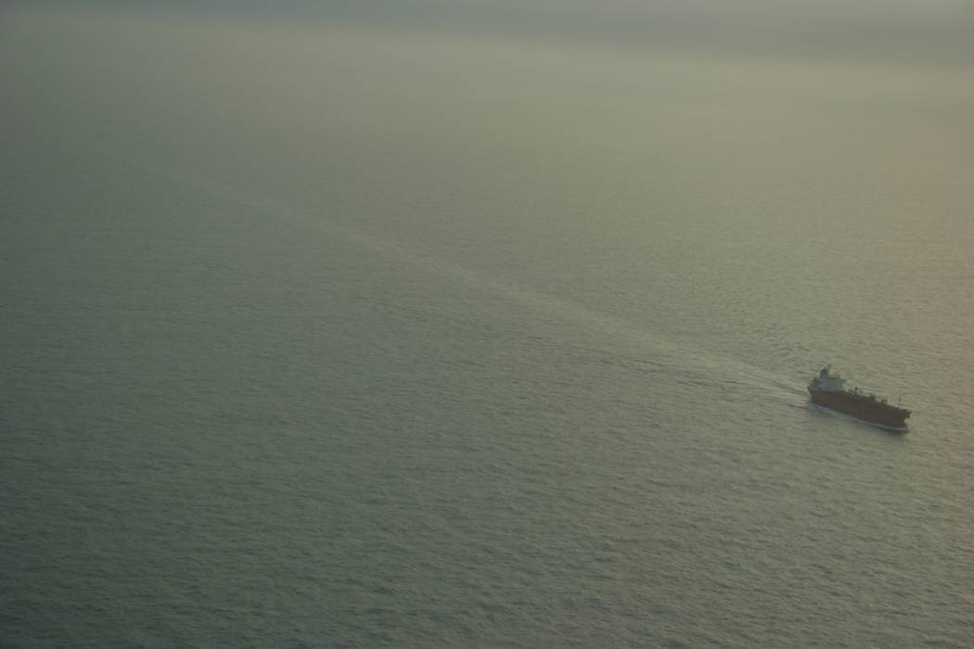
Figure 6.1: Oil discharges in the wake of ships
6.6 A ship may sail through an existing oil slick or sheen that was discharged from another vessel. Such a slick or sheen will be "opened" by the vessel. In some cases, depending on the circumstances, a continuous sheen will be observed after the passing of this ship (see Figure 6.2 below).
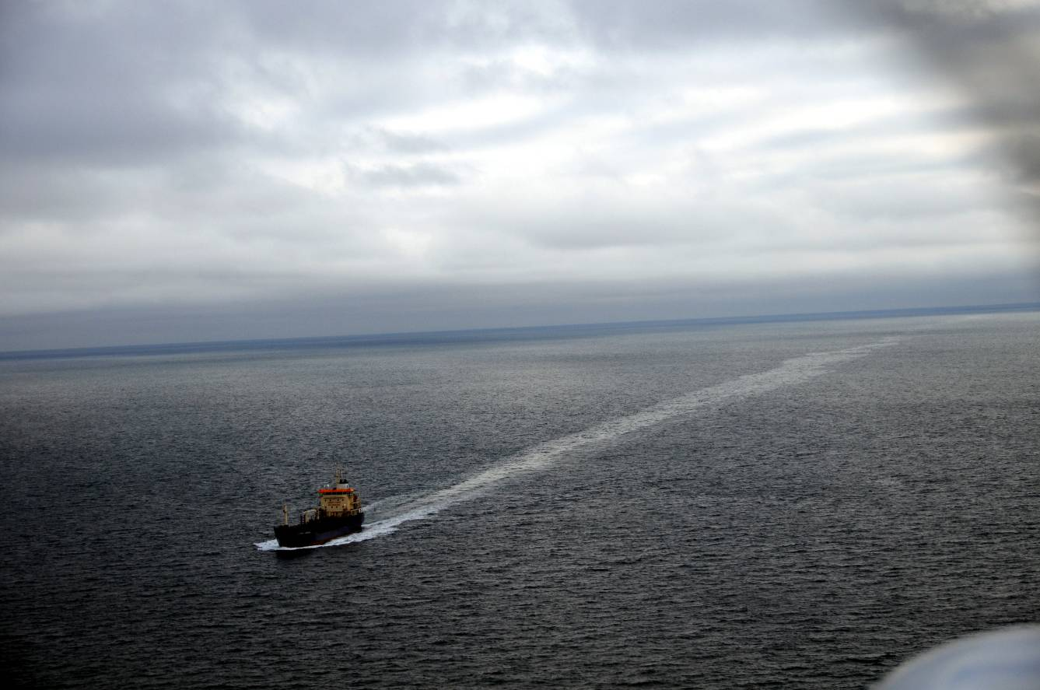
Figure 6.2: Ship sailing through pre-existing oil slick
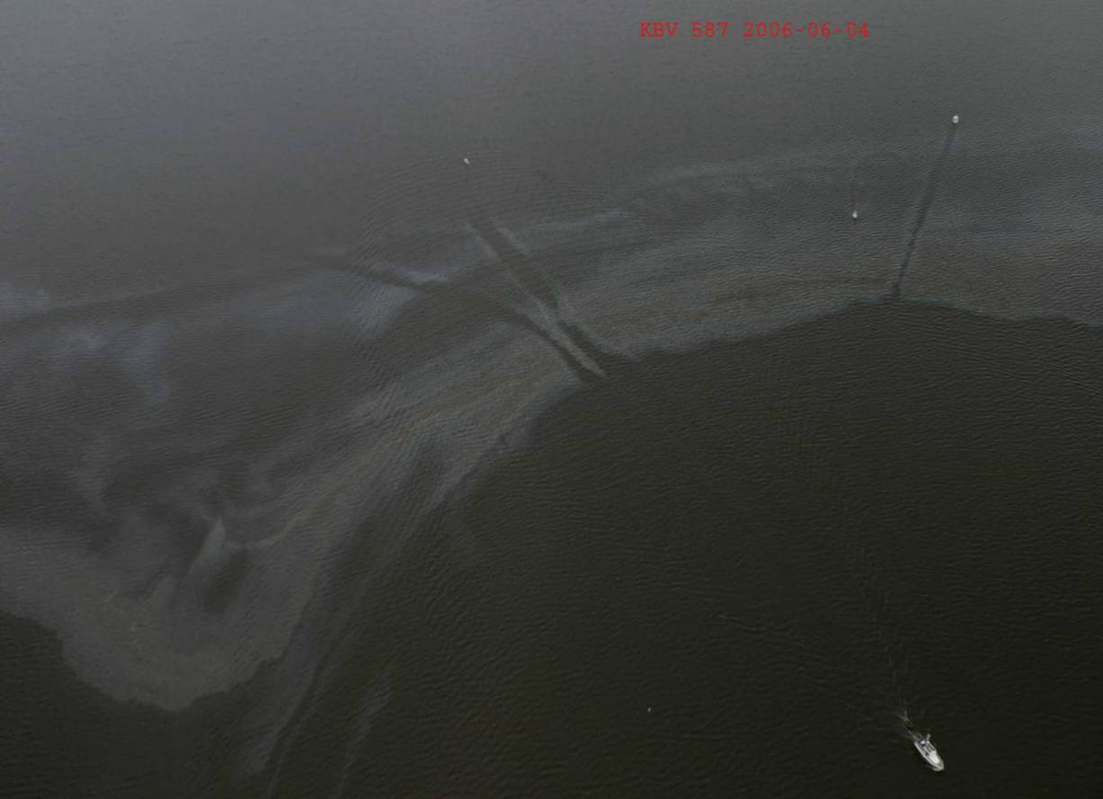
Figure 6.3: Slick after passage through it by another ship
6.7 The two situations, a ship discharging oil or a ship sailing through an existing oil slick, can easily be distinguished by an experienced observer thus enabling the observer to establish whether or not the slick or sheen is a result of a discharge from the observed ship or from another ship.
6.8 Other phenomena also produce anomalies on the sea surface. Such phenomena include cloud shadows, seaweed, jellyfish, plankton blooms and subsurface sand banks. However, these phenomena will never resemble the oil in a ship's wake resulting from an operational discharge.
6.9 Experienced observers are able to determine the difference between these phenomena and oil. They can also distinguish between the different colours which are displayed by patches of oil of different thicknesses.
6.10 It is however sometimes difficult for even experienced observers to determine purely from visual observation whether certain spills result from operational spillages or are non-Annex I products or vegetable oil. In such circumstances an inquiry as to the cargo on board the vessel will resolve the problem. Certain products which are transported and discharged under the Regulations of Annex II of the MARPOL Convention may, when discharged into the sea, form layers on the water surface which could be similar to oil layers. In such an event, only inspection on board can produce a decisive answer as to whether the discharge exceeded the criteria of Annex I or Annex II of the Convention.

Section 6.3: Observations as evidence of violations of MARPOL
Discharges of oil or oily mixtures from the machinery spaces of all vessels
6.11 Investigations have taken place during various trials and intercalibration tests to ascertain whether discharges which are within the limits set by MARPOL (see tables II and III, chapter 2) can be seen by an observer.
6.12 The following conclusions can be drawn from the test results:
a. no discharge with an oil content of 15 PPM or below has ever been detected by visual observation*;
b. discharges with an oil content greater than 15 PPM but less than 100 PPM cannot be observed under normal aerial surveillance conditions, as they never form continuous films or sheens with length greater than a few decimetres. However, discharges between 50 and 100 PPM have been visible under very special conditions (high discharge rate, low ship speed, low wind speed and calm sea).

Discharges from cargo tanks of oil tankers
6.13 Tests indicate that discharges of cargo residues allowed under MARPOL (i.e. beyond 50 nautical miles from the shore) may be observed as a blue or rainbow sheen, sometimes with brown patches, behind the vessel.
6.14 The results of investigations indicate that the discharge of oil or oily mixtures from cargo areas of oil tankers in compliance with applicable regulations may result in oil traces which are visible on the water surface. These oil traces mainly appear as blue or rainbow sheens, although brown patches of oil may occur in the wake of the ship (see photo below). The results of an investigation carried out on board the discharging vessel should give a decisive answer as to whether or not the discharge exceeds the criteria of Regulation 9 of Annex I to the MARPOL Convention.
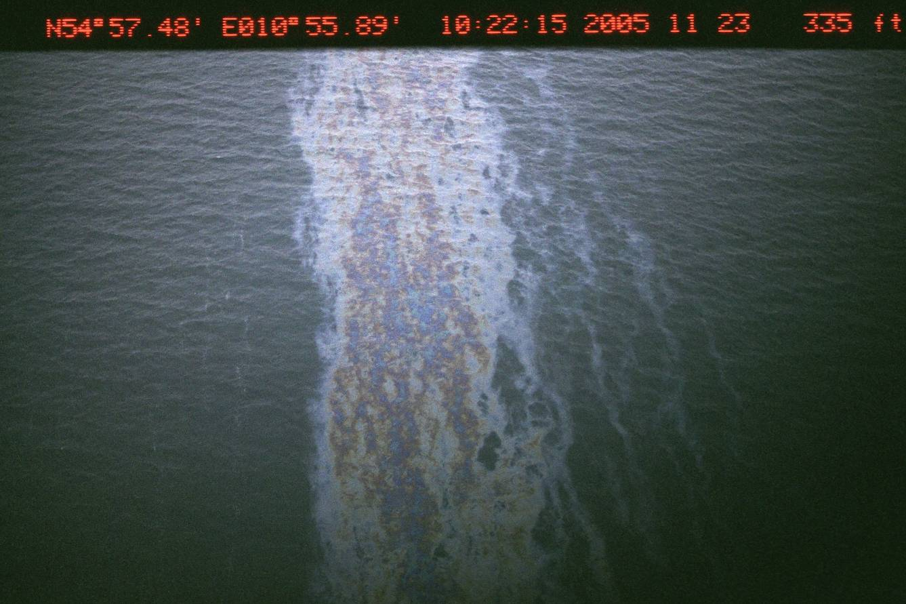
Figure 6.4 Rainbow or sheen patches
6.15 For a detailed description of the tests referred to in this section and their results the reader is referred to the bibliography.

Section 6.4: Assessment of oil quantity
6.16 Although it has been established that evidence through visual observation is sufficient to determine whether a breach of MARPOL has occurred, it may also be useful to estimate the quantity of oil spilt. Such information could be used to assist in determining the level of the penalty which may be imposed.
6.17 It is possible to estimate the quantity of oil by establishing:
a. the extent of the area affected by pollution;
b. the extent of the oil coverage within the area;
c. the thickness of the oil film as estimated by its appearance.
6.18 Research under the auspices of the Bonn Agreement has shown that there is a reliable relationship between the visual appearance of the oil slick and its thickness. This relationship has been tabulated in the Bonn Agreement Oil Appearance Code (BAOAC):
BONN AGREEMENT OIL APPEARANCE CODE
CODE | Description | Layer thickness interval (µm) | Litres per km²
1 | Sheen (silvery/grey) | 0.04 - 0.30 | 40 – 300
2 | Rainbow | 0.30 – 5.0 | 300 – 5000
3 | Metallic | 5.0 – 50 | 5000 – 50,000
4 | Discontinuous true oil colour | 50 – 200 | 50,000 – 200,000
5 | Continuous true oil colour | 200 – more than 200 | 200,000 – more than 200,000

6.19 Codes 4 and 5 are subject to further evaluation.
6.20 Detailed guidelines on the application of the Bonn Agreement Oil Appearance Code have been published by the Bonn Agreement. In summary, a specially trained observer should estimate the area covered by the whole slick, the percentage of that area covered by the oil and the code that is applicable. The area should then be multiplied by the percentage and the appropriate number of litres per square kilometre in order to produce an estimate in litres of the amount of oil involved. It is commonly regarded as appropriate to use the lower end of the range of litres for each code for purposes of enforcement of offences, since this is the minimum amount that the research shows will be involved. (For response purposes, it may be more appropriate to use the upper end of the range, since this will ensure that the response allows a sufficient measure of precaution).

Section 6.5: Reporting visual observation
6.21 The Bonn Agreement and the Helsinki Commission have established common forms for a Standard Pollution Observation/Detection Log and for a Pollution Observation/Detection Report on Polluters and Combatable Spills (Annexes A and B to this chapter). These will normally be completed by the observers.
6.22 Where they are to be used for enforcement purposes, it is also desirable that these operational logs and reports are accompanied by supporting material containing:
a. the details of the member(s) of the aerial surveillance crew that is/are responsible for the observation. This should include name, rank and length of service in aerial surveillance operations and in the present rank;
b. the details of training in aerial observation that the person(s) responsible for the observation have received;
c. (where relevant) the details of the training in the application of the Bonn Agreement Oil Appearance Code that the person(s) responsible for the observation have received.
6.23 Wherever possible, a report of a visual observation should be accompanied by a photograph. Details on photographic possibilities are given in Chapter 7.
Annex A
HELCOM BONN AGREEMENT STANDARD POLLUTION OBSERVATION / DETECTION LOG NO POLLUTION DETECTED

REPORTING AUTHORITY | AIRCRAFT REG | MISSION No | CAPTAIN | CO PILOT | OPERATOR | OBSERVER | DAY | DATE | MONTH | YEAR

FLIGHT TYPE | ROUTE / AREA |  |  |  | TIME OVER THE SEA |  | TIME OVER THE SEA |  | TOTAL
FLIGHT TYPE |  |  |  |  | DAY |  | NIGHT |  | TIME OVER THE SEA
 |  |  |  |  | hrs | mins | hrs | mins | hrs | mins

No | AREACODE | TIME  UTC | POSITION |  | DIMENSIONS |  | AREA COVER  % | OILED AREA  Km² | OIL APPEARANCE COVERAGE  (PERCENTAGE - %) |  |  |  |  |  | MINIMUM VOLUME | MAXIMUM VOLUME | COMBAT
No | AREACODE | TIME  UTC | LATITUDE  ‘NORTH’ | LONGITUDE  ‘EAST/WEST’ | LENGTH  Km | WIDTH  Km | AREA COVER  % | OILED AREA  Km² | 1 | 2 | 3 | 4 | 5 | Oth | m³ | m³ | Y / N

No | POLL  TYPE | DETECTION |  |  |  |  |  | PHOTO | VIDEO | FLIR | WEATHER |  |  |  |  |  |  | REMARKS
No | POLL  TYPE | SLAR | IR | UV | VIS | MW | LF | Y / N | Y / N | Y / N | WIND |  | CLOUD |  | VIS | SEA | Wx
 |  |  |  |  |  |  |  |  |  |  | ^{O} |  |  | FT
 |  |  |  |  |  |  |  |  |  |  | ^{O} |  |  | FT
 |  |  |  |  |  |  |  |  |  |  | ^{O} |  |  | FT
 |  |  |  |  |  |  |  |  |  |  | ^{O} |  |  | FT

No | REMARKS | OIL APPEARANCE TABLE
 |  | No | OIL APPEARANCE  DESCRIPTION | MINIMUM VOLUME m³ / km² | MAXIMUM VOLUME m³ / km²
 |  | 1 | SHEEN | 0.04 | 0.30
 |  | 2 | RAINBOW | 0.30 | 5.00
 |  | 3 | METALLIC | 5.00 | 50.0
 |  | 4 | DISCONTINUOUS TRUE COLOUR | 50.0 | 200
 |  | 5 | TRUE COLOUR | 200 | >200

STANDARD POLLUTION OBSERVATION LOG
COMPLETION GUIDE

HELCOM: Tick HELCOM Box if the flight is in HELCOM Area
BONN AGREEMENT: Tick BONN AGREEMENT Box if flight is in Bonn Agreement Area
NO POLLUTION DETECTED: Tick NO POLLUTION DETECTED if no pollution is detected
REPORTING AUTHORITY: National Authority Responsible for Pollution Control.
AIRCRAFT REG: Aircraft Registration Letters / Numbers.
MISSION No: Nationally Assigned Mission Number.
FLIGHT TYPE: National Designation for Flight Type as follows:
NAT - National
REG - Regional
EXER - Exercises
OPS - Operational Flight.
RIG - Oil Rig Patrol
SHIP - Shipping Patrol
TDH - Tour de Horizon Flight
CEPCO - Co-ordinated Extended Pollution Control Operation
CAPTAIN OF AIRCRAFT: Name of Captain
CO PILOT: Name of Co Pilot
OPERATOR: Name of Operator
OBSERVER: Name of Observer
DAY: Number Assigned to the Day of the Week as follows:
Monday - 01
Tuesday - 02
Wednesday - 03
Thursday - 04
Friday - 05
Saturday - 06
Sunday - 07
DATE/MONTH/YEAR: Two number designation for each of date/month/year of Flight
ROUTE / AREA: Flight Route or Area
TIME OVER THE SEA – DAY: Time over the Sea during Daylight
TIME OVER THE SEA – NIGHT: Time over the Sea at Night
TOTAL TIME OVER SEA: Total time between Coasting Out and Coasting In.
No: Number allocated to pollution detection.
AREA CODE: The international telephone code for the country (Area) in which the pollution is located:
Bonn Agreement
Belgium 32 Denmark (+ Helcom) 45
France 33 Germany (+ Helcom) 49
Netherlands 31 Norway 47
Sweden (+ Helcom) 46 United Kingdom 44
Helcom
Estonia 372 Finland 358
Latvia 371 Lithuania 370
Poland 48 Russia 7
TIME UTC: Time of pollution detection.
POSITION: Latitude and longitude of pollution (degrees, minutes and seconds // WGS / 84 Datum).
DIMENSIONS: Length and width of pollution in kilometres.
AREA COVER %: Observer's assessment of the percentage of the boxed dimensioned area (length x width), covered with pollution.
OILED AREA: Oiled Area covered with pollution; calculated by multiplying length, width and cover %
Example:
Length x Width x Cover %
2 Km x 1 Km x 50%, gives...
[2.0] x [1.0] x [0.5]
= Oiled Area = 1 Km²
OIL APPEARANCE COVERAGE %: Allocation of Percentage of the `Oiled Area' to the Appearance of the pollution.
Example:
1/2 cover – Rainbow - Column 2 = 50%
1/4 cover - Metallic - Column 3 = 25%
1/4 cover - True Colour - Column 5 = 25%
MINIMUM VOLUME: Minimum Quantity of Oil Pollution in cubic metres.
Calculated as follows:
[Oiled Area] x [Appearance Code Minimum Thickness Value] X [Decimal Percentage of Appearance].
[1 Km²] x [0.3 m³/km²] x [0.50] = 0.15 m³
[1 Km²] x [5.0 m³/km²] x [0.25] = 1.25 m³
[1 Km²] x [200 m³/km²] x [0.25] = 50 m³
Minimum Total Quantity = [0.15] + [1.25] + [50] = 51.4 m³
MAXIMUM VOLUME: Maximum Quantity of Oil Pollution in cubic metres.
Calculated as follows:
[Oiled Area] x [Appearance Code Maximum Thickness Value]
X [Decimal Percentage of Appearance].
[1 Km²] x [5.0 m³/km²] x [0.50] = 2.5 m³
[1 Km²] x [50 m³/km²] x [0.25] = 12.5 m³
[1 Km²] x [>200 m³/km²] x [0.25] = > 50 m³
Maximum Total Quantity = [2.5] + [12.5] + [>50] = > 65 m³
No: The same number as previously allocated to the pollution detection.
POLLUTION TYPE: Pollution Type as follows:
OIL - Oil
CHEM - Chemical
FISH - Fish Oil or Waste
VEG - Vegetable Oil or Waste
OTH - Other (Amplify in Remarks)
UNK - Unknown

DETECTION: Detection Sensor.
SLAR - Radar
UV - Ultra Violet
IR - Infrared
VIS - Visual
MW - Microwave
LF - Laser Fluorosensor

PHOTO: Photographs of pollution
VIDEO Video of the pollution
FLIR Forward Looking Infrared of the pollution
WEATHER: Weather at the time of pollution observation / detection
Surface Wind: Direction and Speed (knots or beaufort as required by national authorities),
Cloud: Coverage in Octas or aviation description (scattered / overcast)) and Base in feet,
Visibility: Nautical Miles or Kilometres
Sea State: Using the description code given in the Abbreviations
Weather: Rain, Snow, Haze, Mist etc

REMARKS: Any Amplifying Remarks.

Note: For all Detections / Observations Boxes write:
‘Y’ Sensor used and pollution detected
‘N’ Sensor used but pollution not detected
‘-‘ Sensor was not used or not available

Annex B
POLLUTION OBSERVATION / DETECTION REPORT ON POLLUTERS AND COMBATABLE SPILLS (IMO)

1. REPORTER:
a. Reporting State: :.............……………………..……..……………............................
b. Observer (Organization/Aircraft/Platform) : .........…………………………Call Sign…….……..….….............
c. Observer(s)(Family Name(s)) : 1........................... …..………........2………..….....…..……........

2. DATE AND TIME:
a. Date (yymmdd) b. Time of Observation (UTC) : Date...............................… Time…………...…………….UTC

3. LOCATION OF THE POLLUTION:
a. Position of the Pollution (Lat/Long) : Begin…..………..…..……....N, ……………..…..…..…..W/E
: End……………….………….N, ………..…………....……W/E
b. Inside/Outside Territorial Waters : o Inside o Outside

4. DESCRIPTION OF THE POLLUTION:
a. Type of Substance Discharged : ...................................................………………..……………......
b. Estimated Quantity : ..............................m³
c. Length (km) d. Width (km) e. Coverage (%) : Length.......…...km Width…..........km Coverage…..%
f. Oiled Area (km²⁾ : Oiled Area……….….(km²⁾
g. Percentage of Oiled Area by Appearance (%) 1:…………….% 4:……………..….%
1=Sheen 2=Rainbow 3=Metallic 2:…………….% 5:………………...%
4=Discontinuous True Colour 5=True Colour 3:…………….% Other:…..……….%

5. METHOD OF DETECTION AND INVESTIGATION:
a. Detection (Visual, SLAR, IR, UV, Video, MW : o Visual o SLAR o IR o UV o Video o MW, LFS, Identification Camera, Other) : o LFS o Video o. Ident.Cam o Other
b. Discharge Observed c. Photographs Taken : Observed: Yes / No Photos Yes / No
d. Samples Taken e. Need of Combating : Samples: Yes / No Combat: Yes / No
f. Other Ships/Platforms in Vicinity (Names) : .......................................................………………………………

6. WEATHER AND SEA CONDITIONS:
a. Wind Direction b. Wind Force c. Visibility : Direction…….Degrees Force……...Bft/Kts Vis...…...kms
d. Cloud Coverage e. Wave Height : Cloud………..Octa Wave Ht……..….m
f. Current Direction : Current Direction………….Degrees

OBSERVATION OF A DISCHARGE OF HARMFUL SUBSTANCES BY A SHIP UNDER ARTICLE 6(3) OF MARPOL
7. SHIP INVOLVED:
a. Name : .................………………………………………………….............
b. Callsign c. Flag State : Callsign:............................. Flag State:…………………..........
d. Home Port : ………………………………………............................................
e. Type of Ship : ……………………………………................................................
f. Position (Lat/Long) : …………….....N, ………………...W/E …….…..……UTC : ……………….N, ………………...W/E …….…...…...UTC
g. Heading h. Speed : Heading.............Degrees Speed........................kts
i. Colour of the Hull : ..................……………………………………………...................
j. Colour of the Funnel and Funnel Mark : ...................……………………………………………..................
k. Colour / Description of Superstructure : ………………………………………………………………………
l. Vessels IMO Number : ………………………………………………………………………
8. INFORMATION BY RADIO CONTACT:
a. Radio Contact b. Means of Communication : Contact: Yes / No Means VHF / Teleph, ...…….Ch / Freq
c. Last Port of Call : …………………………………………….....................................
d. Cargo e. Last Cargo : ………………………………………………………………………
f. Next Port of Call, ETA (yymmdd) : ………………………………………..........ETA..........................
e. Statements of Captain/Officer on Duty : ………………………………………...........................................
………………………………………............................................
………………………………………............................................
OBSERVATION OF A DISCHARGE OF HARMFUL SUBSTANCES BY AN OFFSHORE INSTALLATION
9. OFFSHORE INSTALLATION INVOLVED:
a. Platform Name : ………………………………………….............................…........
b. Position (lat/long) : …………………………… N ……………………W/E
c. Type of Platform (Production/Drilling etc) : .............................................……………………………………
d. Company Name : ………………………………………………………………………..

10. INFORMATION BY RADIO CONTACT:
a. Radio Contact b. Means : Contact Yes / No Means VHF / Teleph, .……Ch / Freq
c. Contact with (position) : ............................................……………………………………....
d. Statements : ………………………………………….........................................
: .………………………………………............................…............
: …………………………………………............................….........

11. REMARKS AND ADDITIONAL INFORMATION:
……………………………………………................................….................................................................................
…………………………………………….....................................................................................................................
…………………………………………….....................................................................................................................

Chapter 7: Remote Sensing
This chapter deals with airborne remote sensing systems, which are an efficient means of detecting discharges of oil at sea and supplying information for use as evidence. The data collected from all sensors is stored and can be examined either in flight or after landing. Also, stills or frozen images and conventional high-resolution photographic prints annotated with date, time, position and other mission data can be stored or transferred to the ground via an image link.

Section 7.1: Features and operational capabilities
General
7.1 Most remote sensing instruments compare the radiation or reflection from the unpolluted sea with radiation or reflection from the polluted area. Investigations have shown that traces of oil which are detected by remote sensing equipment exceed discharge limits as specified in MARPOL Annex I.
7.2 Modern civilian airborne remote sensing systems are based on a multi-sensor concept with all-weather and day/night capability and are designed for maritime surveillance. The major use of these systems is the detection and monitoring of oil spills at sea but they can also be used for detection of other harmful substances, for example chemicals, and for the detection of algae. Visual observations and the various sensors complement each other to produce evidence of a violation.


Figure 7.1 Surveillance aircraft
7.3 The design of remote sensing systems varies but they are usually designed with the following functions:
a. Day/night and all-weather capability
b. Real-time presentation of images and selected information on the operator's display
c. Large-area coverage and long-range detection of small targets
d. High quality photography
e. Automatic annotation of all images with date, time, position etc.
f. Automatic positioning of targets selected by the operator
g. Information storage
7.4 Certain systems may also enable:
a. Measurement of spill film thicknesses, mapping of thickness variations within the spill (thus enabling determination of spill volume)
b. Identification (in bad visibility and at night) of ships (suspected of causing a spill)
c. Identification of the pollutant and determination of the type of oil
d. Detection of pollutants below the water surface
e. Documentation support to surface and ground-based units by image link systems
f. Ground-based image-processing
7.5 The following sensors are found in existing operational systems:
a. Side Looking Airborne Radar (SLAR)
b. Infra-Red line scanner (IR-scanner)
c. UltraViolet line scanner (UV-scanner)
d. MicroWave Radiometer (MWR)
e. Photographic cameras and video cameras
f. Image intensifiers; Low Light Level TeleVision (LLLTV)
g. Synthetic Aperture Radar (SAR)
7.6 The capabilities of different remote sensing systems are compared in the following tables. These sensors have different capabilities and therefore in a multi-sensor concept can complement each other and the visual observations. Operationally, the surveillance procedure makes use of these capabilities in the following ways.
1. Spill detection: SLAR or visual
2. Spill/source investigation: IR/UV, MWR, LLLTT, Video camera or visual
3. Spill identification: LFS or visual
4. Documentation: All means
7.7 Most systems have a data presentation and management console which consists of computer signal processor, monitors, data storage, frame memory, hard copy unit, and control panels for different sensors as shown below.
TABLE I

 | SENSOR
 | Human eye | Photograph camera | Video camera | LLLTV | UV-scanner | IR-scanner
Working principle  Capability | passive;  visible light;  reflection | passive;  visible light;  reflection | passive;  visible light;  reflection | passive;  visible light; (UV)  reflection | passive;  UV;  reflection | passive;  thermal IR
Real time | X | X | X | X | X | X
Day | X | X | X | X | X | X
Night |  |  |  | X |  | X
All weather
Oil type determination | (X) | (X) | (X)
Film thickness determination | (X) | (X) | (X)
Subsurface oil detection | (X) | (X) | (X) | (X)
Mapping | (X) | X | X | X | X | X
Detection range | variable |  |  |  | 0.5 - 2.5 km depending on altitude
Electronic image transmission |  |  | X | X | X |  | X
Ship identification | X | X | X | X
Position documentation | X | X | X | X | X |  | X
X = Capability
(X) = Capability depending on circumstances
TABLE II
 | SENSOR
 | Side-Looking Airborne Radar | Microwave radiometer (1 frequency) | Microwave radiometer (3 frequencies)
Working principle  Capability | active;  microwave;  backscatter | passive;  microwave emission | passive;  microwave emission
Real time | X | X | X
Day | X | X | X
Night | X | X | X
All weather | X | X | X
Oil type determination
Film thickness determination |  | 0.1 - 2 mm | 0.05 - 3 mm
Subsurface oil detection
Mapping | X | X | X
Detection range | 40 - 160 km | 500 m | 500 m
Electronic image transmission | X | X | X
Ship identification
Position documentation | X | X | X
X = Capability

Data presentation and management console
7.8 A basic principle of airborne remote sensing systems is the handling and recording of all received information on board the aircraft. This is accomplished by a central management console where the operator can inspect the remote sensing data presented, either as images in real-time, or as replayed recordings.
7.9 An annotation computer can be fed manually by the operator with data before every flight mission. During the flight the annotation computer may continuously and automatically be fed with position data, aircraft heading and altitude. The computer can then automatically furnish all recorded images with information on day, time and position, as well as data related to the sensors, the aircraft and the flight mission.
7.10 At the console, the operator can select information from the different sensors. The output from the sensors can be displayed in black and white or colour as real-time images on a monitor (TV display). Two channels can usually be shown at the same time, for example IR-UV or IR-MWR channels side by side - thereby assisting oil spill quantity assessment.

Data documentation and transmission
7.11 After processing, the information from all sensors is stored by digital cassette recorders and/or hard disks. These recordings can be replayed for evaluation either in flight or after landing. Also, stills or frozen images from conventional TV cameras or low light level TV cameras can be stored digitally and replayed afterwards. Modified single reflex cameras can give conventional high resolution photographic prints annotated with date, time, position and other mission data. All information can be transferred to the ground via an image link and be reproduced as large hard copies.

Calibration
7.12 As remote sensing instruments work on differences between signals rather than absolute signal strength they do not require pre-flight calibration. The quantitative capabilities of the systems are tested in regular exercises.

Section 7.2: Brief description of sensors

General
7.13 Registration and documentation of an oil spill can be accomplished as illustrated in the picture shown in figure 7.2. The way in which this is carried out will depend on different factors such as visibility, cloud-base and wind.
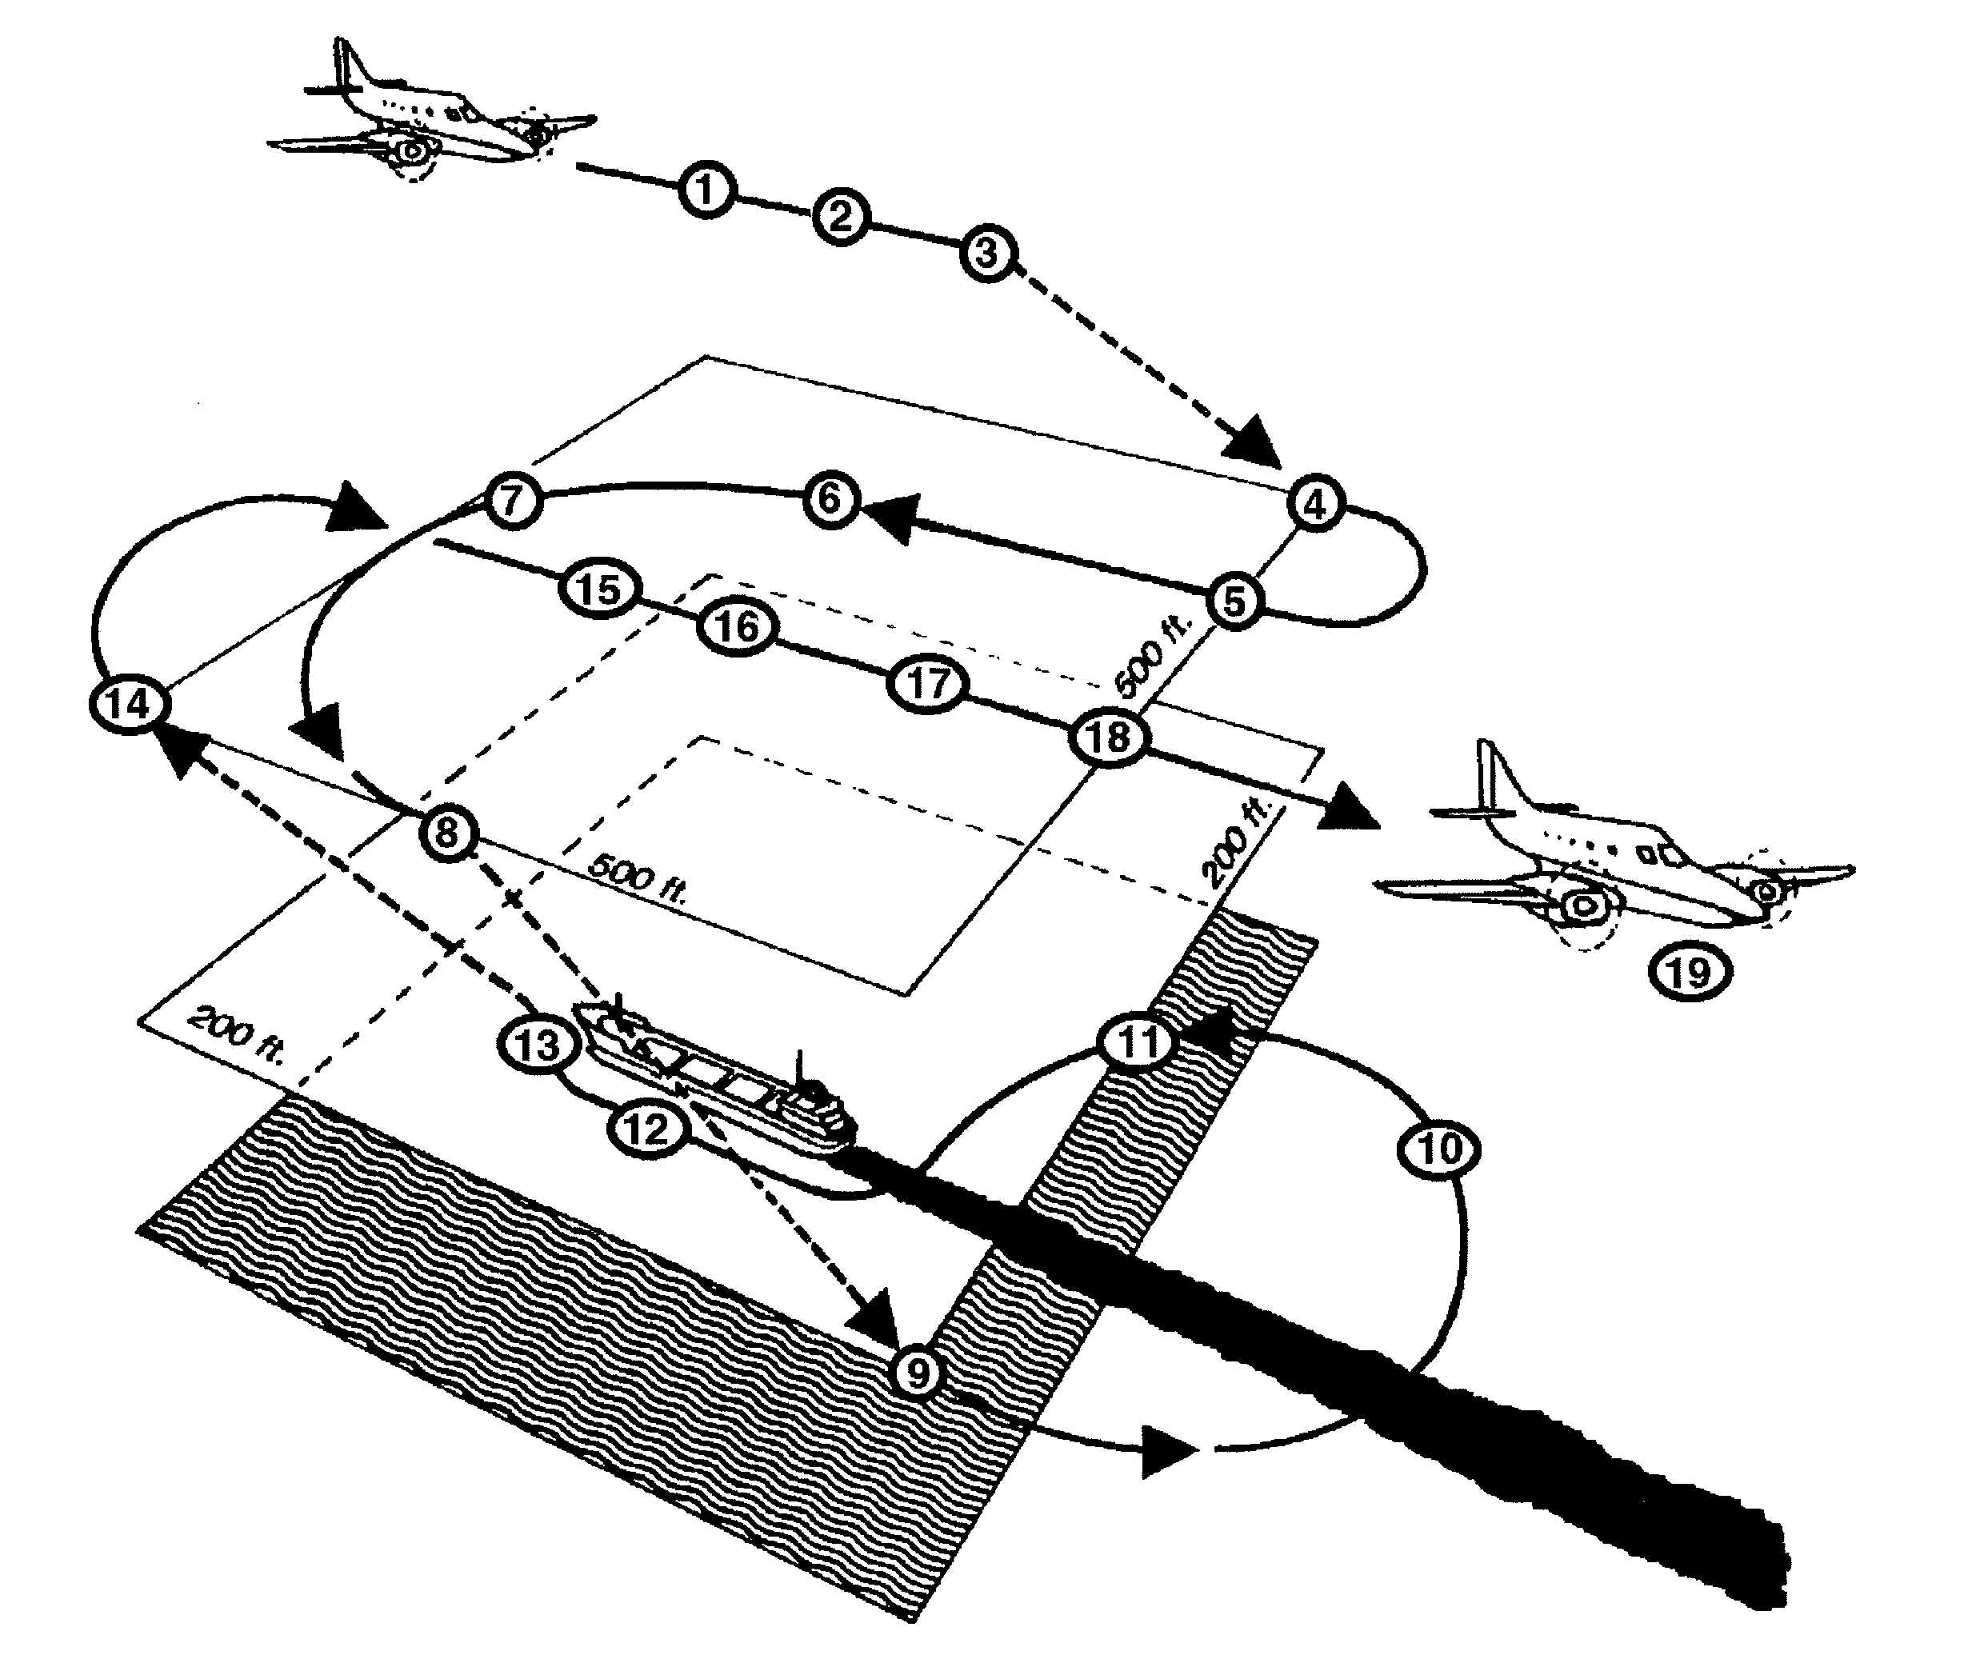
Figure 7.2 Airborne registration and documentation of an oil spill
Legend to Figure 7.2:
Action point | Action
1. | Detection
2. | SLAR and camera registration
3. | Storing of SLAR images
4. | Descending to 500 ft
5. - 8. | Camera registration of the ship's wake
9. | Descending to 200 ft
10. | Obtaining camera registration of the spill
11. - 13. | Obtaining camera registration of the ship (name etc.)
14. | Ascending to 500 ft
15. - 17. | Registration by IR/UV, MWR, and LSF
17. - 18. | Storing of IR/UV images
19. | Documentation and reporting, including tape recording of radio-communication between ship and aircraft

Photographic camera systems
7.14 An aerial camera system is a common tool for recording violations. The system normally used includes modified 35 mm single reflex cameras with special data boxes mounted on the back. It is often used as supporting evidence to visual observations. Data is exposed onto the film and appears as a data strip along the upper part of the developed photograph. This data includes date, time, position, aircraft heading and picture identification numbers. The data boxes are connected to the annotation computer.
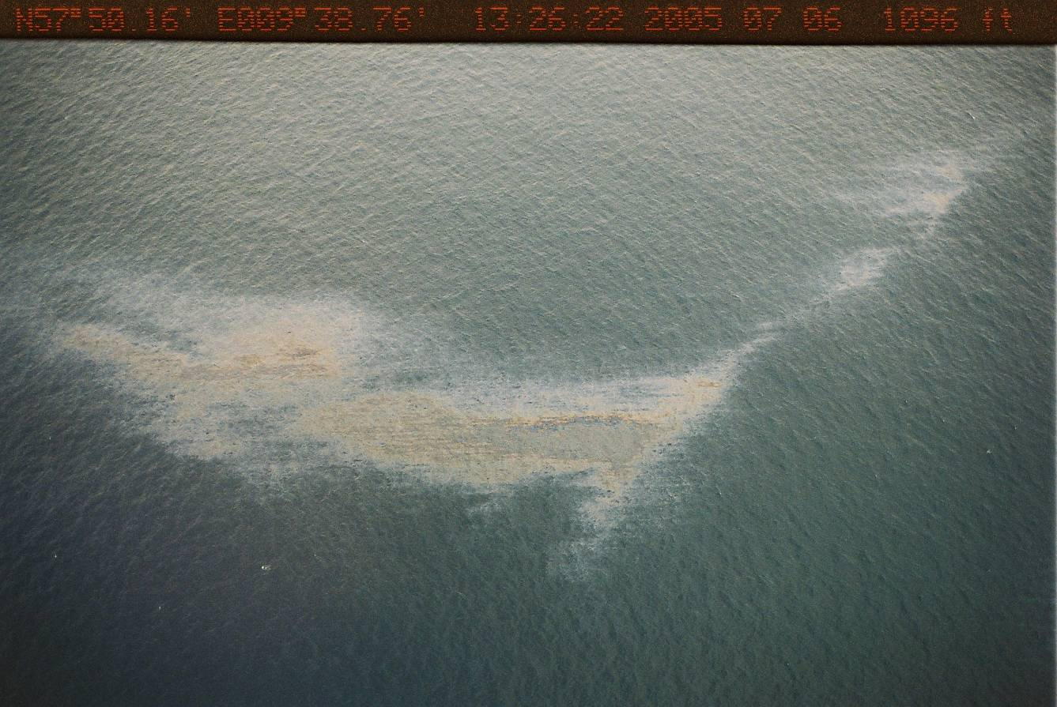
Figure 7.3 Photo with data strip

Video Cameras
7.15 Video cameras are also frequently used. The data, as with photographic camera systems, is recorded on the videotape.

Side-looking airborne radar (SLAR)
7.16 The radar signal of the SLAR is returned when there is reflection from the sea surface (sea clutter). Such reflection is caused by capillary waves which are present on the sea surface even at very low wind velocities. If these capillary waves are smoothed by the presence of a substance on the sea surface, for example oil, little or no signal is returned to the emitting radar. The SLAR can therefore detect such a substance by comparing the level of return from the different parts of the sea. Even a thin oil film makes the sea surface smoother than the surrounding area.
7.17 The SLAR requires a fixed antenna mounted under and along the aircraft fuselage. The radar beam can be directed either to one side or to both sides of the aircraft and is perpendicular to the aircraft's direction of motion. A continuous scan of the ground or sea is obtained due to the aircraft's forward motion. The swath immediately below the aircraft cannot be surveyed because of the construction of the antenna with side-radiating beams.
7.18 A signal processor in the SLAR system integrates several hundred radar pulse responses into one TV line. The resulting image is then presented on a TV monitor. In this way, the clean sea is presented on the screen as a grey background. Oil spills appear as dark areas, while vessels and other objects on the surface show up as white spots. It is often also possible to observe patterns in the sea clutter itself, indicating sea currents, large wave systems, and underwater structures in coastal areas. Dark area are investigated further in order to determine whether they are oil.
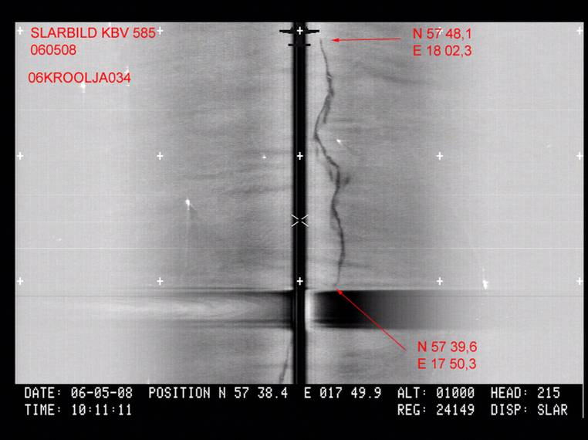
Figure 7.4 SLAR picture showing oil spill and data strip

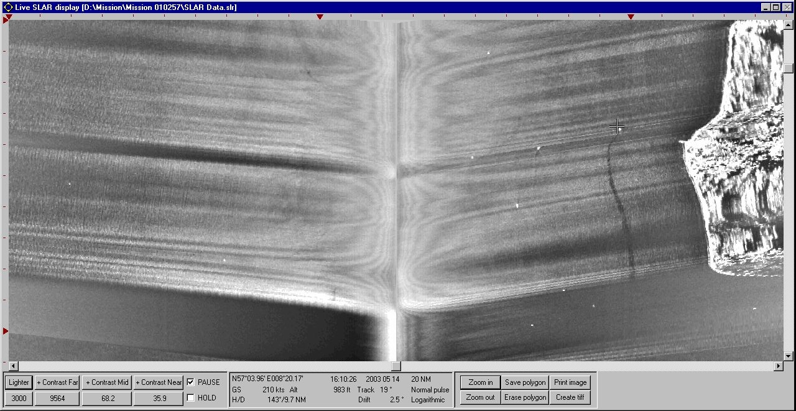
Figure 7.5 SLAR picture showing oil spill and data strip
7.19 One common feature of SLARs is automatic target positioning. The operator can use a special light or roller pen to point at a target on the monitor screen. The position of the target is then automatically calculated and immediately presented as latitude and longitude in the data block together with the other annotation data of the SLAR image.
7.20 For oil spills the detection range by a SLAR, depending on weather conditions, is normally about 30 km on each side of the aircraft and the surface coverage could, depending on the aircraft's speed, be 15 000 km² per hour.

Infrared/ultraviolet (IR/UV) scanner
7.21 The IR-channel can make day and night registrations when there is no mist or clouds between the plane and the sea. It measures the thermal radiation which is generally less from an oil film than from the water. The thicker parts of an oil spill differ more in their radiation from the water than the thinner parts. Consequently the IR-channel gives some indication of film thickness variations in an oil spill.
7.22 The UV-channel can only be used in daylight and clear conditions. It registers the UV-light which is being reflected by the oil. An oil film, even if it is extremely thin, reflects UV-light better than the clean water surface. The reflectivity is not influenced by the film thickness. Thus the UV-channel maps the whole spill area, even the very thin oil films. The contrast variations only show reflectivity differences in the oil spill and do not indicate thickness variations.
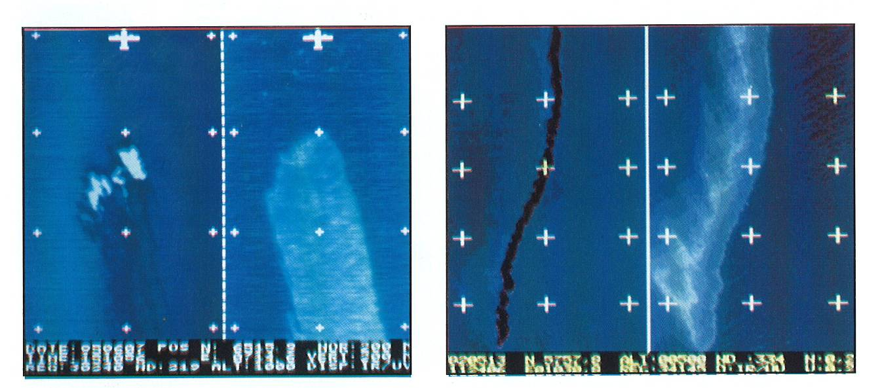
Figure 7.6 IR/UV scanner registrations of oil spills
(with the IR channel to the left and UV to the right for each spill)
7.23 The IR- and UV-channels complement each other. The IR shows the thicker and thinner parts of the spill whereas the UV shows the total coverage (see figure 7.6) The IR-channel on the left half of the picture shows the thicker oil layers as darker in colour. The UV-channel to the right shows the whole oil spill and confirms that the IR-image results from the presence of a substance and not another phenomenon affecting the sea surface temperature. The contrast variations in the UV-channel are caused by differences in UV reflections and do not indicate thickness variations.
7.24 An IR/UV scanner has a much smaller coverage than a SLAR, generally 300 - 500 m width depending on the altitude of the aircraft.
Microwave radiometer (MWR)
7.25 The sea surface naturally radiates microwaves of a wavelength of up to a few centimetres. An oil spill on the sea surface will increase this radiation as a function of the thickness of the oil film. An airborne microwave radiometer records the radiation and when starting a mission will calibrate itself on the natural radiation.
7.26 With a scanning microwave radiometer (coverage generally 300-500 m width) it is possible to map the thickness variations in the oil film and thus calculate the volume of the spill. The console computer calculates the volume of the spill automatically.
7.27 A modern microwave radiometer, using three frequencies simultaneously, can measure the radiation of oil films within a thickness interval from 0.05 to 3 mm (when the thickness is more than 3 mm the MWR measures 3 mm and therefore underestimates the volume of the spill). Experience has shown that most oils, even rather high viscosity types, soon spread out to these film thicknesses.
7.28 The microwave radiometer registration of an oil spill can be presented on a monitor screen as a colour picture where different thicknesses are coded with different colours for easy interpretation. The microwave radiometer is mainly a tool to measure the quantity of an accidental oil spill. As it does not measure thicknesses below 0.05 mm, it will usually not detect operational discharges.
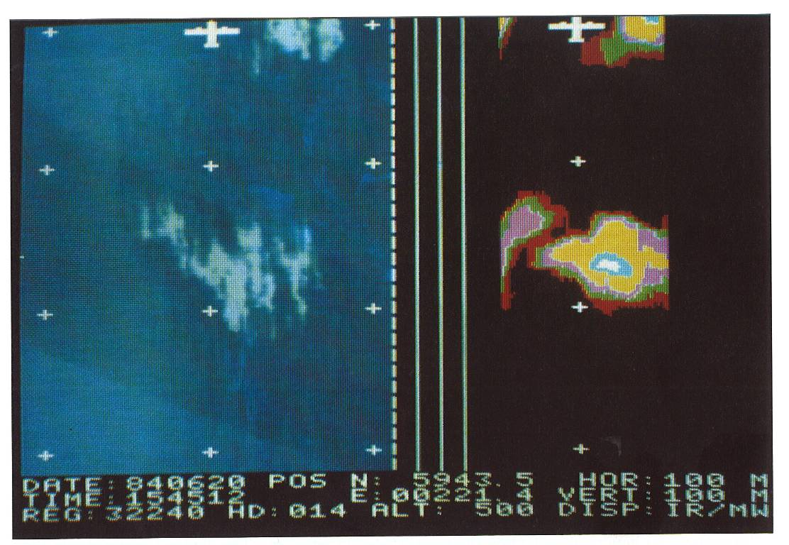
Figure 7.7 IR/MWR scanner registrations
(with the IR channel to the left and MWR channel to the right)
7.29 The MWR image in figure 7.7 shows the thicknesses in different colours for easy interpretation. This figure does not represent an operational discharge.

Synthetic-aperture radar (SAR)
7.30 SAR is especially suited to satellite-borne applications. The first European remote sensing satellite ERS-1, which was launched in July 1991, carries an imaging SAR. The SAR can survey the world's oceans for large oil spills.
7.31 The drawback of a satellite-borne SAR system is the lack of flexibility. The desired place for surveillance cannot be chosen in the same way as for an airborne system. Besides this, the frequency of passage over any given point is at present very low. Satellite-borne systems can therefore not replace the airborne ones. But the satellite-borne systems have the advantage of covering remote areas, which are seldom surveyed by oil spill surveillance aircraft, and could therefore be useful for statistical studies. The SAR is, however, unlikely to be usable for detection and investigation of operational discharges in the predictable future.

Section 7.3: Satellite surveillance
7.32 Cameras and other forms of remote sensors can be mounted on satellites and can provide information about areas of the sea where the sea-surface appears to be modified in some way. Skilled interpretation of such information can identify areas where such changes may be the result of spilled oil.
7.33 However, there is as yet no technique which can definitely identify oil slicks at sea from satellite observation.
7.34 Satellite surveillance is therefore still only a tool for identifying circumstances which require more detailed investigation by visual observation or remote sensing. Nevertheless it is a very useful tool and one of growing importance for this purpose.

Section 7.4: Documenting remote-sensing results
7.35 A distinction can be made between:
a. remote-sensing systems which document the results on “one-time” material – the typical example is a traditional camera which records the results on a negative, where any subsequent changes can (at least in the large majority of cases) be observed by an expert;
b. remote-sensing systems which document the results on material which is inherently capable of modification – the typical example is the digital camera where the file is capable of being manipulated considerably without the resulting file necessarily showing any changes.
7.36 Where the recording medium has little possibility of being changed without leaving traces, documenting the handling chain between the operator of the remote-sensing device and the evidence for production to the court or other decision-taking authority requires ideally:
a. a record of the person who was the operator of the remote-sensing device; and
b. a record of their qualifications for operating the device efficiently; and either
c. their confirmation that the evidence is the recording medium which was used (for example, a polaroid-camera photograph) or that it is a true print or copy of that recording medium; or
d. confirmation of each step in the chain between the making of the record on the recording medium and the evidence produced.
7.37 Where the recording medium is susceptible to change, there is also a need for confirmation by all those who have handled the recording medium that at no stage has it been changed.

Chapter 8: Modelling the Behaviour of Spilt Oil

It is possible, using a computer, to run a mathematical model of the behaviour of spilt oil, the direction and speed at which it moves and the way in which it spreads and changes its properties. It is also possible to use these techniques to follow a spillage back to the geographical area whence it originated.

Section 8.1: Introduction
8.1 This chapter must be read in the knowledge that the technique described here is at best, a secondary tool with which to identify potential suspects. Further evidence will always be needed to make a positive identification.
8.2 Whether something lying on the surface of the sea remains in one position or moves depends upon the effect of the wind, the waves and the current at any given time. In the case of oil, this analysis is too simple and there are additional factors, such as the changes which take place in the spill itself, to be taken into account.
8.3 Using various parameters such as those already mentioned it is possible to formulate a series of equations which describe, mathematically, and with some degree of certainty, the behaviour of an oil spill.
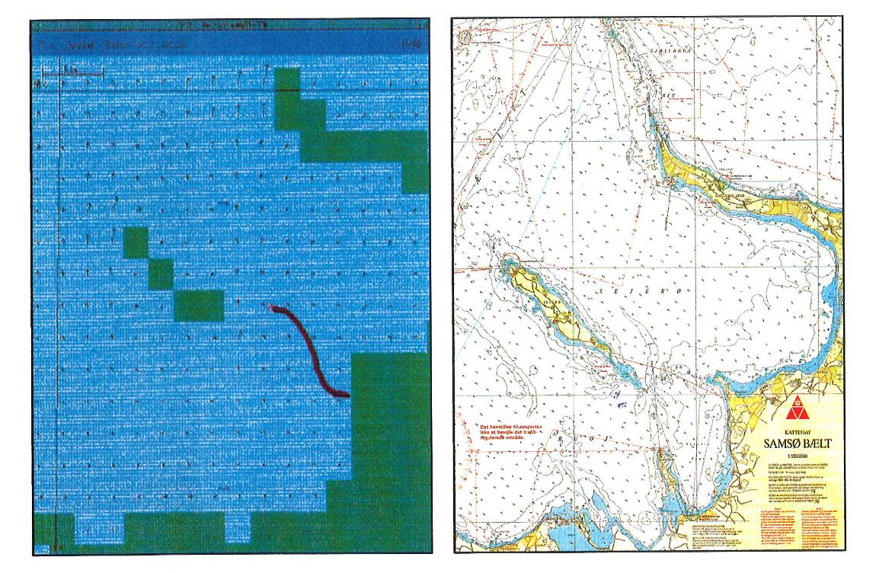
Figure 8.1 Fig 8.2
Computer display (Figure 8.1) compared with the corresponding sea chart (Figure 8.2)
8.4 The technique is useful in pollution combating operations when it is possible to use weather forecast, tide and current predictions to predict where the worst of the spillage will be at a given time in the future. This technique is used as part of contingency planning.
8.5 This technique is useful in reverse for finding the source of pollution. This is the process known as backtracking.

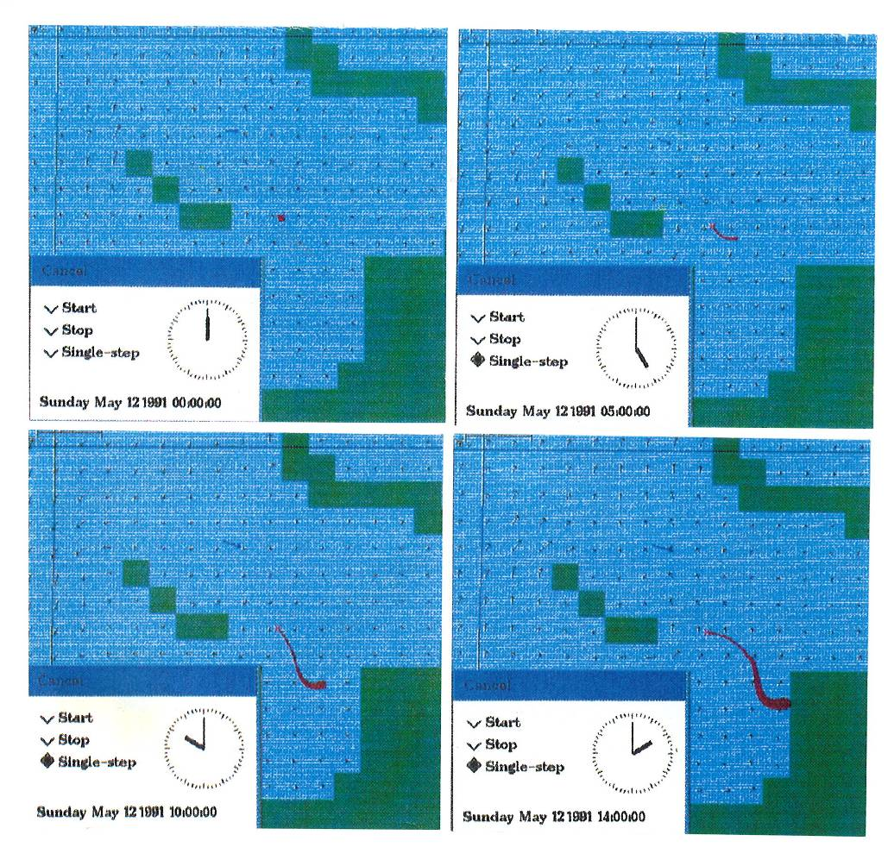
Fig 8.3 Example of graphical presentation of calculated drift and spreading of oil

Section 8.2: Backtracking
8.6 Starting from a spill of known position at a given time and using data of observed wind and current and taking into account the behaviour of the oil, it is possible to calculate to a reasonably high degree of accuracy, where the spill was at given times in its past history. (Heavy oil drifting below the surface can only be backtracked if the influence of wind is removed from the model.)
8.7 When the various positions thus obtained, together with the times at which the oil theoretically reached these positions are plotted on a chart, a "track" for the spillage is generated, this is a line on the chart showing how the oil has moved since it was discharged.
8.8 If similar tracks (with time references) for the ships in the relevant area are available these can be plotted onto the same chart as the track of the oil. Where a vessel's track passes close to the track of the oil, both in terms of distance and time, that vessel is a possible suspect.
8.9 It is important therefore to be able to identify the vessels in the relevant area and to be able to plot their tracks with an indication of time. The latter is reasonably straightforward if there is radar coverage of the area in question, the former extremely difficult without there being in force a legal requirement that vessels identify themselves, their position, course and speed to the coastal state. If the suspect vessel or vessels can be identified, it may be possible to confirm the polluter's identity by taking samples of the spilt oil and the oils aboard the suspected vessel and analysing the samples.
8.10 Backtracking has been used successfully by some authorities to identify a polluting vessel and to eliminate a suspected polluter from their enquiries.

Chapter 9: Sampling and Analysis

When there is doubt as to whether an observation on the sea surface corresponds to oil, sampling of polluted water is one way to remove the doubt. When traces of the oil discharged remain on board the suspected ship, comparisons of samples of oil taken on board the ship and in the spill or contaminated area may assist in the identification. There are several techniques for such comparisons. Combined gas chromatography and mass spectrometry techniques (GC/MS) is the usual method of choice. It can provide a very detailed pattern which is characteristic of the oil analysed, a "fingerprint".

Section 9.1: General
9.1 If the only concern is to establish whether there is oil in the sea, a simple analysis of a sample will confirm whether or not the oil discharged in the sea is allowed under MARPOL (there are other means for this such as enquiry on board the ship).
9.2 When, on the other hand, there is doubt as to the identity of the ship which discharged oil, a comparison of samples may be a powerful piece of evidence . Samples may also be compared when several oil slicks are suspected of originating from the same source. This is particularly relevant in civil liability cases.
9.3 The rest of this chapter deals with cases where comparison of samples is carried out. Such comparison is irrelevant when the oil or oily residues which existed on board were actually discharged in such a way that no trace remained on board the ship (for instance when the discharge concerned oil residues from the bilges, from a carefully cleaned tank or from an oil drum).
9.4 Samples are collected at several spots in the spill area. Even in small spills at least two samples would normally be taken. Care is always taken in order to prevent contamination of samples. All samples are clearly marked to avoid sample confusion and are transported to an authorised laboratory as quickly as possible.
Section 9.2: Gas-chromatography/mass-spectrometry techniques
9.5 Different analytical techniques have been used in the past, but in recent years an increasing number of laboratories have adopted the gas-chromatography/mass-spectrometry (GC/MS) technique for the identification of oil samples. GC relies on the fact that each oil is a different mixture of a number of components. The technique separates the oil into single components according to their boiling points. The result is a very detailed pattern which is characteristic for the specific oil analysed. GC will show a pattern representing the main components in the oil. Fig 9.1 is an example where four samples containing crude oils were analysed. Two of them are identical.
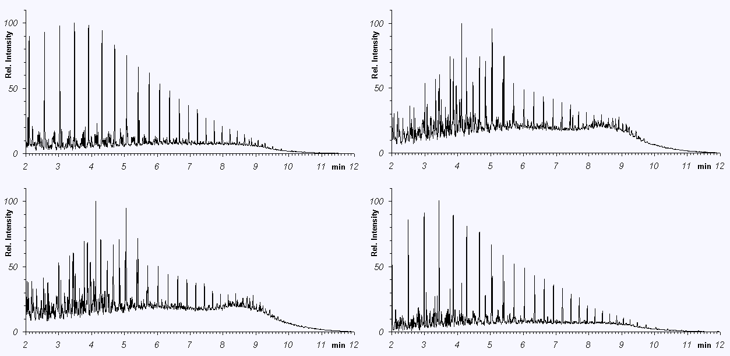
Figure 9.1 Screening with GC of four oil samples

9.6 In the figure each of the peaks represent single chemical components from the oil. It is sufficient for
present purposes to regard the whole pattern as a "fingerprint".
9.7 Screening by GC shows the main components of the oil. If the screening reveals no similarities, then the samples are not of the same origin. If there are similarities, then the identity must be confirmed by MS.
9.8 The GC/MS technique is GC with a selective detector (the MS part) added. The oil is still separated into single components, but in addition the MS shows the selected component types. This means that characteristic components in the oil which cannot be seen by the GC screening, due to their low abundance, can be fingerprinted. The selection of components to conclude identity is a matter of debate. In Europe, most laboratories use the CEN/TR 15522-2 methodology and the selection defined therein.

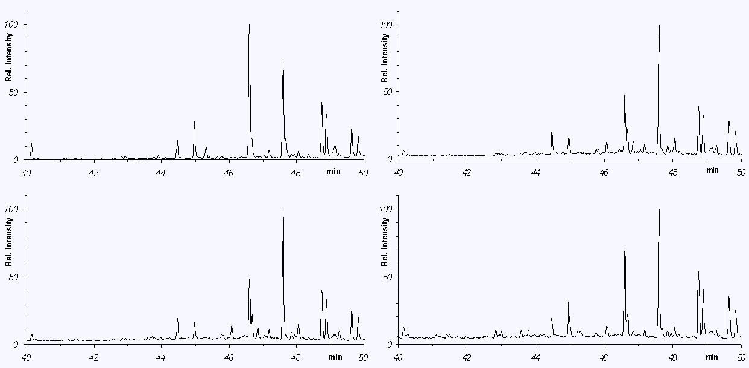
Figure 9.2 GC/MS fingerprinting of the same samples as in Figure 9.1

9.9 Figure 9.2 shows one of the fingerprints taken by MS on the same four samples as shown in Figure 9.1. The similarities and differences are even more pronounced for the pattern selected here.
9.10 In summary, the combined GC/MS techniques allow for optimal fingerprinting providing a greater amount of detail (due to the separation technique) which increases the reliability of the identification, and high selectivity (due to the MS detector). This makes it possible to trace many component groups, even when analysing samples with low oil content.
Section 9.3: Component types used for fingerprinting
9.11 The flexibility of the GC/MS technique makes it possible to measure an almost unlimited amount of information from a single oil. In order to keep the time for the analysis within realistic limits, it is necessary to select a limited number of component types for the routine fingerprinting.
9.12 All oil is formed from plants which lived millions of years ago. Each plant type contains a unique composition of specific natural products, some of which can still be found in the resulting oil in a modified form called biomarkers. It is thus possible to distinguish between oils from different fields – in some cases even from different wells in the same field. These differences are reflected in the refinery products too, and in mixtures of these. The selection of component types for the chemical analysis and fingerprinting is therefore based on their ability to detect significant differences between oils.
9.13 The complexity of oil is increased, accordingly, when two or more oil products are mixed. Sludge residues from machinery room spaces on ships for example form the most complex mixtures of oil. The handling of different oil products aboard a ship leads to a unique composition of these residues. Matching of samples achieved by GC/MS in the case of sludge residues is a very strong indication that the polluter has been identified.
Section 9.4: Weathering
9.14 The GC/MS method is able to correct for the effects of weathering. The biomarkers are extremely resistant to weathering and will still maintain their characteristic pattern even in heavily degraded oils.
9.15 Here “weathering” means all changes in the composition of the oil which occur after the spillage.
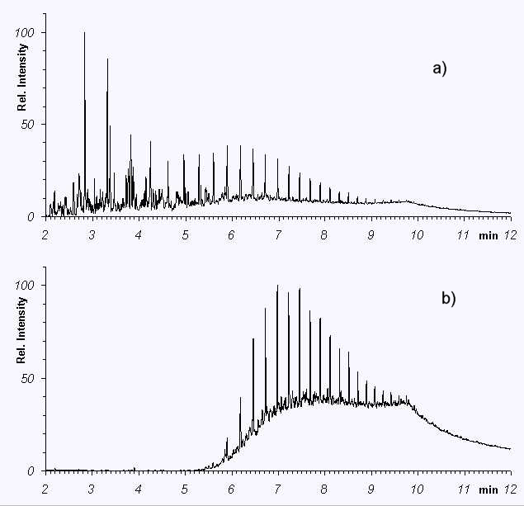
Figure 9.3 Example of heavy weathering (screening GC)
a) is the original oil; b) is a heavily weathered sample from the beach
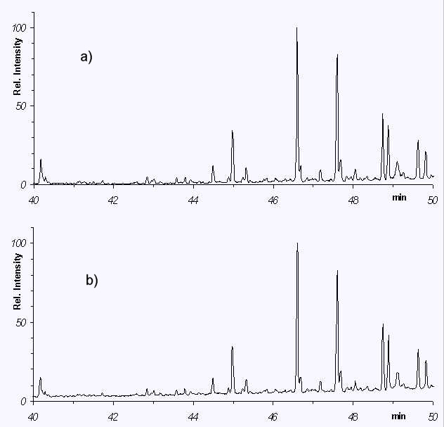
Figure 9.4 Example of one of the biomarker patterns from the same two samples as in Figure 9.3
9.16 Figure 9.3 is an example of heavy weathering. It shows the GC screening of a sample taken from the ship (top), and a sample taken from the beach after a spill. The sample shown from the beach was heavily degraded. At first glance, the GC screening seems to indicate that the two are different. However by means of the MS method, the results of which are shown in Figure 9.4, it was revealed that the fingerprints from the biomarkers were identical.
Section 9.5: Presenting analytical evidence
9.17 Analytical evidence will normally need to be accompanied by a detailed report by the person responsible for carrying out the analysis. This will need to:
a. identify the person responsible for the analysis and his/her qualifications for carrying it out and draw conclusions from the results;
b. explain the background to the analytical work, possibly drawing on the material above;
c. describe in detail what has been done;
d. describe what conclusions about the oil and its origins can be drawn from the results of the analysis.

Chapter 10: Vessel Identification
Automatic Identification Systems (AIS) for vessels enable both shore-based and airborne observers and other vessels to identify vessels automatically. This has practical application in linking observed oil slicks to the relevant vessels.

Section 10.1: Automatic Identification Systems
10.1 The International Convention on the Safety of Life at Sea (SOLAS) (Chapter V) provides for the fitting of Automatic Information Systems (AIS) to ships. Since 1 January 2005, all passenger ships and tankers and all other ships of 300 gross tonnage and above and fishing vessels over 15 metres long (Directive 2009/17/EC are required to fit AIS. Ships fitted with AIS must maintain AIS in operation at all times except where international agreements, rules or standards provide for the protection of navigational information.
10.2 The AIS is a shipboard broadcast system that acts like a transponder, operating in the VHF maritime band. It is capable of handling well over 4,500 reports per minute and updates as often as every two seconds. It uses Self-Organizing Time Division Multiple Access (SOTDMA) technology to meet this high broadcast rate and to ensure reliable ship-to-ship operation.
10.3 On board ship it can give a radar display with overlaid electronic chart data, that includes a mark for every significant ship within radio range, each as desired with a velocity vector (indicating speed and heading). Each ship "mark" can reflect the actual size of the ship, with position to GPS or differential GPS accuracy. By "clicking" on a ship mark, you can learn the ship name, course and speed, classification, call sign, registration number, Maritime Mobile Service Identities, and other information. Other information available is: manoeuvring information, closest point of approach (CPA), time to closest point of approach (TCPA) and other navigation information. The information is more accurate and more timely than information available from an automatic radar plotting aid. Display information previously available only to modern Vessel Traffic Schemes operations centres is now available to every AIS-equipped ship.
10.4 With this information, any ship can be called over VHF radiotelephone by name, rather than by some imprecise means.

Section 10.2: Use in surveillance
10.5 Automatic ship identification systems can be used by aerial surveillance aircraft to obtain accurate identifications of the vessels in which they are interested.

Section 10.3: Recording of identification

10.6 For evidence gathering, there is a requirement to prove a ship’s identity related to its AIS output. Besides identification by aerial surveillance this evidence can also be obtained by officers at shore-based operation centres. The AIS output can be compared with the results of several publicly available AIS monitoring systems including the EMSA systems ImDate, SafeSeaNet and CleanSeaNet, and by radio contact with the vessel involved, which makes the AIS output reliable as evidence.

The North Sea Area covers the North Sea proper (south of latitude 63° 38 10.68N ) and the English Channel to a line 50 nautical miles west of a line from Ushant to the Isles of Scilly; and the waters subject to the jurisdiction of Ireland together with adjoining UK and Norwegian waters.
Oil discharges from an oil tanker falling under Table I include discharges of cargo oil residue and cargo pump-room bilges. However, the conditions in Table I also apply to discharges from machinery space bilges on oil tankers where mixed with cargo oil residue or when transferred to slop tanks.
Oil discharges from machinery spaces falling under Tables II and III include discharges of machinery space bilges and oil residue resulting from the purification of fuel and lubricating oils.
Reference: Interpol Investigative Manual on Illegal garbage discharges from vessels 2016
Reference: Resolution MEPC.295(71) 2017 Guidelines for the implantation of Marpol Annex V.
Ref: MEPC.220(63), 2012 Guidelines for the Development of Garbage Management Plans
Following inter alia Art. 5 and Art. 6 of MARPOL 73/78 and the provisions for Port State control in its annexes, the International Maritime Organization published a document on Procedures for Port State Control, which is intended to provide basic guidance on the conduct of Port State control inspections and to afford consistency in the conduct of these inspections, the recognition of deficiencies of a ship, its equipment, or its crew, and the application of control procedures. It sets out the IMO Resolution A.787 (19) of 23 November 1995 (containing general procedural guidelines for Port State control officers) and includes a list of addresses of Head Offices of Port State Control Administrations party to MARPOL 73/78 in order to assist Administrations and others interested in contacting the pertinent authorities. This Resolution A.787 (19) revoked the former IMO Res. A 542 (13) on procedures for the control of ship and discharges under Annex I of MARPOL 73/78.
The inspection and detention records for a ship are also passed on to the EQUASIS database of maritime authorities of inter alia the European Commission, the United Kingdom, France.
Council Directive 95/21/EC is amended by the following measures: Council Directive 98/25/EC of 27 April 1998; Commission Directive 98/42/EC of 19 June 1998; Commission Directive 1999/97/EC of 13 December 1999; Directive 2001/106/EC of the European Parliament and of the Council of 19 December 2001; Directive 2002/84/EC of the European Parliament and of the Council of 5 November 2002.
The Council of Europe is a regional, intergovernmental organisation, which aims at achieving a greater (political) unity between its Members States. It has set up a programme for legal cooperation in Europe, by creating legal procedures which are both less complicated and more flexible (thus making the European legal system more efficient). The Council now counts 47 Member States.
Extradition means surrendering a person upon request to the requesting State, so that the person can be prosecuted or a custodial sentence can be executed in the requesting State.
Framework Decision 2002/84/JHA of 13 June 2002 on the European Arrest Warrant and Surrender Procedures between Member States.
Environmental offences can be classified as “international” because of the behaviour of the offenders (for example, an offender may escape across a border after committing his offence).
The Schengen Agreement of 1985, the 1990 implementing Convention, and measures, protocols and accession agreements which followed constitute the Schengen acquis.
Updated April 2019
Act No 474 of May 2006 to amend the Marine Environment Act and certain other Acts
Consolidation Act. No 963 of 3 July 2013, section 9 (1)
Consolidation Act. No 963 of 3 July 2013, section 4 (1)
Consolidation Act. No 963 of 3 July 2013, section 11 (1)
For a definition of Danish territorial waters, refer to Act No 200 of 1999 on the definition of the limits of the Territorial Sea
Consolidation Act. No 963 of 3 July 2013, section 11 (2)
Consolidation Act. No 963 of 3 July 2013, section 59 and 61
Executive Order No 491 of 23 May 2014, section 1, chapter XXI, rule 17
Executive Order No 491 of 23 May 2014, section 4
Executive Order No 491 of 23 May 2014, section 4 (4)
Denmark is thus able to enforce all international regulations and norms laid down in conventions and established as the custom under international law in the exclusive economic zones.
Consolidation Act No 963 of 3 July 2013, section 59(2): When the amount of the fine for a violation of section 11 (1) or (2) discharge of oil is determined, a more severe fine must be fixed on the basis of the volume of oil discharged.
Consolidation Act No 963 of 3 July 2013, section 59 (3)
Consolidation Act No 963 of 3 July 2013, section 59 (4)
Consolidation Act No 963 of 3 July 2013, section 62
Consolidation Act No 963 of 3 July 2013, section 63a
Administration of Justice Act Part 73 (sections 793-800)
Consolidation Act No 963 of 3 July 2013, section 63 (1) the first sentence
Consolidation Act No 963 of 3 July 2013, section 63 (1) the second sentence
Administration of Justice Act, section 796 (3)
See the principle of section 807a of the Administration of Justice Act
Consolidation Act 963 of 3 July 2013, section 62a: ”… information concerning its identity and port of registration, its last and next port of call and other relevant details that are necessary to determine whether a violation of the Act has been committed.”
Consolidation Act 963 of 3 July 2013, section 63 (4)
Consolidation Act 963 of 3 July 2013, section 63 (5)
Consolidation Act 963 of 3 July 2013, section 63b (1)
Consolidation Act. No 963 of 3 July 2013, section 63b(4)
Consolidation Act. No 963 of 3 July 2013, section 63b(4)(4) and subsection (5)
Code de l’environnement, article L218-11: “ Est puni de 50 000 euros d'amende le fait, pour tout capitaine ou responsable à bord d'un navire, de se rendre coupable d'un rejet de substance polluante en infraction aux dispositions des règles 15 et 34 de l'annexe I, relatives aux contrôles des rejets d'hydrocarbures, ou en infraction aux dispositions de la règle 13 de l'annexe II, relative aux contrôles des résidus de substances liquides nocives transportées en vrac, de la convention Marpol. En cas de récidive, les peines encourues sont portées à un an d'emprisonnement et 100 000 euros d'amende. »
Code de l’environnement, article L.218-10: “ le terme : " navire " désigne soit un bâtiment de mer exploité en milieu marin de quelque type que ce soit, notamment les hydroptères, les aéroglisseurs, les engins submersibles et les engins flottants, soit un bateau ou un engin flottant fluvial, lorsqu'il se trouve en aval de la limite transversale de la mer » ;
Code de l’environnement, article L.218-17: Est puni de deux ans d'emprisonnement et de 200 000 euros d'amende le fait, pour tout capitaine de navire ou responsable à bord d'un navire auquel est survenu, en mer ou dans les eaux intérieures et les voies navigables françaises jusqu'aux limites de la navigation maritime, un des événements mentionnés par le protocole I de la convention Marpol, ou pour toute autre personne ayant charge dudit navire, au sens de l'article 1er de ce protocole, de ne pas établir et transmettre un rapport conformément aux dispositions dudit protocole.
As defined in Law No 76-655 of 16 July 1976.
Code de l’environnement, article L218-18: “ au propriétaire, soit à l'exploitant ou à leur représentant légal ou dirigeant de fait s'il s'agit d'une personne morale, soit à toute autre personne que le capitaine ou responsable à bord exerçant, en droit ou en fait, un pouvoir de contrôle ou de direction dans la gestion ou la marche du navire ou de la plate-forme, lorsque ce propriétaire, cet exploitant ou cette personne a été à l'origine d'un rejet effectué en infraction aux articles L. 218-11 à L. 218-17 et L.218-19 ou n'a pas pris les mesures nécessaires pour l'éviter.”
Code de l’environnement, article 218-19 I: “…l'imprudence, la négligence ou l'inobservation des lois et règlements…”
Code de l’environnement, article L218-19 I.
Code de l’environnement, article L. 218-19 II
Code de l’environnement, article L218-23 I : “Le tribunal peut, compte tenu des circonstances de fait et notamment des conditions de travail de l'intéressé, décider que le paiement des amendes prononcées à l'encontre du capitaine ou du responsable à bord, en vertu des articles L. 218-11 à L. 218-19, est en totalité ou en partie, à la charge de l'exploitant ou du propriétaire. Le tribunal ne peut user de la faculté prévue à l'alinéa précédent que si le propriétaire ou l'exploitant a été cité à l'audience.”
Code de l’environnement, article L218-23 II: “Les personnes physiques coupables des infractions prévues par la présente sous-section encourent également, à titre de peine complémentaire, la peine d'affichage de la décision prononcée ou de diffusion de celle-ci dans les conditions prévues à l'article 131-35 du code pénal.”
Code de l’environnement, article L218-24 [details of the penalties have not yet been traced]
Code de l’environnnement, article L218-26 and 27.
Code de l’environnnement, article L218-28.
Code de l’environnement, article L218-30.
The law of 15 April 2003 and the Decree of 8 January 2004 have established a "zone of ecological protection in the Mediterranean", allowing the prosecution beyond the territorial sea.
Updated April 2019
Strafgesetzbuch “Wer unbefugt ein Gewässer verunreinigt oder sonst dessen Eigenschaften nachteilig verändert”.
Originally called the Law on the 1973 International Convention on the Prevention of Marine Pollution by Ships and the 1978 Protocol to this Convention (Gesetz zu dem Internationalen Übereinkommen von 1973 zur Verhütung der Meeresverschmutzung durch Schiffe und zu dem Protokoll von 1978 zu diesem Übereinkommen).
§ 28 See-Umweltverhaltensverordnung
Strafgesetzbuch §4: “Das deutsche Strafrecht gilt, unabhängig vom Recht des Tatorts, für Taten, die auf einem Schiff…begangen werden, das berechtigt ist, die Bundesflagge…der Bundesrepublik Deutschland zu führen.”
Strafgesetzbuch §5 Nr. 11: “Das deutsche Strafrecht gilt, unabhängig vom Recht des Tatorts, für folgende Taten, die im Ausland begangen werden: 11º Straftaten gegen die Umwelt in den Fällen der §§ 324, 326, 330, 330a, die im Bereich der deutschen ausschließlichen Wirtschaftszone begangen werden, soweit völkerrechtliche Übereinkommen zum Schutze des Meeres ihre Verfolgung als Straftaten gestatten”.
Ausführungsgesetz Seerechtsübereinkommen 1982/1994, article 12: “Das deutsche Strafrecht gilt für Straftaten gegen die Umwelt in den Fällen der §§ 324, 326, 330 und 330a des Strafgesetzbuches, die von einem Schiff aus in der Nordsee oder Ostsee außerhalb der deutschen ausschließlichen Wirtschaftszone durch Einleiten von Stoffen unter Verletzung verwaltungsrechtlicher Pflichten (§ 330d Nr. 4, 5 des Strafgesetzbuches) begangen werden, welche der Durchführung völkerrechtlicher Übereinkommen zum Schutz des Meeres dienen. Soweit die Tat in den Hoheitsgewässern eines anderen Staates begangen wird, gilt dies, wenn die Tat nach dem Recht dieses Staates mit Strafe bedroht ist. Für die Abgrenzung der Nordsee ist Artikel 2 des Übereinkommens zur Zusammenarbeit bei der Bekämpfung der Verschmutzung der Nordsee durch Öl und andere Schadstoffe vom 13. September 1983 (BGBl. 1990 II S. 70) maßgebend.”
In the case of ships flying the flag of a State which is not a Contracting Party to MARPOL, the obligation is only imposed if the vessel comes into German internal waters from outside the territorial sea (UNCLOS).
Strafgesetzbuch § 13(1): “Wer es unterläßt, einen Erfolg abzuwenden, der zum Tatbestand eines Strafgesetzes gehört, ist nach diesem Gesetz nur dann strafbar, wenn er rechtlich dafür einzustehen hat, daß der Erfolg nicht eintritt, und wenn das Unterlassen der Verwirklichung des gesetzlichen Tatbestandes durch ein Tun entspricht.”
Strafgesetzbuch § 14. Acting for another (Handeln für einen anderen).
Strafgesetzbuch § 15: “Strafbar ist nur vorsätzliches Handeln, wenn nicht das Gesetz fahrlässiges Handeln ausdrücklich mit Strafe bedroht.”
Strafgesetzbuch 330(1): “In besonders schweren Fällen wird eine vorsätzliche Tat nach den §§ 324.. mit Freiheitsstrafe von sechs Monaten bis zu zehn Jahren bestraft.
Strafgesetzbuch § 330(1): “Ein besonders schwerer Fall liegt in der Regel vor, wenn der Täter 1. ein Gewässer…derart beeinträchtigt, daß die Beeinträchtigung nicht, nur mit außerordentlichem Aufwand oder erst nach längerer Zeit beseitigt werden kann, … 3. einen Bestand von Tieren oder Pflanzen der vom Aussterben bedrohten Arten nachhaltig schädigt oder 4. aus Gewinnsucht handelt.“
Seeaufgabengesetz § 15
Discretional power of the regulatory authority to impose a penalty as a means to press the ship owner to comply with requirements, but not with the purpose of punishment.
Fines may be imposed by the regulatory authority. The fine is meant to be a punishment for an unlawful act.
Lag om åtgärder mot förorening från fartyg (SFS (1980:424).
SFS 1980:424, chapter 10, §1.
The demand for « damage to Swedish interest » does not apply when Sweden has complied with a request from a Contracting Party to the European Convention of 15th of May 1972 on the transferrance of criminal proceedings.
SFS 1980:242, chapter 10, §1 and §2: “…den som uppsåtligen eller av oaktsamhet bryter mot förbud som gäller enligt 2 kap. 2 § första stycket…”; “…befälhavaren, om han eller hon uppsåtligen eller av oaktsamhet har brustit i den tillsyn som behövs för att utsläpp inte skall ske i strid med denna lag eller föreskrifter som har meddelats med stöd av lagen. Om befälhavaren har delegerat ansvaret för tillsynen över hanteringen ombord av skadliga ämnen till ett annat befäl eller om ett visst befäl har sådant ansvar till följd av tjänstens beskaffenhet, gäller vad som nu har sagts i motsvarande mån det befälet.”
This refers to general provisions concerning company fines.
SFS 1980:242, chapter 10, §2: “Vattenföroreningsavgiften skall påföras den fysiska eller juridiska person som vid överträdelsen var fartygets ägare eller redare. Om ägaren visar att han eller hon har saknat inflytande över fartygets drift får avgift dock inte påföras honom eller henne. För vattenföroreningsavgift som delägarna i ett partrederi skall betala enligt första stycket, svarar de solidariskt.”
SFS 1980:242, chapter 8, §3.
The reason for this is that the Merchant Shipping Act aims at implementing the provisions of MARPOL, and therefore included the defences. The Water Resources Act is a consolidation of older legislation which has gradually been extended to cover sea areas. The conflict between the two approaches was not really registered until a prosecution was brought under the Water Resources Act in the Sea Empress case.
* See IMO Resolution MEPC 61(34) "Visibility Limits of Oil Discharges of Annex I of MARPOL 73/78".

