

Agreement on a Monitoring Programme for Concentrations of Radioactive Substances in the Marine Environment
(Reference number: 2005-8, 2018 Revision)

1. This agreement sets out the basis for future monitoring by OSPAR Contracting Parties of concentrations of radioactive substances in the marine environment of the OSPAR maritime area.
2. These arrangements should be reviewed by 2022. In the meantime, Contracting Parties may notify changes in the monitoring stations and frequencies of monitoring, provided that these changes do not undermine the general framework of this monitoring programme.
3. Monitoring should continue to be carried out in the following fifteen RSC sub-regions within the OSPAR maritime area:
RSC sub-region 1 – Wider Atlantic, Bay of Biscay/Golfe de Gascogne, Iberian Waters and the Western Approaches
RSC sub-region 2 – Cap de la Hague Channel
RSC sub-region 3 – Channel East
RSC sub-region 4 – Irish Sea (Republic of Ireland)
RSC sub-region 5 – Irish Sea (Northern Ireland)
RSC sub-region 6 – Irish Sea (Sellafield)
RSC sub-region 7 – Scottish Waters (Dounreay)
RSC sub-region 8 – North Sea South
RSC sub-region 9 – German Bight (Limfjord, German Bight and Dollart)
RSC sub-region 10 – North Sea (North-West, South-West and Central)
RSC sub-region 11 – North Sea (Skaggerrak)
RSC sub-region 12 – Kattegat
RSC sub-region 13 – Norwegian Coastal Current
RSC sub-region 14 – Barents Sea
RSC sub-region 15 – West of Spitsbergen
4. In each RSC sub-region, monitoring should be continued as set out below for the specified radionuclides in the specified environmental compartments at the specified sampling stations.
5. Monitoring of indicator radionuclides associated with the nuclear sector should be carried out for ³H, ¹³⁷Cs, ⁹⁹Tc and ^{239,240}Pu, where possible, in seawater and for ¹³⁷Cs, ⁹⁹Tc and ^{239,240}Pu, where possible, in biota.
6. Monitoring of indicator radionuclides associated with the non-nuclear sector (oil and gas) should be carried out for ²¹⁰Po, ²¹⁰Pb, ²²⁶Ra and ²²⁸Ra, where possible, in seawater and biota.
7. Sampling of seawater should be confined to surface sampling (0.5 m to 4 m).
8. Sampling of biota should be confined to fish, molluscs and seaweed.
9. Environmental concentration data should be reported to OSPAR using the agreed reporting format.
Key to all following tables
T = Sampling carried out triennially (once every three years)
B = Sampling carried out biennially (once every two years)
A = Sampling carried out annually (once per year)
H = Sampling carried out half-yearly (twice per year).
Q = Sampling carried out quarterly (four times per year).
M = Sampling carried out monthly (twelve times per year)
RSC sub-region 1 – Wider Atlantic, Bay of Biscay/Golfe de Gascogne, Iberian Waters and the Western Approaches

CP | Location | Environmental Compartment and Radionuclides
 |  | Seawater |  |  |  | Fish | Molluscs |  | Seaweed
 |  | ³H | ¹³⁷Cs | ⁹⁹Tc | ^{239,240}Pu | ¹³⁷Cs | ¹³⁷Cs | ^{239,240}Pu | ¹³⁷Cs | ⁹⁹Tc | ^{239,240}Pu
DE | Open sea¹ | B | B |  | B
ES | Cabo Ajo | Q | Q² |  | T | T | T |  | T |  | T
ES | Cabo Ortegal | Q | Q³
ES | Cabo Villano | Q | Q³
ES | Cabo Silleiro | Q | Q³
ES | Isla Cristina | Q | Q³
ES | Puerto de Cádiz | Q | Q³
FR | Roscoff | A | A |  |  |  |  |  | H
FR | Brest | Q | A⁴
FR | Concarneau | A | A |  |  |  |  |  | H
FR | Pornichet | H | A
FR | Oléron | H | A |  |  |  |  |  | H
FR | Arcachon | A | A
IE | Dunmore East |  | B |  |  |  |  |  | B | B
IE | Salthill-Galway |  | B |  |  |  |  |  | B | B
IE | Killybegs |  | B |  |  | A |  |  | B | B
IE | Kilmore Quay |  | B |  |  | A |  |  | B | B
UK | W. of Portland | A⁵ | A⁵
UK | Bristol Channel | A⁶
1. Sampling carried out at 3 open sea stations.
2.¹³⁷Cs determination after radiochemical separation
3. Gamma-spectrometry of seawater sample without ¹³⁷Cs radiochemical separation; only elevated levels can be detected.
4. As of 2017, monthly samples in Brest are pooled for one radiochemical separation on a bigger volume to achieve a lower detection limit and one annual significant ¹³⁷Cs concentration result.
5. Two stations.
6. Up to 6 samples around the perimeter of the Bristol Channel.

CP |  | Location | Environmental Compartment and Radionuclides
 |  |  | Seawater |  |  |  | Fish, Molluscs, Seaweed
 |  |  | ²¹⁰Po | ²¹⁰Pb | ²²⁶Ra | ²²⁸Ra | ²¹⁰Pb | ²²⁶Ra | ²²⁸Ra
ES | Cabo Ajo |  | T | T | T | T | T | T | T

Changes in monitoring in RSC sub-region 1 compared to initial 2005-8 monitoring agreement
France - Sampling station at Dinard removed. Sampling stations at St Jean de Monts, La Rochelle and Biarritz replaced with stations at Pornichet, Oléron and Arcachon, respectively. Additional monitoring of ³H and ¹³⁷Cs in seawater at Roscoff, Concarneau and La Tremblade. Reporting of ¹³⁷Cs in seaweed changed from quarterly to twice a year.
Spain - Addition of sampling stations for ¹³⁷Cs in fish, molluscs and seaweed and for naturally occurring radionuclides in seawater and biota.
Ireland - Reporting of ¹³⁷Cs in fish from Kilmore Quay instead of Castletownbere. No reporting of ¹³⁷Cs in fish from Salthill-Galway (fish taken from same area as fish landed at Killybegs).
UK - Addition of sampling stations around the perimeter of the Bristol Channel.

Changes in monitoring in RSC sub-region 1 compared to the 2011 revision of the 2005-8 monitoring agreement
France - As of 2017, monthly samples in Brest are pooled for one radiochemical separation on a bigger volume to achieve a lower detection limit and one annual significant ¹³⁷Cs concentration result. Sampling frequency of tritium measurements at Pornichet and Oléron changed from quarterly to half-yearly.
Germany – Additional sampling for ¹³⁷Cs, ³H and ^{239,240}Pu in seawater carried out biennially at 3 open sea stations.
Ireland - Mussels no longer available from Bantry Bay. Seawater samples no longer analysed for ⁹⁹Tc. Seawater and sediment samples no longer taken from Killybegs or Casteltownbere. Salthill-Galway samples deemed representative of Atlantic water. Station at Dunmore East included.
Spain - Sample station names changed, but locations remain the same as before. Station MAS 08 (Estrecho de Gibraltar) lies outside of OSPAR maritime area and therefore not included. Data for ^{239,240}Pu in seawater, molluscs and seaweed to be reported triennially from Cabo Ajo.
UK - W. of Portland reassigned to correct RSC sub-region (previously assigned to RSC sub-region 2).
RSC sub-region 2 – Cap de la Hague Channel

CP | Location | Environmental Compartment and Radionuclides
 |  | Seawater |  |  |  | Fish | Molluscs |  | Seaweed
 |  | ³H | ¹³⁷Cs | ⁹⁹Tc | ^{239,240}Pu | ¹³⁷Cs | ¹³⁷Cs | ^{239,240}Pu | ¹³⁷Cs | ⁹⁹Tc
DE | Channel¹ | B | B |  | B
FR | Carteret | Q |  |  |  |  |  | H/Q² | H
FR | Goury | Q | Q |  | A |  |  | H/Q² | H
FR | Cherbourg | Q
FR | Barfleur | Q |  |  |  |  |  | H/Q² | H
UK | Winfrith |  |  |  |  |  |  | A | H³ | H³
1. Sampling carried out at 2 open sea stations.
2. Samples either 2 or 4 times per year.
3. Two stations

Changes in monitoring in RSC sub-region 2 compared to initial 2005-8 monitoring agreement
France - Reduction in sampling stations from 5 to 4 for seawater. Sampling stations for seawater and biota revised on basis of dispersion modelling results. Addition of sampling station for ^{239,240}Pu in seawater. Tc-99 in seaweed no longer reported.
UK - No changes.
Changes in monitoring in RSC sub-region 2 compared to the 2011 revision of the 2005-8 monitoring agreement
France - Species of molluscs sampled at Barfleur are now oysters instead of mussels.
Germany – Additional sampling for ¹³⁷Cs, ³H and ^{239,240}Pu in seawater carried out biennially at 2 open sea stations.
UK - No changes.

RSC sub-region 3 – Channel East

CP | Location | Environmental Compartment and Radionuclides
 |  | Seawater |  |  |  | Fish | Molluscs |  | Seaweed
 |  | ³H | ¹³⁷Cs | ⁹⁹Tc | ^{239,240}Pu | ¹³⁷Cs | ¹³⁷Cs | ^{239,240}Pu | ¹³⁷Cs | ⁹⁹Tc
DE | Channel East¹ | B | B |  | B
FR | Honfleur | H |  |  |  |  |  |  | H
 | Wimereux | A | A |  |  |  |  |  | H
 | Mers-Les-Bains | H
UK | Dungeness | H | A |  |  |  |  |  | A | A
UK | Winfrith |  |  |  |  |  |  | A | H | H
1. Sampling carried out at 3 open sea stations.

Changes in monitoring in RSC sub-region 3 compared to initial 2005-8 monitoring agreement
France - Sampling station in Seine estuary moved from Le Havre to Honfleur. Additional seawater station at Wimereux. Tc-99 in seaweed no longer reported. Reporting of ¹³⁷Cs in seaweed changed from quarterly to twice a year.
UK - No changes.
Changes in monitoring in RSC sub-region 3 compared to the 2011 revision of the 2005-8 monitoring agreement
France - As of 2016, sampling frequency of tritium measurements at Honfleur changed from quarterly to half-yearly. A station with half-yearly sampling of tritium at Mers-Les-Bains has been added.
Germany – Additional sampling for ¹³⁷Cs, ³H and ^{239,240}Pu in seawater carried out biennially at 3 open sea stations.
UK - One Winfrith station (of 3 stations in total) reassigned to correct RSC sub-region (previously assigned to RSC sub-region 2).

RSC sub-region 4 – Irish Sea (Republic of Ireland)

CP | Location | Environmental Compartment and Radionuclides
 |  | Seawater |  |  |  | Fish | Molluscs |  | Seaweed
 |  | ³H | ¹³⁷Cs | ⁹⁹Tc | ^{239,240}Pu | ¹³⁷Cs | ¹³⁷Cs | ^{239,240}Pu | ¹³⁷Cs | ⁹⁹Tc
IE | Irish Sea N1 |  | A
IE | Irish Sea N2 |  | A
IE | Irish Sea N3 |  | A
IE | Irish Sea N4 |  | A
IE | Irish Sea N5 |  | A
IE | Irish Sea N6 |  | A
IE | Ballagan |  | Q | Q |  |  |  |  | Q | Q
IE | Carlingford |  |  |  |  |  |  | A
UK | Irish Sea |  | B¹
1. 10 stations.

Changes in monitoring in RSC sub-region 4 compared to initial 2005-8 monitoring agreement
Ireland - Reduction in number of sampling stations from 14 to 10 for ¹³⁷Cs and ⁹⁹Tc in seawater.
Changes in monitoring in RSC sub-region 4 compared to the 2011 revision of the 2005-8 monitoring agreement
Ireland - Seawater samples no longer analysed for ⁹⁹Tc. Samples no longer collected at Cahore or Balbriggan. Greenore sampling point moved to Ballagan.
UK - No changes.

RSC sub-region 5 – Irish Sea (Northern Ireland)

CP | Location | Environmental Compartment and Radionuclides
 |  | Seawater |  |  |  | Fish | Molluscs |  | Seaweed
 |  | ³H | ¹³⁷Cs | ⁹⁹Tc | ^{239,240}Pu | ¹³⁷Cs | ¹³⁷Cs | ^{239,240}Pu | ¹³⁷Cs | ⁹⁹Tc
UK | Irish Sea |  | B¹
UK | North of Larne |  | M
UK | NI coast |  |  |  |  | Q² |  | H/Q³
UK | Hunterston |  |  |  |  | H |  | A/Q⁴
UK | Ardglass |  |  |  |  |  |  |  |  | H/Q³
UK | Strangford Lough |  |  |  |  |  |  |  |  | H/Q³
UK | Carlingford Lough |  |  |  |  |  |  |  |  | H/Q³
1. 2 stations.
2. Between 4 and 8 times per year.
3. Between 2 and 4 times per year.
4. Between 1 and 4 times per year

Changes in monitoring in RSC sub-region 5 compared to initial 2005-8 monitoring agreement
UK - No changes.
Changes in monitoring in RSC sub-region 5 compared to the 2011 revision of the 2005-8 monitoring agreement
UK - No changes.

RSC sub-region 6 – Irish Sea (Sellafield)

CP | Location | Environmental Compartment and Radionuclides
 |  | Seawater |  |  |  | Fish | Molluscs |  | Seaweed
 |  | ³H | ¹³⁷Cs | ⁹⁹Tc | ^{239,240}Pu | ¹³⁷Cs | ¹³⁷Cs | ^{239,240}Pu | ¹³⁷Cs | ⁹⁹Tc
UK | Irish Sea | B¹ | B¹
UK | Sellafield | M | M | M |  |  | H/Q² | H/Q² |  | H/Q²
UK | Heysham | A | A |  |  |  | H/Q² | H/Q² |  | H/Q²
UK | Wylfa | A | A |  |  |  | H | H |  | H
UK | Chapelcross | Q |  |  |  |  | Q³ | Q³ |  | Q
UK | Springfields |  |  |  |  |  | A/H² | A/H²
UK | Capenhurst |  |  |  |  |  | Q
1. 23 stations.
2. Between 2 and 4 times per year.
3. Between 4 and 8 times per year.
4. Between 1 and 2 times per year

CP | Location | Environmental Compartment and Radionuclides
 |  | Fish |  | Molluscs
 |  | ²¹⁰Po | ²¹⁰Pb | ²¹⁰Po | ²¹⁰Pb
UK | Saltom Bay |  |  | Q | Q
UK | Parton | H | H | Q | Q
UK | Nethertown |  |  | Q
UK | Kirkcudbright |  |  | A
UK | Chapelcross |  |  | A
UK | Whitehaven | A

Changes in monitoring in RSC sub-region 6 compared to initial 2005-8 monitoring agreement
UK - Addition of sampling stations for naturally occurring radionuclides ²¹⁰Po and ²¹⁰Pb in fish and molluscs.

Changes in monitoring in RSC sub-region 6 compared to the 2011 revision of the 2005-8 monitoring agreement
UK - No changes.

RSC sub-region 7 – Scottish Waters (Dounreay)

CP | Location | Environmental Compartment and Radionuclides
 |  | Seawater |  |  |  | Fish | Molluscs |  | Seaweed
 |  | ³H | ¹³⁷Cs | ⁹⁹Tc | ^{239,240}Pu | ¹³⁷Cs | ¹³⁷Cs | ^{239,240}Pu | ¹³⁷Cs | ⁹⁹Tc
UK | Scottish waters | B¹ | B¹
 | Sandside Bay | Q | Q |  |  |  |  | Q | A/Q² | H/Q³
 | Brims Ness |  |  |  |  |  |  | Q | A/Q²
 | Echnaloch Bay |  |  |  |  |  |  | Q
 | Burwick Pier |  |  |  |  |  |  |  | A/Q² | H/Q³
 | Kinlochbervie |  |  |  |  |  |  |  | A/Q² | H/Q³
DE | Scottish waters⁴ | A | A |  | A
1. 2 stations.
2. Between 1 and 4 times per year.
3. Between 2 and 4 times per year.
4. Sampling carried out at 16 open sea stations.
Changes in monitoring in RSC sub-region 7 compared to initial 2005-8 monitoring agreement
UK - No changes.
Changes in monitoring in RSC sub-region 7 compared to the 2011 revision of the 2005-8 monitoring agreement
Germany – Additional sampling for ¹³⁷Cs, ³H and ^{239,240}Pu in seawater carried out annually at 16 open sea stations.
UK - No changes.

RSC sub-region 8 – North Sea South

CP | Location | Environmental Compartment and Radionuclides
 |  | Seawater |  |  |  | Fish |  | Molluscs |  | Seaweed
 |  | ³H | ¹³⁷Cs | ⁹⁹Tc | ^{239,240}Pu | ¹³⁷Cs | ^{239,240}Pu | ¹³⁷Cs | ^{239,240}Pu | ⁹⁹Tc | ¹³⁷Cs
BE | North Sea South |  | Q¹ |  | Q¹ | Q² | Q²
BE | Ostend |  |  |  |  |  |  | Q³ | Q³ | Q⁴ | Q⁴
BE | Hoofdplaat/ Kloosterzande |  |  |  |  |  |  | Q³ | Q³ | Q⁴ | Q⁴
NL | VLISSGBISSVH | M | Q |  | Q
NL | KNUITHK |  |  |  |  |  |  | A
NL | SCHOUWN10 | M
NL | NOORDWK2 | Q
NL | NOORDWK10 | Q |  |  |  |  |  | T
NL | MARSDND | Q
NL | NOORDWK70 | Q | Q |  | Q
NL | DANTZGT | Q
NL | PETT5 | Q | Q |  | Q
NL | HANSWBIOHMG |  |  |  |  |  |  | T
NL | SLIJKGBISG14 |  |  |  |  |  |  | T
NL | MALZN |  |  |  |  |  |  | T
NL | North Sea South |  |  |  |  | A⁵
UK | Scottish waters | B⁶ | B⁶
DE | North Sea South⁷ | A/B | A/B |  | A/B
1. 5 stations.
2. 5 or 6 stations.
3. 2 stations at Ostend and Hoofdplaat.
4. 2 stations at either (a) Ostend and Hoofdplaat or (b) Ostend and Kloosterzande.
5. Fish to be sampled for ¹³⁷Cs in 2 areas from 2018.
6. 3 stations.
7. Annual sampling at 5 open sea stations, biennial sampling at 1 open sea station.

CP | Location | Environmental Compartment and Radionuclides
 |  | Seawater | Fish |  | Molluscs |  |  | Seaweed
 |  | ²²⁶Ra | ²²⁶Ra | ²²⁸Ra | ²¹⁰Pb | ²²⁶Ra | ²²⁸Ra | ²²⁶Ra | ²²⁸Ra
BE | North Sea South |  | Q¹ | Q¹
BE | Ostend |  |  |  |  | Q² | Q² | Q³ | Q³
BE | Hoofdplaat/Kloosterzande |  |  |  |  | Q² | Q² | Q³ | Q³
NL | VLISSGBISSVH | Q
NL | SCHOUWN10 | Q
NL | KNUITHK |  |  |  | A | A
NL | NOORDWK2 | Q
NL | NOORDWK10 | Q
NL | HANSWBIOHMG |  |  |  | T | T
NL | SLIJKGBISG14 |  |  |  | T | T
NL | MALZN |  |  |  | T | T

NL | NOORDWK70 | Q | Q |  | Q

1. 5 or 6 stations.
2. 2 stations at Ostend and Hoofdplaat.
3. 2 stations at either (a) Ostend and Hoofdplaat or (b) Ostend and Kloosterzande.

Changes in monitoring in RSC sub-region 8 compared to initial 2005-8 monitoring agreement
Belgium - Monitoring of ^{239,240}Pu in molluscs previously carried out at 3 locations (Ostend, Yerseke and Kieldrecht) and now carried out at only two locations (Ostend and Hoofdplaat). Addition of sampling stations for ⁹⁹Tc in seaweed and for naturally occurring radionuclides ²²⁶Ra and ²²⁸Ra in fish, molluscs and seaweed.
Netherlands - 1 additional sampling stations for ³H in seawater. Addition of sampling stations for ¹³⁷Cs in molluscs. Addition of sampling stations for naturally occurring radionuclides ²²⁶Ra in seawater and ²¹⁰Pb and ²²⁶Ra in molluscs.
UK - No changes.
Changes in monitoring in RSC sub-region 8 compared to the 2011 revision of the 2005-8 monitoring agreement
Belgium - No changes.
Germany – Additional sampling for ¹³⁷Cs, ³H and ^{239,240}Pu in seawater carried out annually at 5 open sea stations and biennially at 1 open sea station.
Netherlands - Addition of station KNUITHK for annual sampling of molluscs. Addition of quarterly sampling for ¹³⁷Cs and ^{239,240}Pu in seawater at VLISSGBISSVH, PETT5 and NOORDWK70. Sampling of molluscs carried out every third year at NOORDWK2, HANSWBIOHMG, SLIJKGBISG14 and MALZN. Fish sampling for ¹³⁷Cs to be carried out in 2 areas from 2018.
UK - No changes.
RSC sub-region 9 – German Bight (Limfjord, German Bight and Dollart)

CP | Location | Environmental Compartment and Radionuclides
 |  | Seawater |  |  |  | Fish |  | Molluscs | Seaweed
 |  | ³H | ¹³⁷Cs | ⁹⁹Tc | ^{239,240}Pu | ¹³⁷Cs | ^{239,240}Pu | ¹³⁷Cs | ¹³⁷Cs | ⁹⁹Tc
DK | Hvide Sande |  |  |  |  |  |  |  | Q | A⁴
DK | Agger |  |  |  |  |  |  |  | Q | A⁴
DE | German Bight | A¹ | A¹/M² |  | A¹ | A³ | A⁴
NL | HUIBGOT | Q | Q |  | Q
NL | BOCHTVWTM |  |  |  |  |  |  | A
NL | German Bight |  |  |  |  | A⁵
UK | German Bight | B⁶ | B⁶
1. 12 stations
2. 2 stations monthly
3. Possible sampling in 3 areas, from which at least data from 2 areas are reported.
4. No of stations for which data reported can vary.
5. Fish to be sampled for ¹³⁷Cs in 1 area from 2018.
6. 3 stations

CP | Location | Environmental Compartment and Radionuclides
 |  | Seawater | Molluscs
 |  | ²²⁶Ra | ²¹⁰Pb | ²²⁶Ra
NL | HUIBGOT | Q
NL | BOCHTVWTM |  | A | A

Changes in monitoring in RSC sub-region 9 compared to initial 2005-8 monitoring agreement
Denmark- Data now to be provided for ¹³⁷Cs and ⁹⁹Tc in seaweed for 2 sampling stations.
Germany - Change in sampling frequency for ¹³⁷Cs in seawater from bi-annually to annually for 8 stations.
Netherlands - Addition of sampling station for naturally occurring radionuclide ²²⁶Ra in seawater.
UK - No changes.
Changes in monitoring in RSC sub-region 9 compared to the 2011 revision of the 2005-8 monitoring agreement
Denmark: Sampling location for seaweed changed from Rømø to Hvide Sande. Sampling frequency for ¹³⁷Cs in seaweed on a quarterly basis not annually. Results for ⁹⁹Tc in seaweed not always available.
Germany – No of stations for annual sampling of ¹³⁷Cs, ³H and ^{239,240}Pu in seawater increased to 12 stations. Clarification of footnote to fish sampling for ¹³⁷Cs.
Netherlands - Addition of station BOCHTVWTM for annual sampling of molluscs. Addition of quarterly sampling for ¹³⁷Cs and ^{239,240}Pu in seawater at HUIBGOT. Fish sampling for ¹³⁷Cs to be carried out in 1 area from 2018.
UK - No changes.
RSC sub-region 10 – North Sea (North-West, South-West and Central)

CP | Location | Environmental Compartment and Radionuclides
 |  | Seawater |  |  |  | Fish | Molluscs |  | Seaweed
 |  | ³H | ¹³⁷Cs | ⁹⁹Tc | ^{239,240}Pu | ¹³⁷Cs | ¹³⁷Cs | ^{239,240}Pu | ¹³⁷Cs | ⁹⁹Tc
DE | North Sea | A/B¹ | A/B¹ |  | A/B¹ | A²
NL | TERSLG235 | Q | Q |  | Q
NO | Lista |  |  |  |  |  |  |  | A | A
NO | North Sea³ | T | T | T | T | T
UK | Dungeness | H | A |  |  |  |  |  | A | A
UK | North Sea | B⁴ | B⁴
UK | Rosyth | A
UK | Hartlepool | H |  |  |  | H |  | H |  | H
UK | Sizewell | H |  |  |  | H
UK | Torness |  |  |  |  | H |  |  |  | H
UK | Bradwell |  |  |  |  | H |  |  |  | H
1. Annual sampling at 43 open sea stations, biennial sampling at 1 open sea station.
2. Possible sampling in 7 areas, but number of areas for which data is reported can vary.
3. Norway will provide data for ¹³⁷Cs, ⁹⁹Tc, ^{239,240}Pu in seawater and ¹³⁷Cs in fish from cruise stations when available.
4. 29 stations.

CP | Location | Environmental Compartment and Radionuclides
 |  | Seawater |  |  | Molluscs
 |  | ²¹⁰Po | ²²⁶Ra | ²²⁸Ra | ²¹⁰Po | ²¹⁰Pb
NO | North Sea | T | T | T | A¹
UK | Hartlepool |  |  |  | H | H
1. When data available

Changes in monitoring in RSC sub-region 10 compared to initial 2005-8 monitoring agreement
Germany - No changes.
Norway - Inclusion of cruise stations for ¹³⁷Cs, ⁹⁹Tc, ^{239,240}Pu in seawater and ¹³⁷Cs in fish when available. Addition of sampling stations for naturally occurring radionuclides ²¹⁰Po, ²²⁶Ra and ²²⁸Ra in seawater and ²¹⁰Po in molluscs.
UK - Addition of sampling station for naturally occurring radionuclides ²¹⁰Po and ²¹⁰Pb in molluscs.
Changes in monitoring in RSC sub-region 10 compared to the 2011 revision of the 2005-8 monitoring agreement
Germany – No of stations for annual sampling of ¹³⁷Cs, ³H and ^{239,240}Pu in seawater increased to 44 stations, as well as biennial sampling at 1 open sea station. Clarification of footnote to fish sampling for ¹³⁷Cs.
Netherlands - Addition of quarterly sampling for ¹³⁷Cs and ^{239,240}Pu in seawater at TERSLG235.
Norway - Further clarification of sampling frequencies. Lista reassigned to correct RSC sub-region (previously assigned to RSC sub-region 11).
UK - One Dungerness station (of 2 stations in total) reassigned to correct RSC sub-region (previously assigned to RSC sub-region 3).

RSC sub-region 11 – North Sea (Skaggerrak)

CP | Location | Environmental Compartment and Radionuclides
 |  | Seawater |  |  |  | Fish | Molluscs |  | Seaweed
 |  | ³H | ¹³⁷Cs | ⁹⁹Tc | ^{239,240}Pu | ¹³⁷Cs | ¹³⁷Cs | ^{239,240}Pu | ¹³⁷Cs | ⁹⁹Tc
DE | North Sea¹ | A/B | A/B |  | A/B
NO | Tjøme |  |  |  |  |  |  |  | A | A
NO | Narestø-Tromøy |  |  |  |  |  |  |  | A | A
NO | Hvaler |  |  |  |  |  |  |  | A | A
NO | North Sea² | T | A | T | T | T
SE | North Sea³ | H | H |  |  |  | A
1. Annual sampling at 1 open sea station, biennial sampling at 6 open sea stations.
2. Norway will provide data for ¹³⁷Cs, ⁹⁹Tc, ^{239,240}Pu in seawater and ¹³⁷Cs in fish from cruise stations when available.
3. Seawater sampled at 1 station, molluscs sampled at 2 stations

CP | Location | Environmental Compartment and Radionuclides
 |  | Seawater |  |  | Molluscs
 |  | ²¹⁰Po | ²²⁶Ra | ²²⁸Ra | ²¹⁰Po
NO | North Sea | T | T | T | A¹
1. When data available

Changes in monitoring in RSC sub-region 11 compared to initial 2005-8 monitoring agreement
Norway - Planned change in sampling in seawater at Lista and Tjøme from ¹³⁷Cs and ⁹⁹Tc to ¹³⁷Cs and ^{239,240}Pu. Additional sampling station at Narestø-Tromøy for ¹³⁷Cs and ⁹⁹Tc in seaweed included. Addition of sampling stations for naturally occurring radionuclides ²¹⁰Po, ²²⁶Ra and ²²⁸Ra in seawater and ²¹⁰Po in molluscs.
Sweden - Data now to be provided for ¹³⁷Cs in molluscs for 1 sampling station.
Changes in monitoring in RSC sub-region 10 compared to the 2011 revision of the 2005-8 monitoring agreement
Germany – Additional sampling for ¹³⁷Cs, ³H and ^{239,240}Pu in seawater carried out annually at 1 open sea station and biennially at 6 open sea stations.
Norway – No seawater data from Lista and Tjøme. Further clarification of sampling frequencies.
Sweden - Sampling for ³H and ¹³⁷Cs in seawater added. Further clarification of number of sampling stations given.

RSC sub-region 12 – Kattegat

CP | Location | Environmental Compartment and Radionuclides
 |  | Seawater |  |  |  | Fish | Molluscs |  | Seaweed
 |  | ³H | ¹³⁷Cs | ⁹⁹Tc | ^{239,240}Pu | ¹³⁷Cs | ¹³⁷Cs | ^{239,240}Pu | ¹³⁷Cs | ⁹⁹Tc
DE | Kattegat¹ | B | B |  | B
DK | Kullen |  | A
DK | Hesselø |  | A | A² | A²
DK | Kattegat SW |  | A
DK | Asnæs rev |  | A
DK | Kattegat-413 |  | A | A² | A²
DK | Hundested |  |  |  |  | A²
DK | Klint |  |  |  |  |  |  |  | Q | Q
SE | Ringhals³ | H | H |  |  | H | A |  | A
1. 2 stations.
2. No of samples for which data reported can vary.
3. Seawater sampled at 1 station, fish at 3 stations, molluscs at 3 stations and seaweed at 4 stations.

CP | Location | Environmental Compartment and Radionuclides
 |  | Fish
 |  | ²¹⁰Po
DK | Kattegat | A¹
1. Results reported for different species of fish.

Changes in monitoring in RSC sub-region 12 compared to initial 2005-8 monitoring agreement
Denmark - Addition of sampling stations for ¹³⁷Cs in fish and ¹³⁷Cs and ⁹⁹Tc in seaweed.
Sweden - Change in sampling location. From 2006 is the station placed further from the outlet.
Changes in monitoring in RSC sub-region 12 compared to the 2011 revision of the 2005-8 monitoring agreement
Denmark - No sampling from Asnæs rev reported. Change in seawater sampling frequency seawater from half-yearly to annually. Results for ⁹⁹Tc and ^{239,240}Pu in seawater not always available. Po-210 in fish from the Kattegat reported.
Germany – Additional sampling for ¹³⁷Cs, ³H and ^{239,240}Pu in seawater carried out biennially at 2 open sea stations.
Sweden - Sampling for ³H in seawater and ¹³⁷Cs in molluscs and seaweed added. Further clarification of number of sampling stations given.

RSC sub-region 13 – Norwegian Coastal Current

CP | Location | Environmental Compartment and Radionuclides
 |  | Seawater |  |  |  | Fish | Molluscs |  | Seaweed
 |  | ³H | ¹³⁷Cs | ⁹⁹Tc | ^{239,240}Pu | ¹³⁷Cs | ¹³⁷Cs | ^{239,240}Pu | ¹³⁷Cs | ⁹⁹Tc
NO | Hillesøy |  | A |  | A |  |  |  | M | M
NO | Bud |  |  |  |  |  |  |  | A | A
NO | Ingøy |  |  |  |  |  |  |  | A | A
NO | Vestvågøy |  |  |  |  |  |  |  | A | A
NO | Vikna |  |  |  |  |  |  |  | A | A

CP | Location | Environmental Compartment and Radionuclides
 |  | Seawater |  |  | Molluscs
 |  | ²¹⁰Po | ²²⁶Ra | ²²⁸Ra | ²¹⁰Po
NO | Norwegian Coastal Current | T | T | T | A¹
1. When data available.

Changes in monitoring in RSC sub-region 13 compared to initial 2005-8 monitoring agreement
Norway - Change in monitoring frequency at Hillesøy for ¹³⁷Cs and ⁹⁹Tc in seawater. Addition of sampling stations for naturally occurring radionuclides ²¹⁰Po, ²²⁶Ra and ²²⁸Ra in seawater and ²¹⁰Po in molluscs.
Changes in monitoring in RSC sub-region 13 compared to the 2011 revision of the 2005-8 monitoring agreement
Norway - Clarification of sampling frequency for ²¹⁰Po in molluscs. Sampling of seawater for Tc-99 at Hillesøy no longer carried out.

RSC sub-region 14 – Barents Sea

CP | Location | Environmental Compartment and Radionuclides
 |  | Seawater |  |  |  | Fish | Molluscs |  | Seaweed
 |  | ³H | ¹³⁷Cs | ⁹⁹Tc | ^{239,240}Pu | ¹³⁷Cs | ¹³⁷Cs | ^{239,240}Pu | ¹³⁷Cs | ⁹⁹Tc
NO | Hopen |  | A
NO | Grense Jakobselv |  | A |  | A |  |  |  | A | A
NO | Indre Kiberg |  |  |  |  |  |  |  | A | A
NO | Barents Sea¹ | T | T | T | T | A
1. Norway will provide data for ¹³⁷Cs, ⁹⁹Tc, ^{239,240}Pu in seawater and ¹³⁷Cs in fish from cruise stations when available.

CP | Location | Environmental Compartment and Radionuclides
 |  | Seawater |  |  | Fish
 |  | ²¹⁰Po | ²²⁶Ra | ²²⁸Ra | ²¹⁰Po
NO | Barents Sea | T | T | T | A¹
1. When data available.

Changes in monitoring in RSC sub-region 14 compared to initial 2005-8 monitoring agreement
Norway - Addition of ¹³⁷Cs sampling in seawater at Grense Jakobselv. Addition of sampling stations for naturally occurring radionuclides ²¹⁰Po, ²²⁶Ra and ²²⁸Ra in seawater and ²¹⁰Po in fish.
Changes in monitoring in RSC sub-region 14 compared to the 2011 revision of the 2005-8 monitoring agreement
Norway - Seawater from Hopen no longer analysed for ⁹⁹Tc, data for ¹³⁷Cs reported instead. Further clarification of sampling frequencies.

RSC sub-region 15 – West of Spitsbergen

CP | Location | Environmental Compartment and Radionuclides
 |  | Seawater |  |  |  | Fish | Molluscs |  | Seaweed
 |  | ³H | ¹³⁷Cs | ⁹⁹Tc | ^{239,240}Pu | ¹³⁷Cs | ¹³⁷Cs | ^{239,240}Pu | ¹³⁷Cs | ⁹⁹Tc
DK¹ | Danmarkshavn |  | A | A | A
DK¹ | Scoresbysund |  | A | A | A
DK¹ | Thorshavn |  | A | A | A
DK¹ | Greenland |  | A |  |  | A
DK¹ | Faroes |  |  |  |  | A
DK¹ | Strømø/Streymoy |  | A |  |  |  |  |  | A | A
IS | Vestmannaeyjar |  |  |  |  |  |  |  | A
IS | Icelandic waters |  | H² |  |  | Q | T
NO | Bjørnøya |  | A
NO | Jan Mayen |  | A
NO | Ny Ålesund |  | A
NO | West of Spitsbergen³
1. Number of samples from each station for which data will be available each year may vary.
2. Sampling of seawater for ¹³⁷Cs can occur at different fixed stations.
3. Norway will provide data for ¹³⁷Cs, ⁹⁹Tc, ^{239,240}Pu in seawater from cruise stations when available.

CP | Location | Environmental Compartment and Radionuclides
 |  | Fish
 |  | ²¹⁰Po
DK¹ | Greenland | A²
DK¹ | Faroes | A²
1. Number of samples from each station for which data will be available each year may vary.
2. Results reported for different species of fish.

Changes in monitoring in RSC sub-region 15 compared to initial 2005-8 monitoring agreement
Denmark - Sampling stations for ³H in seawater no longer included. Sampling stations for ¹³⁷Cs in fish and ¹³⁷Cs and ⁹⁹Tc in seaweed added to monitoring agreement.
Iceland - Inclusion of sampling stations for ¹³⁷Cs and ⁹⁹Tc in seawater, ¹³⁷Cs in fish and ¹³⁷Cs and ⁹⁹Tc in seaweed.
Norway - No sampling for ¹³⁷Cs and ⁹⁹Tc in seaweed at Bjørnøya, Jan Mayen and Ny Ålesund
Changes in monitoring in RSC sub-region 15 compared to the 2011 revision of the 2005-8 monitoring agreement
Denmark - Sampling frequency may vary for each station. Biota data now reported under different given station names, but these refer to same sampling areas as previously. Po-210 in fish reported when data available.
Iceland - Seaweed sampled annually at only one location (Vestmannaeyjar) currently. Clarification of sampling frequency and sample type.
Norway - Seawater from Bjørnøya, Jan Mayen and Ny Ålesund no longer analysed for ⁹⁹Tc, data for ¹³⁷Cs reported instead.

Appendix 1
Overview of named monitoring stations by RSC sub-region
Note, environmental concentration data has been and can be reported for other locations than those given in the following figures.

RSC sub-region 1 - Wider Atlantic
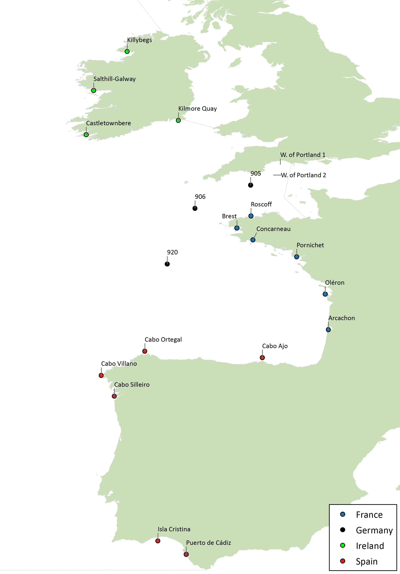

RSC sub-region 2 - Cap de la Hague Channel
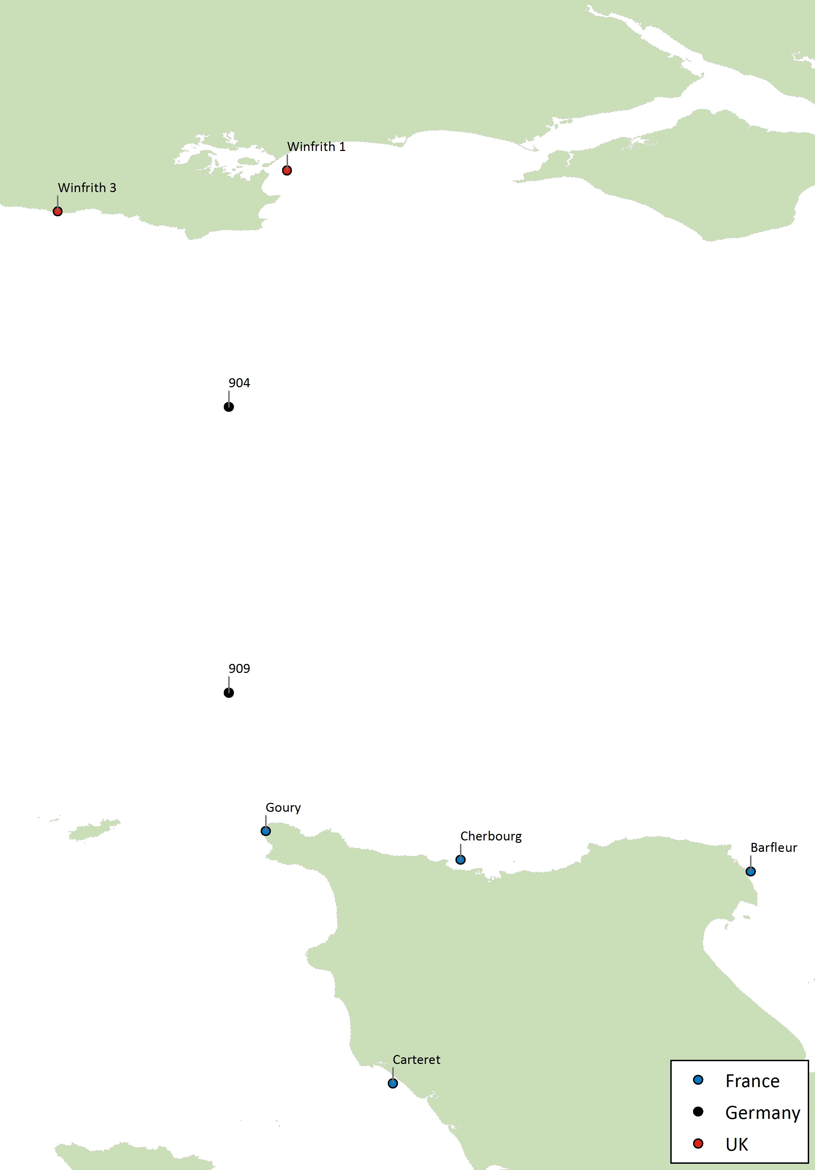

RSC sub-region 3 - Channel East
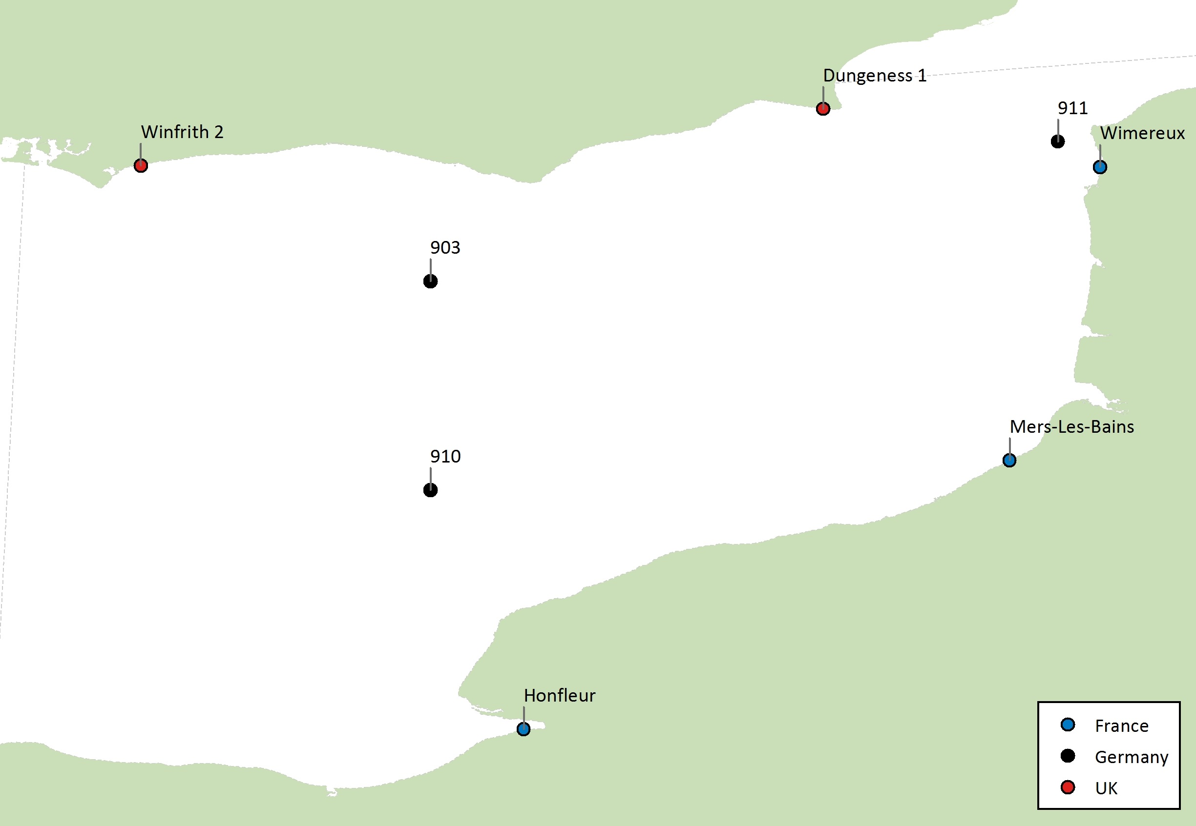

RSC sub-region 4 - Irish Sea (Rep. of Ireland)
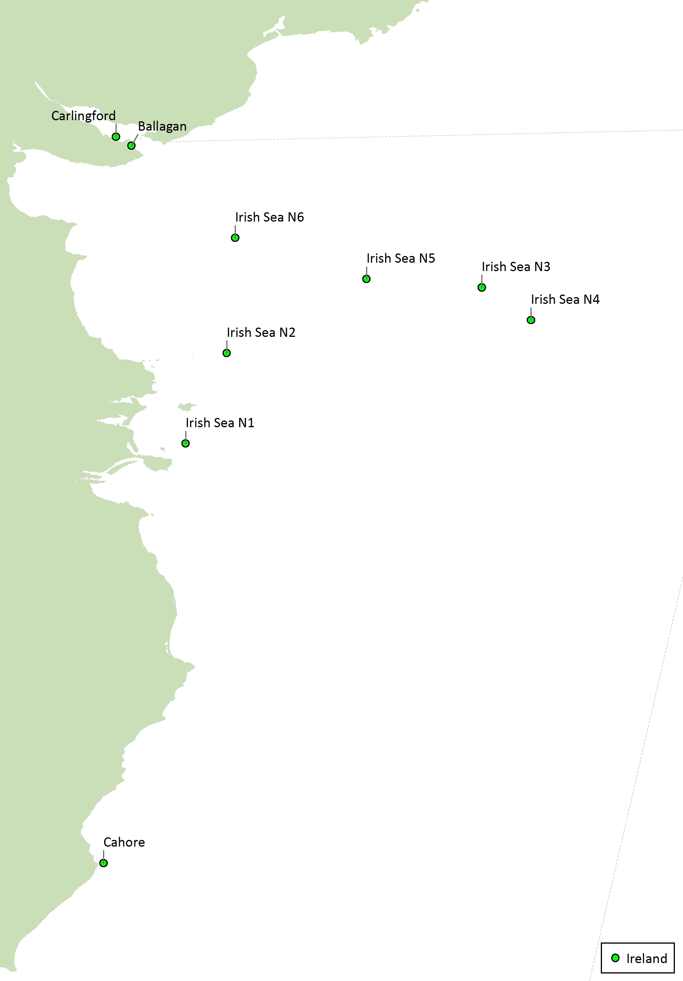
RSC sub-region 5 - Irish Sea (Northern Ireland)
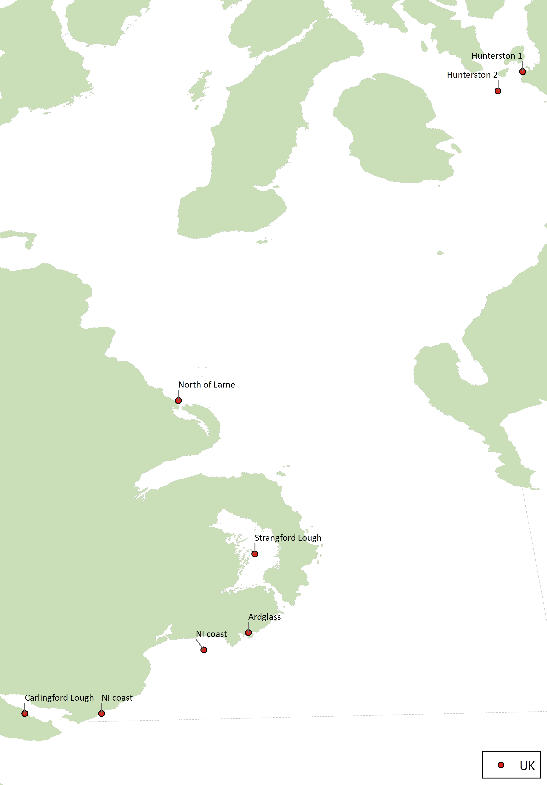
RSC sub-region 6 - Irish Sea (Sellafield)
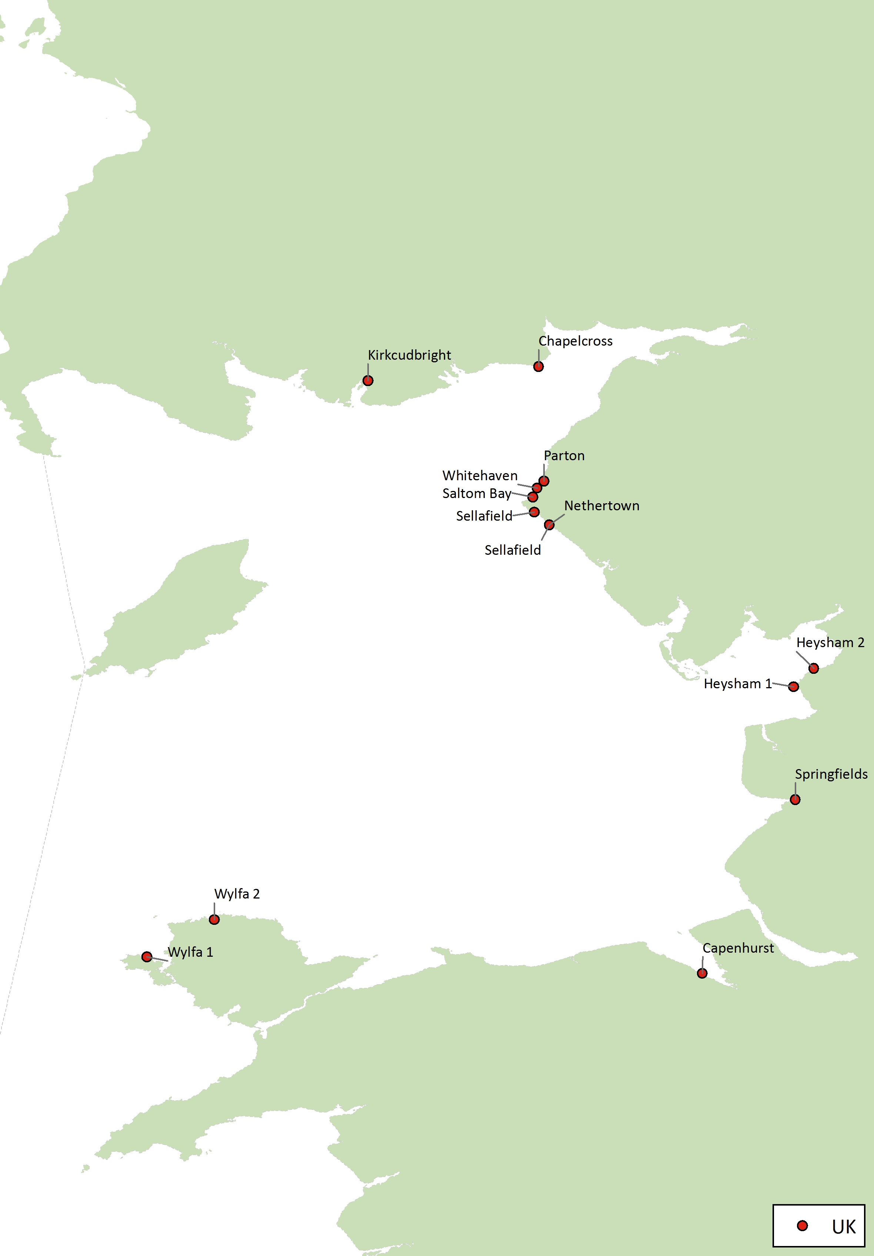
RSC sub-region 7 – Scottish waters (Dounreay)
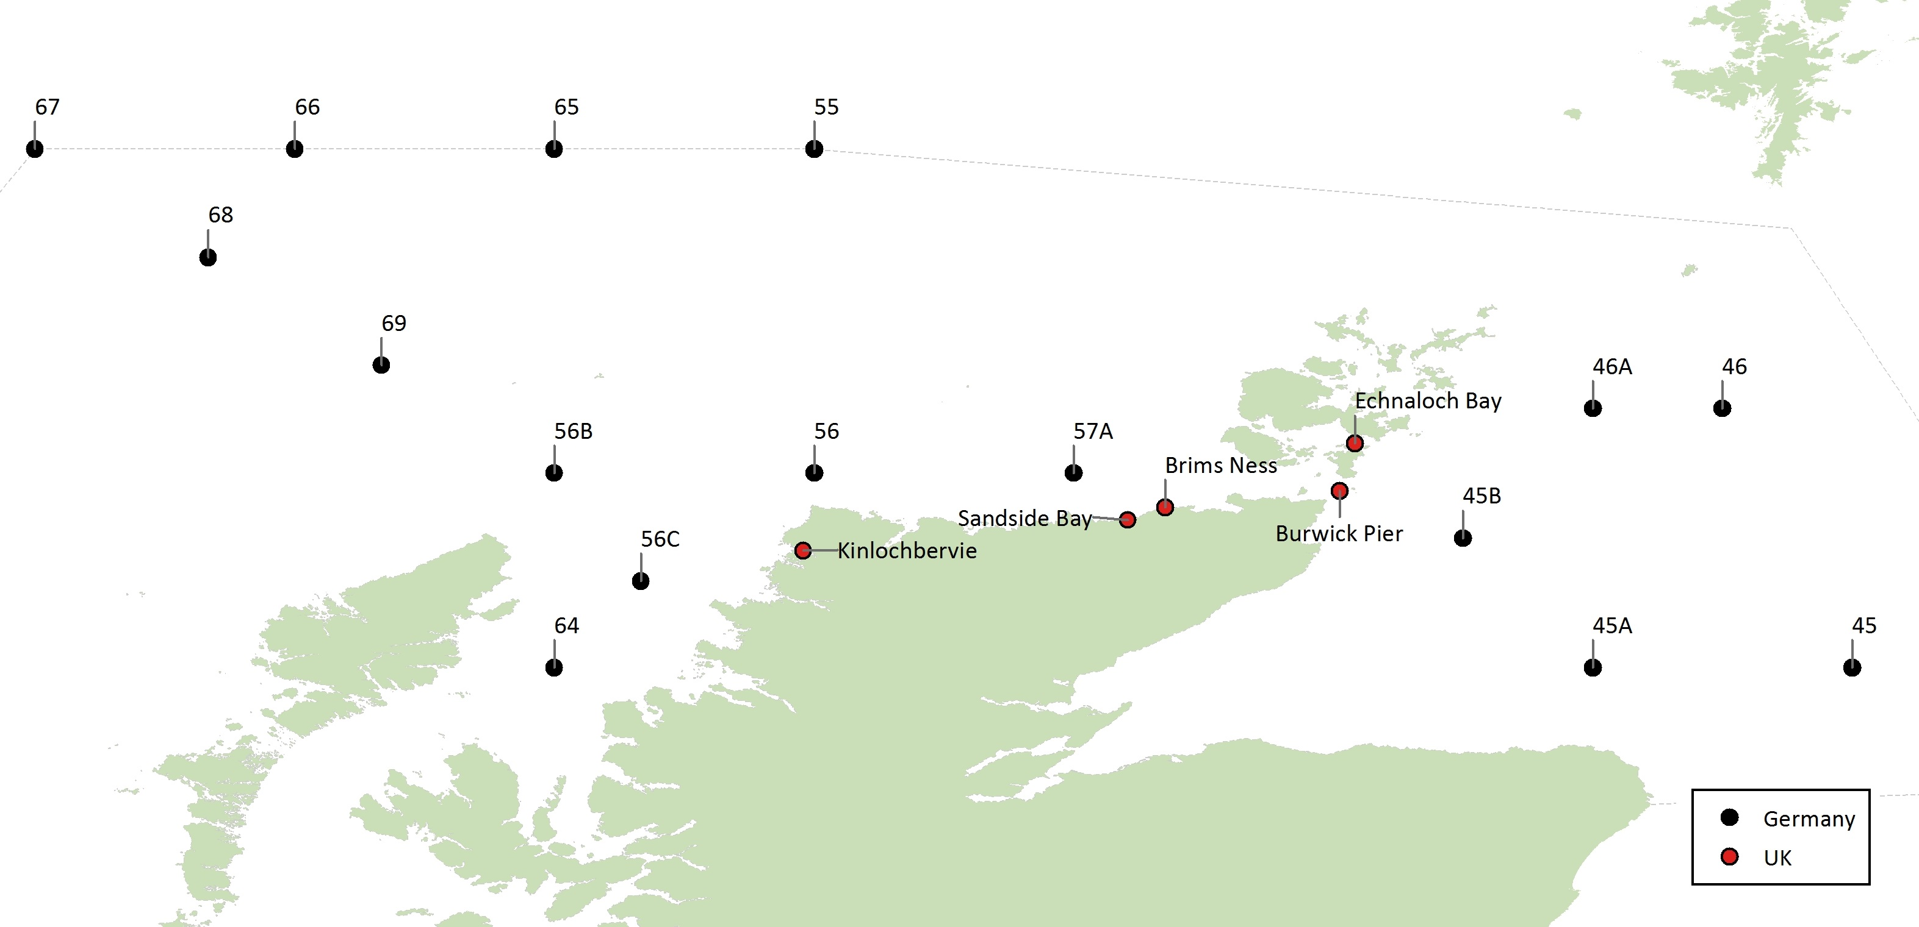
RSC sub-region 8 - North Sea South (Belgian and Dutch coast)
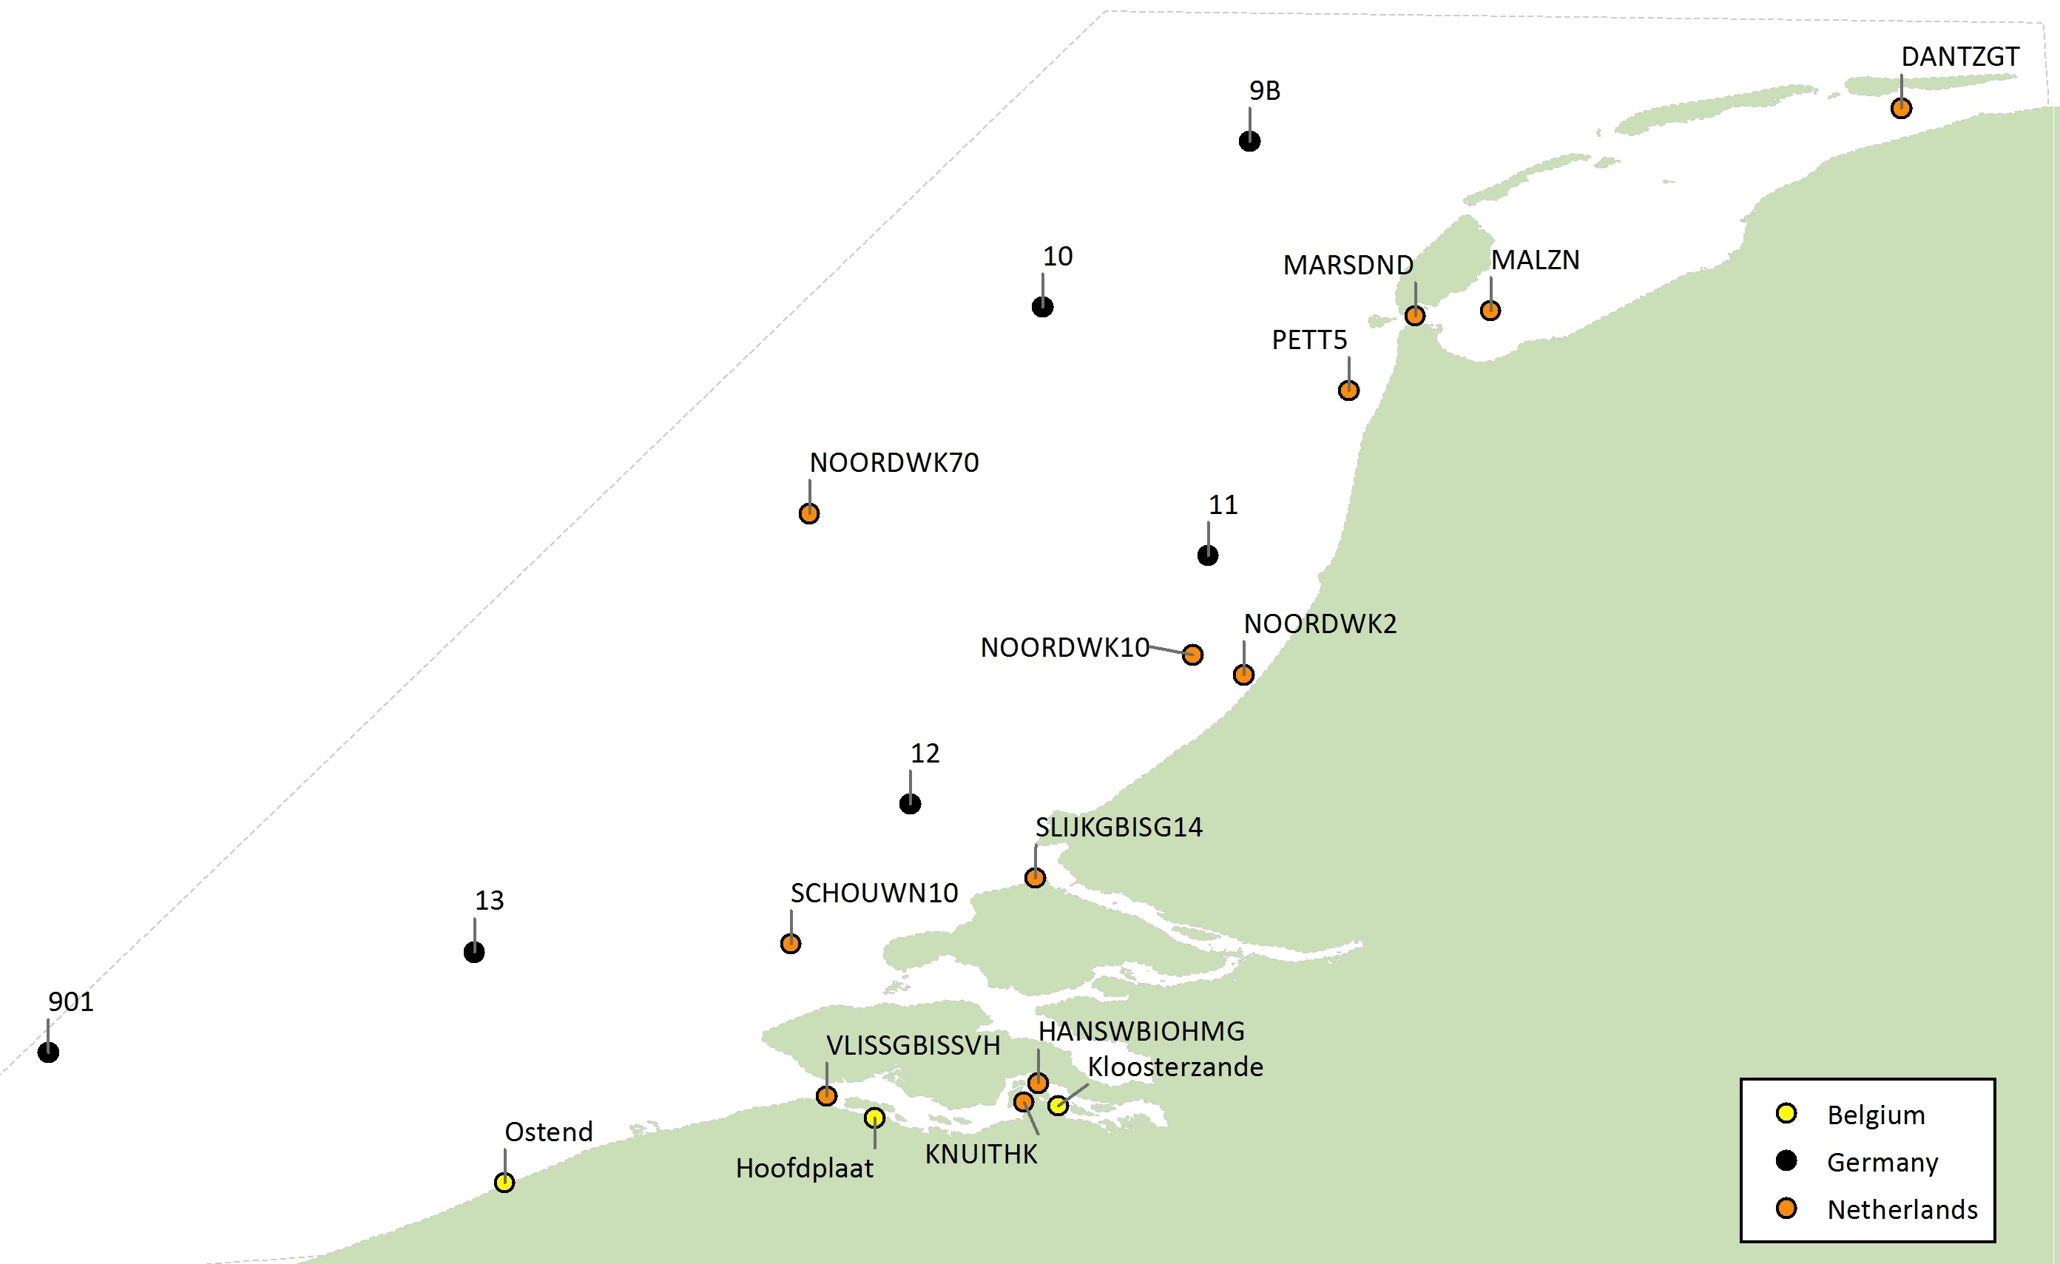

RSC sub-region 9 – German Bight
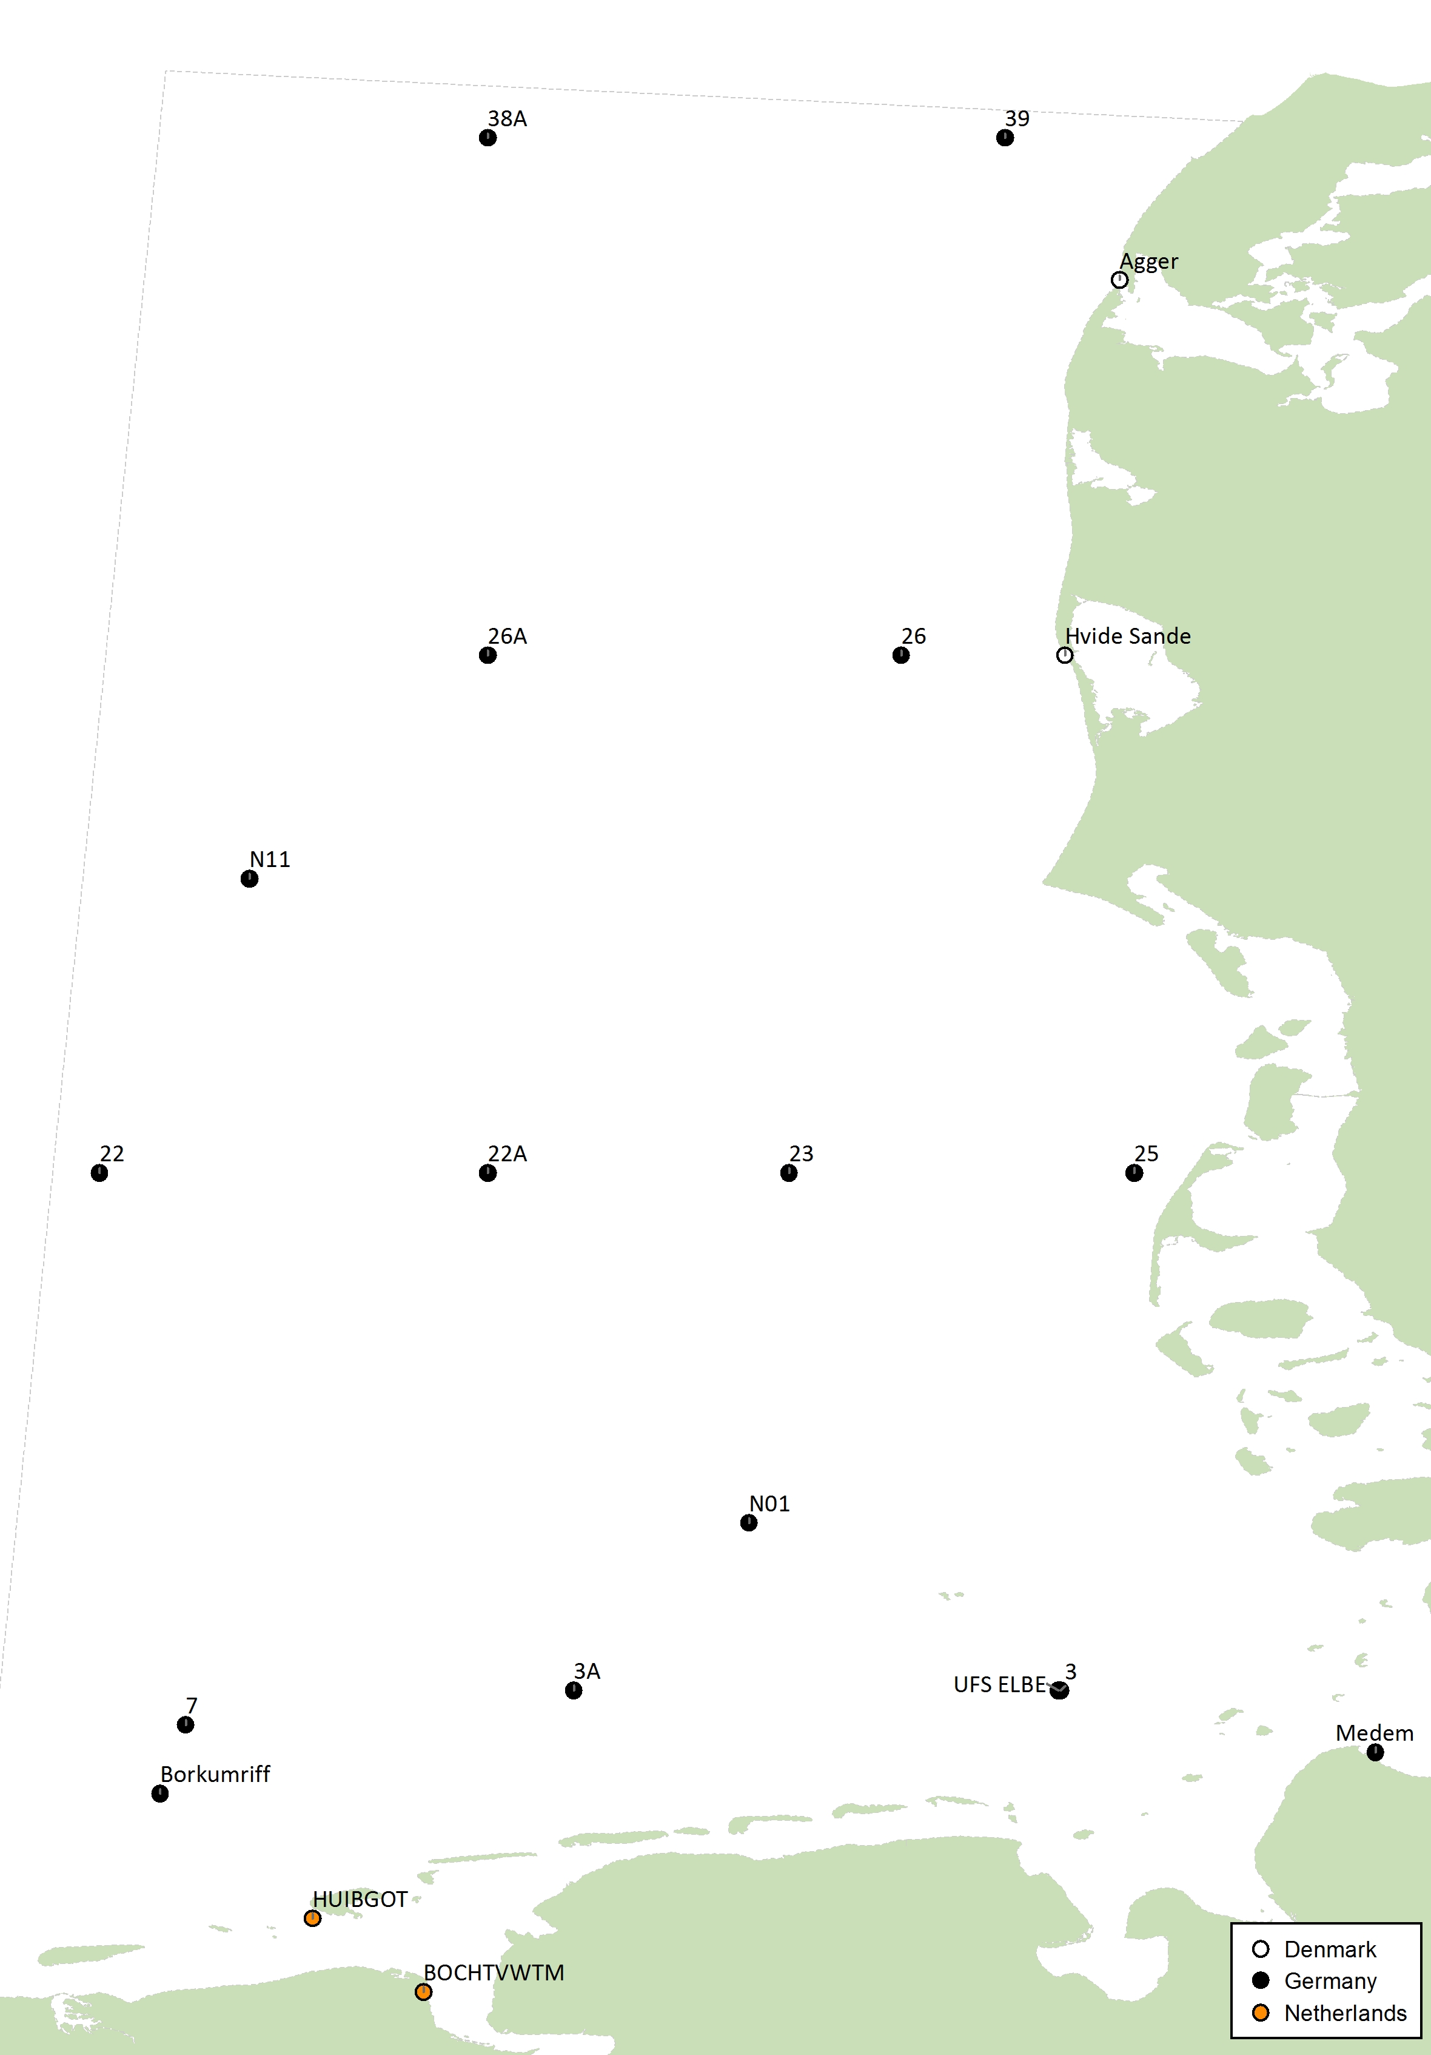
RSC sub-region 10 – North Sea (NW, SE and Central)
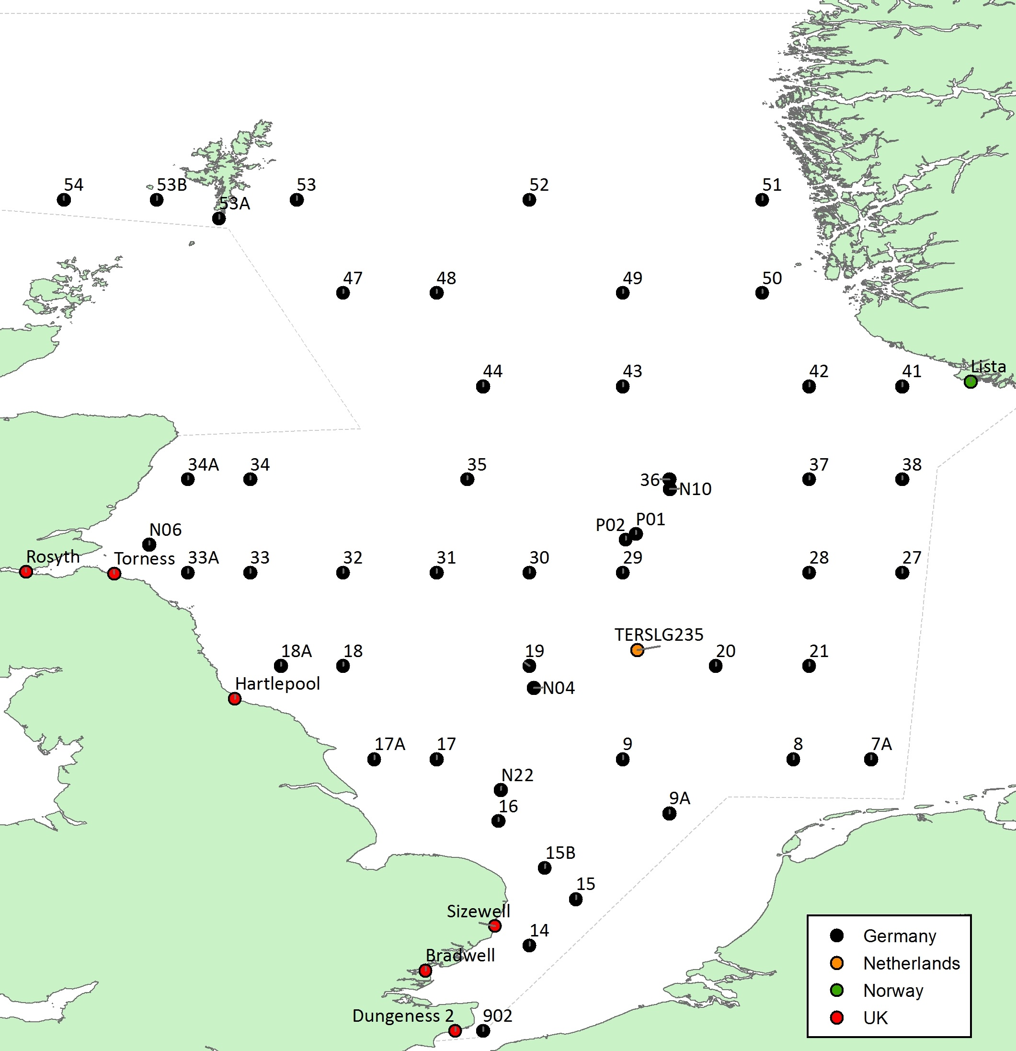

RSC sub-region 11 – North Sea (Skagerrak)
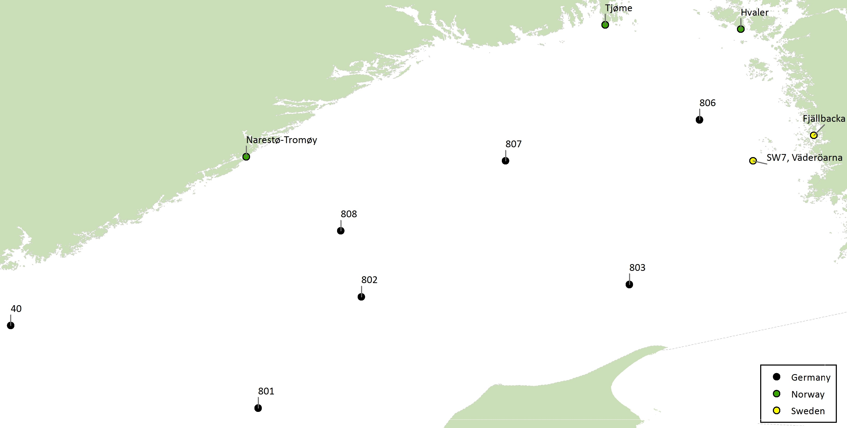
RSC sub-region 12 – Kattegat
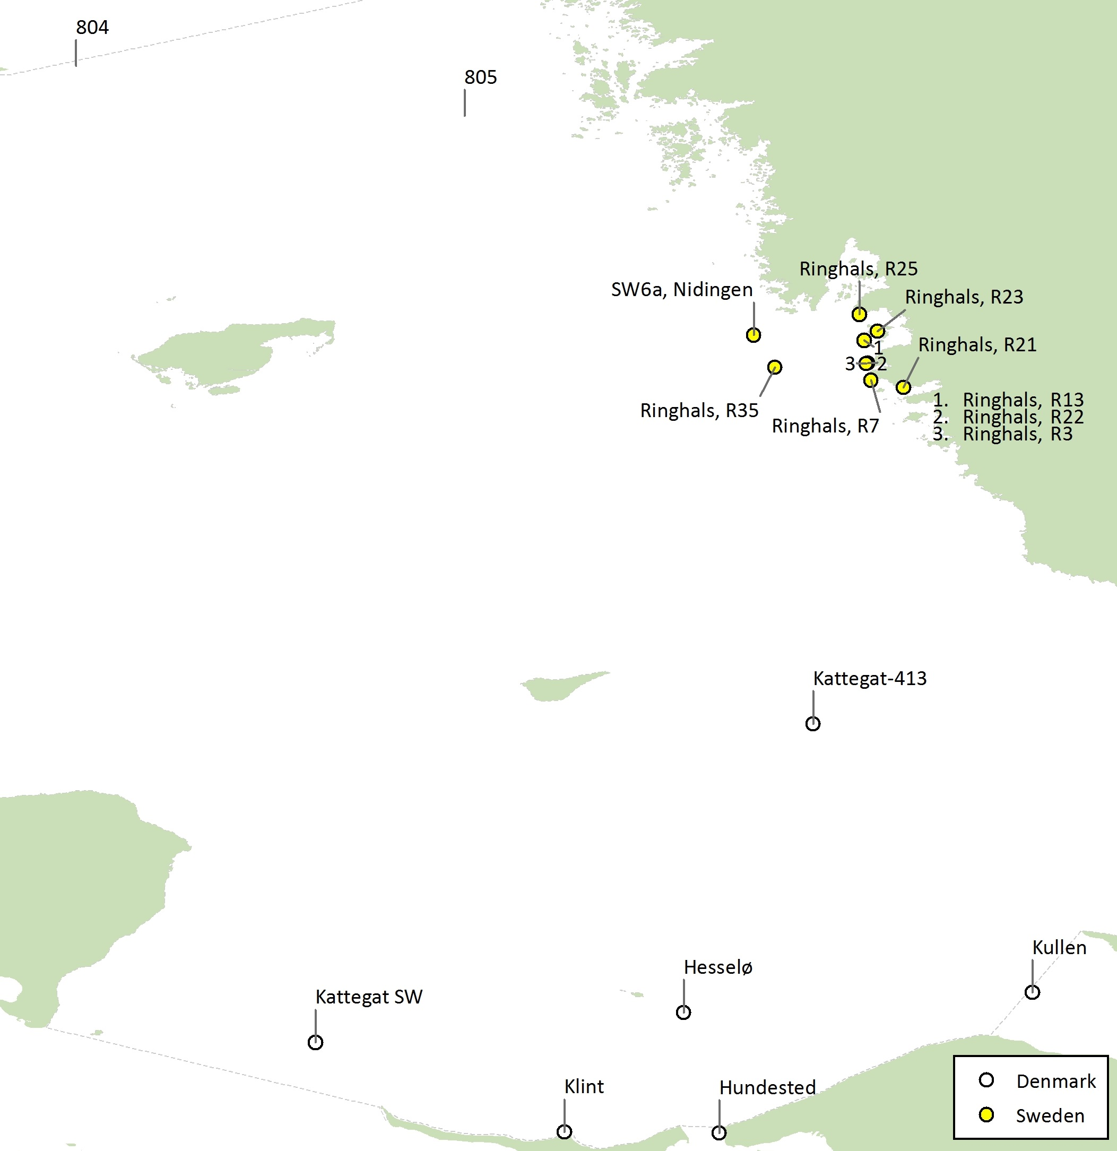

RSC sub-region 13 – Norwegian Coastal Current
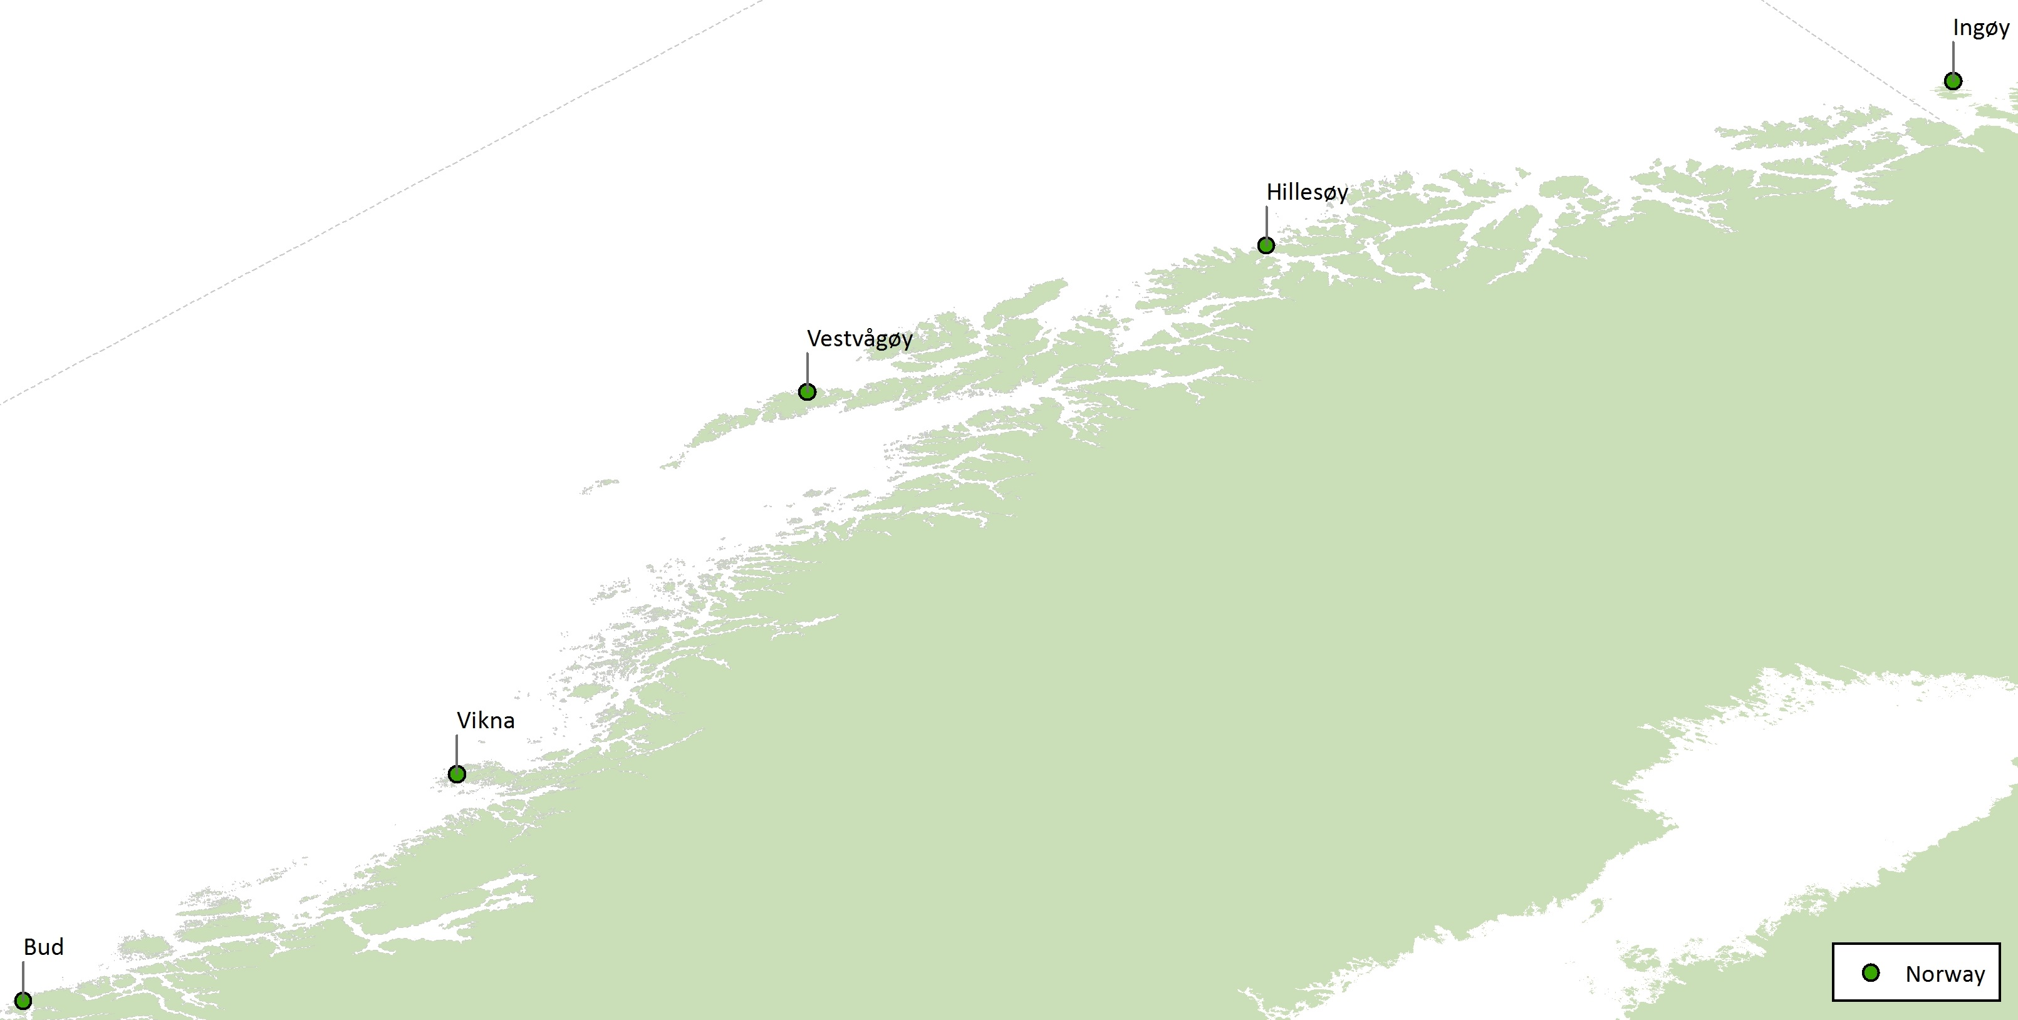
RSC sub-region 14 – Barents Sea
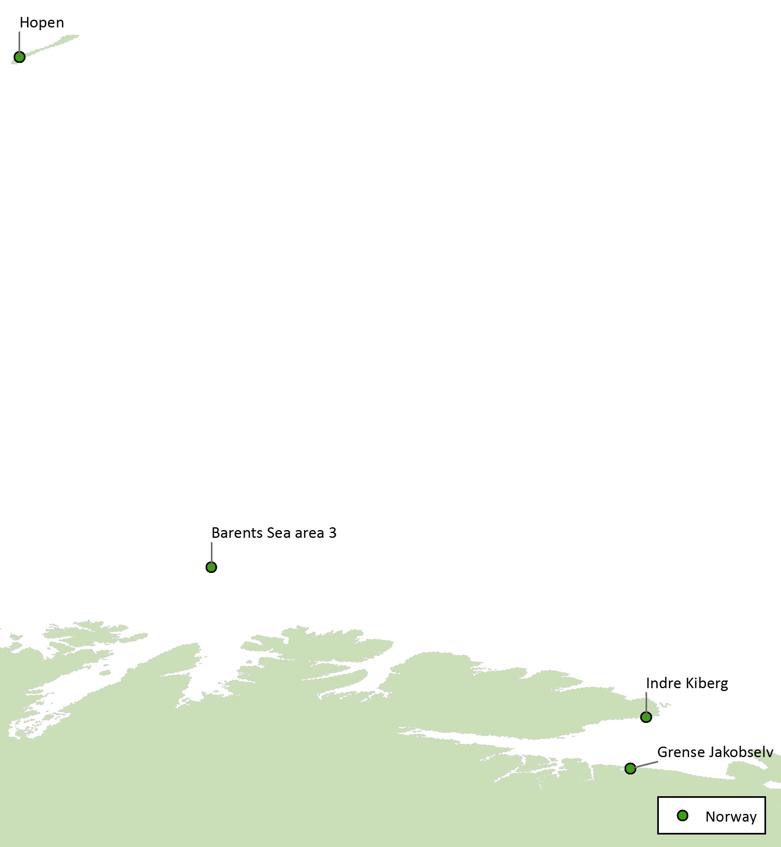

RSC sub-region 15 – Norwegian, Greenland Seas and Icelandic waters
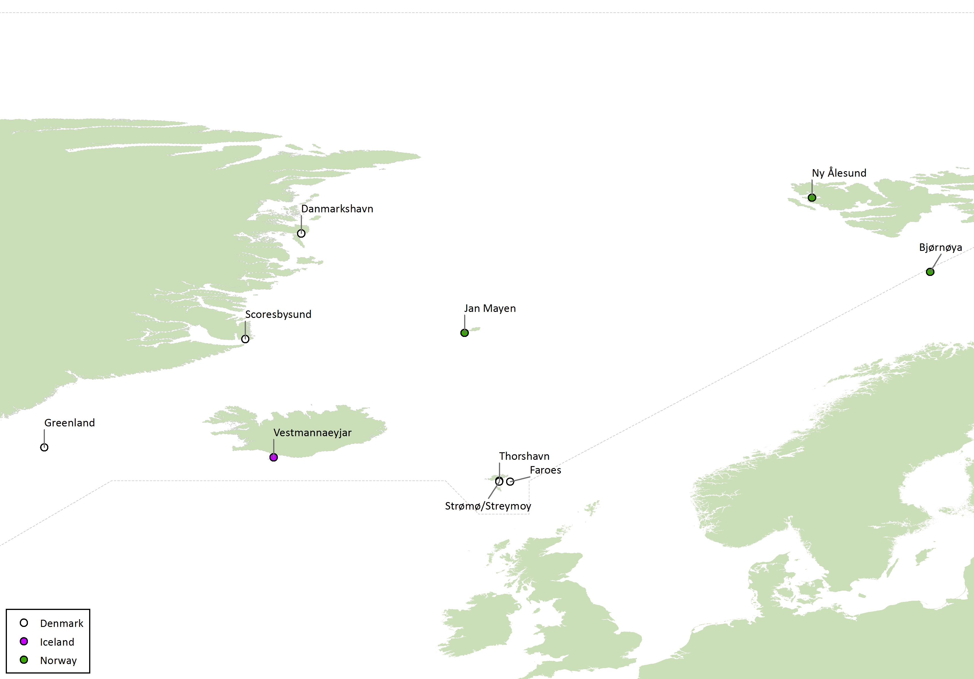

Coordinates for named monitoring stations in maps

CP | RSC region | Station name | LatD | LatM | LatS | LatDir | LongD | LongM | LongS | LongDir
Belgium | 8 | Ostend | 51 | 14 | 17 | N | 2 | 55 | 6 | E
Belgium | 8 | Hoofdplaat | 51 | 22 | 10 | N | 3 | 39 | 43 | E
Belgium | 8 | Kloosterzande | 51 | 23 | 36 | N | 4 | 1 | 52 | E
CP | RSC region | Station name | LatD | LatM | LatS | LatDir | LongD | LongM | LongS | LongDir
Denmark | 9 | Hvide Sande | 56 | 0 | 0 | N | 8 | 7 | 0 | E
Denmark | 9 | Agger | 56 | 43 | 31 | N | 8 | 12 | 78 | E
Denmark | 12 | Kullen | 56 | 12 | 0 | N | 12 | 22 | 0 | E
Denmark | 12 | Hesselø | 56 | 10 | 0 | N | 11 | 47 | 0 | E
Denmark | 12 | Kattegat SW | 56 | 7 | 0 | N | 11 | 10 | 0 | E
Denmark | 12 | Kattegat-413 | 56 | 39 | 0 | N | 12 | 0 | 0 | E
Denmark | 12 | Hundested | 55 | 57 | 55 | N | 11 | 50 | 32 | E
Denmark | 12 | Klint | 55 | 58 | 0 | N | 11 | 35 | 0 | E
Denmark | 15 | Danmarkshavn | 76 | 48 | 0 | N | 18 | 38 | 0 | W
Denmark | 15 | Scoresbysund | 70 | 29 | 0 | N | 21 | 58 | 0 | W
Denmark | 15 | Thorshavn | 62 | 0 | 15 | N | 6 | 46 | 56 | W
Denmark | 15 | Strømø/Streymoy | 61 | 57 | 0 | N | 6 | 47 | 0 | W
Denmark | 15 | Greenland | 64 | 0 | 0 | N | 34 | 0 | 0 | W
Denmark | 15 | Faroes | 61 | 57 | 0 | N | 6 | 7 | 0 | W
CP | RSC region | Station name | LatD | LatM | LatS | LatDir | LongD | LongM | LongS | LongDir
France | 1 | Roscoff | 48 | 43 | 40 | N | 3 | 59 | 20 | W
France | 1 | Brest | 48 | 17 | 53 | N | 4 | 29 | 41 | W
France | 1 | Concarneau | 47 | 52 | 5 | N | 3 | 55 | 3 | W
France | 1 | Pornichet | 47 | 15 | 28 | N | 2 | 20 | 39 | W
France | 1 | Oléron | 45 | 54 | 44 | N | 1 | 19 | 26 | W
France | 1 | Arcachon | 44 | 38 | 29 | N | 1 | 12 | 13 | W
France | 2 | Carteret | 49 | 20 | 47 | N | 1 | 45 | 39 | W
France | 2 | Goury | 49 | 42 | 52 | N | 1 | 56 | 46 | W
France | 2 | Cherbourg | 49 | 40 | 21 | N | 1 | 39 | 44 | W
France | 2 | Barfleur | 49 | 39 | 20 | N | 1 | 14 | 20 | W
France | 3 | Honfleur | 49 | 25 | 42 | N | 0 | 13 | 23 | E
France | 3 | Mers-Les-Bains | 50 | 4 | 17 | N | 1 | 23 | 3 | E
France | 3 | Wimereux | 50 | 46 | 24 | N | 1 | 36 | 0 | E
CP | RSC region | Station name | LatD | LatM | LatS | LatDir | LongD | LongM | LongS | LongDir
Germany | 1 | 905 | 49 | 50 | 00 | N | 004 | 00 | 00 | W
Germany | 1 | 906 | 49 | 00 | 00 | N | 006 | 00 | 00 | W
Germany | 1 | 920 | 47 | 00 | 00 | N | 007 | 00 | 00 | W
Germany | 2 | 904 | 50 | 20 | 00 | N | 002 | 00 | 00 | W
Germany | 2 | 909 | 49 | 55 | 00 | N | 002 | 00 | 00 | W
Germany | 3 | 903 | 50 | 30 | 00 | N | 000 | 00 | 00 | E
Germany | 3 | 910 | 50 | 00 | 00 | N | 000 | 00 | 00 | E
Germany | 3 | 911 | 50 | 50 | 00 | N | 001 | 30 | 00 | E
Germany | 7 | 45 | 58 | 00 | 00 | N | 001 | 00 | 00 | W
Germany | 7 | 45A | 58 | 00 | 00 | N | 002 | 00 | 00 | W
Germany | 7 | 45B | 58 | 30 | 00 | N | 002 | 30 | 00 | W
Germany | 7 | 46A | 59 | 00 | 00 | N | 002 | 00 | 00 | W
Germany | 7 | 46 | 59 | 00 | 00 | N | 001 | 30 | 00 | W
Germany | 7 | 65 | 60 | 00 | 00 | N | 006 | 00 | 00 | W
Germany | 7 | 66 | 60 | 00 | 00 | N | 007 | 00 | 00 | W
Germany | 7 | 67 | 60 | 00 | 00 | N | 008 | 00 | 00 | W
Germany | 7 | 68 | 59 | 35 | 00 | N | 007 | 20 | 00 | W
Germany | 7 | 69 | 59 | 10 | 00 | N | 006 | 40 | 00 | W
Germany | 7 | 56B | 58 | 45 | 00 | N | 006 | 00 | 00 | W
Germany | 7 | 56C | 58 | 20 | 00 | N | 005 | 40 | 00 | W
Germany | 7 | 64 | 58 | 00 | 00 | N | 006 | 00 | 00 | W
Germany | 7 | 56 | 58 | 45 | 00 | N | 005 | 00 | 00 | W
Germany | 7 | 57A | 58 | 45 | 00 | N | 004 | 00 | 00 | W
Germany | 7 | 55 | 60 | 00 | 00 | N | 005 | 00 | 00 | W
Germany | 8 | 9B | 53 | 20 | 00 | N | 004 | 25 | 00 | E
Germany | 8 | 10 | 53 | 00 | 00 | N | 004 | 00 | 00 | E
Germany | 8 | 11 | 52 | 30 | 00 | N | 004 | 20 | 00 | E
Germany | 8 | 12 | 52 | 00 | 00 | N | 003 | 44 | 00 | E
Germany | 8 | 13 | 51 | 42 | 12 | N | 002 | 51 | 24 | E
Germany | 8 | 901 | 51 | 30 | 00 | N | 002 | 00 | 00 | E
Germany | 9 | Medem | 53 | 52 | 48 | N | 008 | 43 | 00 | E
Germany | 9 | 3 | 54 | 00 | 00 | N | 008 | 06 | 30 | E
Germany | 9 | 3A | 54 | 00 | 00 | N | 007 | 10 | 00 | E
Germany | 9 | 7 | 53 | 56 | 00 | N | 006 | 25 | 00 | E
Germany | 9 | 22 | 55 | 00 | 00 | N | 006 | 15 | 00 | E
Germany | 9 | 22A | 55 | 00 | 00 | N | 007 | 00 | 00 | E
Germany | 9 | 23 | 55 | 00 | 00 | N | 007 | 35 | 00 | E
Germany | 9 | 25 | 55 | 00 | 00 | N | 008 | 15 | 00 | E
Germany | 9 | 26 | 56 | 00 | 00 | N | 007 | 48 | 00 | E
Germany | 9 | 26A | 56 | 00 | 00 | N | 007 | 00 | 00 | E
Germany | 9 | 38A | 57 | 00 | 00 | N | 007 | 00 | 00 | E
Germany | 9 | 39 | 57 | 00 | 00 | N | 008 | 00 | 00 | E
Germany | 9 | UFS ELBE | 54 | 00 | 00 | N | 008 | 06 | 12 | E
Germany | 9 | Borkumriff | 53 | 48 | 00 | N | 006 | 22 | 00 | E
Germany | 9 | N01 | 54 | 19 | 25 | N | 7 | 30 | 20 | E
Germany | 9 | N11 | 55 | 34 | 7 | N | 6 | 32 | 22 | E
Germany | 10 | N04 | 54 | 46 | 1 | N | 2 | 2 | 40 | E
Germany | 10 | N06 | 56 | 18 | 1 | N | 2 | 5 | 4 | W
Germany | 10 | N10 | 56 | 53 | 53 | N | 3 | 30 | 21 | E
Germany | 10 | N22 | 53 | 40 | 4 | N | 1 | 41 | 37 | E
Germany | 10 | P01 | 56 | 24 | 49 | N | 3 | 8 | 28 | E
Germany | 10 | P02 | 56 | 21 | 9 | N | 3 | 2 | 1 | E
Germany | 10 | 902 | 51 | 05 | 00 | N | 001 | 30 | 00 | E
Germany | 10 | 7A | 54 | 00 | 00 | N | 005 | 40 | 00 | E
Germany | 10 | 8 | 54 | 00 | 00 | N | 004 | 50 | 00 | E
Germany | 10 | 9 | 54 | 00 | 00 | N | 003 | 00 | 00 | E
Germany | 10 | 9A | 53 | 25 | 00 | N | 003 | 30 | 00 | E
Germany | 10 | 14 | 52 | 00 | 00 | N | 002 | 00 | 00 | E
Germany | 10 | 15 | 52 | 30 | 00 | N | 002 | 30 | 00 | E
Germany | 10 | 15B | 52 | 50 | 00 | N | 002 | 10 | 00 | E
Germany | 10 | 16 | 53 | 20 | 00 | N | 001 | 40 | 00 | E
Germany | 10 | 17 | 54 | 00 | 00 | N | 001 | 00 | 00 | E
Germany | 10 | 17A | 54 | 00 | 00 | N | 000 | 20 | 00 | E
Germany | 10 | 18A | 55 | 00 | 00 | N | 000 | 40 | 00 | W
Germany | 10 | 18 | 55 | 00 | 00 | N | 000 | 00 | 00 | E
Germany | 10 | 19 | 55 | 00 | 00 | N | 002 | 00 | 00 | E
Germany | 10 | 20 | 55 | 00 | 00 | N | 004 | 00 | 00 | E
Germany | 10 | 21 | 55 | 00 | 00 | N | 005 | 00 | 00 | E
Germany | 10 | 27 | 56 | 00 | 00 | N | 006 | 00 | 00 | E
Germany | 10 | 28 | 56 | 00 | 00 | N | 005 | 00 | 00 | E
Germany | 10 | 29 | 56 | 00 | 00 | N | 003 | 00 | 00 | E
Germany | 10 | 30 | 56 | 00 | 00 | N | 002 | 00 | 00 | E
Germany | 10 | 31 | 56 | 00 | 00 | N | 001 | 00 | 00 | E
Germany | 10 | 32 | 56 | 00 | 00 | N | 000 | 00 | 00 | E
Germany | 10 | 33 | 56 | 00 | 00 | N | 001 | 00 | 00 | W
Germany | 10 | 33A | 56 | 00 | 00 | N | 001 | 40 | 00 | W
Germany | 10 | 34A | 57 | 00 | 00 | N | 001 | 40 | 00 | W
Germany | 10 | 34 | 57 | 00 | 00 | N | 001 | 00 | 00 | W
Germany | 10 | 35 | 57 | 00 | 00 | N | 001 | 20 | 00 | E
Germany | 10 | 36 | 57 | 00 | 00 | N | 003 | 30 | 00 | E
Germany | 10 | 37 | 57 | 00 | 00 | N | 005 | 00 | 00 | E
Germany | 10 | 38 | 57 | 00 | 00 | N | 006 | 00 | 00 | E
Germany | 10 | 41 | 58 | 00 | 00 | N | 006 | 00 | 00 | E
Germany | 10 | 42 | 58 | 00 | 00 | N | 005 | 00 | 00 | E
Germany | 10 | 43 | 58 | 00 | 00 | N | 003 | 00 | 00 | E
Germany | 10 | 44 | 58 | 00 | 00 | N | 001 | 30 | 00 | E
Germany | 10 | 47 | 59 | 00 | 00 | N | 000 | 00 | 00 | E
Germany | 10 | 48 | 59 | 00 | 00 | N | 001 | 00 | 00 | E
Germany | 10 | 49 | 59 | 00 | 00 | N | 003 | 00 | 00 | E
Germany | 10 | 50 | 59 | 00 | 00 | N | 004 | 30 | 00 | E
Germany | 10 | 51 | 60 | 00 | 00 | N | 004 | 30 | 00 | E
Germany | 10 | 52 | 60 | 00 | 00 | N | 002 | 00 | 00 | E
Germany | 10 | 53 | 60 | 00 | 00 | N | 000 | 30 | 00 | W
Germany | 10 | 53A | 59 | 48 | 00 | N | 001 | 20 | 00 | W
Germany | 10 | 53B | 60 | 00 | 00 | N | 002 | 00 | 00 | W
Germany | 10 | 54 | 60 | 00 | 00 | N | 003 | 00 | 00 | W
Germany | 11 | 801 | 57 | 30 | 00 | N | 009 | 00 | 00 | E
Germany | 11 | 802 | 57 | 57 | 00 | N | 009 | 25 | 00 | E
Germany | 11 | 803 | 58 | 00 | 00 | N | 010 | 30 | 00 | E
Germany | 11 | 806 | 58 | 40 | 00 | N | 010 | 47 | 00 | E
Germany | 11 | 807 | 58 | 30 | 00 | N | 010 | 00 | 00 | E
Germany | 11 | 808 | 58 | 13 | 00 | N | 009 | 20 | 00 | E
Germany | 11 | 40 | 57 | 50 | 00 | N | 008 | 00 | 00 | E
Germany | 12 | 804 | 57 | 45 | 00 | N | 010 | 46 | 00 | E
Germany | 12 | 805 | 57 | 40 | 00 | N | 011 | 25 | 00 | E
CP | RSC region | Station name | LatD | LatM | LatS | LatDir | LongD | LongM | LongS | LongDir
Iceland | 15 | Vestmannaeyjar | 63 | 24 | 37 | N | 20 | 16 | 59 | W
CP | RSC region | Station name | LatD | LatM | LatS | LatDir | LongD | LongM | LongS | LongDir
Ireland | 1 | Castletownbere | 51 | 38 | 40 | N | 9 | 54 | 30 | W
Ireland | 1 | Salthill-Galway | 53 | 14 | 5 | N | 9 | 37 | 83 | W
Ireland | 1 | Killybegs | 54 | 37 | 58 | N | 8 | 26 | 6 | W
Ireland | 1 | Kilmore Quay | 52 | 9 | 55 | N | 6 | 35 | 36 | W
Ireland | 4 | Irish Sea N1 | 53 | 25 | 0 | N | 6 | 1 | 0 | W
Ireland | 4 | Irish Sea N2 | 53 | 36 | 0 | N | 5 | 56 | 0 | W
Ireland | 4 | Irish Sea N3 | 53 | 44 | 0 | N | 5 | 25 | 0 | W
Ireland | 4 | Irish Sea N4 | 53 | 40 | 0 | N | 5 | 19 | 0 | W
Ireland | 4 | Irish Sea N5 | 53 | 45 | 0 | N | 5 | 39 | 0 | W
Ireland | 4 | Irish Sea N6 | 53 | 50 | 0 | N | 5 | 55 | 0 | W
Ireland | 4 | Cahore | 52 | 34 | 0 | N | 6 | 11 | 0 | W
Ireland | 4 | Ballagan | 54 | 1 | 13 | N | 6 | 7 | 36 | W
Ireland | 4 | Carlingford | 54 | 2 | 19 | N | 6 | 9 | 29 | W
CP | RSC region | Station name | LatD | LatM | LatS | LatDir | LongD | LongM | LongS | LongDir
Netherlands | 8 | VLISSGBISSVH | 51 | 24 | 43 | N | 3 | 33 | 56 | E
Netherlands | 8 | KNUITHK | 51 | 24 | 0 | N | 3 | 57 | 44 | E
Netherlands | 8 | SCHOUWN10 | 51 | 43 | 10 | N | 3 | 29 | 38 | E
Netherlands | 8 | NOORDWK2 | 52 | 15 | 38 | N | 4 | 24 | 17 | E
Netherlands | 8 | NOORDWK10 | 52 | 18 | 5 | N | 4 | 18 | 4 | E
Netherlands | 8 | NOORDWK70 | 52 | 35 | 8 | N | 3 | 31 | 48 | E
Netherlands | 8 | MARSDND | 52 | 58 | 57 | N | 4 | 45 | 0 | E
Netherlands | 8 | DANTZGT | 53 | 24 | 4 | N | 5 | 43 | 37 | E
Netherlands | 8 | PETT5 | 52 | 49 | 55 | N | 4 | 36 | 55 | E
Netherlands | 8 | HANSWBIOHMG | 51 | 26 | 24 | N | 3 | 59 | 26 | E
Netherlands | 8 | SLIJKGBISG14 | 51 | 51 | 7 | N | 3 | 59 | 7 | E
Netherlands | 8 | MALZN | 52 | 59 | 35 | N | 4 | 54 | 3 | E
Netherlands | 9 | BOCHTVWTM | 53 | 25 | 2 | N | 6 | 52 | 34 | E
Netherlands | 9 | HUIBGOT | 53 | 33 | 33 | N | 6 | 39 | 40 | E
Netherlands | 10 | TERSLG235 | 55 | 10 | 18 | N | 3 | 9 | 22 | E
CP | RSC region | Station name | LatD | LatM | LatS | LatDir | LongD | LongM | LongS | LongDir
Norway | 10 | Lista | 58 | 3 | 9 | N | 6 | 44 | 0 | E
Norway | 11 | Tjøme | 59 | 3 | 4 | N | 10 | 24 | 8 | E
Norway | 11 | Narestø-Tromøy | 58 | 31 | 3 | N | 8 | 57 | 5 | E
Norway | 11 | Hvaler | 59 | 2 | 1 | N | 10 | 57 | 0 | E
Norway | 13 | Hillesøy | 69 | 37 | 5 | N | 17 | 57 | 0 | E
Norway | 13 | Bud | 62 | 54 | 7 | N | 6 | 54 | 3 | E
Norway | 13 | Ingøy | 71 | 5 | 2 | N | 24 | 3 | 3 | E
Norway | 13 | Vestvågøy | 68 | 19 | 4 | N | 13 | 52 | 6 | E
Norway | 13 | Vikna | 64 | 55 | 5 | N | 10 | 45 | 5 | E
Norway | 14 | Hopen | 76 | 30 | 16 | N | 25 | 1 | 12 | E
Norway | 14 | Grense Jakobselv | 69 | 47 | 4 | N | 30 | 47 | 5 | E
Norway | 14 | Indre Kiberg | 70 | 16 | 2 | N | 30 | 56 | 7 | E
Norway | 14 | Barents Sea area 3 | 71 | 41 | 0 | N | 26 | 50 | 0 | E
Norway | 15 | Bjørnøya | 74 | 30 | 0 | N | 19 | 0 | 0 | E
Norway | 15 | Jan Mayen | 70 | 50 | 49 | N | 8 | 51 | 57 | W
Norway | 15 | Ny Ålesund | 78 | 55 | 60 | N | 11 | 56 | 0 | E
CP | RSC region | Station name | LatD | LatM | LatS | LatDir | LongD | LongM | LongS | LongDir
Spain | 1 | Cabo Ajo | 43 | 38 | 4 | N | 3 | 34 | 41 | W
Spain | 1 | Cabo Ortegal | 43 | 52 | 0 | N | 7 | 48 | 0 | W
Spain | 1 | Cabo Villano | 43 | 0 | 0 | N | 9 | 22 | 0 | W
Spain | 1 | Cabo Silleiro | 42 | 15 | 0 | N | 8 | 54 | 0 | W
Spain | 1 | Isla Cristina | 37 | 3 | 0 | N | 7 | 20 | 0 | W
Spain | 1 | Puerto de Cádiz | 36 | 34 | 0 | N | 6 | 19 | 0 | W
CP | RSC region | Station name | LatD | LatM | LatS | LatDir | LongD | LongM | LongS | LongDir
Sweden | 11 | Fjällbacka | 58 | 36 | 12 | N | 11 | 14 | 42 | E
Sweden | 11 | SW7, Väderöarna | 58 | 30 | 0 | N | 11 | 0 | 0 | E
Sweden | 12 | Ringhals, R35 | 57 | 14 | 45 | N | 11 | 56 | 8 | E
Sweden | 12 | Ringhals, R22 | 57 | 15 | 10 | N | 12 | 5 | 29 | E
Sweden | 12 | SW6a, Nidingen | 57 | 18 | 00 | N | 11 | 54 | 00 | E
Sweden | 12 | Ringhals, R21 | 57 | 12 | 45 | N | 12 | 09 | 01 | E
Sweden | 12 | Ringhals, R23 | 57 | 18 | 23 | N | 12 | 06 | 27 | E
Sweden | 12 | Ringhals, R25 | 57 | 20 | 07 | N | 12 | 04 | 36 | E
Sweden | 12 | Ringhals, R3 | 57 | 15 | 08 | N | 12 | 05 | 17 | E
Sweden | 12 | Ringhals, R7 | 57 | 13 | 29 | N | 12 | 05 | 48 | E
Sweden | 12 | Ringhals, R13 | 57 | 17 | 28 | N | 12 | 05 | 06 | E
CP | RSC region | Station name | LatD | LatM | LatS | LatDir | LongD | LongM | LongS | LongDir
UK | 1 | W. of Portland 1 | 50 | 34 | 41 | N | 2 | 56 | 17 | W
UK | 1 | W. of Portland 2 | 50 | 11 | 38 | N | 3 | 10 | 43 | W
UK | 2 | Winfrith 1 | 50 | 40 | 41 | N | 1 | 54 | 54 | W
UK | 2 | Winfrith 3 | 50 | 37 | 5 | N | 2 | 14 | 59 | W
UK | 3 | Winfrith 2 | 50 | 46 | 35 | N | 0 | 41 | 32 | W
UK | 3 | Dungeness 1 | 50 | 54 | 43 | N | 0 | 56 | 17 | E
UK | 5 | North of Larne | 54 | 52 | 1 | N | 5 | 48 | 0 | W
UK | 5 | NI coast | 54 | 3 | 0 | N | 6 | 0 | 0 | W
UK | 5 | NI coast | 54 | 12 | 59 | N | 5 | 43 | 59 | W
UK | 5 | Hunterston 2 | 55 | 40 | 31 | N | 4 | 57 | 57 | W
UK | 5 | Hunterston 1 | 55 | 43 | 31 | N | 4 | 54 | 7 | W
UK | 5 | Ardglass | 54 | 15 | 40 | N | 5 | 37 | 1 | W
UK | 5 | Carlingford Lough | 54 | 3 | 0 | N | 6 | 12 | 0 | W
UK | 5 | Strangford Lough | 54 | 28 | 1 | N | 5 | 36 | 0 | W
UK | 6 | Sellafield | 54 | 29 | 20 | N | 3 | 36 | 25 | W
UK | 6 | Sellafield | 54 | 27 | 18 | N | 3 | 33 | 58 | W
UK | 6 | Heysham 1 | 54 | 1 | 40 | N | 2 | 55 | 20 | W
UK | 6 | Heysham 2 | 54 | 4 | 39 | N | 2 | 52 | 8 | W
UK | 6 | Wylfa 1 | 53 | 18 | 59 | N | 4 | 37 | 44 | W
UK | 6 | Wylfa 2 | 53 | 24 | 53 | N | 4 | 27 | 5 | W
UK | 6 | Chapelcross | 54 | 52 | 22 | N | 3 | 35 | 40 | W
UK | 6 | Springfields | 53 | 43 | 52 | N | 2 | 55 | 2 | W
UK | 6 | Capenhurst | 53 | 16 | 20 | N | 3 | 9 | 44 | W
UK | 6 | Saltom Bay | 54 | 31 | 42.3 | N | 3 | 36 | 37.14 | W
UK | 6 | Parton | 54 | 34 | 15.6 | N | 3 | 34 | 51.6 | W
UK | 6 | Nethertown | 54 | 27 | 18 | N | 3 | 33 | 57.6 | W
UK | 6 | Kirkcudbright | 54 | 50 | 8.4 | N | 4 | 2 | 45 | W
UK | 6 | Whitehaven | 54 | 33 | 6.96 | N | 3 | 35 | 55.98 | W
UK | 7 | Sandside Bay | 58 | 34 | 12 | N | 3 | 47 | 30 | W
UK | 7 | Brims Ness | 58 | 37 | 7 | N | 3 | 38 | 52 | W
UK | 7 | Echnaloch Bay | 58 | 52 | 0 | N | 2 | 55 | 0 | W
UK | 7 | Burwick Pier | 58 | 40 | 57 | N | 2 | 58 | 30 | W
UK | 7 | Kinlochbervie | 58 | 27 | 9 | N | 5 | 2 | 30 | W
UK | 10 | Dungeness 2 | 51 | 5 | 3 | N | 1 | 12 | 11 | E
UK | 10 | Rosyth | 56 | 0 | 40 | N | 3 | 24 | 24 | W
UK | 10 | Hartlepool | 54 | 38 | 55 | N | 1 | 9 | 41 | W
UK | 10 | Hartlepool | 54 | 38 | 48 | N | 1 | 8 | 7 | W
UK | 10 | Hartlepool | 54 | 38 | 25 | N | 1 | 8 | 24 | W
UK | 10 | Sizewell | 52 | 9 | 17 | N | 1 | 36 | 25 | E
UK | 10 | Sizewell | 52 | 12 | 27 | N | 1 | 37 | 53 | E
UK | 10 | Torness | 55 | 59 | 20 | N | 2 | 27 | 31 | W
UK | 10 | Torness | 55 | 57 | 56 | N | 2 | 23 | 45 | W
UK | 10 | Bradwell | 51 | 45 | 21 | N | 0 | 54 | 35 | E
UK | 10 | Bradwell | 51 | 43 | 52 | N | 0 | 53 | 1 | E

