Please consult the associated guidance document (updated 25/05/2021) for more information on how to populate this template and associated content, including all the elements of the DAPSIR framework, the Bow-Tie Analysis, and the section on climate change.

QSR template for Thematic Assessments

Submitting thematic assessment material
In order to assist the Secretariat in producing the online layout of the thematic assessment, information should be submitted in the following MS Word document template.
The thematic assessment template includes an excel Addendum for summary results of relevance to those Contracting Parties that are also EU Member States. The addendum is to be completed by the thematic assessment experts and provided to the Secretariat.

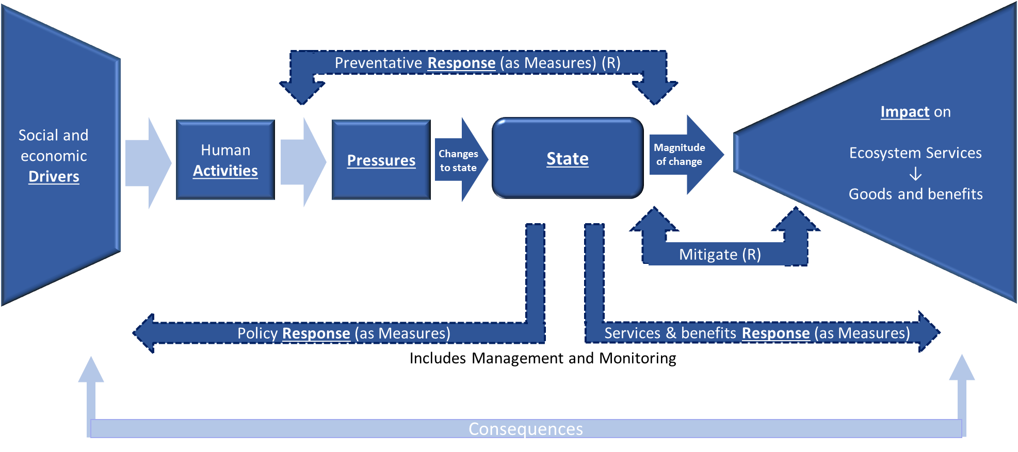
Figure 1. Framework to underpin thematic assessments. This schema is compatible with the European Commission Staff Working Document DAPSES-MMM framework.
The boxes underlined in Figure 1 correspond to DAPSIR elements or chapters that will have to be populated at the level of thematic assessment – see below.
Content
Field name | Data type: text
 | NOTE: [The executive summary should pull together the key findings from the main body of text. It should provide a generic introduction, highlight particular issues and areas of interest and ensure continuity with the QSR 2010. It should make clear the link between DAPSIR components and the answers to the five questions. This box should contain a brief overview (300 words).]
 | Q1. Identify the problems? Are they the same in all OSPAR regions?
 | Q2. What has been done?
 | Q3. Did it work?
 | Q4. How does this field affect the overall quality status?
 | Q5. What do we do next?
Body Text | [Heading]
D - Driver(s) | [Heading]
[Chapter summary for the OSPAR Maritime area]
NOTE: to be populated towards the end of drafting based on extracts from the Driver(s) [Content] narrative.
[Content]
NOTE: Please consult the associated thematic assessment template guidance document.
A – Activity(ies) | [Heading]
[Chapter summary per [OSPAR Region] or [OSPAR Maritime area]]
Region I | Region II | Region III | Region IV | Region V
NOTE: to be populated towards the end of drafting based on extracts from the Activity(ies)[Content] narrative.
[Content]
NOTE: Please consult the associated thematic assessment template guidance document.
P – Pressure(s) | [Heading]
[Chapter summary per [OSPAR Region] or [OSPAR Maritime area]]
Region I | Region II | Region III | Region IV | Region V
NOTE: to be populated towards the end of drafting based on extracts from the Pressure(s)[Content] narrative.
[Content]
NOTE: Please consult the associated thematic assessment template guidance document.
S – State | [Heading]
[Chapter summary per [OSPAR Region] or [OSPAR Maritime area]
Region I | Region II | Region III | Region IV | Region V
NOTE: to be populated towards the end of drafting based on extracts from the State [Content] narrative.
[Content]
NOTE: Please consult the associated thematic assessment template guidance document.
I – Impact (on Ecosystem Services) | [Heading]
[Chapter summary per [OSPAR Region] or [OSPAR Maritime area]]
Region I | Region II | Region III | Region IV | Region V
NOTE: to be populated towards the end of drafting based on extracts from the Impact [Content] narrative.
[Content]
NOTE: Please consult the associated thematic assessment template guidance document.
R – Response | [Heading]
[Chapter summary for the OSPAR Maritime area]
NOTE: to be populated towards the end of drafting based on extracts from the Response [Content] narrative.
[Content]
NOTE: Please consult the associated thematic assessment template guidance document.
Bow-tie analysis | [Content]  NOTE: Please consult the associated thematic assessment template guidance document.
Climate change | [Content]  Note on the process: The Climate Change Expert Group are developing the climate change thematic assessment and request that all other thematic assessments contribute in responding to questions, as below, for each of the parameters assessed in QSR 2010 tables 3.1 and 3.2 (https://qsr2010.ospar.org/en/ch03_01.html). In the prepopulated templates provided to assessors, the Secretariat has listed the proposed parameters for each thematic assessment.  QSR 2010 QSR 2023  Impact What might happen What has been observed Did the foreseen change happen? How has the change happened? What has been the impact? Confidence (guidance document annex 1)  [QSR 2010 text] [QSR 2010 text] [QSR 2010 text] [Yes/No/Not possible to know] [Comment] [faster/slower than anticipated, more drastic/very mild change] [Comment] [strong negative / mild positive etc] [Comment] Evidence [Robust/medium/limited] Degree of agreement [High/medium/low] Has confidence increased over 10 years? [Yes/No] [Comment]

Thematic Metadata
Field | Data Type | Explanation
Summary Results (template Addendum 1) | URL | Link to MSFD results table,including: Descriptor, Criterion, GESComponent, Feature, Marine Reporting Units, etc.
Contributor | Text | Lead author organisation / Individual name
Linkage | URL | Weblinks to additional information about the assessment e.g. link to Publication, common indicator agreement  Where available links to other references, e.g. scientific journal papers, can be provided.  The items in the list should be line-separated
Relevant OSPAR Documentation | Text | OSPAR-relevant Publication, Decision, Recommendation or Other Agreement.  Use the following naming protocols:  [OSPAR Publication] [YYYY]-  [publication number] [title] [OSPAR Recommendation] [YYYY]-[number] [title] [OSPAR Decision] [YYYY]-[number] [title]  [OSPAR Agreement] [YYYY]-[number] [title]  For example:  OSPAR CEMP Guidelines e.g. Agreement 2016-09 CEMP Guideline: Common Indicator – Marine Bird Abundance (B1)  OSPAR Publication 2008-379 CEMP Assessment Manual: Coordinated Environmental Monitoring Programme Assessment Manual for contaminants in sediment and biota  OSPAR Recommendation 2015-04 on furthering the protection and conservation of the Allis shad (Alosa alosa) in Regions II, III and IV of the OSPAR maritime area  OSPAR Decision 2012-1 on the establishment of the Charlie-Gibbs North High Seas Marine Protected Area  OSPAR Agreement 2004-15 Provisional JAMP Assessment Criteria for TBT – Specific Biological Effects. Amendments agreed by ASMO 2008

Additional Guidance for completion
Figure/Table naming
The numbering of the figures/tables/formulae/charts etc. in the “brief” sections, will follow a Figure 1, Figure 2, Figure 3, etc. structure;
For the online only “extended” sections, the figure/table numbering will follow a Figure a, Figure b, Figure c, Table a, Table b, etc. structure.
To be supplied to the Secretariat in a zip file.
Photos
As jpeg A minimum of 2 photographs should be supplied and all photos must be fully accredited with permission for publication and online use. If no accreditation is necessary, please make this clear. Images must be at a resolution of 300dpi and in jpeg format – screenshots are not suitable
Graphs
As jpeg All graphs need to have clear, brief titles and be provided as a high-resolution jpeg. All data used to make the graph must be supplied in Excel or readily accessible format
Formulae
As jpeg For example
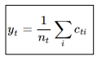
Tables
As Excel file
All tables need to have a clear, brief title. All data used to make the table must be supplied in Excel or Word format.
Infographics
As jpeg All infographics need to have a clear, brief title and be provided as a high resolution jpeg. All information used to make the infographic must be provided in a suitable and accessible format.
Maps
As jpeg
All maps need to have a clear, brief title. All background data used to make the maps, such as shapefiles, need to be supplied in the assessment snapshot data package.
Use of language
Scientific names – try to avoid using scientific names if at all possible. If this is not possible, be consistent e.g. do not use scientific names in tables and common names in text. Scientific names can be used in the extended online text, provided the common name is referenced in the first instance it is used. In translating between scientific and common names use the World Register of Marine Species, available from http://www.marinespecies.org/.
Avoid acronyms or explain them – avoid the use of acronyms in the summary text, in the extended text they can be used but written in full in their first instance.
Referencing
References should be placed within the references section using the following layouts for peer reviewed and grey literature publications respectively:
Author, X.Y., Date YYYY, Title. Organisation or Journal, Location, Number of pages (e.g. 123 pp) or pages (12- 15)
Title. Organisation, Location, date YYYY. Publication Ref. Number of Pages

(Developed by Cefas (Judd & Lonsdale, 2021) within the OSPAR ICG-EcoC - this amalgamates thinking from NCC , UK NEA , Elliot et al.,2017 , Hooper et al., 2019 , Maes et al., 2013 , CICES)

