OSPAR REGIONAL ACTION PLAN ON MARINE LITTER

ACTION BRIEFING NOTE: ACTION 48

Evaluating the potential harm caused to the marine environment by items such as cigarette filters, butts, balloons, shotgun wads, cotton buds and bio-film support media.

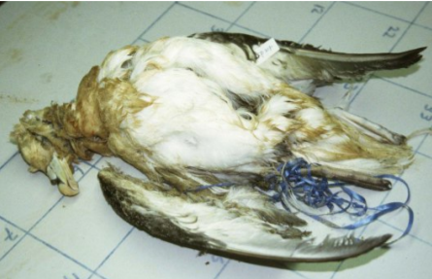
Fulmar (Fulmarus glacialis) entangled in a balloon ribbon
Source: “Five Small facts about balloon litter” (2015), by J.A. Van Franeker, p. 4

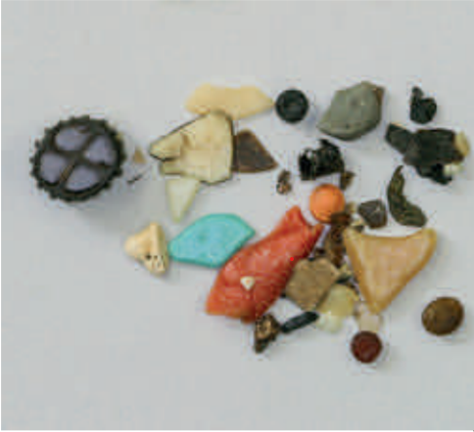
Biomedia and microplastics removed from the digestive tract
of a fulmar from the Faroe Islands
Source: “Sewage filter media and pollution of the aquatic environment”
(2018) by Surfrider Foundation Europe, p. 13

The Regional Action Plan for Marine Litter (RAP ML)
OSPAR’s marine litter objective is “to substantially reduce marine litter in the OSPAR Maritime Area to levels where properties and quantities do not cause harm to the marine environment”. OSPAR 2014 agreed a Regional Action Plan for Marine Litter for 2014-2021; this will be reviewed at the end of this period until spring 2021 after which OSPAR will work on the development of a new or updated RAP.
The RAP ML (2014-2021) defines the four key areas (themes) of actions to be implemented:
A. Actions to combat sea-based sources
B. Actions to combat land-based sources
C. Removal Actions
D. Education and outreach
The full Regional Action Plan and its outputs can be accessed via https://www.ospar.org/work-areas/eiha/marine-litter/regional-action-plan
This Action Briefing Note focuses on Action 48. It sets out the issue, its relevance for OSPAR and the North-East Atlantic Ocean, the work that has been completed by regional action under OSPAR as well as contributions delivered via the Interreg Clean Atlantic Project. The Action Briefing note also highlights possible next steps which could be taken forward through the OSPAR regional action plan on marine litter.
The Action
Action 48 was to Evaluate the potential harm caused to the marine environment by items such as cigarette filters/butts, balloons, shotgun wads, cotton buds and bio-film support media used in sewage plants. Based on this evaluation, proposals can be made on the elimination, change or adaptation requirements for these other potentially problematic items.
The action formed a component of Theme B of the RAP ML to combat land-based sources of marine litter under the sub-theme Elimination, change or adaptation of the products for environmental benefits and was led by France.
Geographic scope: the whole OSPAR Maritime Area

The issue
What potential harm can marine litter items cause to the environment?
Once in the marine environment macro plastic particles degrade into microplastics. There are a range of impacts from macro and micro-litter including entanglement, injury and ingestion of litter by wildlife; the colonisation of floating debris by invasive species; as well as toxicological effects of hazardous chemicals released by degrading plastics. There are also serious socio-economic implications from the loss of litter via waste management sources, including loss of tourism revenue, increased clean-up costs, particularly for municipalities along the coast and increased navigation hazards at sea.
The particular items tackled by action 48 which are cigarette filters/butts, balloons, shotgun wads, cotton buds and bio-film support media used in sewage plants, play a part in those impacts. They have been shown to be ingested by species, in particular turtles, and create entanglements.
If animals entangled in plastic (for instance, in the ribbons of balloons) can drown or choke to death, and if ingestion of several or even a single item (for instance, cotton bud) can perforate the digestive tract, ingestion and entanglement are most frequently the cause of sub-lethal effects. They can impact the ability to feed and grow (obstruction of the gastro-intestinal tract stimulates a feeling of satiety, but the individual still lacks the energy resources provided by natural food, necessary to ensure its vital needs or its growth, and the individual thus dies of starvation), move (lacerations, amputation of a limb, infectious complications, ingestion of litter also causes gas and air pockets in the digestive tract, which can lead to problems with flotation and diving ability in sea turtles) or protect from predators, and therefore in the long term, could affect fertility and the ability to survive. Moreover, plastic additives or the toxicity of the items before or after they become marine litter interfere with endocrine functions, affect the development of the individual by modifying thyroid and growth hormones, and lead to malformations of the reproductive organs. When plastic become microplastics, it can potentially cause damage to the brain and changes in behaviour (the nicotine in cigarette butts provokes acute poisoning, palsy of gills, convulsion and death, they also induce genotoxic erythrocyte disorders).

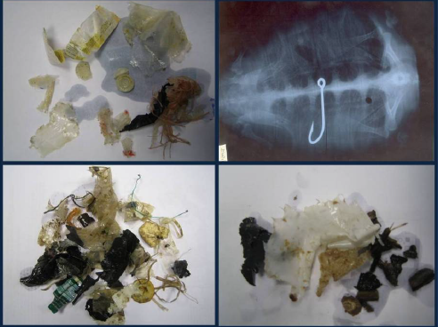

Stomach contents of loggerhead turtles stranded on the French mediterranean coast (photos © CESTMed)
Source: F. Claro & P. Hubert, « Impacts des macro-déchets marins sur les tortues marines en France métropolitaine et d’Outre-mer », (2011) Rapport GTMF-SPN 1. MNHN-SPN, Paris, p. 27

Significance of marine litter causing harm in the marine environment
The harm caused by marine litter has significant economic cost for a range of marine industries, such as: aquaculture, fisheries, harbours, industrial seawater users, marinas, municipalities, power stations, rescue services, shipping and water authorities. These costs can include cleaning, blockages, entanglement and contamination. The social impacts of marine litter relate to the ways in which marine litter affects people’s quality of life and include reduced recreational opportunities and loss of aesthetic value. Moreover, having an impact on biodiversity, marine litter has an impact on the ecosystem services that biodiversity provide (research purposes, food supplies, role in the environment, etc).

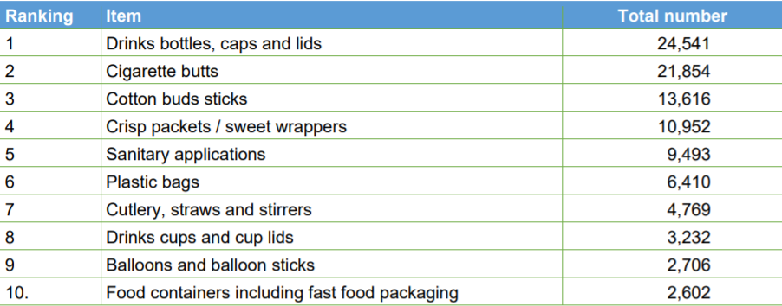

Sampling numbers of top ten SUP items amongst marine litter
Source: “Reducing Marine Litter: action on single use plastics and fishing gear” (2018), Commission staff working document - Impact Assessment, p. 11

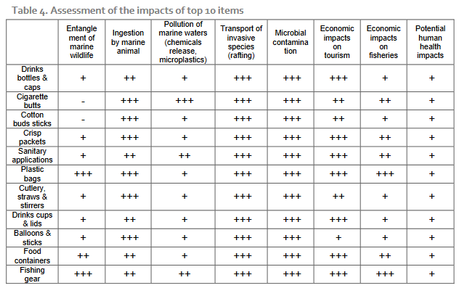

Assessment of the impacts of top 10 items
Source: “Reducing Marine Litter: action on single use plastics and fishing gear” (2018), Commission staff working document - Impact Assessment, p. 20

What has been done by OSPAR to address the issue
The aim of action 48 was to evaluate the potential harm caused to the marine environment by items such as cigarette filters, butts, balloons, shotgun wads, cotton buds and bio-film support media.
An analysis for two of the specified items was undertaken through the Interreg CleanAtlantic project. These studies were developed by three partners, Cedre from France (action leader), Cefas from United Kingdom and Instituto Español de Oceanografía from Spain. The two documents constitute a substantial contribution to the delivery of this Action. The first focused on cigarette filter behaviour, degradation, chemical contamination and toxicity in the marine environment. The second on the behaviour, degradation and impact of cotton buds.
For the remaining specified items a bibliographic study was developed, based on data collected via an OSPAR questionnaire during 2020/2021. The questionnaire gathered information on studies that have been carried out across 11 OSPAR Contracting Parties to assess the potential harm caused to the marine environment by items such as cigarette filters/butts, balloons, shotgun wads, cotton buds and bio-film support media.
Summary of key findings from these reports
Evaluation of the potential harm caused to the marine environment by cigarette filters (Interreg Clean Atlantic Project: Cedre/Cefas/EIO/ 2021)
Cigarette filters are very common litter found under the form of cigarette butts (CBs), which are the combination of the filter and the remnants of a smoked cigarette. Worldwide, it is estimated that 4.5 trillion CBs are littered and end up in the environment every year and they are usually found in the marine environment. This study has provided new knowledge on abundance, fate and potential impact of cigarette butts in the marine environment and recommendations to decrease cigarette butt pollution. It confirms that cigarette butts are harmful for the marine environment. This harm is mainly related to chemical contamination contained in butts. Current actions should be continued and strengthened to eliminate this litter type not only from the marine environment but from the environment in general. The following are highlights of the key findings and the reader is referred to the full report for further details on this work.
Cigarette butts are abundant on Atlantic area beaches: Analysis of OSPAR beach litter monitoring data (CleanAtlantic WP4.1) indicates that CBs are the 5th most collected items on Atlantic area beaches over the period 2016-2019. Over the considered period, 25 183 CBs have been collected during the 922 surveys on the 62 survey sites located in the different parts of the AA. CBs have been found on 50% of surveys performed over the four-year period.
Cigarette butts have a complex chemical composition that vary between brands and types: CB contains organic and metallic contaminants. Among organic contaminants studied, nicotine appears to be the most abundant. Results suggests that CB contamination is higher for strong cigarettes than for light ones.
Cigarette butts have a complex behaviour and can reach every marine compartments: Despite being predominantly made of cellulose acetate, a polymer denser than seawater, CB have a complex behaviour due to their fibrous structure and associated air content. They can eather float or subfloat and drift with wind and current or sink to the seafloor. Thus, CB can reach every marine compartments: shoreline, seafloor, sea surface and water column.
Cigarette butts appear to degrade in seawater but to persist longer on a sandy beach: After one year on a sandy beach, CB exhibit, visually, a negligible degradation (apart from the surrounding papers) suggesting a slow degradation rate in outdoor conditions despite sun and rain exposure. On the seafloor, degradation rate (though involved processes remain unknown) appear to be higher but dependent on filter composition.
Cigarette butts contain soluble contaminants which are rapidly released in seawater: CB contain soluble contaminants, especially nicotine, that can be released in water in less than 24h, suggesting CB represent a risk for water quality when in contact with water (seawater or freshwater, including rainwater).
In a short period of time, one cigarette butt can contaminate water or sediment at a level that may affect marine organisms: In 24h, a CB can contaminate a quarter of litter of seawater at a level affecting 50% of a population of water column organisms. When milled into powder and mixed with sediment (for more than 24h), a CB can contaminate about 1 kg of dry sediment at a level affecting 50% of a population of burrowing organisms.
There are numerous initiatives, measures and actions existing to combat cigarette butts but not all are satisfactory They include environmental clean-up, selective collection, recycling, awareness raising, eco-conception, public policies... Environmental clean-up and the development of filter biodegradable in the environment are not satisfactory solutions as they do not prevent the transfer of chemical contaminants in the environment.
Evaluation of the potential harm caused to the marine environment by cotton bud sticks (Interreg Clean Atlantic Project: Cedre/Cefas/EIO/ 2021)
Plastic cotton bud sticks (CBS) have been reported on beaches worldwide. In Europe, Plastic CBS are among the top marine beach litter items. In 2016, they were the 6th most frequent items found on European beaches during beach litter monitoring, representing 3,82% of beach litter surveyed. They were also the main groups of items found on the Grandola coast in Portugal and on beaches in the Mediterranean reaching more than 30% of the total amount of collected litter along the Tyrrhenian coast of central Italy. Analysis of OSPAR beach litter monitoring data (CleanAtlantic WP4.1) indicates that CBS are the 3rd most collected items on Atlantic area beaches over the period 2016-2019.
The cotton buds found in the marine environment are believed to originate primarily from sewage due to improper disposal via toilets and the inability of the sewage treatment plant to retain them (oversized screening and/or lack of sewage treatment during storms or blockages.
In most cases, cotton buds, consisting mainly of polypropylene, are found intact on the beaches, except for the cotton tips, which have disappeared. Polypropylene is known to be weather resistant and degrade in the marine environment, but differently under dry (beach) and seawater conditions. The degradation of polypropylene appears to be mainly due to photo-initiated oxidation by the sun's ultraviolet rays, although degradation rates can be modulated by the presence of additives. However, no information was found on potential additives used in polypropylene in cotton buds. Degradation of polypropylene results in increased opacity, yellowing and brittleness of the material as well as changes in its thermal and mechanical properties.
The main hazards associated with cotton buds are (i) transport and release of contaminants (chemicals, microplastics and nanoplastics) and (ii) interactions with biota through transport of potential pathogens, transport of non-native species, ingestion or disruption of the behaviour of natural organisms.
Overall, this study provides new knowledge on abundance, fate and potential impact of cotton buds in the marine environment. It confirms that cotton buds made of plastic represent a risk for the marine environment. Replacement by a non-plastic material as recently adopted by the European Union appears to be a satisfactory measure (Directive EU 2019/904).
Conclusions and envisioned measures from a bibliography of studies for key marine litter items (November 2021)
Balloons: there is a possibility to ban (with the use of fines in case of infringements) or regulate (e.g. requirement of an approval beforehand) the use or release of these items during social events. As such, the new regional action plan for marine litter decided upon Helcom in October 2021 includes an action which aims at phasing out intentional releases of inflated balloons. It has been noted that taxation is not a suitable measure to decrease balloon litter. Balloon sticks could also be made of other materials such as paper. It could help to raise awareness (e.g. by registry offices, through citizen initiatives such as ‘Ban a Ballon’ in Netherlands-Belgium) about the environmental impact of the launching of balloons, and the usage of alternatives such as soap bubbles, helium filled foam clouds or seed bombs.

Cigarettes filters and butts: the report highlights the opportunity to support smoking cessation projects, authorize only degradable cigarette buds (however, the shift to cellulose filters should not exempt users from disposing their waste in appropriate collection systems), distribute pocket ashtrays, impose ash trays on café and restaurant terraces, create more visible ashtrays that would be better placed and empty them more often, forbid smoking on beaches, increase the density of waste bins and decrease the distance between waste bins on beaches. Awareness concerning the consequences of these items on marine biodiversity could also be raised (e.g. through large double-ashtrays asking funny questions) as well as incentives to create behavioral change. More restrictive laws, environmental campaigns and extended produced responsibility schemes could also be applied to tobacco products. For instance, in the UK, at the September roundtable on Smoking Related Litter, Minister Pow asked parties to consider whether a non-regulatory producer responsibility scheme could be developed for tobacco waste products (https://www.gov.uk/government/publications/defra-engagement-with-the-tobacco-industry-on-litter/smoking-related-litter-roundtable-meeting-2-sep-2020). UK Government has decided that a regulatory approach may be required to ensure that the industry takes sufficient financial responsibility for the litter created by its products and to prevent them from undermining public health policy. The Environment Bill will allow UK to legislate for extended producer responsibility schemes, which could be applied to tobacco products. Cigarette and tobacco product packaging is already covered by the proposed packaging producer responsibility scheme, which is currently undergoing a second phase of consultation. The UK Government has decided that a regulatory approach may be required to ensure that the industry takes sufficient financial responsibility for the litter created by its products and to prevent them from undermining public health policy. The Environment Bill will allow to legislate for extended producer responsibility schemes, which could be applied to tobacco products. Cigarette and tobacco product packaging is already covered by the proposed packaging producer responsibility scheme, which is currently undergoing a second phase of consultation.

Cotton buds: solutions include encouraging the use of alternatives, both reusable and non-single-use, that do not use plastic. They include: U-tips, a cotton bud-like tool made of plastic that can be washed under the tap, other types of make-up tools such as spongetipped applicators and synthetic bristle brushes and craft and cleaning tools (e.g. technical cleaning swabs made of plastic and foam) all of which can be repeatedly cleaned and washed. These alternatives could be made more available to the public. In the study mentioned by Sweden “Mapping Plastic Flows in Sweden”, the authors propose several measures to prevent littering from cotton swabs: including to legislate against plastic cotton swabs so that they disappear from the market. Only allow cotton swabs with a stick of degradable material, such as paper; tackling the problem upstream, at the source. The amount of cotton swabs thrown in the toilet needs to be minimized. Households need clear information that cotton swabs must not be thrown down the drain and there needs to be continued conversion of combined pipes to separate pipes for stormwater and wastewater.
Water and sewage companies can review how and where to purify overflowed wastewater and how overflows can be reduced. The UK has established the ban on supplying plastic straws and stirrers and plastic-stemmed cotton buds. This ban came into force on Thursday 1 October 2020.

Shotgun wads: hunters could be entitled to retain/retrieve empty shotgun shells during hunting so as to discard them later with their household waste. Regulatory and civil society actions could support such a campaign, for example through implementation of a deposit system for used empty cartridges, as known for other potential waste items e.g. plastic or glass bottles. Hunters and their clubs could also initiate or get actively involved in existing beach clean-up programmes. Wads require a different approach as hunters cannot retrieve wads when hunting. The only way to prevent dispersal of wadplastic is to switch away from plastic to wads made from marine biodegradable or soluble materials that are not harmful in the marine environment. Technology for this is already in place and several products are available on the market and used in a variety of cartridges. Biodegradable alternatives made for example of compressed cardboard already exist, but the degradation still has to be examined. Furthermore, such a ban on nondegradable shot wads should be accompanied by information campaigns on the need for picking up the shotgun ammunition shells. The ammunition shells are easier to collect as they land close to the shooter. Awareness should be risen on the impact of shotgun wads on the marine environment amongst hunters and civil society, in part to increase pressure for voluntary behavior change. In October 2021, Helcom decided on a new regional action plan on marine litter. One of the actions is to investigate opportunities for substitution with subsequent phasing-out nondegradable shot wads and launch information campaigns targeted at hunters.

Bio-film support media and microbeads: wastewater treatment plants could have systems in place to collect microbeads and prevent the loss of biofilm support media. More emphasis could be placed on the implementation of good practices in facility operation, and regulation increased to hold polluters accountable. Awareness could be raised about this littering problem. Another suggestion that can be made is to mark the support media with codes to enable tracking.

Additional items were identified through the information collated:
- fireworks, measures taken and envisaged could include bans especially close to protected areas, central fireworks in distance to aquatic systems, laser and light shows as alternatives and timely clean-ups after events.
- dog poo bags, measures could include the provision of colourful bags to prevent littering, higher density of waste bins, fines and cautions (e.g. by public waste watchers) and awareness raising in dog owners.

Additional measure that were identified in the collated information
- encourage the use of reusable items (e.g. water bottles or coffee cups);
- ban single use plastic products such as plastic cutlery and plates; beverage stirrers; straws; food containers and cups made of expanded polystyrene; oxo-degradable products such as carrier bags that fragment to micro fragments; wet wipes and cleaning products;
- tax single-use items, adopt punitive measures, and that more people raise fines;
- improve public access to tap water and encourage drinking tap water;
- develop returnable products, especially on beach areas and event catering;
- develop and assist beach cleaning events, as well as raising awareness on plastic pollution;
- improve the organization of waste selection on beaches, and to adopt labels and certificates;
- to extend clean beach programmes to rivers and lands;
- implement systems to collect microbeads in wastewater treatment plants;
- work specifically with the catering sector, use table bins;
- post signs so as not to add waste in the event of overflowing bins, encourage people to always bring their own bin to take away;
- create more visible rubbish bins that would be better placed, and to empty them more often;
- strengthen social standards, clarify the possibility of getting rid of litter and emphasize personal responsibility, for example by informing and advertising with messages that strengthen social norms (e.g. sense of participation, ownership and commitment), engage voices and channels that are specifically aimed at young people (e.g. Youtubers and influencers).

Barriers to progress
- It is in some cases difficult to make connection to sources of causing harm impacts ;
- The extent of some impacts, such as toxicity, have not been fully understood yet ;
- While impact has been shown, the degree to which specific litter items impact the species surviving rate is intricate to evaluate ;
- Measures to prevent or reduce the emergence of these items in the environment imply the development of alternatives and a change of habits thus involving awareness raising and engagement of the public and users.

Potential options for future work (next steps)
The issue of reducing environmental harm from marine litter is one that has been taken up in the North East Atlantic Environment Strategy 2020-2030, adopted by OSPAR Ministers in October 2021. The Operational Objective S4.O2 states that “By 2023 OSPAR will improve the evidence base on harm in relation to marine litter with the aim of developing and agreeing actions and measures to reduce harm by 2025”.

In order to support the delivery of this objective, work will resume on strengthening the evidence base on harmful impacts of marine litter on biota and habitats in the North-East Atlantic based on a review the information made available through this action and any additional information.

Future tasks could include the development of new common OSPAR indicators for measuring the environmental harm of certain marine litter items applying agreed harmonised protocols and future agreed action; as well considering measures where these have been identified as lacking.

