Document handling for QSR 2023 using SharePoint

Structure:
The homepage of the OSPAR QSR SharePoint https://osparcsp.sharepoint.com/sites/QSR:
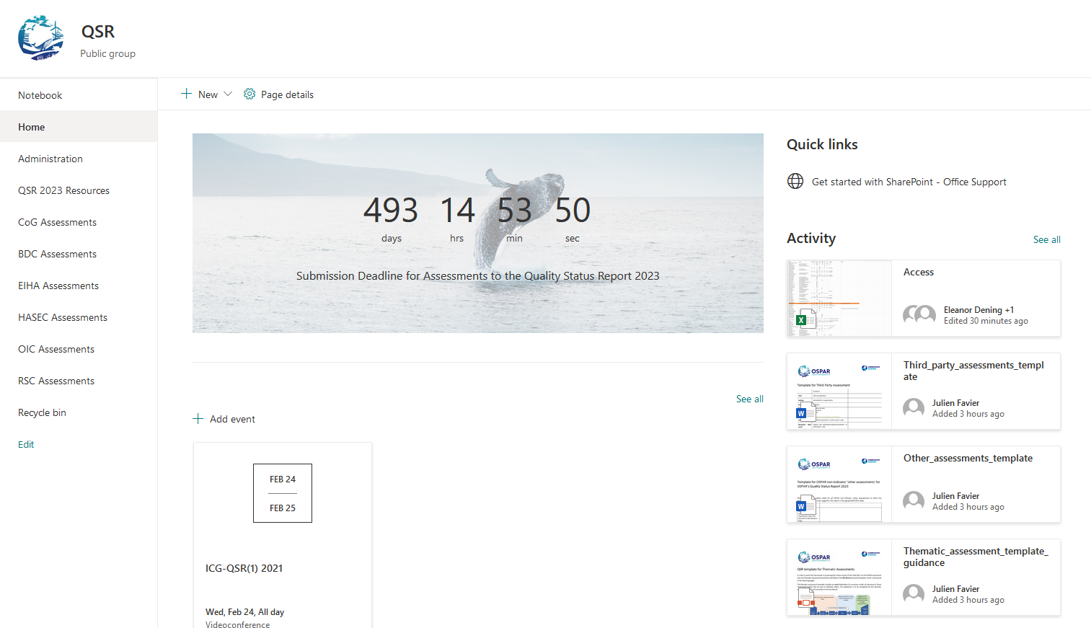
Figure 1 SharePoint layout. Blue box – available libraries; Orange box – Recent activity; and Green Box – Upcoming events.

- The homepage is formed of three distinct parts, highlighted by coloured boxes above. In the blue box are the available “libraries” (a library is a discrete workspace, like a folder but with more functionality): The “QSR 2023 Resources” library contains administrative aspects of the QSR 2023 while each group responsible for producing content can work in their own specific Assessment Document library i.e., all of the HASEC work on eutrophication and contaminants will be housed under “HASEC Assessments”. The green box highlights upcoming events that may be of interest to SharePoint site users. The orange box shows a list of recent activity on the site and is included for information.
- The ‘QSR Master Table’ is stored in the QSR2023 Resources library and assessment leads are expected to update it as and when appropriate to track assessment progress.

Assessment Subfolders: what they are and how to populate them
- Common indicator assessments and thematic assessments have the same folder structure, despite using different templates. Both types of assessments include figures and data and will be presented in the OSPAR Assessment Portal (OAP) as full electronic products, therefore the same folder structure is appropriate.
- Other assessments have a different folder structure, recognising the different nature of these assessments.
- Within each of the available libraries presented on the homepage, there are subfolders for each of the assessments. Within these subfolders, there are five folders where indicator specific data and information are to be stored to allow the formation of the QSR in OAP:
- 00_Drafting: To be used to store any content that is work in progress. Sharing any files used as a basis for discussion or drafting, for example reports used as references or early drafts of assessments. This is the ‘free-for-all’ folder that assessors can use in whatever way best supports their work.
- 01_Assessment: To be used to store the master version of the assessment. Using the assessment Word template, Excel MSFD template, in line with the guidance (https://www.ospar.org/work-areas/cross-cutting-issues/qsr2023/assessment-templates).
- 02_Figures: This folder should contain all figures and tables as images, with the corresponding data that underpins the figure stored in the ‘04_Data_Results’ folder;
- 03_Data_Snapshot: All the data underpinning the assessment that would be required to re-run the assessment needs to be stored here. The Shapefile representing the Assessment Units should also be present in this folder.
- 04_Data_Results: A Zip file containing the final results file(s) generated by the assessment e.g., shapefile, MS Excel spreadsheet. Any data required to enable the Secretariat to recreate tables, graphs or figures should be stored within this folder in its own folder (named in accordance with the corresponding image stored in ‘02_Figures’).
- Wherever possible, a prefilled template with material copied from the final version of the Indicator Assessment published in the Intermediate Assessment 2017, or where relevant a later update of the indicator, has been placed in 01_Assessment.
- As SharePoint allows for versioning control, leads and contributors should edit a single file (stored under “01_Assessment”) and not create multiple versions (further info under “Editing” below).
- Many sections of an operational indicator should remain unchanged from their IA2017 basis, such as the background, methodology etc. The main section anticipated to be updated is the results and the key message. The indicator assessor needs to amend the sections which are updated due to the addition of data. In a Version-0 pre-filled template it is expected that some material will need to be completely removed whilst other sections will require only minor edits or no changes at all.

Editing
- SharePoint allows for co-authoring, which enables multiple users to work on a document, at any time, without interfering with each other's changes. Authors are invited to work in the same file. As stated above, every time a change is made and autosaved a new minor version is made. Authors are encouraged to avoid saving multiple files e.g., with a different ending in the file name OSPARassessmnt_NN_PX_OB to avoid a situation where authors are working in parallel versions. Parallel versions would require extra work for the indicator lead in collating comments.
- It is also possible to open the assessment in Desktop App, which may be of use when the file size increases, and internet bandwidth is affected.
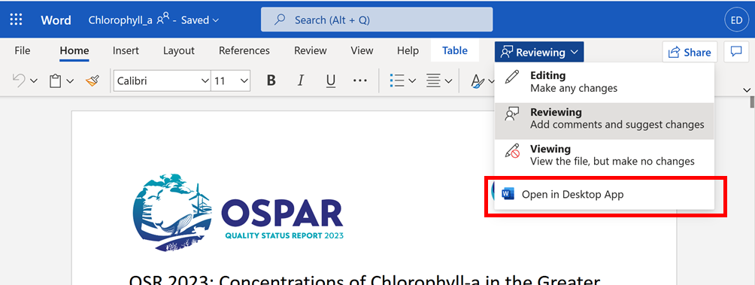
Figure 2 Screenshot of how to work in Desktop App
- When working within the Desktop App ensure AutoSave is switched on, and any edits will be automatically saved in SharePoint.
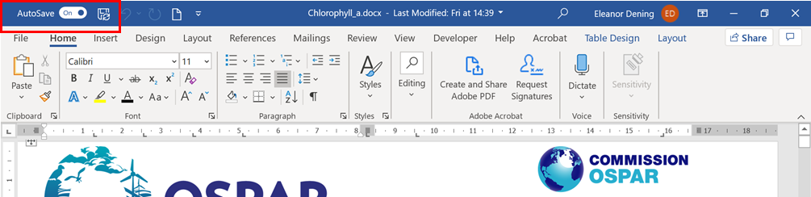
Figure 3 AutoSave highlighted in red box

Version control for working documents
- Effective use of SharePoint will ensure that all Contracting Parties and contributors to each QSR product can easily identify which version is referred to in meeting documents and which is the most recent version.
- SharePoint saves edits and times of when an edit is made, so it should be simple to see the most recent version. A major version number change happens after the assessment has been reviewed and agreed at Committee/CoG/OSPAR level (Figure 4). The author would download the latest version, and this would be presented as a meeting document for review at the meeting, then reuploaded to SharePoint with an updated version number.

Customisable workflow to approve document changes
- SharePoint allows customised user privileges with QSR Publishers, Editors and Readers able to publish major version, read and write documents and read documents, respectively.
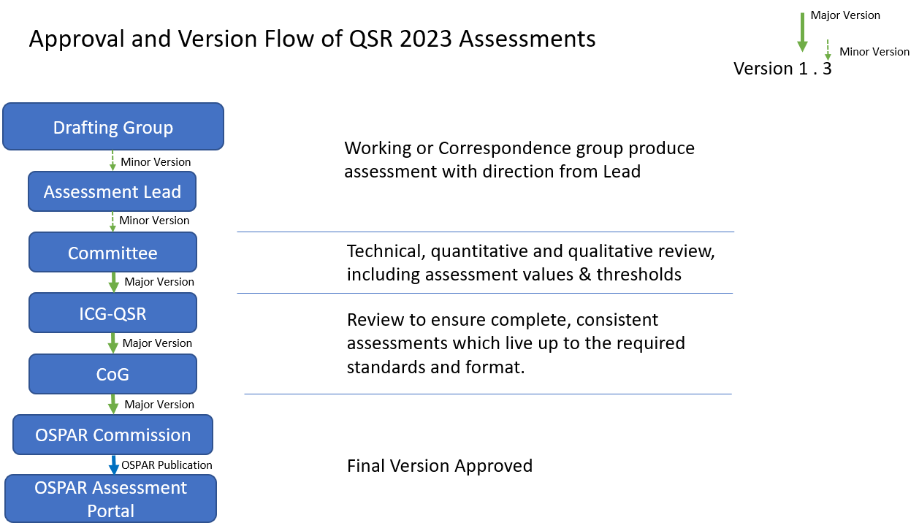
Figure 4: Example Workflow and Version control of QSR 2023 Assessments to ensure all OSPAR delegates and experts can at any time identify the latest version of an assessment document.
- Minor versions prepared by QSR Editors are automatically created each time a change is made within a document. To publish a new major version, the QSR Publisher must select the three dots next to the document name, then navigate to ‘More’ and then ‘Publish’.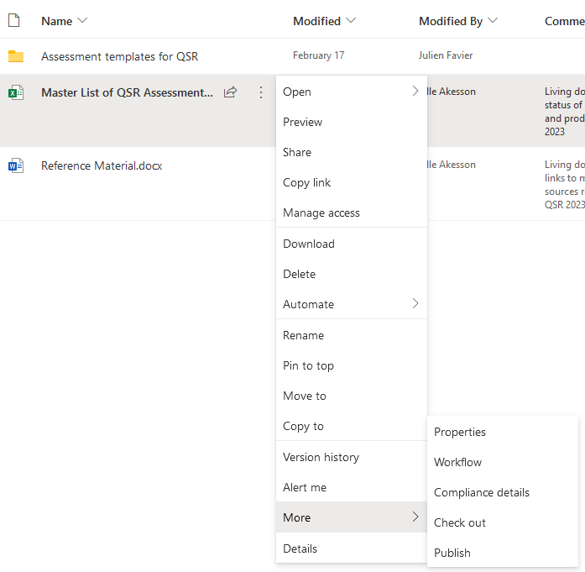
- For any technical support or issues with the platform, please contact olle.akesson@ospar.org.

