Press release 5 November 2021

OSPAR Contact:  Lucy Ritchie | Tel: +44 (0)20 7430 5200  Email: lucy.ritchie@ospar.org  www.ospar.org | The Aspect  12 Finsbury Square  London, EC2A 1AS

REGIONAL COOPERATION TO ACHIEVE A PRODUCTIVE AND SUSTAINABLY USED NORTH-EAST ATLANTIC

OSPAR special consultative meeting on the Disposal of Disused Offshore Installations

On Friday 5 November 2021 a special consultative meeting in accordance with OSPAR Decision 98/3 on the Disposal of Disused Offshore Installations was held in London. The Decision prohibits the dumping, and leaving wholly or partly in place, of disused offshore installations within the maritime area but sets out a consultative process for considering derogations to this general prohibition. The meeting discussed the United Kingdom’s intention to issue a derogation for leaving in-situ the footings of the Brae Bravo Alpha Steel Jacket, located 270 km north-east of Aberdeen in 99 meters of water.
Held on the same day as the Ocean Action Day at the UN Climate Change Conference of the Parties (COP26), the meeting highlighted the value of constructive dialogue within the OSPAR framework to achieve a productive and sustainably used North-East Atlantic while safeguarding the seabed and its marine ecosystems.
An assessment undertaken by the operator of the Brae fields (TAQA) concluded that re-using the installation for hydrocarbon storage, carbon dioxide sequestration or renewable energy generation was not possible due to its age, unsuitability, and distance from shore. Complete removal of the substructure with cutting of piles 3 meters below seabed was considered to pose unacceptable safety risks and to be technically unfeasible. Their evaluation concluded that the partial removal of the jacket was the only practicable alternative: the footings would be left in place approximately 35 meters above the seabed and subject to periodic survey and monitoring. The United Kingdom made clear that if the technology improved, the operator would be asked to review their assessment.
Under the consultation procedure set out by the Decision, Belgium, the European Union, Germany, the Netherlands, Spain, and Sweden raised concerns with the issuing of the derogation permit. The United Kingdom provided responses to the comments and objections received on the comparative assessment methodology used, the lack of technological development for a complete removal, the management of the well conductors and the monitoring programme. The special consultative meeting was requested in accordance with Annex 3 of the Decision to further discuss the unresolved issues. At the meeting Greenpeace International, observer to OSPAR, stated its support for the complete removal of the structure.
The Chair of OSPAR, Richard Cronin, recalled the North-East Atlantic Environment Strategy (NEAES) 2030 adopted by Ministers on 1 October 2021, which provided the political mandate for OSPAR to take action on this important issue. He concluded that OSPAR needed to agree in a timely fashion on a harmonised approach for the comparative assessment methodology, to promote the advancement of decommissioning technologies, to improve transparency on monitoring requirements and to develop a shared understanding of the UK permitting process.

ENDS

Note for editors
- The OSPAR Commission was set up by the 1992 OSPAR Convention for the Protection of the Marine Environment of the North-East Atlantic, which unified and updated the 1972 Oslo and 1974 Paris Conventions. It brings together the governments of Belgium, Denmark, Finland, France, Germany, Iceland, Ireland, Luxembourg, the Netherlands, Norway, Portugal, Spain, Sweden, Switzerland and the United Kingdom, together with the European Community. Belgium, Denmark, The European Commission, Germany, The Netherlands, Norway, Spain, Sweden and the United Kingdom attended the meeting.
- More than 30 international non-governmental organisations are involved in OSPAR as official Observers. They represent a broad range of interests and expertise related to the marine environment and the uses of marine resources. Many contribute information, insights and standpoints. This is much appreciated feedback from civil society and the economy. The OSPAR Commission greatly values these partnerships that help inform its decisions and other results. (See list on OSPAR website at http://www.ospar.org/organisation/observers). OSPAR observers Greenpeace, KIMO and the International Association of Oil and Gas Producers (IOGP) attended the meeting.
- The OSPAR Commission, as an intergovernmental organisation composed of 15 governments and the European Union, provides a forum for inter-governmental cooperation on matters related to the protection and conservation of the North-East Atlantic, and is committed to ensuring impartiality when supporting Contracting Parties in the application of the OSPAR Convention.
4. Since 1998 the dumping, and leaving wholly or partly in place, of disused offshore installations is prohibited within the OSPAR maritime area under OSPAR Decision 98/3 on the Disposal of Disused Offshore Installations https://www.ospar.org/documents?d=32703. However, following assessment, the competent authority of the relevant Contracting Party may give permission to an operator to leave installations or parts of installations in place in certain cases.
5. In the OSPAR Maritime Area, more than 1300 offshore installations are operational and 170 have been decommissioned https://odims.ospar.org/en/submissions/ospar_offshore_installations_2019_01/. Since 2001 and under OSPAR Decision 98/3, 10 derogations have been granted by the United Kingdom and Norway. In nine cases comments and objections were solved during the consultation process in accordance with Annex 3 of OSPAR Decision 98/3. A Special Consultative Meeting (SCM) was held on 19 October 2019 to consider issuing a permit for leaving in situ the footings of the Brent Alpha steel jacket and the gravity based concrete installations of Brent Bravo, Brent Charlie and Brent Delta.
6. OSPAR Contracting Parties with oil and gas industry offshore installations are: Denmark, Germany, Ireland, the Netherlands, Norway, Spain and the United Kingdom. Offshore Installations in the offshore maritime area are shown below.
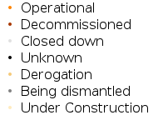
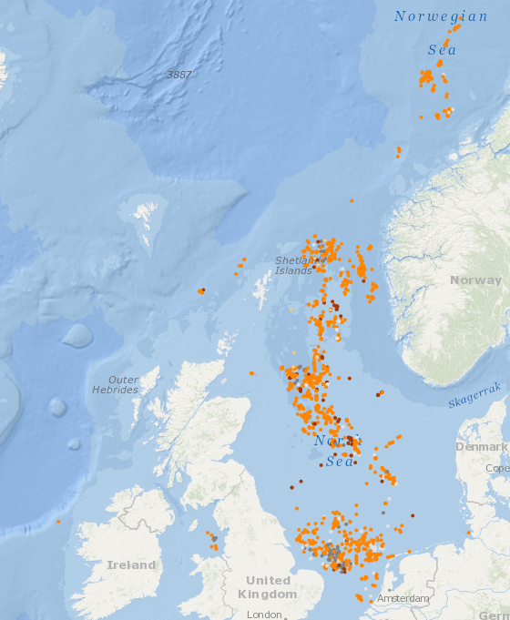
Offshore installations in the OSPAR maritime area (2019)

