CoG(1) 26 Summary Record, Annex 3
Terms of Reference for ICG-Ecosystem Assessment Outlook - Cumulative Effects Assessment (ICG-Eco-C), 2026-2028

Background and purpose
1. ICG-Eco-C will continue its work to deliver North-East Atlantic Environment Strategy Strategic Objective 7.01 through tasks:
  - S7.01.T2: Cumulative effect method development (CEMD).
Specifically:
- ICG-EcoC will focus on performing a quantitative cumulative effects assessment (CEA) for the OSPAR Intermediate assessment.
- The geographic coverage of the assessment (e.g. OSPAR regions) chosen for the IA will be dependent on the availability of evidence, resources and time to undertake the CEA.
- The CEA performed under ICG-EcoC will be inform the cumulative impacts on the OSPAR Common Indicators. Furthermore, it will be compatible with and inform the regional implementation of the EU Marine Strategy Framework Directive, by incorporating the MSFD Descriptors in the output of the CEA. This will enhance understanding of the MSFD Descriptors that experience the highest pressures and therefore require most attention from member states.
Participants
2. ICG-Eco-C will be convened by the UK and the Netherlands and is open to all OSPAR Contracting Parties and Observers, noting the need to proactively include expertise from across all OSPAR’s thematic work areas.

Scope of Work – phased approach
3. Further progress cumulative effects method development and data collection, aiming for a regional scale cumulative effects assessment (CEA) for the IA 2029 assessment in 2028, for approval at CoG(1) 2028. A visual overview of the phased approach is given in Annex A.
This work directly contributes to the cross-cutting NEAES objective:
- S7.O1: By 2028 OSPAR will further develop methods for the analysis of cumulative effects in the marine ecosystems of the North-East Atlantic, taking into account relevant spatial and temporal information on human activities, pressures, sensitive receptors and habitats, and use the results to inform the establishment of measures and actions to prevent, reduce or otherwise manage impacts – ICG-EcoC lead.
To achieve this, ICG-EcoC proposes a phased approach of the planning of the scope of work for each year leading up to the IA 2029, to ensure sufficient focused capacity towards achieving S7.01.T2. A distinction is made between milestones (M) and deliverables (D). In addition, there will be ongoing cross-cutting work to ensure cooperation with relevant groups and progression of the work of ICG-EcoC and to contribute to cross-cutting NEAES objectives and workstreams (described under 7).

4. Scope 2026
Milestones (M), deliverables (D)
- 4.1) Regional spatial scale for CEA analysis (D1): agreeing options on best feasible spatial scope for regional scale quantitative spatial analysis for the IA 2029 based on data availability, time and expert experience.
Expected timeline Q1;
- 4.2) Acquiring financial support for consultant work (M1): asking financial support from CPs during the CoG for consulting work under ICG-EcoC (initial informal pledges by CPs have been made to this end).
Timeline Qq (for agreement of CoG).
- 4.3) Terms of reference for the consultant assignment (D2): development of the specific ToR for the consultant work. Elements could include:
1) Following the SCAIRM approach for the analysis, thus building on the ICES scientific advice to GNSBI on Cumulative Impacts for GNSBI, work for the QSR 2023 and experience with the ORED Bird Pilot;
2) ensuring clear incorporation of OSPAR Indicators and link to the MSFD Descriptors in the output of the work;
3) focusing on presentation of results on policy level;
4) building on the recommendations from the QSR 2023 CEA analysis (see Annex B)
5) progressing on spatial presentation of CEA results where possible.
Expected timeline Q1-2.
- 4.4) Data collection (M2): focusing on receiving best available data from relevant OSPAR groups (e.g. ICG-ORED, ICG-COBAM) and relevant EU projects. This work can be ongoing during the consultant work, but should have a clear starting point to build on.
Expected timeline: Q1-3.
- 4.5) Request for proposals and commencement of consultant assignment (M3): Based on the available financial support and agreement of the CoG on elements of the ToR for the consultant work under ICG-EcoC, there will be a request for proposals in 2026 followed by commencement of the consultant work. Revisit 4.1 to reach final agreement on spatial scope for the regional scale spatial analysis for the IA 2029 based on the chosen consultant’s capacity.
Expected timeline Q3-4.
- 5.6) Continuous cooperation with relevant groups working on CEA (CC). The increased interest in cumulative impacts assessments internationally causes many cooperation opportunities (GNSBI, HELCOM, ICES and groups within OSPAR). ICG-EcoC will contribute to these opportunities by ensuring cooperation and yield input for achieving the OSPAR Strategic Objectives and Science Agenda.
Ongoing depending on agenda and availability of experts

5. Scope 2027
Milestones (M) and deliverables (D):
- 5.1) Consultant work on CEA for OSPAR IA 2029 assessment (M4): The work of the consultant is expected to be ongoing in 2027. There will be a presentation of draft data, and continuous cooperation for the duration of the assignment with ICG-EcoC.
Expected timeline Q1-4.
- 5.2) Progressing work on spatial presentation of CEA results (M5): In order to better understand the spatial activities, pressures and impacts on the ecosystem related to OSPAR indicators and corresponding MSFD Descriptors, effort will be put on progressing spatial presentation of CEA results, in cooperation with the consultant work.
Expected timeline Q1-4 (tbd).
- 5.3) Final report of regional CEA assignment of consultant (D): The work of the consultant is expected to be delivered by Q4 of 2027, allowing ICG-EcoC to interpret and further progress the outcomes of the work in 2028 towards to 2029 IA.
Expected timeline Q3-4.

6. Scope 2028
Milestones (M) and deliverables (D):
- 6.1) Discuss the output of the CEA work and outline the work towards the IA 2029 (M6). Based on the output of the CEA consultant work, the progress made in the meantime on spatial presentation and relevant developments, the outline of the work towards the IA 2029 will be made early 2028.
Expected timeline Q1-2
- 6.2 Developing ICG-EcoC contribution to IA 2029 (D4). Writing of the narrative, presentation of the results, integrating the work with the IA work. Details tbd.
Expected timeline Q1-4

7. Progression of this work requires recognition in CoG and support for dialogue and collaboration between related cross-cutting NEAES objectives and workstreams, namely:
- S7.O3 By 2025 OSPAR will start accounting for ecosystem services and natural capital by making maximum use of existing frameworks in order to recognise, assess and consistently account for human activities and their consequences in the implementation of ecosystem-based management – ICG-ESA lead. Expected capacity for cooperation from ICG-EcoC in 2027 and 2028.
- S12.O4: By 2023 OSPAR will develop common principles and by 2027 develop guidance to promote and facilitate sustainable development and scaling up of offshore renewable energy in a way that cumulative environmental impacts are minimised and in line with the ecosystem-based approach. – ICG-ORED lead.
- SX.O2: By 2024 OSPAR will initiate discussions on the development of a practical approach for regional-scale ecosystem-based management, including through the ‘Collective Arrangement’ and in cooperation with fisheries management bodies and other competent organisations, in order to strengthen ecosystem resilience to climate change and to safeguard the marine environment, its biodiversity and ecosystem services – Pilot Project.

Working procedures
7. The work of ICG-Eco-C reports directly to CoG, but is relevant to all OSPAR Committees, as well as ICG-MSFD, ICG-POSH, ICG-ESA, ICG-COBAM, and ICG-ORED. ICG-EcoC will actively search for cooperation to ensure best available data for the assessment.
8. ICG-Eco-C will work by correspondence and meet as and when required, ensuring to have 1-2 meetings a year to discuss progress and results and modify planning and actions if necessary. In between meetings there will be regular correspondence to ensure progress towards reporting to CoG and working towards the IA 2029.
9. ICG-EcoC will proactively engage in exchanging information with other European Regional Seas Conventions, ICES, GNSBI and the European Commission.

OSPAR Science Agenda
10. ICG-EcoC will periodically review, and update as necessary, the status and scoring of the knowledge gaps and science needs in the OSPAR Science Agenda that fall under its responsibility, prioritising those that are more relevant to its work and identifying the need for external resources and implementing the OSPAR Project Mechanism as appropriate. ICG-EcoC will also add, if relevant, any new knowledge gaps and science needs to the OSPAR Science Agenda.

Annex A - Visual overview phased approach - Planning and timeline of ICG-EcoC 2026-2028

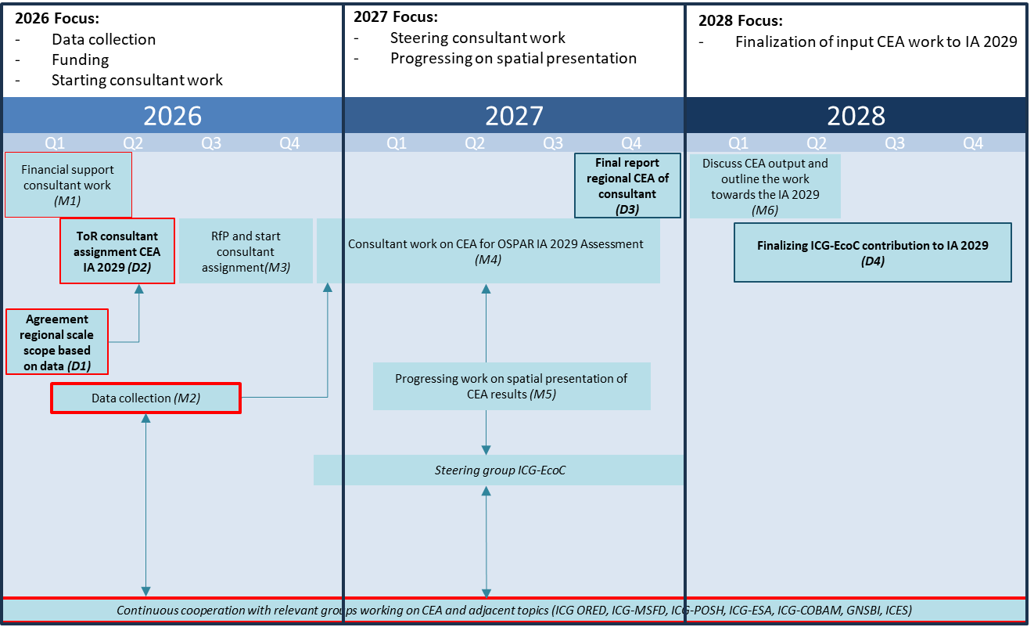

Annex B - recommendations from the QSR 2023 CEA analyses (→NEAES S7.01.T2)
- Ensure there is built-in collaboration and engagement across OSPAR Expert Groups and Committees to further develop and progress the work, maintain the momentum achieved in progressing the work from the QSR 2023.
- Improve collaboration and engagement across OSPAR Contracting Parties.
- Improve collaboration and engagement with external bodies, e.g., ICES, HELCOM, GNSBI.
- Improve integration between human activity, pressure, biodiversity assessments (Ecosystem Approach - DAPSIR).
- DAPSIR – Natural Capital Accounting continued alignment (working with ICG-ESA).
- Undertake regional scale analyses.
- Explore options for spatial analyses – mapping human activities, pressures, ecosystem components and impacts.
- Improve methodologies for the identification and quantification of impacts, individually and cumulatively.
- Consider refinements to the persistence and resilience analyses.
- Consider management responses and effectiveness of measures, including working with OSPAR Regional Action Plan leads (i.e., marine birds, benthic habitats).

ICG-EcoC recognizes the existence of different CEA methodologies that each have their own characteristics and could be relevant for OSPAR. While no finite choices for future work and development of CEA are made, for the OSPAR 2029 Intermediate Assessment ICG-EcoC has made the decision to work with the SCAIRM approach, building on the work and lessons learned from the ORED Bird Pilot, incorporating ICES advice to GNSBI and building on the QSR 2023 work.
Secretariat note: The NEAES was revised in 2025. As part of the 2025 review, the date of 2024 in the operational objective S12.O4 in the NEAES adopted in Cascais in 2021 was changed to 2027

