Workshop on Riverine litter – Summary record

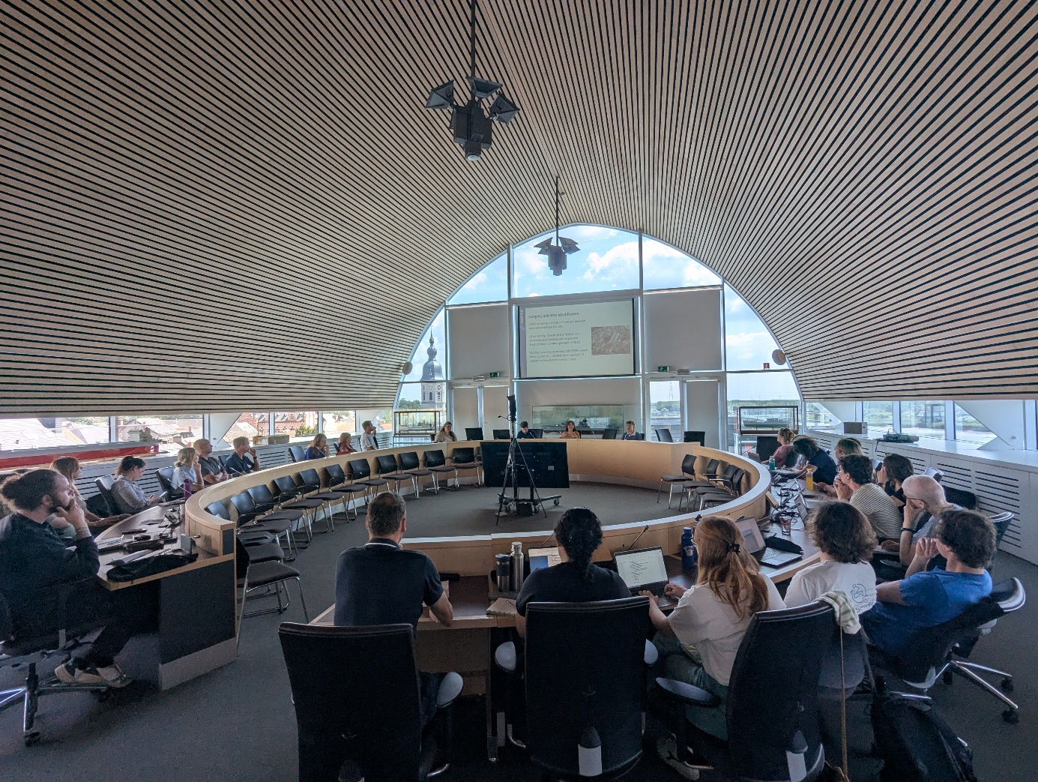

16 June 2025, 12:00-18:00, Temse municipality hall, Belgium
Jointly organized by Belgium, France and The Netherlands

Goal of the meeting

The goal of this workshop was for OSPAR’s Riverine litter Expert Group (REG) and the action group for action A.3.1 of OSPAR’s second Regional Action Plan on marine litter (RAP ML 2) (OSPAR Agreement 2022-05) to receive input on two products they are working on, these being 1) the monitoring guidelines for riverbank litter, and 2) the development of best practices for source prevention of riverine litter.

Overview of activities

To achieve this goal, the day was split up in several parts:

- A welcome and general introduction by host Senne Aertbeliën (Belgium)

- Introduction of the draft guidelines for riverbank litter monitoring by Camille Lacroix (France, CEDRE)

- Interactive break out session to discuss barriers to implementation of the draft guidelines

- Introduction to source prevention best practices by Guido van den Ende (The Netherlands, Rijkswaterstaat)

- Interactive break out session on linking sources to preventative measures

- Live demonstration of monitoring techniques developed within the EU INSPIRE project

The workshop had a total of 30 participants, including representation from OSPAR Contracting Parties, JRC, research institutes and citizen science initiatives. The full list of participants can be found in annex 1 of this document.

This document provides an overview of the presentations given during the workshop, as well as a summary of the main conclusions from the breakout session.

Riverbank litter monitoring

Camille Lacroix (France, CEDRE) presented the draft guidelines for riverbank litter monitoring. The slides for this presentation can be found in annex 2 of this document. These guidelines are based on the OSPAR beach litter monitoring protocol, with minor adaptations made to make it applicable for the riverbank context. Adaptations include the way the sampling area is defined and the surface types that can be sampled on (to include non-sandy locations). These changes were made based on experience from pilot studies in France and The Netherlands. The purpose of this workshop was to identify what barriers to implementation exist for other parts of the OSPAR Maritime Area. To this end, 6 questions were answered in break out groups, these being:

- Open question: What barriers to implementation for the draft monitoring guidelines do you identify for you country and why?

- In a group, can you give a range (order of magnitude) of how much a potential monitoring strategy can cost per year?

- Are there any regulatory barriers that should be overcome for implementation?

- Which stakeholders (national and international) should be involved in the process?

- What technical elements in the monitoring guidelines hinder implementation?

- Any other things that should be considered?

The main barriers that were identified by participants included:

Site selection
- Sometimes difficult to find (safely) accessible location
- If we want to sample in the river: where does the river end, and the estuary/sea start?
- A definition of a river is important as well. Most likely the bigger ones will be the most obvious and/or suitable, but no definition is given. In countries without big rivers there is a risk that they don't feel concerned and don't engage in this monitoring.
- What to do with meandering of rivers? (Sample inside or outside of corner when no straight location is available?)
- Non-tidally influenced location not always possible (e.g. Scotland)

Sampling area
- Current protocol stipulates sand, grass or pebbles. Not always available. Therefore include boulders and artificial surfaces as well
- High water line not always available, how to determine sampling area width?
- The sampling width of 25m is too big for some countries
- Riverbanks in northern parts of OSPAR Maritime Area can be very steep and narrow (mountainous). Not possible to set wide sampling area
- Sampling area length of 100m can be too big for local litter concentrations, meaning that sampling takes too long (what about a time limit or sampling in shorter parallel transects for 30m?)
- Sampling area can be full of vegetation, how to deal with this?

Frequency
- Not all riverbanks in the OSPAR Maritime Area have year-round accessibility. For example, rivers can be frozen over in winter (north) or rivers fall dry in summer (south). Similarly daylight can be a limiting factor. Frequency of 4 times per year therefore not always possible.
- Weather conditions are not constant. Waiting for a high discharge event in rain fed rivers can therefore jeopardize regular sampling frequency. Including a description of the metadata when the sampling was conducted is important.
- Main concern: how to introduce flexibility in the frequency without making comparison impossible

Litter characterization
- Rivers have litter items that are not included in the OSPAR beach litter list. This includes plastics used in agriculture
- Data has to be standardized in order to be useful and has to be in control of a datamaster.
- Bridge between protocol makers and implementation will be needed in order to make it work. Applicability & common understanding of the protocol will be very important otherwise there could be resistance to this extra piece of work

Cost
- Budget and staff is limited, preference for simple and resource extensive monitoring protocols.
- A plus if protocol can be executed by citizen scientists (with proper QA/QC) but the incentive or guidance has to come from the government initially.
- Cost will also depend on how many sites have to be monitored and de frequency of monitoring. Therefore, it is important to have recommendations on this (give a range / min number of sites to be monitored).
- It is best to link to existing monitoring programmes such as MSFD and it is crucial that macrolitter becomes obligatory to monitor under the WFD.
- It is important to also consider alternative forms of monitoring such as the riverbed or water column where the riverbank is not possible or too expensive.

Riverine litter source prevention

Guido van den Ende (The Netherlands, Rijkswaterstaat) presented the riverine litter prevention program that has been implemented in The Netherlands. The slides to his presentation can be found in annex 3 of this document. The program itself does not consist of banning certain items. Instead, it helps local authorities in reducing emissions of litter to the (riverine) environment by developing guidelines on how certain sources can be reduced.

To reduce litter, it is key to know its source. Key sources identified in The Netherlands included recreational activities on river beaches, construction sites, sewage overflows, plastic production facilities (plastic pellets), river cruise ships, and recreational fishing. Next, interventions targeting these sources were developed, mostly aimed at ensuring that the right behaviour is followed by the people in these areas. To achieve this, people must want to this behaviour (motivation: I throw this empty food wrapper in the bin) and be able to execute this behaviour (there are enough empty bins to throw out the wrapper).

Using these insights, the participants were divided into 3 groups for a breakout session. Within this session they were asked the answer 3 questions:

- What are the main litter items/sources in your rivers?

- What are measures that can be taken to reduce these measures?

- What is the role that OSPAR can play in this process?

The main items found in rivers that were identified by participants include:

- Food and drink packaging
- Cigarette butts and vapes
- Agricultural plastics and pesticides
- Plastic pellets
- Sanitary waste
- Unidentified plastic foils
- Glass bottles
- Dumping of household waste
- Hunting related items (e.g. shotgun shells)
- Construction related plastic items (e.g. EPS)
- Sewage overflow
- Recreational shipping litter
- Historic landfills

Participants noted that there are actions on reducing some of these items included within OSPAR’s RAP ML 2. It would however be beneficial to have one document which collates best practices to reduce litter from each of these sources. The role of OSPAR could therefore be creating this best practice document. Besides this, OSPAR could consider work towards the banning / restriction of some of the most found items (e.g. cigarette butts) or promoting less harmful alternatives. Furthermore, participants supported OSPAR’s continued collaboration on this topic with the other Regional Sea Conventions surrounding Europe seeking to harmonize possible guidelines and measures.
Annex 1: participants

Name | Representing
Mariana Miranda | Belgium/VLIZ
Camille Lacroix | France/Cedre
Therese Nitschke | VLIZ, Belgium
Josie Russell | UK
Yannik Heisel-Sure | Germany / University of Oldenburg
Morag Campbell | Scottish Government
Jennifer Godwin | OSPAR RAP ML Coordination
Ryan Metcalfe | Denmark / KIMO International
Hubert Verhaeghe | Agence de l'eau Artois Picardie
Elien Schildermans | River Cleanup
Patrick Pouline | France/Office Français de la Biodiversité
Rik Seniow | Belgium/OVAM/Mooimakers
Eva Blidberg | Sweden/Keep Sweden Tidy
Anja Meland Rød | The Norwegian Environmental Agency, Norway
Paul Vriend | NL - RWS
Sylvia Drok | Nederland
Guido van den ende | NL/Rijkswaterstaat
Johanna Eriksson | Sweden
Liesbeth De Keukelaere | Belgium/VITO
Mattias Bossaer | VLIZ
Carolyn Caporusso | Bonaire, Caribbean Netherlands
Julie Muyle | Belgium, Flanders Marine Institute
John Seghers | European Commission Joint Research Centre
Thomais Vlachogianni | MIO-ECSDE
Arno Doggen | River Cleanup
Heather McLaughlin | Keep Scotland Beautiful, Scotland, UK
Mieke Degloire | Belgium, FPS Environment
Marijke Boonstra | NL- Ministry Infra & Water
Guido vd Ende | NL

https://www.ospar.org/documents?v=49384
https://www.ospar.org/documents?d=44122
https://www.ospar.org/documents?v=7260

